

BAŞKENT UNIVERSITY
ELECTRIC & ELECTRONICS ENGINEERING

EEM 214 ~ ELECTRONICS–I
LABORATORY
REPORT

Experiment Name : BJT Biasing
Experiment Number : 8

Student Name : Buğra BAYRAM
Student Number :20193272
Experiment Date/Day: 5 / 5 / 2006
Laboratory Number:

Honor Pledge:

I did this preliminary work or lab report by myself and I have neither cheat from anybody nor let anybody cheat from me at the any part of this work.

Student Signature:
……………………….

- The results of mesurments :

1kΩ = 972Ω

100Ω= 98Ω

2.2kΩ=2.162kΩ

470kΩ=471.2kΩ

2.

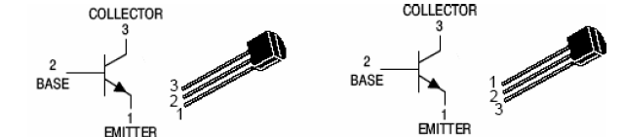

BC238B 2N3903-2N3904

We built circuit in fig 1 with Rb=470kΩ and we used it to calculate the beta of each of the three transistors.And we measured node voltages : Vcc,Vc,VB and ß=Ic/IB .They are shown in the table below.

 | VCC | VCmeasured | VBmeasured | ßcalculated
2N3903 | 15V | 13,242V | 0,680V | 54,77
2N3904 | 15V | 10,444V | 0,712V | 154,45
BC238B | 15V | 4,132V | 0,697V | 365,7

ß values are calculated below

For transistor 2N3903 ;

IC= (Vcc – Vc)/Rc → Ic= (15-13,242)/972Ω = 1,88A
Ib= (Vcc – Vc)/Rb → Ib= (15-0,680)/417,2kΩ= 34,32mA

ß= Ic/Ib = (1,88/34,32)*1000 = 54,77

For transistor 2N3904 ;

Ic = (15-10,444)/972 Ω = 4,68mA
Ib= (15- 0,712)/471,2k Ω= 30,3A
ß = Ic/Ib= 4,68mA/30,3A= 154,45

For transistor BC238B;

Ic=(15-4,132)/972 Ω= 11,1mA
Ib=(15-0,697)/471,2k Ω= 30,35A
ß =Ic/Ib= 11,1mA/30,35A=365,7

- We used the medium value of ß which is 154,45 and we calculate the values of the specified resistor for each of the four circuits.Where Ic=6mA.

Ib= Ic/ ß=6mA/154,45=3,88*10^-5

a.
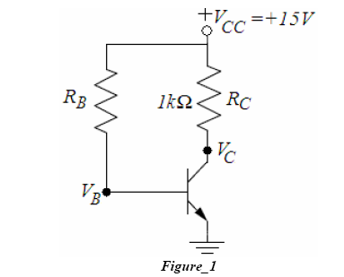

Rb= (Vcc-VBE)/Ib= (15-0,65)/3,88*10^-5 = 369,8k

b.
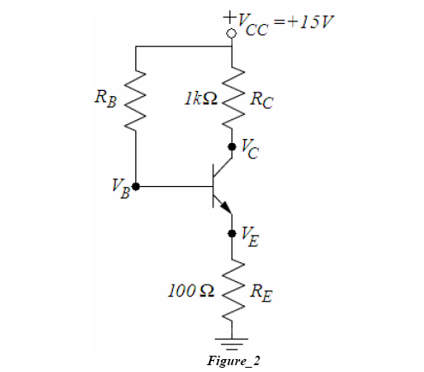

Rb=(Vcc-VBE-IcRE)/Ib = (15-0,65-(6*10^-3*100))/3,88*10^-5

Rb = 354,8k

c.

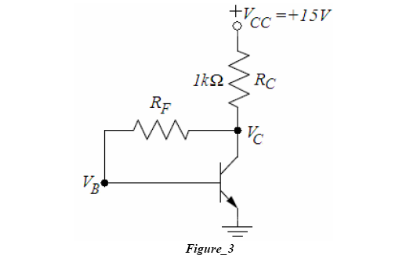

RF = (VCE –VBE)/Ib

Vc=15-(6/154,45*0,972)=14,96V

RF= (14,96-0,65)/3,88*10^-5 = 368,8k

d.
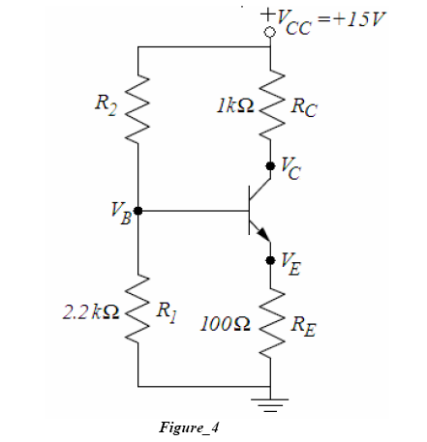

IR1 = 0,65 + 6/154,45*100/2,2k = 4,53/2,2k = 206mA
R2= (Vcc-VBE-IcRE)/ (IR1+Ib)
R2= ( 15-0,65-6/154,45*0,1)/(0,206+6/154,45)= 14,35/5,28=27,2k

3.

 |  | VC measured | ICQ calculated
Circuit in Fig.1 | Low β | 13,372 V | 2,628 mA
Circuit in Fig.1 | Medium β | 8,993 V | 6 mA
Circuit in Fig.1 | High β | 1,400 V | 13,6 mA
Circuit in Fig.2 | Low β | 12,411 V | 2,589 mA
Circuit in Fig.2 | Medium β | 9,245 V | 5,755 mA
Circuit in Fig.2 | High β | 2,576 V | 12,424 mA
Circuit in Fig.3 | Low β | 11,302 V | 3,698 mA
Circuit in Fig.3 | Medium β | 9,003 V | 5,997 mA
Circuit in Fig.3 | High β | 5,808 V | 9,192 mA
Circuit in Fig.4 | Low β | 9,315 V | 5,685 mA
Circuit in Fig.4 | Medium β | 9,297 V | 5,703 mA
Circuit in Fig.4 | High β | 9,016 V | 5,991 mA

Calculations are shown below;

For figure 1 :

Low ß → IcQ=(15-12,372)/1k= 2,628mA
Medium ß→ IcQ= (15-8,993)/1k=6mA
High ß→ IcQ= (15-1,4)/1k=13,6mA

For figure2:

Low ß→ IcQ= (15-12,411)/1k=2,589mA
Medium ß→ IcQ=(15-9,245)/1k=5,755mA
High ß→ IcQ=(15-2,576)/1k=12,424mA

For figure3:

Low ß→ IcQ=(15-11,302)/1k= 3,698mA
Medium ß→ IcQ= (15-9,003)/1k=5,997mA
High ß→ IcQ= (15-5,808)/1k=9,192mA

For figure4:

Low ß→ IcQ=(15-9,315)/1k= 5,685mA
Medium ß→ IcQ=(15-9,297)/1k=5,703mA
High ß→ IcQ=(15-9,016)/1k= 5,991mA

5-)
a-)
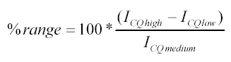
For Fig.1:
% range = 100 x (13,6-2,628) / 6 = 182

For Fig.2:
% range = 100 x (12,424-2,589) / 5,755 = 171

For Fig.3:
% range = 100 x (9,192-3,698) / 5,997 = 92

For Fig.4:
% range = 100 x (5,991-5,685) / 5,703 = 5

b-)

Circuit in Fig.4 → Circuit in Fig.3 → Circuit in Fig.2 → Circuit in Fig.1
Most Stable →→→→→→→→→→→→→→→→→→ Least Stable

% range calculations shows us that the circuit in Fig.4 is most stable.Changes in β doesn’t effect the ICQ circuit in Fig.4.So it is the most stable circuit.

c-)
There are some small differnces between theoretical and experimental values.
Reasons are be defined as mesarument errors and probably we couldn’t set the pot correctly to the resistor value of we want.

