Başkent University
Department of Electrical and Electronics Engineering
EEM 214 Electronics I Experiment 9

Aim:
MOSFET Transistor Basics

The aim of this lab is to familiarize the student with the basic regions of operation of a
MOSFET transistor.

Theory:

The MOSFET device is a four terminal device with connections for the drain, gate, source, and body as shown in the symbol in Fig.1. However, a more common symbol used to identify the MOSFET is shown in Fig.2 and is what will be used in this experiment. The MOSFET devices used in this lab have the body internally connected to the source such that the body terminal is not externally accessible. Shown in these figures are N- channel MOSFETs.

figure_1: MOSFET 4-Terminal Symbol figure_2: MOSFET 3-Terminal Symbol
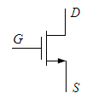

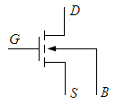

To study the MOSFET we connect two external voltage sources to the device as shown in Fig.3. These provide a drain-source voltage VDS and a gate-source voltage VGS.

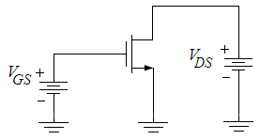
figure_3: MOSFET with VGS and VDS connected

The voltage VDS may cause a drain-source current IDS to flow provided a path exists from the drain to the source inside the device. This internal current path can be controlled by the gate-source voltage VGS. For a sufficiently high VGS, an internal current path, called the channel, is established between the drain and the source. The higher the VGS value the easier it is to flow for the drain-source current IDS. Note that the only DC current in the MOSFET is IDS since the gate is internally insulated from the channel.

1

By operating the MOSFET in particular bias regions, based on the VGS, VDS, and IDS values, it can be used to perform a variety of functions. The two regions that the MOSFET device can operate in are the ohmic(linear) and saturation(active) regions. Both of these regions will be explored in this experiment through the exploration of a few of the MOSFET device implementations. These regions can be graphically represented. Shown in Fig.4 is the MOSFET IDS / VDS curve for constant values of VGS. Notice that, the ohmic region exists where VDS is very small and the curve is nearly linear, hence another name for the region, the linear region. As VDS increases, the curve begins to flatten. When VDS is equal to the saturation voltage, VD(SAT), the device enters the saturation region. This voltage, VD(SAT), is determined by the voltage VGS of the MOSFET along with a physical parameter of the MOSFET called the threshold voltage VT.

figure_4: Typical MOSFET IDS / VDS curve
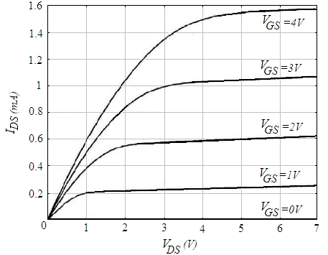

For a MOSFET, VD(SAT)=VGS–VT, and for VDS(SAT)≥VD≥0, the device is in the ohmic(linear) region of operation, and for VDS≥VD(SAT)≥0, the device is in the saturation region of operation.
The current flowing through the device in the ohmic(linear) region of operation is given by the following equation:

1) I DS

W COX L

O
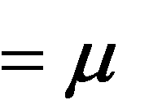

(VGS

VT )
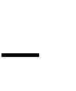

VDS
2

VDS

Given the VGS and VDS values as well as the physical MOSFET sizing W/L and the physical parameter oCox, the current IDS can be found for the ohmic(linear) region. The W/L parameter is the width of the device divided by its length and the fabrication process of the device determines the physical parameter oCox. In this region of operation, the MOSFET acts as a voltage controlled resistor where the value of drain-source resistance can be found by taking the partial derivative of IDS with respect to VDS as shown below:
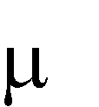

2) DS DS

V
I

W COX

O
L

VGS 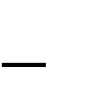 T )
(
V

DS

V
2 DS
V

W COX

O
L

VGS T DS
V
V
1
rohmic

2

The device can also be operated in the saturation region. This region is primarily used for amplification of an input signal. However, amplification will be studied in subsequent experiments, in this experiment we are limiting the discussion to DC bias conditions in the saturation region of operation. The current IDS in the saturation region of operation can be found from the following equation (for simplicity, λ is assumed to be zero):

1

O
3) I DS
2

W COX

L

VGS T
V
(
)
2

In this region, the device acts as a voltage-controlled current source, hence its use as an amplifier. The current source created is not ideal and is shunted by a small signal equivalent resistance referred to as rds. The small signal resistance rds will be studied in more detail later. For this experiment, the concern is with find the current IDS based on the values of VGS and VDS.

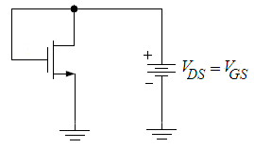
figure_5: Diode-Connected MOSFET

In the saturation region, the MOSFET can be connected to act similar to a diode. The MOSFET is commonly called diode-connected when configured as in Fig.5. The voltage across the device can be set to provide a reference voltage that may be needed in a particular application. The equation to find the voltage across the device can be found by solving Equation3 for VGS since the VGS of the device is equal to VDS. This equation for VMOSDIODE is shown below:

4) V

MOSDIODE VT
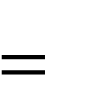

I DS

1 W COX

O
2 L

By diode-connecting the device, the saturation region is virtually guaranteed. Knowing the IDS, W/L, and oCox the voltage VMOSDIODE can be found.

3

Preliminary Work:

Review the sections 4.10 from the Text Book.

In laboratory you will use the MOSFET Chip CD4007. The NMOS has μoCox=
166.67μA/V2, W/L=3 and VT = 1.45V. Assume VA =1/λ =100V. The Pin Diagram of the
CD4007 Chip is in Fig.6.

figure6
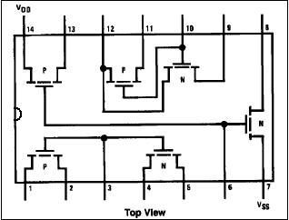

Reference:

[1] The values given for the μoCox(W/L) and VT found using the measured data on the CD4007 chip were provided courtesy of Dr. David M. Binkley, Associate Professor at the University of North Carolina at Charlotte and Clark Hopper M.S, R.A. and Harold Hearne M.S., R. A. both also at the University of North Carolina at Charlotte.

1) For the MOSFET shown in Fig.3, solve for the drain-source current IDS, indicate the region of operation, and, if necessary, solve for the drain-source resistance rohmic for the following conditions.

a) VGS = 3V ; VDS = 0.5V b) VGS = 5V ; VDS = 0.5V c) VGS = 2V ; VDS = 3V.

2) Using the following peusedocode, plot the mosfet IDS-VDS curve in Matlab for the VGS values increments by 0.5 volt from 0 to 4 overlaid on the same graph like in figure_4. Clearly indicate the operation regions. Vary the VDS from 0V to +5V by 0.01 increments.

for λ=0
if VGS<VT mosfet operate in cut off region ID=0 if VGS≥VT mosfet operate in active region
if VDS≤VGS-VT mosfet in linear(ohmic) region
ID=μoxCox (W/L)(VGS-VT-VDS/2)VDS
if VDS>VGS-VT mosfet in saturation region
ID=(1/2)μoxCox (W/L)(VGS-VT)2

4

3) Desiring a MOSFET resistor with a resistance of 100kΩ, find the value of VGS needed to create this resistor given VDS=0V.

4) For the MOSFET shown in Fig.7, solve for VDS=VMOSDIODE and the value of R. (Hint: Write a KCL equation at the drain of the MOSFET and use Equations 3 and 4.)

figure_7
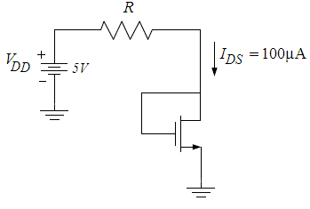

5) Read the experimental Work.

5
Experimental Work:

You will be using CD4007 MOSFET array as in this experiment. This array contains three NMOS and three PMOS transistors as shown in Fig.6. Again, the key point to remember is that the bulk (or substrates) of all NMOS transistors are connected to the VSS (pin 7) and all PMOS substrates are connected to VDD (pin 14). When using this array pin 7 should be connected to the most negative supply voltage or to the source of the transistor. Pin 14 is the substrate of the PMOS and must be connected to the most positive supply voltage in the circuit!
CD4007 MOSFET array should not be connected to circuits with the power on because high transient voltages may cause permanent damage. Therefore, do not apply input signals until you have connected PIN 7 and 14; otherwise, serious damage to the device could result.
It should be mentioned that the transistor characteristics of CD4007 could vary considerably from chip to chip. The transistors may come from a different batch, what can explain why the threshold voltage, the transconductance parameter and the output resistance is different from the one used in the hand calculations and Spice simulation. Precaution: MOSFET transistors are very susceptible to breakdown due to electrostatic discharge. It is recommended that you always ground yourself before picking up the MOSFET chip. Do no touch any of the pins of the chip.

Note: Use jumper wires as possible as short on your board to connect the pins of the transistors.

Before constructing the circuit,

 Verify the values of the resistors that you are going to use by measuring their resistances with a multimeter. Make sure that all resistors are within 2% of their marked values. This will assure that your current measurements are accurate

Prepare the power supply for VGS to ensure a DC voltage of +4V (before connecting to the circuit. Prepare the other power supply for VDS to ensure a DC voltage of 0V (before connecting to the circuit.

***Note: Always turn on the DC power supply before applying the AC signal. Always turn off the AC signal before turning off the DC power supply.

1) a. Observe the schematic shown in Fig.8. Notice that the numbers correspond to the pin connections on the CD4007 chip.

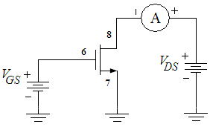
Figure_8: MOSFET Connections – MOSFET Curves

6
b. Connect the circuit as shown in Fig.8. Measure and record the drain current IDS as VDS is varied from 0V to +5V with VGS = 4V. Take data points in 0.4V increments in order to have a sufficient number of values since these will be used to plot IDS/VDS.

c. Repeat the entire b. for VGS = 3V, and VGS = 2V.

 | IDS
VDS | VGS = 2V | VGS = 3V | VGS = 4V
0.4V
0.8V
1.2V
1.4V
1.6V
1.8V
2V
2.2V
2.4V
2.6V
2.8V
3V
3.2V
3.4V
3.6V
3.8V
4V
4.2V
4.4V
4.6V
4.8V
5V

Using the data collected in Part.1 plot a family of curves(using Excel) for the three values of VGS overlaid on the same graph. There should be one curve for each of the three values of VGS (2V, 3V and 4V). Label each curve with the appropriate VGS values and label approximately where the ohmic(linear) and saturation regions exist.

2) With VDS = 5V, determine the value of VGS at which the current IDS becomes negligible; assume for the purposes here that this means 5 A. This value of VGS is close to the threshold voltage, VT, of the transistor for the MOSFET we are working with.

7
3) a. Now observe the schematic shown in Fig.9. Again, note the pin connections to the
CD4007 chip.

Figure_9: MOSFET Connections – MOSFET Curves
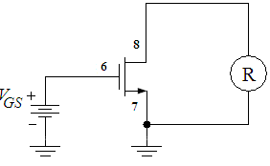

b. Connect the circuit as shown in Fig.9 with the ohmmeter across the drain and source.
Vary VGS and notice the change in resistance values. Measure and record the values of resistance for VGS = 1.5V, 2V, 3V, 4V, and 5V.

VGS | rohmic
1.5V
2V
3V
4V
5V

Using Equation 2 for the drain-source resistance rohmic for a MOSFET in the ohmic(linear) region of operation, find the resistance of the MOSFET for the following conditions given; 166.67μA/V2, W/L=3, VT = 1.45V and VDS=0. Compare these with the values obtained in Part.3b. Complete a table of results compiling the measured and calculated values.

a) VGS = 1.5V
b) VGS = 2V
c) VGS = 3V
d) VGS = 4V
e) VGS = 5V

8
4) a. Prepare a DC current supply to a value of 100 A to the circuit as shown in Fig.10. (Hint : Use the R value that you found on preliminary work part4). If necessary (if IDS ≠ 100 A) vary the DC current supply IDS(by varying the Potentiometer) to



100 A.

Figure_10: MOSFET Connections – Diode Connected MOSFET
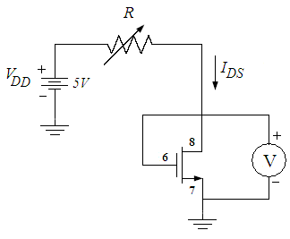

b. Measure and record to voltage across the MOSFET and RPOT as shown Fig.10.

c. Now vary the DC current supply IDS(by varying the Potentiometer) to the following values: 75 A, and 50 A. Measure and record the values of RPOT and VDS for each condition.

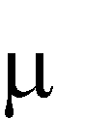

RPOT | IDS | VDS
 | 100 A
 | 75 A
 | 50 A

Using Equation 4 for the voltage of a diode-connected MOSFET, calculate the voltages for the following conditions given. Compare these values with those obtained in Part.4. Complete a table of results compiling the measured and calculated values.

a) IDS=100 A b) IDS=75 A c) IDS=50 A

5) Why would it be necessary to create a resistor from a MOSFET? Name some advantages of doing so.

6) Why would a MOSFET be connected like a diode? Would the voltage set by the
MOSFET be helpful in circuit design?

Lab Instruments:
Breadboard
Multimeter
DC Power Supply
Components:
1 CD4007 Chip
100k POT

9

