

BAŞKENT UNIVERSITY
ELECTRIC & ELECTRONICS ENGINEERING

EEM 214 ~ ELECTRONICS–I
LABORATORY
REPORT

Experiment Name : MOSFET Transistor Basics
Experiment Number : 9

Student Name : Buğra BAYRAM
Student Number :20193272
Experiment Date/Day: 12 / 5 / 2006
Laboratory Number:

Honor Pledge:

I did this preliminary work or lab report by myself and I have neither cheat from anybody nor let anybody cheat from me at the any part of this work.

Student Signature:
……………………….

1-)

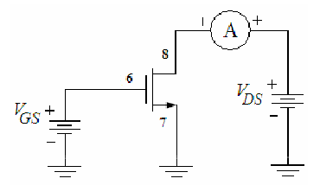

c-)

 | IDS
VDS | VGS =2V | VGS =3V | VGS =4V
0,4 V | 0,250 | 0,738 | 1,393
0,8V | 0,262 | 1,170 | 2,129
1,2V | 0,265 | 1,270 | 2,680
1,4V | 0,266 | 1,284 | 2,880
1,6V | 0,267 | 1,294 | 2,969
1,8V | 0,268 | 1,301 | 3,014
2V | 0,268 | 1,304 | 3,049
2,2V | 0,269 | 1,309 | 3,068
2,4V | 0,270 | 1,312 | 3,082
2,6V | 0,270 | 1,315 | 3,090
2,8V | 0,270 | 1,319 | 3,099
3V | 0,271 | 1,321 | 3,108
3,2V | 0,272 | 1,324 | 3,115
3,4V | 0,272 | 1,326 | 3,120
3,6V | 0,272 | 1,328 | 3,126
3,8V | 0,273 | 1,330 | 3,132
4V | 0,273 | 1,332 | 3,136
4,2V | 0,273 | 1,334 | 3,139
4,4V | 0,274 | 1,336 | 3,143
4,6V | 0,274 | 1,338 | 3,148
4,8V | 0,275 | 1,340 | 3,151
5V | 0,276 | 1,342 | 3,154
All IDS values are measured as mA
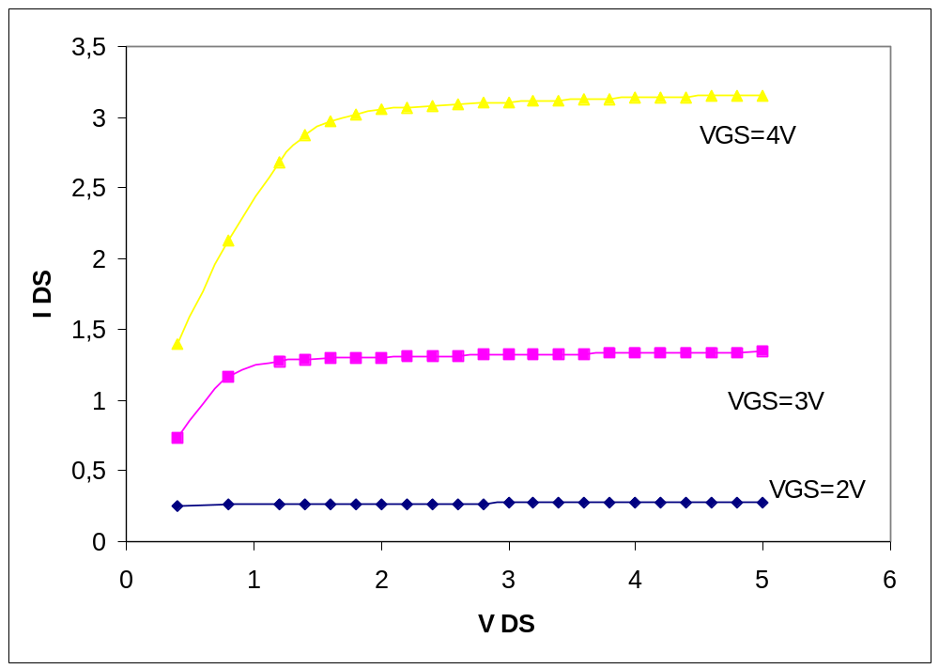

Using the data collected in Part.1 we plotted a family of curves (using Excel) for the three values of VGS overlaid on the same graph.

2-) With VDS = 5V, we determine the value of VGS at which the current IDS becomes
negligible; assume for the purposes here that this means 5 μA.
VGS = 1.2 V
3-)

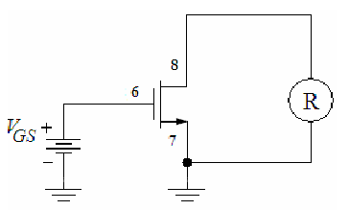

b-)

VGS | rohmic
1.5 V | 2,634 K
2 V | 960 Ω
3 V | 447 Ω
4 V | 302 Ω
5 V | 241 Ω
For the following conditions given, we calculated the drain-source rohmic. We saw that the measured and calculated values were nearly the same values.
a.) VGS = 1.5V;

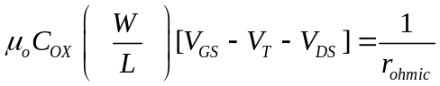 ➔ 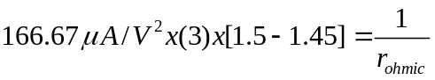 ➔ 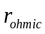 = 4.000 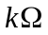

b.) VGS = 2V;

➔
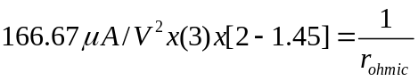 ➔ = 3.636

c.) VGS = 3V;

➔
-2-
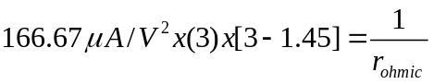➔ = 1.290

d.) VGS = 4V;

➔
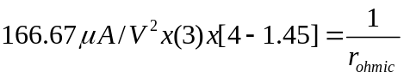 ➔ = 0.784

e.) VGS = 5V;

➔
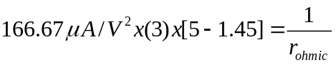 ➔ = 0.563

4-)
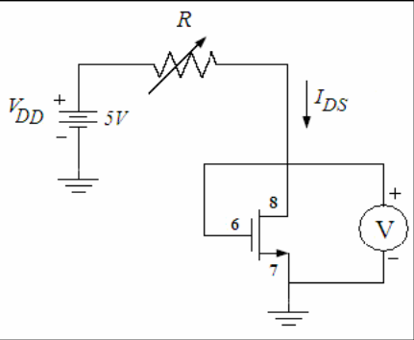
1,744V

c-)
RPOT | IDS | VDS
29,18 K | 100μA | 1,744 V
40,92 K | 75μA | 1,658 V
70,5 K | 50μA | 1,556 V

Using Equation 4 for the voltage of a diode-connected MOSFET, we calculated the voltages for the following conditions given: We again saw that the measured and calculated values were nearly the same.

IDS=100μA
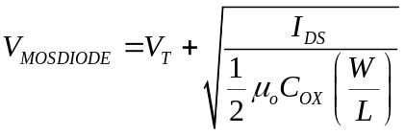 ➔ 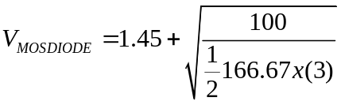
➔ 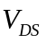= 2.08 V

IDS=75μA
➔ 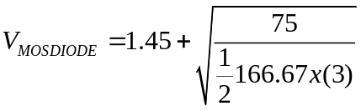
➔ = 2.00 V

IDS=50μA
➔ 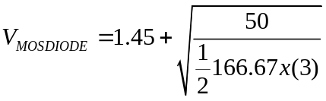
➔ = 1.90 V

IDS | VDS  (Calculated)
100μA | 2.08 V
75μA | 2.00 V
50μA | 1.90 V

