FOURIER SUMMARY
_________________________CT SIGNALS______________DT SIGNALS________

CONVOLUTION
non-causal x(∙), h(∙) 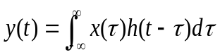 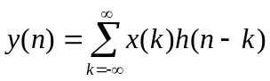

causal x(∙), h(∙) 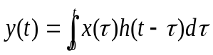 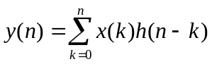
_{FS} _{FS}
FOURIER SERIES x(t) a_{k} x(n) a_{k}
synthesis equation 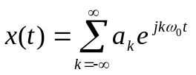 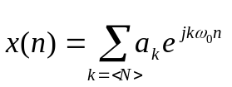
analysis equation 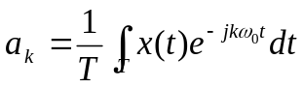 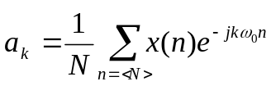

_{F} _{F}
FOURIER TRANSFORMS x(t) X(ω) x(n) X(e^{jω})
F[x(t)] = X(ω) F[x(n)] = X(e^{jω})
x(t) = F⁻¹[X(ω)] x(n) = F⁻¹[X(e^{jω})]

sythesis equation 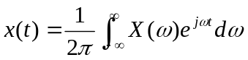 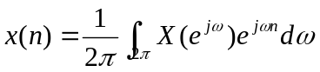
analysis equation 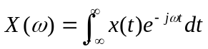 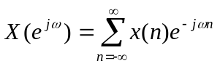

SOME USEFUL INTEGRALS

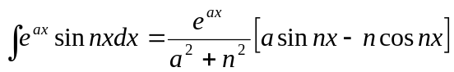, 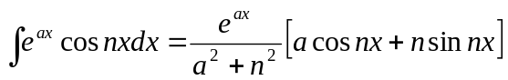

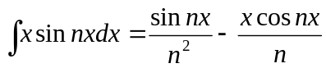, 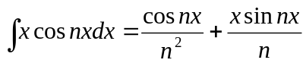

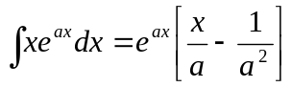, 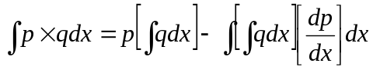

Uraz

SOME USEFUL RELATIONS
∕ for a=1
Finite Sum Formula: 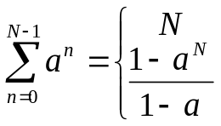 for any complex number a≠1

Infinite Sum Formula: 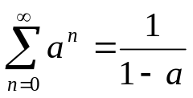 for |a| < 1

Derivatives: 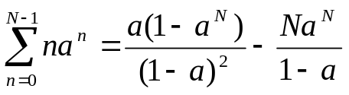

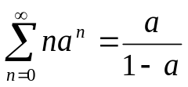 for |a| < 1
∕ for a=1
With Different Limits: 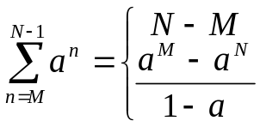 for a≠1, +ve / –ve M, N with M≤N

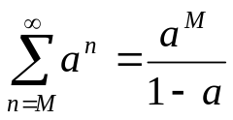 for |a| < 1

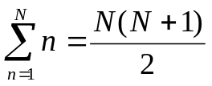, 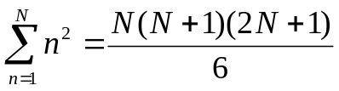

Rectangular ↔ Polar: For +ve real a, b and integer n;
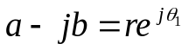 => 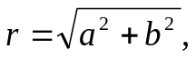 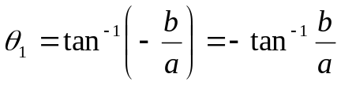

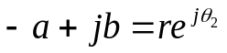 => 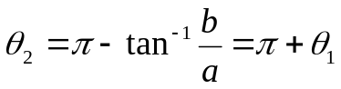
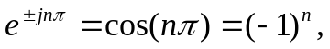 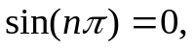 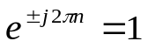, 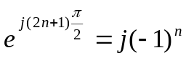

(-j)² = -1, (-j)³ = +j, (-j)⁴ = 1, (-j)⁵ = (-j)⁴(-j)¹ = -j, …
(+j)² = -1, (+j)³ = -j, (+j)⁴ = 1, (+j)⁵ = (+j)⁴(+j)¹ = +j, ... Uraz

