Başkent University

Department of Electrical and Electronics Engineering
EEM_417 ~ Control System Design(Denetim Sistemi Tasarımı)

Tutorial_2 Introduction to MATLAB

Functions

To make life easier, MATLAB includes many standard functions. Each function is a block of code that accomplishes a specific task. MATLAB contains all of the standard functions such as sin, cos, log, exp, sqrt, as well as many others. Commonly used constants such as pi, and i or j for the square root of -1, are also incorporated into MATLAB.

sin(pi/4)
ans =
0.7071

To determine the usage of any function, type help [function name] at the MATLAB command window.
MATLAB even allows you to write your own functions with the function command. When entering a command such as roots, plot, or step into MATLAB what you are really doing is running an m-file with inputs and outputs that has been written to accomplish a specific task. These types of m-files are similar to subroutines in programming languages in that they have inputs (parameters which are passed to the m-file), outputs (values which are returned from the m-file), and a body of commands which can contain local variable. MATLAB calls these m-files functions. You can write your own functions using the function command.
The new function must be given a filename with a '.m' extension. This file should be saved in the same directory as the MATLAB software, or in a directory which is contained in MATLAB's search path. The first line of the file should contain the syntax for this function in the form :

function [output1,output2] = filename(input1,input2,input3)

A function can input or output as many variable as are needed. The next few lines contain the text that will appear when the help filename command is evoked. These lines are optional, but must be entered using % in front of each line in the same way that you include comments in an ordinary m-file. Finally, below the help text, the actual text of the function with all of the commands is included. One suggestion would be to start with the line:

error(nargchk(x,y,nargin));

The x and y represent the smallest and largest number of inputs that can be accepted by the function; if more or less inputs are entered, an error is triggered.

Functions can be rather tricky to write, and practice will be necessary to successfully write one that will achieve the desired goal. Below is a simple example of what the function, add.m, might look like.

function [var3] = add(var1,var2)
%add is a function that adds two numbers
var3 = var1+var2;

If you save these three lines in a file called "add.m" in the MATLAB directory, then you can use it by typing at the command line:

y = add(3,8)

Obviously, most functions will be more complex than the one demonstrated here. Look at the functions in the toolbox folder in the MATLAB software (for more sophisticated examples), or try help function for more information.

Plotting

One of the most important functions in MATLAB is plot function. Plot also happens to be one of the easiest functions to learn how to use. The basic format of the function is to enter the following command in the MATLAB command window or into a m-file.

plot(x,y)

This command will plot the elements of vector x on the horizontal axis of a figure, and the elements of the vector y on the vertical axis of the figure. The default is that each time the plot command is issued, the current figure will be erased.
Suppose you wanted to plot a sine wave as a function of time. First make a time vector (the semicolon after each statement tells MATLAB we don't want to see all the values) and then compute the sin value at each time.

t=0:0.25:7;
y = sin(t);
plot(t,y)

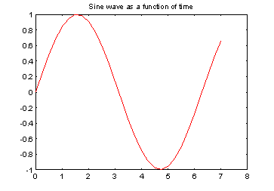

If we wanted to plot the simple, linear formula:

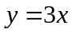

We could create a m-file with the following lines of code:

x = 0:0.1:100;
y = 3*x;
plot(x,y)

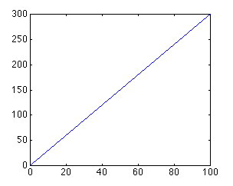

One thing to keep in mind when using the plot command is that the vectors x and y must be the same length. The other dimension can vary. MATLAB can plot a 1 x n vector versus a n x 1 vector, or a 1 x n vector versus a 2 x n matrix (you will get two lines), as long as n is the same for both vectors.
The plot command can also be used with just one input vector. In that case the vector columns are plotted versus their indices (the vector 1:1:n will be used for the horizontal axis). If the input vector contains complex numbers, MATLAB plots the real part of each element (on the x-axis) versus the imaginary part (on the y-axis).

Plot Aesthetics
The color and point marker can be changed on a plot by adding a third parameter (in single quotes) to the plot command. For example, to plot the above function as a red, dotted line, the m-file should be changed to:
x = 0:0.1:100;
y = 3*x;
plot(x,y,'r:')

The plot now looks like:

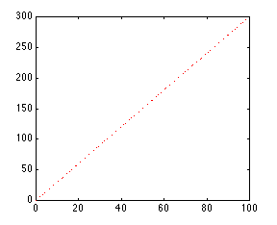
The third input consists of one to three characters which specify a color and/or a point marker type. The list of colors and point markers is as follows:
y yellow . point - solid
m magenta o circle : dotted
c cyan x x-mark -. dashdot
r red + plus -- dashed
g green * star
b blue s square
w white d diamond
k black v triangle (down)
^ triangle (up)
< triangle (left)
> triangle (right)
p pentagram
h hexagram

You can plot more than one function on the same figure. Let's say you want to plot a sine wave and cosine wave on the same set of axes, using a different color and point marker for each. The following m-file could be used to do this:

x = linspace(0,2*pi,50);
y = sin(x);
z = cos(x);
plot(x,y,'r', x,z,'gx')

You will get the following plot of a sine wave and cosine wave, with the sine wave in a solid red line and the cosine wave in a green line made up of x's:

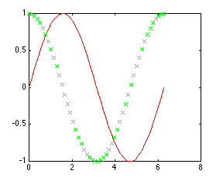
By adding more sets of parameters to plot, you can plot as many different functions on the same figure as you want. When plotting many things on the same graph it is useful to differentiate the different functions based on color and point marker. This same effect can also be achieved using the hold on and hold off commands. The same plot shown above could be generated using the following m-file:
x = linspace(0,2*pi,50);
y = sin(x);
plot(x,y,'r')
z = cos(x);
hold on
plot(x,z,'gx')
hold off

Always remember that if you use the hold on command, all plots from then on will be generated on one set of axes, without erasing the previous plot, until the hold off command is issued.

Subplotting
More than one plot can be put on the same figure using the subplot command. The subplot command allows you to separate the figure into as many plots as desired, and put them all in one figure. To use this command, the following line of code is entered into the MATLAB command window or an m-file:
subplot(m,n,p)

This command splits the figure into a matrix of m rows and n columns, thereby creating m*n plots on one figure. The p'th plot is selected as the currently active plot. For instance, suppose you want to see a sine wave, cosine wave, and tangent wave plotted on the same figure, but not on the same axis. The following m-file will accomplish this:

x = linspace(0,2*pi,50);
y = sin(x);
z = cos(x);
w = tan(x);

subplot(2,2,1)
plot(x,y)
subplot(2,2,2)
plot(x,z)
subplot(2,2,3)
plot(x,w)

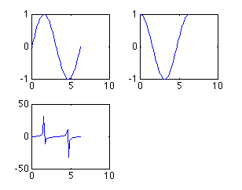
As you can see, there are only three plots, even though we created a 2 x 2 matrix of 4 subplots. We did this to show that you do not have to fill all of the subplots you have created, but MATLAB will leave a spot for every position in the matrix. We could have easily made another plot using the subplot(2,2,4) command. The subplots are arranged in the same manner as you would read a book. The first subplot is in the top left corner, the next is to its right. When all the columns in that row are filled, the left-most column on the next row down is filled (all of this assuming you fill your subplots in order i.e. 1, 2, 3,..).
One thing to note about the subplot command is that every plot command issued later will place the plot in whichever subplot position was last used, erasing the plot that was previously in it. For example, in the m-file above, if a plot command was issued later in the m-file, it would be plotted in the third position in the subplot, erasing the tangent plot. To solve this problem, the figure should be cleared (using clf), or a new figure should be specified (using figure).

Changing the axis
Now that you have found different ways to plot functions, you can customize your plots to meet your needs. The most important way to do this is with the axis command. The axis command changes the axis of the plot shown, so only the part of the axis that is desirable is displayed. The axis command is used by entering the following command right after the plot command (or any command that has a plot as an output):
axis([xmin, xmax, ymin, ymax])

For instance, suppose want to look at a plot of the function y=exp(5t)-1. If you enter the following into MATLAB

t=0:0.01:5;
y=exp(5*t)-1;
plot(t,y)

you should have the following plot:

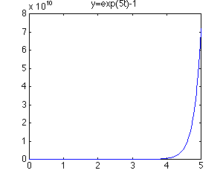
As you can see, the plot goes to infinity. Looking at the y-axis (scale: 8e10), it is apparent that not much can be seen from this plot. To get a better idea of what is going on in this plot, let's look at the first second of this function. Enter the following command into the MATLAB command window.
axis([0, 1, 0, 50])

and you should get the following plot:

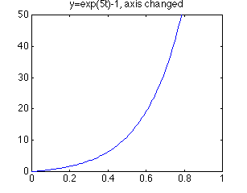
Now this plot is much more useful. You can see more clearly what is going on as the function moves toward infinity. You can customize the axis to your needs. When using the subplot command, the axis can be changed for each subplot by issuing an axis command before the next subplot command. There are more uses of the axis command which you can see if you type help axis in the MATLAB command window.
Adding text
Another thing that may be important for your plots is labeling. You can give your plot a title (with the title command), x-axis label (with the xlabel command), y-axis label (with the ylabel command), and put text on the actual plot. All of the above commands are issued after the actual plot command has been issued.
A title will be placed, centered, above the plot with the command: title('title string'). The x-axis label is issued with the following command: xlabel('x-axis string'). The y-axis label is issued with the following command: ylabel('y-axis string').
Furthermore, text can be put on the plot itself in one of two ways: the text command and the gtext command. The first command involves knowing the coordinates of where you want the text string. The command is text(xcor,ycor,'textstring'). To use the other command, you do not need to know the exact coordinates. The command is gtext('textstring'), and then you just move the cross-hair to the desired location with the mouse, and click on the position you want the text placed.
To further demonstrate labeling, take the exponential plot from above. Assuming that you have already changed the axis, copying the following lines of text after the axis command will put all the labels on the plot:
title('exponential function')
xlabel('time (sec)')
ylabel('output')
gtext('unnecessary labeling')

The text "unnecessary labeling" was placed right above the position that was clicked on. The plot should look like the following:

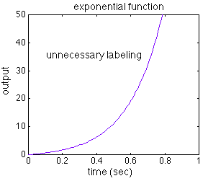

Other commands that can be used with the plot command are:
- clf (clears the current plot, so it is blank)
- figure (opens a new figure to plot on, so the previous figure is saved)
- close (closes the current figure window)
- loglog (same as plot, except both axes are log base 10 scale)
- semilogx (same as plot, except x-axis is log base 10 scale)
- semilogy (same as plot, except y-axis is log base 10 scale)
- grid (adds grid line to your plot)
Of course this is not a complete account of plotting with MATLAB, but it should give you a nice start.

