1.3)

a)
n=-3:1:7;
x=[0 0 0 2 0 1 -1 3 0 0 0];
stem(n,x);
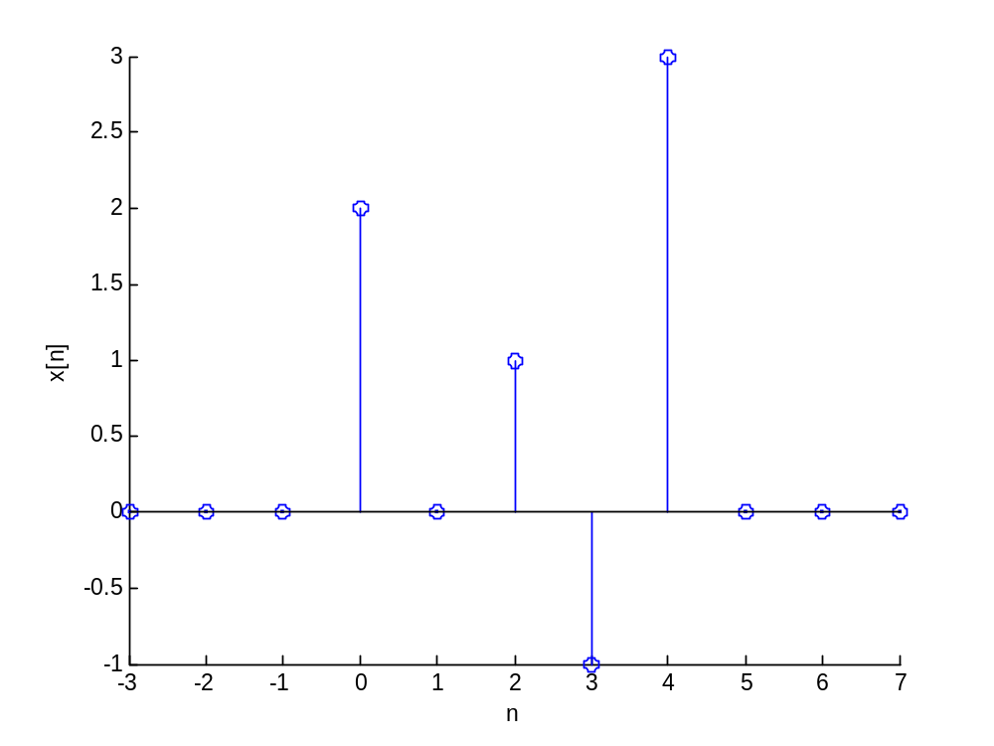

b)
y1[n]=[0 0 0 0 0 2 0 1 -1 3 0] , n= -3 ->7
y2[n]=[0 0 2 0 1 -1 3 0 0 0 0] , n= -3 ->7
y3[n]=[0 0 0 3 -1 1 0 2 0 0 0] , n= -7 ->3
y4[n]=[0 0 0 0 3 -1 1 0 2 0 0] , n= -7 ->3

c)
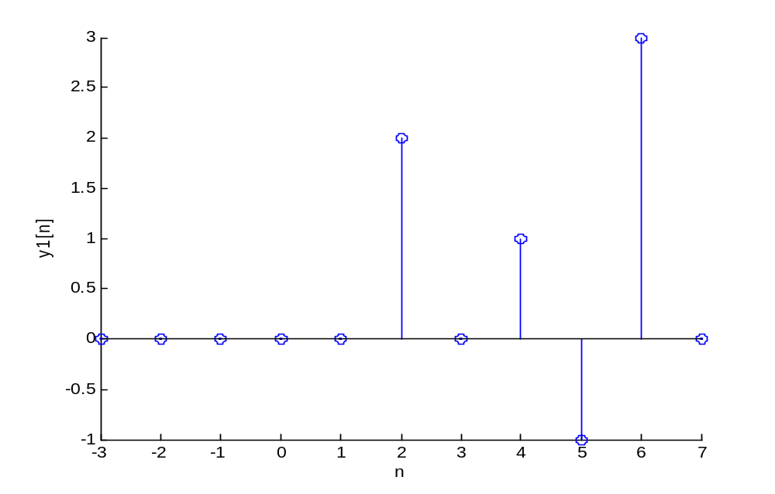
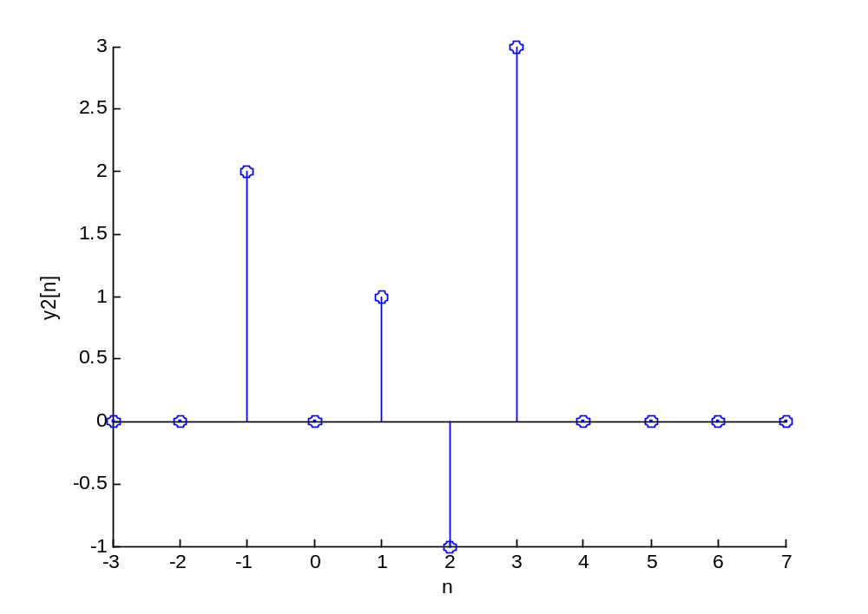
y-3 ve y4 de, n negatif olduğu için zaman aralığı olan “n” de -7 ve 3 arasında değiştirilecektir:
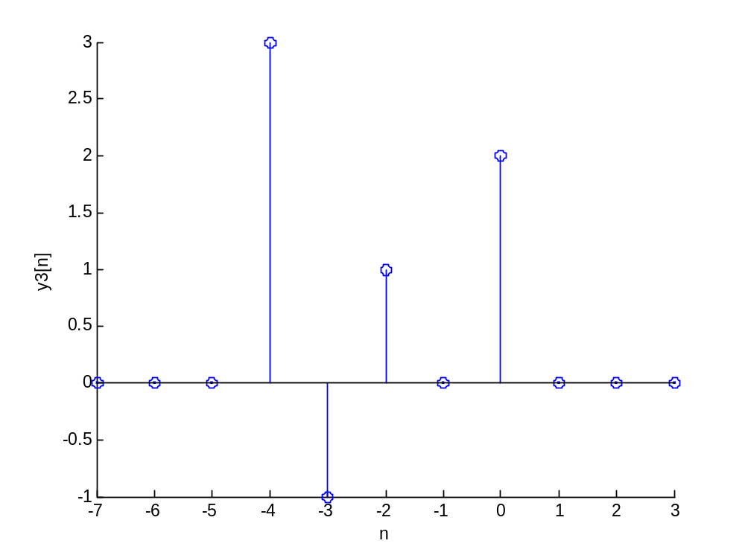
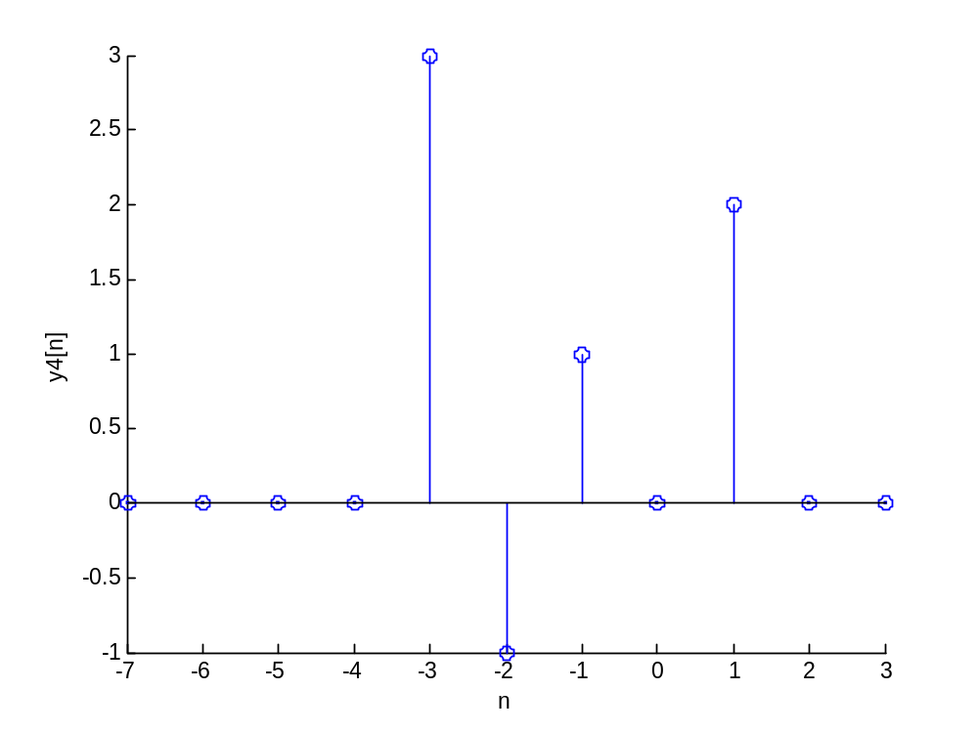

2.1)
a)
y[n]=x[0].x[n-0]+x[1].x[n-1]+x[2].x[n-2]+x[3].x[n-3]+x[4].x[n-4]+x[5].x[n-5]

y[0]=1 , y[1]=2 , y[2]=3 , y[3]=4 , y[4]=5 , y[5]=6 , y[6]=5 , y[7]=4 , y[8]=3 , y[9]=2 ,y[10]=1
b)
x=[1 1 1 1 1 1]
y=conv(x,x)
n=0:1:5
z=length(n)
ny=0:1:(2*z-2)
stem(ny,y)
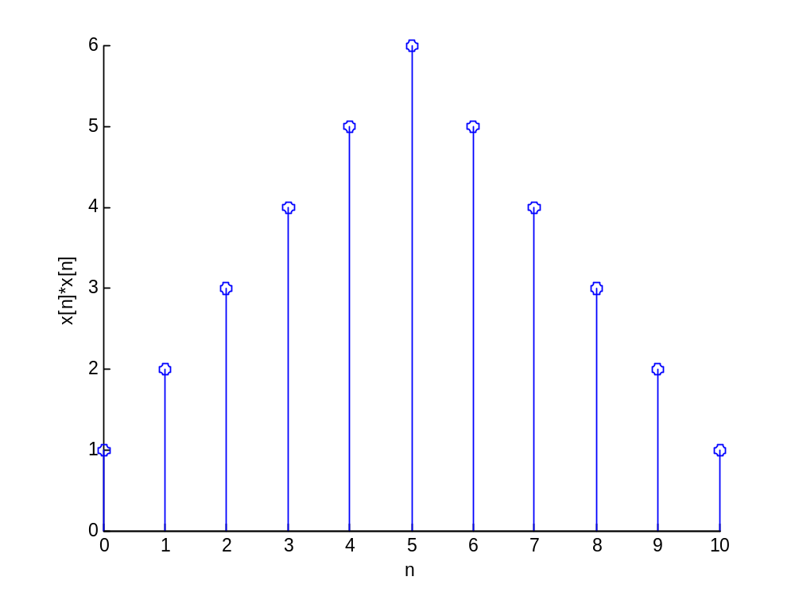

c)
x=[1,1,1,1,1,1]
h=0:1:5
n=0:1:5
z=length(n)
ny=0:1:((z.*2)-2)
y=conv(x,h)
stem(ny,y)
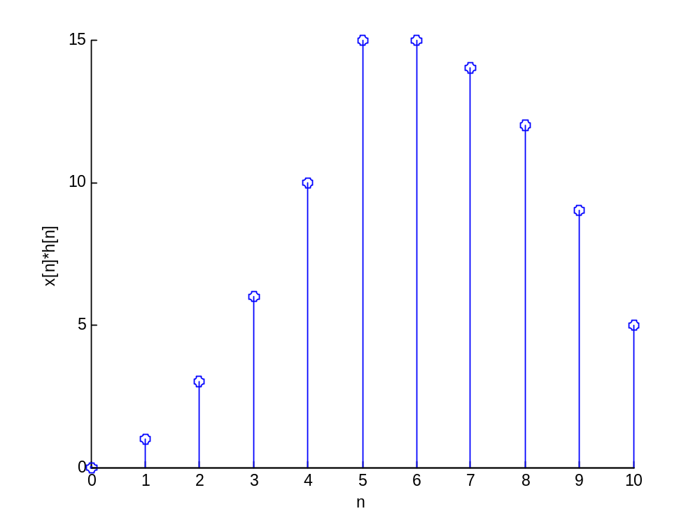

d)
x=[1,1,1,1,1,1]
h=0:1:5
n=-5:1:0
z=length(n)
ny=0:1:((z.*2)-2-5)
y=conv(x,h)
stem(ny,y)
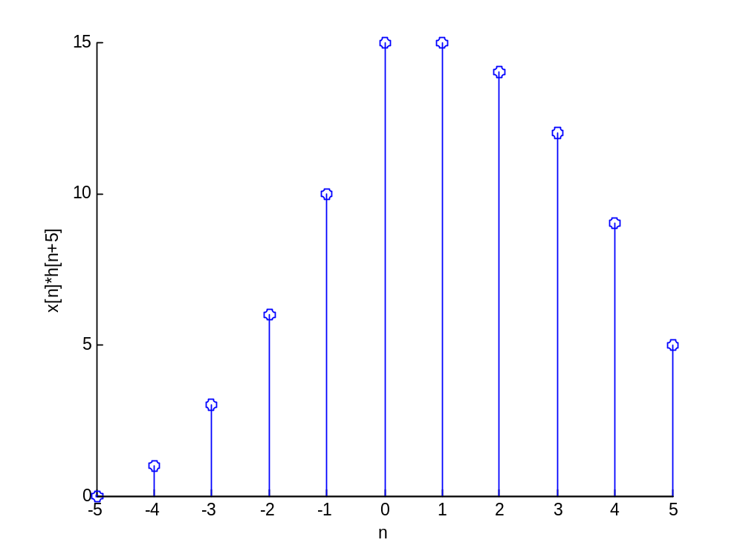
2.2)
a) a1=[1],b1=[0.5,1,2]

b) a2=[1],b2=[2,0.8]

c) a3=[1,-0.8],b3=[0,2]

d)
>> x=[1,2,3,4]

x =

1 2 3 4

>> y1=filter(b1,a1,x)

y1 =

0.5000 2.0000 5.5000 9.0000

>> a2=[1 -0.8];
>> b2=[2];
>> y2=filter(b2,a2,x)

y2 =

2.0000 5.6000 10.4800 16.3840

>> y3=filter(b3,a3,x)

y3 =

0 2.0000 5.6000 10.4800
2.7)
a)
y[-1]=h[-1]*x[0]=2
y[0]=h[0]*x[0]+h[-1]*x[1]=0+0=0
y[1]=h[-1]*x[2]+h[0]*x[1]+h[1]*x[0]=2+0-2=0
y[2]=h[1]*x[1]+h[0]*x[2]=0+0=0
y[3]=h[1]*x[2]=-2

x=[1 0 1]
nx=0:1:2
h=[2 0 -2]
nx=0:1:2
nh=-1:1:1
a1=length(nx)
a2=length(nh)
ny=-1:1:(a1+a2-2-1)
y=conv(x,h)
stem(ny,y)
