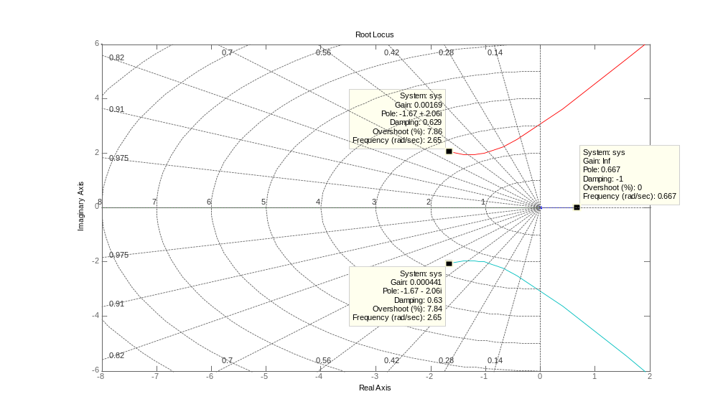
B.6-13)

num=[0 0 0 30.926 -20.618]
den=[1 3.3401 7.0325 0 0]
rlocus(num,den)
grid

