B.6-9)

num=[0 0 8.8 9]
den=[1 4 11 0]
rlocus(num,den)
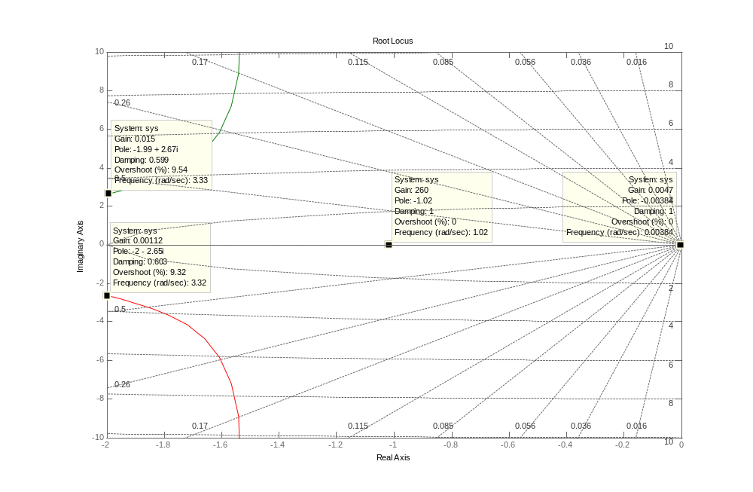
grid

