Başkent University
Department of Electrical and Electronics Engineering
EEM 311 Electronics II

Experiment 2

Single Stage BJT Amplifier

Aim:

The aim of the experiment is the investigate the single stage BJT (Bipolar Junction Transistor) amplifier.

Theory :

The npn transistor which is connected in a common emitter configuration, shown in Fig.1. The input and output voltage signals are coupled to and from the amplifier with the use of coupling capacitors. The base resistors R_{B1} and R_{B2} bias the transistor to a Q-point. The collector resistor R_{C} converts the output current to an output voltage signal. The amplifier output drives a load with resistance R_{L}. The simple biasing scheme used in this circuit leaves the Q-point sensitive to changes in the value of the transistor.

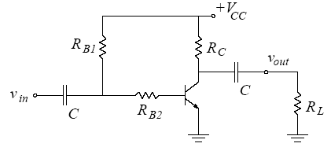
figure1

The small-signal model for BJT is shown in the Fig.2.

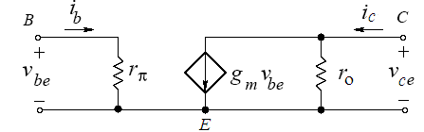
figure2

The value of the small-signal input resistance is determined by the DC base current; 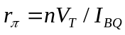, where n is the emission coefficient and the value of the small signal output resistance is determined by the DC collector current; 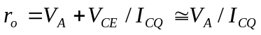where V_{A} is the early voltage. The small-signal transconductance is given by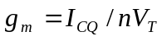. At room temperature V_{T} ≈ 25mV
Preliminary Work:

Review the sections 13.1, 13.2, 13.5 and 13.6 from the Course Book.

In laboratory you will construct the circuit in Fig.1 using the transistor BC238B and following values ;

V_{CC} | R_{B1} | R_{B2} | R_{C} | R_{L} | C
15 V | 470 kΩ | 1.8 kΩ | 1 kΩ | 100 kΩ | 10 μF

The BC238B has a 200< β <320, V_{CE(SAT)} = 0.2V, V_{BE(ON)} = 0.6V and V_{A} =100 . Use V_{T}=25mV and the emission coefficient as n = 1 even though BC238B transistors may exhibit an emission coefficient in the range (1≤ n ≤2). (You can download data sheet BC238B.pdf from course web page). The Pin Diagram of the BC238B is in Fig.3

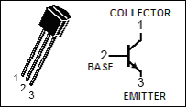
figure3

For each β value(β =200, β = 250, β =320 ) do following steps(1 through 4) ;

- Analyze the DC circuit to determine the Q-point. Find I_{BQ}, I_{CQ} and V_{CEQ}.

- Draw the load line and the transistor i_{C}-v_{CE} characteristics on a graph paper, and indicate the Q-point. (Separate graph for each β value.)

- Calculate the peak-to-peak maximum undistorted voltage swing at the output.

- Draw the small signal AC equivalent model of the amplifier assuming that the capacitors are short circuit at the operating frequency. Calculate 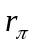, 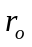, 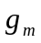 and the voltage gain 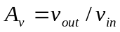.

- Simulate the amplifier circuit using PSPICE. You will need to use a model for the BC238B transistor. The models can be found in the EEM311.LIB library which you have it in deney1.zip. Save both the EEM311.lib and EEM311.olb files in your directory. You will need to add this library when drawing the schematic. Also, when creating a new Simulation Profile, while doing the simulation, you will need to add the library path and Filename (under the Libraries tab). See PSpiceDocument.pdf, section4 on "Using and Adding Vendor Libraries" or the how to add an include file.doc which is in deney1.zip.

First do a Bias Point analysis to determine DC voltages V_{CQ}, V_{EQ} and currents I_{BQ}, I_{CQ}, I_{EQ},

Next, do Time Domain analysis using an input sine wave of 2 mV peak-to-peak at a frequency of 1 kHz, and determine input, output voltage and voltage gain. Repeat with input amplitudes of 20 mV, 140mV, and 500mV; note the changes on the output waveform. Comment on your results.

Summarize the simulation results in table form and hand it in together with the calculations and the simulation print-outs. Label each graph clearly.

Experimental Work:

Before constructing the circuit, verify the values of the resistors that you are going to use by measuring their resistances with a multimeter. Make sure that all resistors are within 2% of their marked values. This will assure that your current measurements are accurate.

Construct the amplifier circuit using the values indicated in the preliminary work section.

- Measure and record I_{BQ}, I_{CQ} and V_{CEQ} and compare these with your calculations. Draw the load line on a graph and indicate the Q-point.

I_{BQ} =
I_{CQ} =
V_{CEQ} =

- Using your measurements from the previous part, determine the β of the transistor that you are using.

- In this part you are going to measure the small signal input resistance r_{π} at the operating point. The resistor R_{B2} and r_{π} form a voltage divider in the AC circuit. Set the input voltage signal to a sinusoid with 1 kHz frequency and 40 mV peak-to-peak amplitude. Measure v_{be} and determine r_{π}. Compare this value with your calculations and determine the value of the emission coefficient n.

v_{be} =

- In this part you are going to measure the small signal output resistance r_{o} at the operating point. Consider that the resistors R_{C,} R_{L} and r_{o} are parallel. Set the input voltage signal to a sinusoid with 1 kHz frequency and 20mV peak-to-peak amplitude. Measure the output voltage v_{out} and determine r_{o} where r_{o}//R_{C}//R_{L} is equal to v_{out}/g_{m}v_{be}. Compare this value with your calculations and determine the value of the early voltage V_{A}.

v_{out} =

- Now you have measured the particular β and n values for the specific transistor that you are using. Calculate the voltage gain of the amplifier using these values.

- Set the input voltage signal to a sinusoid with 1 kHz frequency and 2mV peak-to-peak amplitude. Observe the input and output voltage waveforms on the oscilloscope. Measure the voltage gain of the amplifier and compare with your calculations from the previous part.

v_{in} v_{out}



A_{v} =

- Gradually increase the input signal amplitude and determine the onset of distortion at the output. Measure v_{be} at this point and compare with V_{T}.

v_{be} =

- Further increase the input signal amplitude and determine the onset of clipping. Measure the peak-to-peak maximum undistorted output voltage swing (here “undistorted” really means “unclipped”). Comment on how this value is related to the location of the Q-point on the load line.

v_{out,undistorted} =

- Measure output waveform for three different values of peak-to-peak input amplitude: 20mV, 140mV and 500mV. On each plot, indicate any distortion or clipping you may see.

v_{out} (20mV)


v_{out} (140mV)

v_{out} (500mV)

Experiment Instruments:  - Breadboard  - Oscilloscope  - Signal Generator  - Multimeter  - DC Power Source | Experiment Components:  1 BC238B  1 100kΩ  1 1kΩ  1 1.8kΩ  1 470kΩ  2 10μF

...............................………………………………………………………………..

Experiment Results

Part1 | I_{BQ} =  I_{CQ} =  V_{CEQ} =
Part3 | v_{be} =
Part4 | v_{out} =
Part7 | v_{be} =
Part8 | v_{out,undistorted} =

Student Name :

Signature…………….………….

