Başkent University
Department of Electrical and Electronics Engineering
EEM 311 Electronics II

Experiment VII

Frequency Response of Common Emitter Amplifier

Aim:

The aim of this experiment is to study the frequency response of a common emitter amplifier stage.

Theory :

All amplifiers typically exhibit a frequency response as in Fig.1. The cut-off frequency on the low end (ω_{L}) is usually determined by the coupling and bypass capacitors. The high frequency limit (ω_{H}) is typically determined by internal capacitances in the transistor itself. The difference between the high cut-off frequency and low cut-off frequency is called bandwidth.

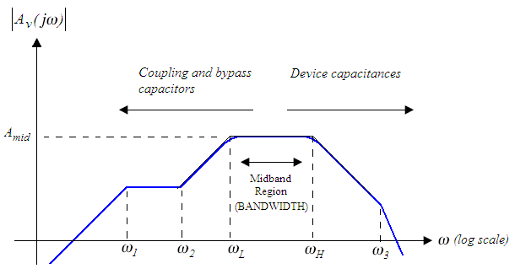
figure1

Low Frequency Response

In the low frequency band the response is limited because of external capacitors. If an amplifier does not have coupling or bypass capacitors, then in general the low frequency response goes all of the way down to DC. However, it is desirable to have these capacitors in the circuit to isolate the amplifiers DC bias point from outside world.

In a typical common emitter stage in Fig.2 there are three capacitors; the coupling capacitors, and the bypass capacitor used to bypass the emitter resistor to the ground.

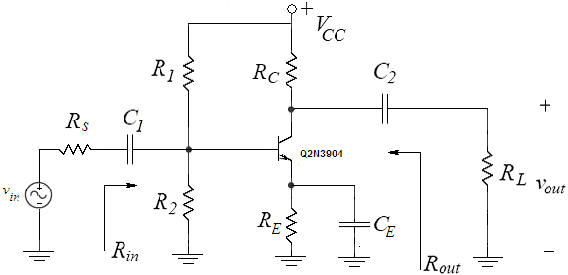
figure2

As the signal frequency drops below midband, the impedance of the coupling capacitors C₁ and C₂ and emitter bypass capacitor C_{E} increases. The couple capacitors drop more signal voltage and the emitter bypass capacitor begins to open up and causes increased series-series feedback resulting in a reduction of the gain.

One method of relating C₁, C₂ and C_{E} to the low cutoff frequency is the short circuit time constant method. The time constant method is advantageous because it provides an approximate value for the cutoff frequencies without exactly finding all the poles and zeroes of a circuit which is difficult to find. The time constant method also helps show which capacitors are dominant in determining the cut-off frequencies. The short circuit time constant method relates and circuit capacitors by:

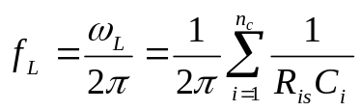

Where f_{L} is the low cut off frequency, n_{c} is the number of coupling and bypass capacitors in the circuit, and C_{i} is the value, in Farads, of the ith capacitor. R_{is} is the resistance facing the ith capacitor with the ith capacitor removed and all other coupling and bypass capacitors replaced by short circuits and the input signal reduced to zero. The product of the R_{is}C_{i} represents the short circuit time constant associated with the capacitor C_{i}.

High Frequency Response

In the upper frequency band the frequency response is limited by internal parasitic capacitances of the transistor. The most significant are the ones present between base and emitter (C_{π}) and between base and collector (C_{μ}). The complete small signal hybrid-π model of bjt is shown in Fig.3:

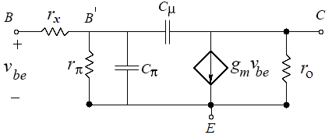
figure2

The capacitances C_{π} and C_{μ} are always present in BJT. At low frequencies, the impedance of these capacitances is usually very large therefore they have negligible effect (open circuit). However at high frequencies, capacitances have very small impedances therefore they are short out at high frequencies which results: transistor stop acting as an amplifier and cannot provide amplification.

One method of relating C_{π} and C_{μ} to the high cutoff frequency is the open circuit time constant method. The open circuit time constant method relates and internal transistor capacitances by:

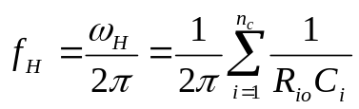

Where f_{H} is the high cut-off frequency, n_{c} is the number of internal transistor capacitances in the circuit, and C_{i} is the value, in Farads, of the ith capacitance. R_{io} is the resistance facing the ith capacitance with the ith capacitor removed and all other internal transistor capacitances replaced by open circuits and the input signal reduced to zero. The product of the R_{io}C_{i} represents the open circuit time constant associated with the capacitance C_{i}.

The base resistance r_{x} completes the basic small signal hybrid-π model of bipolar transistor. In the bipolar transistor, the base current i_{b} enters the transistor through the external base contact and traverses high resistance region before actually entering the active area of transistor. The base resistance r_{x} models the voltage drop between the internal(B) and external(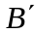) base nodes.

Preliminary Work:

Review the sections 17.1 through 17.9 from the Course Book.

In preliminary work you will analyze frequency response of the common emitter amplifier circuit in Fig.2 using the transistor 2N3904 and following values;

V_{CC} | R₁ | R₂ | R_{C} | R_{E} | R_{s} | R_{L} | C₁ | C₂ | C_{E}
12 V | 8.2 kΩ | 3.9 kΩ | 6.3 kΩ | 3.3 kΩ | 3 kΩ | 3.9 kΩ | 10 μF | 1 μF | 100 μF

Assume the 2N3904 has a β =100, V_{BE(ON)} = 0.7V, V_{A} = 100V, r_{x}=100, C_{π}=13.9pF and C_{μ}=8pF. Use the emission coefficient as n = 1 and V_{T}=25mV. (You can download data sheet 2N3904.pdf from course web page). The Pin Diagram of the 2N3904 is in Fig.4.

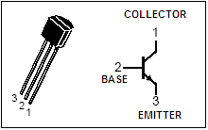
figure4

- Analyze the DC circuit to determine the Q-point(I_{CQ}, V_{CEQ}) and I_{BQ}.

- Using the hybrid-π small signal model and assuming all capacitors as short circuits to AC voltages, find the input and output impedances, R_{in} and R_{out}, and midband voltage gain A_{v-mid} = v_{out}/v_{in} (do not neglect r_{x} and r_{o}). In what case (I_{BQ} << ?) the base resistance r_{x} has a negligible effect on A_{v-mid} and R_{in}.

- Find the short circuit time constant of all the external capacitors by the drawing the circuits, used to find the equivalent resistance at the terminals of the each capacitor. Find the low cut-off frequency of the amplifier using short circuit time constant method.

- Find the open circuit time constant of all internal capacitance by the drawing the circuits, used to find the equivalent resistance at the terminals the each capacitance. Find the high cut-off frequency of the amplifier using open circuit time constant method.

- Find the bandwidth of the amplifier.

- Simulate the amplifier circuit using PSPICE. You will need to use a model for the Q2N3904 transistor. The models can be found in the bipolar.lib library.

a. First do a Bias Point analysis to determine DC voltages V_{CE} currents I_{BQ}, I_{CQ.}

b. Next, do Time Domain analysis using an input sine wave of v_{s}=20 mV peak-to-peak at a frequency of 1 kHz, and determine input voltage v_{in}, output voltage and voltage gain.

c. Next, do a AC sweep analysis using an input AC Source(V_{AC}) of ACMAG =1V and determine the frequency response of the amplifier(A_{v} vs frequency) and mark the high cut-off and low cut-off frequencies which corresponds to 0.707A_{v-mid.}(Note: Choose appropriate sweep type parameters which includes complete frequency response).

d. Remove the bypass capacitor C_{E} and do the same b. Time domain and c. AC sweep analysis. Comment on the changes.

e. Summarize the simulation results in table form and hand it in together with the calculations and the simulation print-outs. Label each graph clearly.

- Read the experiment.

Experimental Work:

Before constructing the circuit,

- Verify the values of the resistors that you are going to use by measuring their resistances with a multimeter. Make sure that all resistors are within 2% of their marked values. This will assure that your current measurements are accurate

- Prepare the power supply for V_{CC} to ensure a DC voltage of 12V and adjust the function generator for v_{in} to a voltage level of approximately 20mV_{peak-peak} at a frequency of 1kHz.

Construct the amplifier circuit using the values indicated in the preliminary work section.

- Measure I_{BQ}, I_{CQ} and V_{CEQ} and compare these with your calculations.

I_{BQ} =
I_{CQ} =
V_{CEQ} =

- Apply a small signal input of v_{in}=20mV_{peak-peak} with a frequency of 1kHz. Observe the input v_{in} and output voltage waveforms on the oscilloscope. Measure the midband voltage gain A_{v-mid} of the amplifier and compare with your calculations.

v_{in} v_{out}


A_{v-mid} =

- a. Measure and record the high cut-off and low cut-off frequencies.

f_{H} =
f_{L} =

  - Vary the input frequency and measure the output voltage in order to obtain the necessary data to create a frequency response plot for the voltage gain A_{v}. Use Excel or a similar spreadsheet software and plot a frequency response curve for the voltage gain. When plotting the frequency response curves make sure the x axis is log (i.e. 1 10 100 1000, etc.) in Excel.

Frequency | v_{out (peak)}
30Hz
40Hz
50Hz
80Hz
150Hz
200Hz
250Hz
300Hz
500Hz
1kHz
10kHz
20kHz
60kHz
120kHz
200
200kHz
500kHz
750kHz
1MHz
1.3MHz
1.5MHz

Measurement of High Cut-off and Low Cut-Off Frequencies

Select an input signal frequency which falls within the mid-band region to drive a small-signal into the input of the amplifier circuit. Adjust the input level such that an undistorted signal is produced at its output. Use the oscilloscope to monitor the input and output signal waveforms of the amplifier simultaneously. Measure the peak voltage V_{p} of the output waveform. Without making any further adjustment to the input signal level, vary the signal frequency until the output peak voltage drops to 0.707V_{p}. Measure the corresponding signal frequency using the oscilloscope.

***You will measure two frequency value that corresponds …***

- Remove the bypass capacitor C_{E}.

- Apply a small signal input v_{in} with a frequency of 1kHz and adjust the level such that an undistorted signal is produced at its output. Observe the input v_{in} and output voltage waveforms on the oscilloscope. Measure the midband voltage gain A_{v-mid} of the amplifier and compare with your Pspice simulation result.

v_{in} v_{out}

A_{v-mid} =

- Measure and record the high cut-off and low cut-off frequencies.

f_{H} =
f_{L} =

- Comment on the changes which result of removing bypass capacitor C_{E} (Gain Bandwidth Trade-Off) in midband gain A_{v-mid}, high cut off frequency f_{L} and low cut of frequency f_{H} if there is any…

- Measure the input resistance. (R_{POT}=5k)

R_{in} =

Measurement of input resistance

Fig.5 shows an arrangement for measuring the input resistance of the amplifier circuit.

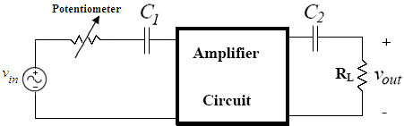
figure5

Be sure to disconnect the R_{S} from the amplifier circuit as shown in Fig.5. Set the potentiometer to zero Ω and select an input signal frequency which falls within the mid-band region to drive a small-signal into the input of the amplifier circuit. Adjust the input level such that an undistorted signal is produced at its output. Use the oscilloscope to monitor the input and output signal waveforms of the amplifier simultaneously. Measure the peak voltage of the output waveform. For given input voltage and frequency setting, adjust the potentiometer until the output peak voltage drops to half its original value. The input resistance of the circuit is given by the resistance of the potentiometer.

- Measure the output resistance. (R_{POT}=10k)

R_{out} =

Measurement of output resistance

Fig.6 shows the arrangement for measuring the output resistance of the amplifier circuit.

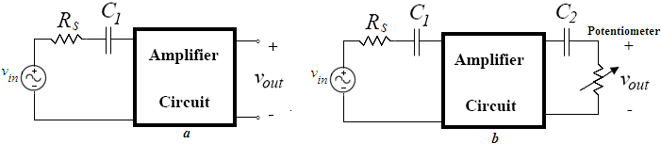
figure6

Be sure to disconnect the load resistance from the output of the amplifier circuit as shown in Fig.6(a). With the output open-circuited, select an input signal frequency which falls within the mid-band region to drive a small signal into the input of the amplifier circuit. Adjust the input level such that an undistorted signal is produced at its output. Use oscilloscope to monitor the input and output signal waveforms of the amplifier simultaneously. Measure the peak voltage of the output waveform(Make sure oscilloscope is AC coupled). For the given input voltage and frequency setting, connect a potentiometer across the output terminals as shown in Fig.6(b). Adjust the potentiometer until the output peak voltage drops to half its original value. The output resistance of the amplifier circuit is given by the resistance of the potentiometer.
Experiment Instruments:  - Breadboard  - Oscilloscope  - Signal Generator  - Multimeter  - DC Power Source | Experiment Components:  1 2N3904  2 3.9kΩ  1 3kΩ  1 8.2kΩ  1 3.3kΩ  1 6.2kΩ  1 10k POT  1 5k POT  1 1 μF  1 10 μF  1 100 μF

...............................………………………………………………………………..

Experiment Results

Part1 | I_{BQ} =  I_{CQ} =  V_{CEQ} =
Part2 | A_{v-mid} =
Part3 | a. | f_{H} =  f_{L} =
Part4 | a. | A_{v-mid} =
Part4 | b. | f_{H} =  f_{L} =
Part5 | R_{in} =
Part6 | R_{out} =

Student Name :

Signature…………….………….

