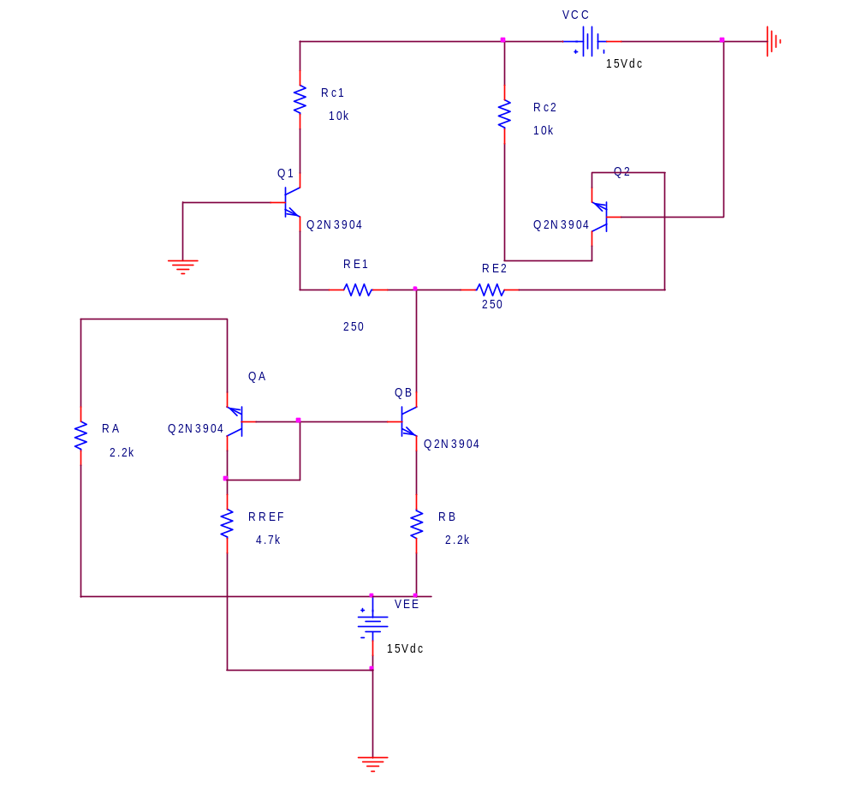

3.c

Time
0s
0.5ms
1.0ms
1.5ms
2.0ms
2.5ms
3.0ms
3.5ms
4.0ms
4.5ms
5.0ms
V(V3:+)
V(V4:+)
-40mV
-20mV
0V
20mV
40mV
(1.2529m,-24.996m)
(252.815u,24.996m)

Vin1,Vin2

Vout1,Vout2

Time
0s
0.5ms
1.0ms
1.5ms
2.0ms
2.5ms
3.0ms
3.5ms
4.0ms
4.5ms
5.0ms
V(Q1:c)
V(Q2:c)
3.0V
4.0V
5.0V
6.0V
(1.7529m,3.9111)
(752.846u,5.6900)

Time
0s
0.5ms
1.0ms
1.5ms
2.0ms
2.5ms
3.0ms
3.5ms
4.0ms
4.5ms
5.0ms
V(Q1:c) - V(Q2:c)
-2.0V
-1.0V
0V
1.0V
2.0V
(752.846u,1.7789)
Vodm=Vout1-Vout2

Time
0s
0.5ms
1.0ms
1.5ms
2.0ms
2.5ms
3.0ms
3.5ms
4.0ms
4.5ms
5.0ms
V(V3:+) - V(V4:+)
-50mV
0V
50mV
(252.815u,49.992m)

Vidm=Vin1-Vin2

For Vin1=Vin2=2V peak

Time
0s
0.5ms
1.0ms
1.5ms
2.0ms
2.5ms
3.0ms
3.5ms
4.0ms
4.5ms
5.0ms
V(Q1:c)
4.798V
4.800V
4.802V
4.804V
(742.845u,4.8028)
028n,4.8006)

Vout1

Time
0s
0.5ms
1.0ms
1.5ms
2.0ms
2.5ms
3.0ms
3.5ms
4.0ms
4.5ms
5.0ms
V(Q2:c)
4.798V
4.800V
4.802V
4.804V
(752.846u,4.8027)
028n,4.8006)

Vout2

Time
0s
0.5ms
1.0ms
1.5ms
2.0ms
2.5ms
3.0ms
3.5ms
4.0ms
4.5ms
5.0ms
( V(V3:+) + V(V4:+)) /2
-2.0V
-1.0V
0V
1.0V
2.0V
(252.815u,1.9997)
Vicm=(Vin1+Vin2)/2

