

**1.a.**

**\*\***

**.MODEL MOSN NMOS LEVEL=2 LD=0.15U TOX=200.0E-10**

**+ NSUB=5.36726E+15 VTO=0.743469 KP=8.00059E-05 GAMMA=0.543**

**+ PHI=0.6 U0=655.881 UEXP=0.157282 UCRIT=31443.8**

**+ DELTA=2.39824 VMAX=55260.9 XJ=0.25U LAMBDA=0.0367072**

**+ NFS=1E+12 NEFF=1.001 NSS=1E+11 TPG=1.0 RSH=70.00**

**+ CGDO=4.3E-10 CGSO=4.3E-10 CJ=0.0003 MJ=0.6585**

**+ CJSW=8.0E-10 MJSW=0.2402 PB=0.58**

**.MODEL MOSP PMOS LEVEL=2 LD=0.15U TOX=200.0E-10**

**+ NSUB=4.3318E+15 VTO=-0.738861 KP=2.70E-05 GAMMA=0.58**

**+ PHI=0.6 U0=261.977 UEXP=0.323932 UCRIT=65719.8**

**+ DELTA=1.79192 VMAX=25694 XJ=0.25U LAMBDA=0.0612279**

**+ NFS=1E+12 NEFF=1.001 NSS=1E+11 TPG=-1.0 RSH=120.6**

**+ CGDO=4.3E-10 CGSO=4.3E-10 CJ=0.0005 MJ=0.5052**

**+ CJSW=1.349E-10 MJSW=0.2417 PB=0.64**

**\*M1 D G S B MOSP W=1.8u L=1.2u NRS=0.333 NRD=0.333**

**\*+ AD=6.5p PD=9.0u AS=6.5p PS=9.0u**

**VDD 3 0 DC 3.1**

**VIN 1 0 PULSE(0 5 0 1ns 1ns 5ns 10ns)**

**M1 2 1 0 0 MOSN W=1.8u L=1.2u NRS=0.333 NRD=0.333**

**+ AD=6.5p PD=9.0u AS=6.5p PS=9.0u**

**R1 3 2 100K**

**C1 2 0 1F**

**.CONTROL**

**DC VIN 0 5 0.1**

**PLOT V(2) VS V(1)**

**.ENDC**

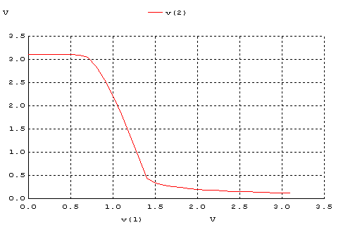

**1.b.**

**\*\***

**.MODEL MOSN NMOS LEVEL=2 LD=0.15U TOX=200.0E-10**

**+ NSUB=5.36726E+15 VTO=0.743469 KP=8.00059E-05 GAMMA=0.543**

**+ PHI=0.6 U0=655.881 UEXP=0.157282 UCRIT=31443.8**

**+ DELTA=2.39824 VMAX=55260.9 XJ=0.25U LAMBDA=0.0367072**

**+ NFS=1E+12 NEFF=1.001 NSS=1E+11 TPG=1.0 RSH=70.00**

**+ CGDO=4.3E-10 CGSO=4.3E-10 CJ=0.0003 MJ=0.6585**

**+ CJSW=8.0E-10 MJSW=0.2402 PB=0.58**

**.MODEL MOSP PMOS LEVEL=2 LD=0.15U TOX=200.0E-10**

**+ NSUB=4.3318E+15 VTO=-0.738861 KP=2.70E-05 GAMMA=0.58**

**+ PHI=0.6 U0=261.977 UEXP=0.323932 UCRIT=65719.8**

**+ DELTA=1.79192 VMAX=25694 XJ=0.25U LAMBDA=0.0612279**

**+ NFS=1E+12 NEFF=1.001 NSS=1E+11 TPG=-1.0 RSH=120.6**

**+ CGDO=4.3E-10 CGSO=4.3E-10 CJ=0.0005 MJ=0.5052**

**+ CJSW=1.349E-10 MJSW=0.2417 PB=0.64**

**VDD 3 0 DC 3.1**

**VIN 1 0 PULSE(0 5 0 1ns 1ns 5ns 10ns)**

**M1 2 1 0 0 MOSN W=1.8u L=1.2u NRS=0.333 NRD=0.333**

**+ AD=6.5p PD=9.0u AS=6.5p PS=9.0u**

**M1 2 0 3 3 MOSP W=1.8u L=1.2u NRS=0.333 NRD=0.333**

**+ AD=6.5p PD=9.0u AS=6.5p PS=9.0u**

**C1 2 0 1F**

**.CONTROL**

**DC VIN 0 5 0.1**

**PLOT V(2) VS V(1)**

**.ENDC**

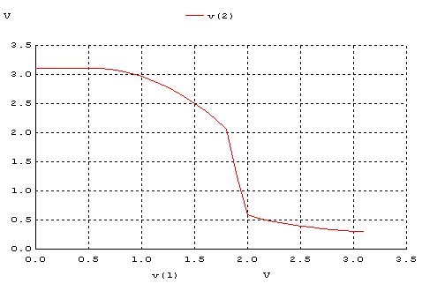

**1.c.**

**\*\***

**.MODEL MOSN NMOS LEVEL=2 LD=0.15U TOX=200.0E-10**

**+ NSUB=5.36726E+15 VTO=0.743469 KP=8.00059E-05 GAMMA=0.543**

**+ PHI=0.6 U0=655.881 UEXP=0.157282 UCRIT=31443.8**

**+ DELTA=2.39824 VMAX=55260.9 XJ=0.25U LAMBDA=0.0367072**

**+ NFS=1E+12 NEFF=1.001 NSS=1E+11 TPG=1.0 RSH=70.00**

**+ CGDO=4.3E-10 CGSO=4.3E-10 CJ=0.0003 MJ=0.6585**

**+ CJSW=8.0E-10 MJSW=0.2402 PB=0.58**

**.MODEL MOSP PMOS LEVEL=2 LD=0.15U TOX=200.0E-10**

**+ NSUB=4.3318E+15 VTO=-0.738861 KP=2.70E-05 GAMMA=0.58**

**+ PHI=0.6 U0=261.977 UEXP=0.323932 UCRIT=65719.8**

**+ DELTA=1.79192 VMAX=25694 XJ=0.25U LAMBDA=0.0612279**

**+ NFS=1E+12 NEFF=1.001 NSS=1E+11 TPG=-1.0 RSH=120.6**

**+ CGDO=4.3E-10 CGSO=4.3E-10 CJ=0.0005 MJ=0.5052**

**+ CJSW=1.349E-10 MJSW=0.2417 PB=0.64**

**\*M1 D G S B MOSP W=1.8u L=1.2u NRS=0.333 NRD=0.333**

**\*+ AD=6.5p PD=9.0u AS=6.5p PS=9.0u**

**VDD 3 0 DC 3.1**

**VIN 1 0 PULSE(0 5 0 1ns 1ns 5ns 10ns)**

**M1 2 1 3 3 MOSP W=1.8u L=1.2u NRS=0.333 NRD=0.333**

**+ AD=6.5p PD=9.0u AS=6.5p PS=9.0u**

**R1 2 0 100K**

**C1 2 0 1F**

**.CONTROL**

**DC VIN 0 5 0.1**

**PLOT V(2) VS V(1)**

**.ENDC**

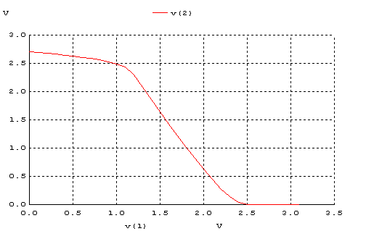

**1.d.**

**\*\***

**.MODEL MOSN NMOS LEVEL=2 LD=0.15U TOX=200.0E-10**

**+ NSUB=5.36726E+15 VTO=0.743469 KP=8.00059E-05 GAMMA=0.543**

**+ PHI=0.6 U0=655.881 UEXP=0.157282 UCRIT=31443.8**

**+ DELTA=2.39824 VMAX=55260.9 XJ=0.25U LAMBDA=0.0367072**

**+ NFS=1E+12 NEFF=1.001 NSS=1E+11 TPG=1.0 RSH=70.00**

**+ CGDO=4.3E-10 CGSO=4.3E-10 CJ=0.0003 MJ=0.6585**

**+ CJSW=8.0E-10 MJSW=0.2402 PB=0.58**

**.MODEL MOSP PMOS LEVEL=2 LD=0.15U TOX=200.0E-10**

**+ NSUB=4.3318E+15 VTO=-0.738861 KP=2.70E-05 GAMMA=0.58**

**+ PHI=0.6 U0=261.977 UEXP=0.323932 UCRIT=65719.8**

**+ DELTA=1.79192 VMAX=25694 XJ=0.25U LAMBDA=0.0612279**

**+ NFS=1E+12 NEFF=1.001 NSS=1E+11 TPG=-1.0 RSH=120.6**

**+ CGDO=4.3E-10 CGSO=4.3E-10 CJ=0.0005 MJ=0.5052**

**+ CJSW=1.349E-10 MJSW=0.2417 PB=0.64**

**VDD 3 0 DC 3.1**

**VIN 1 0 PULSE(0 5 0 1ns 1ns 5ns 10ns)**

**M1 2 1 0 0 MOSN W=1.8u L=1.2u NRS=0.333 NRD=0.333**

**+ AD=6.5p PD=9.0u AS=6.5p PS=9.0u**

**M1 2 1 3 3 MOSP W=1.8u L=1.2u NRS=0.333 NRD=0.333**

**+ AD=6.5p PD=9.0u AS=6.5p PS=9.0u**

**C1 2 0 1F**

**.CONTROL**

**DC VIN 0 5 0.1**

**PLOT V(2) VS V(1)**

**.ENDC**

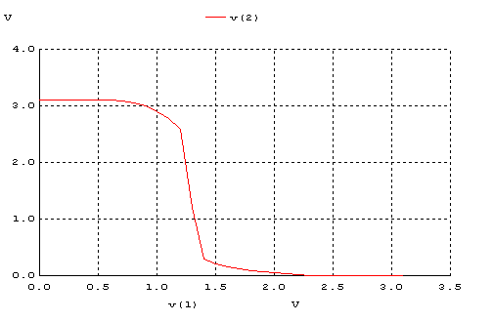

|  | VOH | VOL | VIH | VIL | VM | NMH | NML |
| --- | --- | --- | --- | --- | --- | --- | --- |
| (a) | 3.15 V | 0.47 V | 1.35 V | 0.55 V | 1.27 V | 1.68 V | 0.2 V |
| (b) | 3.15 V | 0.62 V | 2.4 V | 1.4 V | 1.65 V | 1.11 V | 0.78 V |
| (c) | 2.4 V | 0.09 V | 2.25 V | 1.43 V | 1.55 V | 0.15 V | 1.34 V |
| (d) | 3.13 V | 0.32 V | 1.35 V | 1.23 V | 1.29 V | 1.78 V | 0.91 V |

**2.a.**

**\*\***

**.MODEL MOSN NMOS LEVEL=2 LD=0.15U TOX=200.0E-10**

**+ NSUB=5.36726E+15 VTO=0.743469 KP=8.00059E-05 GAMMA=0.543**

**+ PHI=0.6 U0=655.881 UEXP=0.157282 UCRIT=31443.8**

**+ DELTA=2.39824 VMAX=55260.9 XJ=0.25U LAMBDA=0.0367072**

**+ NFS=1E+12 NEFF=1.001 NSS=1E+11 TPG=1.0 RSH=70.00**

**+ CGDO=4.3E-10 CGSO=4.3E-10 CJ=0.0003 MJ=0.6585**

**+ CJSW=8.0E-10 MJSW=0.2402 PB=0.58**

**.MODEL MOSP PMOS LEVEL=2 LD=0.15U TOX=200.0E-10**

**+ NSUB=4.3318E+15 VTO=-0.738861 KP=2.70E-05 GAMMA=0.58**

**+ PHI=0.6 U0=261.977 UEXP=0.323932 UCRIT=65719.8**

**+ DELTA=1.79192 VMAX=25694 XJ=0.25U LAMBDA=0.0612279**

**+ NFS=1E+12 NEFF=1.001 NSS=1E+11 TPG=-1.0 RSH=120.6**

**+ CGDO=4.3E-10 CGSO=4.3E-10 CJ=0.0005 MJ=0.5052**

**+ CJSW=1.349E-10 MJSW=0.2417 PB=0.64**

**VDD 3 0 DC 3.1**

**VIN 1 0 PULSE(0 3.1 0 1ns 1ns 4ns 10ns)**

**M1 2 1 0 0 MOSN W=1.8u L=1.2u NRS=0.333 NRD=0.333**

**+ AD=6.5p PD=9.0u AS=6.5p PS=9.0u**

**R1 3 2 100K**

**C1 2 0 1F**

**.CONTROL**

**TRAN 0.1NS 20NS**

**PLOT V(2) V(1)**

**.ENDC**

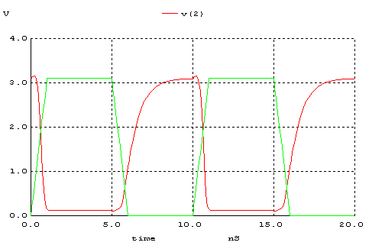

**2.b.**

**\*\***

**.MODEL MOSN NMOS LEVEL=2 LD=0.15U TOX=200.0E-10**

**+ NSUB=5.36726E+15 VTO=0.743469 KP=8.00059E-05 GAMMA=0.543**

**+ PHI=0.6 U0=655.881 UEXP=0.157282 UCRIT=31443.8**

**+ DELTA=2.39824 VMAX=55260.9 XJ=0.25U LAMBDA=0.0367072**

**+ NFS=1E+12 NEFF=1.001 NSS=1E+11 TPG=1.0 RSH=70.00**

**+ CGDO=4.3E-10 CGSO=4.3E-10 CJ=0.0003 MJ=0.6585**

**+ CJSW=8.0E-10 MJSW=0.2402 PB=0.58**

**.MODEL MOSP PMOS LEVEL=2 LD=0.15U TOX=200.0E-10**

**+ NSUB=4.3318E+15 VTO=-0.738861 KP=2.70E-05 GAMMA=0.58**

**+ PHI=0.6 U0=261.977 UEXP=0.323932 UCRIT=65719.8**

**+ DELTA=1.79192 VMAX=25694 XJ=0.25U LAMBDA=0.0612279**

**+ NFS=1E+12 NEFF=1.001 NSS=1E+11 TPG=-1.0 RSH=120.6**

**+ CGDO=4.3E-10 CGSO=4.3E-10 CJ=0.0005 MJ=0.5052**

**+ CJSW=1.349E-10 MJSW=0.2417 PB=0.64**

**VDD 3 0 DC 3.1**

**VIN 1 0 PULSE(0 3.1 0 1ns 1ns 4ns 10ns)**

**M1 2 1 0 0 MOSN W=1.8u L=1.2u NRS=0.333 NRD=0.333**

**+ AD=6.5p PD=9.0u AS=6.5p PS=9.0u**

**M1 2 0 3 3 MOSP W=1.8u L=1.2u NRS=0.333 NRD=0.333**

**+ AD=6.5p PD=9.0u AS=6.5p PS=9.0u**

**C1 2 0 1F**

**.CONTROL**

**TRAN 0.1NS 20NS**

**PLOT V(2) V(1)**

**.ENDC**

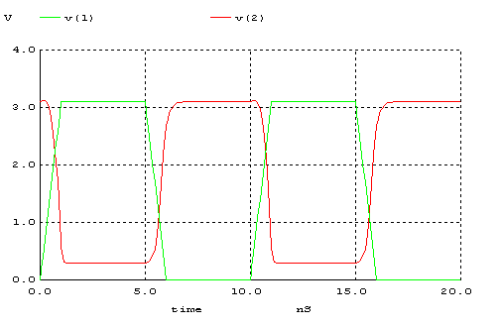

**2.c.**

**\*\***

**.MODEL MOSN NMOS LEVEL=2 LD=0.15U TOX=200.0E-10**

**+ NSUB=5.36726E+15 VTO=0.743469 KP=8.00059E-05 GAMMA=0.543**

**+ PHI=0.6 U0=655.881 UEXP=0.157282 UCRIT=31443.8**

**+ DELTA=2.39824 VMAX=55260.9 XJ=0.25U LAMBDA=0.0367072**

**+ NFS=1E+12 NEFF=1.001 NSS=1E+11 TPG=1.0 RSH=70.00**

**+ CGDO=4.3E-10 CGSO=4.3E-10 CJ=0.0003 MJ=0.6585**

**+ CJSW=8.0E-10 MJSW=0.2402 PB=0.58**

**.MODEL MOSP PMOS LEVEL=2 LD=0.15U TOX=200.0E-10**

**+ NSUB=4.3318E+15 VTO=-0.738861 KP=2.70E-05 GAMMA=0.58**

**+ PHI=0.6 U0=261.977 UEXP=0.323932 UCRIT=65719.8**

**+ DELTA=1.79192 VMAX=25694 XJ=0.25U LAMBDA=0.0612279**

**+ NFS=1E+12 NEFF=1.001 NSS=1E+11 TPG=-1.0 RSH=120.6**

**+ CGDO=4.3E-10 CGSO=4.3E-10 CJ=0.0005 MJ=0.5052**

**+ CJSW=1.349E-10 MJSW=0.2417 PB=0.64**

**VDD 3 0 DC 3.1**

**VIN 1 0 PULSE(0 3.1 0 1ns 1ns 4ns 10ns)**

**M1 2 1 3 3 MOSP W=1.8u L=1.2u NRS=0.333 NRD=0.333**

**+ AD=6.5p PD=9.0u AS=6.5p PS=9.0u**

**R1 2 0 100K**

**C1 2 0 1F**

**.CONTROL**

**TRAN 0.1NS 20NS**

**PLOT V(2) V(1)**

**.ENDC**

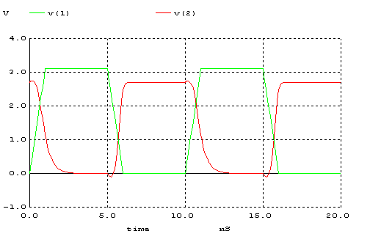

**2.d.**

**\*\***

**.MODEL MOSN NMOS LEVEL=2 LD=0.15U TOX=200.0E-10**

**+ NSUB=5.36726E+15 VTO=0.743469 KP=8.00059E-05 GAMMA=0.543**

**+ PHI=0.6 U0=655.881 UEXP=0.157282 UCRIT=31443.8**

**+ DELTA=2.39824 VMAX=55260.9 XJ=0.25U LAMBDA=0.0367072**

**+ NFS=1E+12 NEFF=1.001 NSS=1E+11 TPG=1.0 RSH=70.00**

**+ CGDO=4.3E-10 CGSO=4.3E-10 CJ=0.0003 MJ=0.6585**

**+ CJSW=8.0E-10 MJSW=0.2402 PB=0.58**

**.MODEL MOSP PMOS LEVEL=2 LD=0.15U TOX=200.0E-10**

**+ NSUB=4.3318E+15 VTO=-0.738861 KP=2.70E-05 GAMMA=0.58**

**+ PHI=0.6 U0=261.977 UEXP=0.323932 UCRIT=65719.8**

**+ DELTA=1.79192 VMAX=25694 XJ=0.25U LAMBDA=0.0612279**

**+ NFS=1E+12 NEFF=1.001 NSS=1E+11 TPG=-1.0 RSH=120.6**

**+ CGDO=4.3E-10 CGSO=4.3E-10 CJ=0.0005 MJ=0.5052**

**+ CJSW=1.349E-10 MJSW=0.2417 PB=0.64**

**VDD 3 0 DC 3.1**

**VIN 1 0 PULSE(0 3.1 0 1ns 1ns 4ns 10ns)**

**M1 2 1 0 0 MOSN W=1.8u L=1.2u NRS=0.333 NRD=0.333**

**+ AD=6.5p PD=9.0u AS=6.5p PS=9.0u**

**M1 2 1 3 3 MOSP W=1.8u L=1.2u NRS=0.333 NRD=0.333**

**+ AD=6.5p PD=9.0u AS=6.5p PS=9.0u**

**C1 2 0 1F**

**.CONTROL**

**TRAN 0.1NS 20NS**

**PLOT V(2) V(1)**

**.ENDC**

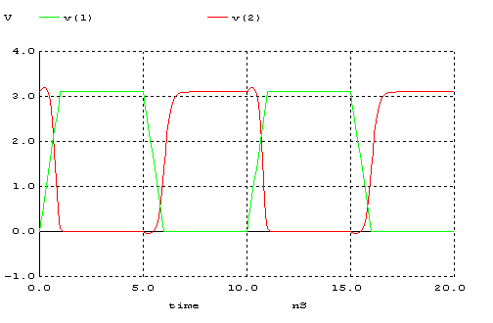

|  |  |  |  |  |  |
| --- | --- | --- | --- | --- | --- |
|  | tr | tf | tpLH | tpHL | Td |
| (a) | 2.1 ns | 0.57 ns | 0.85 ns | 0.25 ns | 0.55 ns |
| (b) | 0.63 ns | 0.32 ns | 0.33 ns | 0.34 ns | 0.335 ns |
| (c) | 1.61 ns | 3.7 ns | 0.37 ns | 0.32 ns | 0.345 ns |
| (d) | 0.43 ns | 0.27 ns | 0.42 ns | 0.31 ns | 0.365 ns |

**3. a.**

Bir devrenin iyi bir tersleyici olması isteniyorsa; noise margin aralıklarının geniş ve simetrik (NMH=NML) olması istenir.Bu açıdan baktığımız da b devresi en iyi devre iken tanımsız bölgenin (undefined region) de olabildiğince dar olmasının istenildiği düşünüldüğünde ve sinyalimizin bu bölgede çalışmaması istenildiğinde d devresi tersleyici için en iyi sonuçları vermektedir.

**3.b.**

Şekil 1’de verilen devreler simetrik değildir.

Zaman sabiti τ = RC olduğundan ve devrenin simetrik olması için R ve C değerlerinin aynı olması gerektiğinden kullandığımız C değerleri her devrede aynı değerdedir, R değerlerinide aynı yapmak gerekmektedir.Bundan dolayı da NMOS ve PMOS transistörlerinin parazitik dirençlerinin ve devrelerde kullanılan diğer dirençlerin aynı olması gerekir

**4.**

**.MODEL MOSN NMOS LEVEL=2 LD=0.15U TOX=200.0E-10**

**+ NSUB=5.36726E+15 VTO=0.743469 KP=8.00059E-05 GAMMA=0.543**

**+ PHI=0.6 U0=655.881 UEXP=0.157282 UCRIT=31443.8**

**+ DELTA=2.39824 VMAX=55260.9 XJ=0.25U LAMBDA=0.0367072**

**+ NFS=1E+12 NEFF=1.001 NSS=1E+11 TPG=1.0 RSH=70.00**

**+ CGDO=4.3E-10 CGSO=4.3E-10 CJ=0.0003 MJ=0.6585**

**+ CJSW=8.0E-10 MJSW=0.2402 PB=0.58**

**.MODEL MOSP PMOS LEVEL=2 LD=0.15U TOX=200.0E-10**

**+ NSUB=4.3318E+15 VTO=-0.738861 KP=2.70E-05 GAMMA=0.58**

**+ PHI=0.6 U0=261.977 UEXP=0.323932 UCRIT=65719.8**

**+ DELTA=1.79192 VMAX=25694 XJ=0.25U LAMBDA=0.0612279**

**+ NFS=1E+12 NEFF=1.001 NSS=1E+11 TPG=-1.0 RSH=120.6**

**+ CGDO=4.3E-10 CGSO=4.3E-10 CJ=0.0005 MJ=0.5052**

**+ CJSW=1.349E-10 MJSW=0.2417 PB=0.64**

**VDD 3 0 DC 3.1**

**VIN 1 0 PULSE(0 3.1 0 1ns 1ns 5ns 10ns)**

**M1 2 1 0 0 MOSN W=1.8u L=1.2u NRS=0.333 NRD=0.333**

**+ AD=6.5p PD=9.0u AS=6.5p PS=9.0u**

**M1 2 1 3 3 MOSP W=5.4u L=1.2u NRS=0.111 NRD=0.111**

**+ AD=16.2p PD=11.4u AS=16.2p PS=11.4u**

**C1 2 0 1F**

**.CONTROL**

**DC VIN 0 3.1 0.1**

**PLOT V(2) VS V(1)**

**.ENDC**

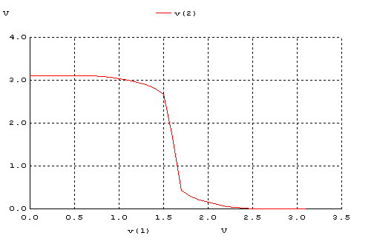

Bir MOSFETin W/L oranını artırırsak mosfetin direnç değeri azalmaktadır. Bundan dolayı da zaman sabiti küçülür ve Vm değeri yukarı doğru kayar.1. sorunun d şıkkındaki devrede PMOS direnç değerini buna göre değiştirdik. Sonuç olarak Vm=1.29 iken Vm=1.59 olmuştur.

Çıkan grafikte egimli alanlar daha belirgin ve keskin bir hale gelmiştir.Çünkü W/L uzunluğu 3 katına çıkarılmıştır.