1)RL-Lead

>> num=[0,0,0,12];
>> den=[1,3.2,2.4,0];
>> G=tf(num,den)

Transfer function:
12
---------------------
s^3 + 3.2 s^2 + 2.4 s

>> rlocus(G)
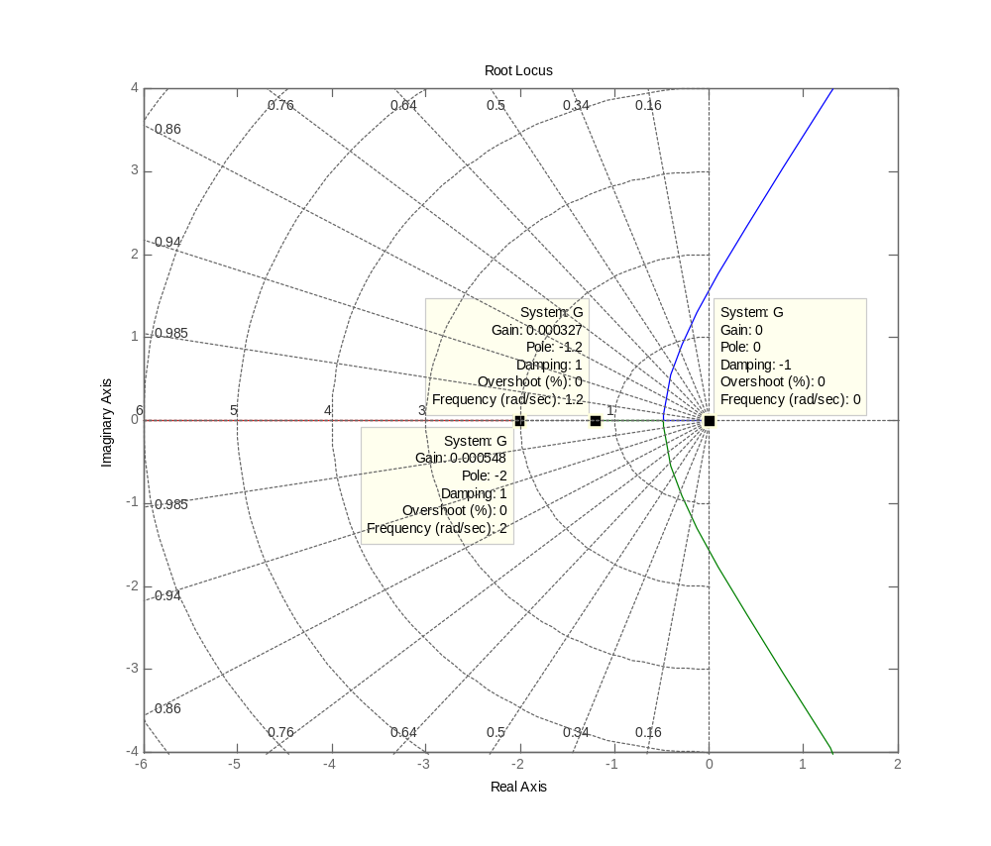
>> grid

