Soru 6-8
num=[0 0 1 0.5]
den=[1 1 0 1]
K=[0:0.2:1000]
r=rlocus(num,den,K)
plot(r,'o')
v=[-5 1 -8 8]; axis(v)
grid
title('Root-Locus Plot of problem 6-8')
xlabel('Real Axis')
ylabel('Imag Axis')
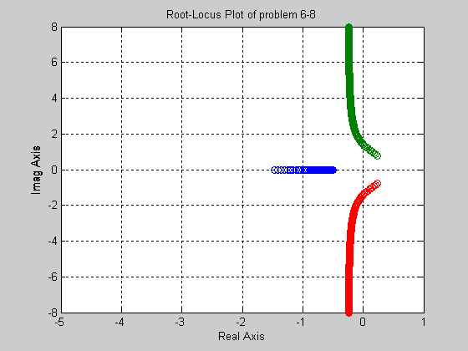
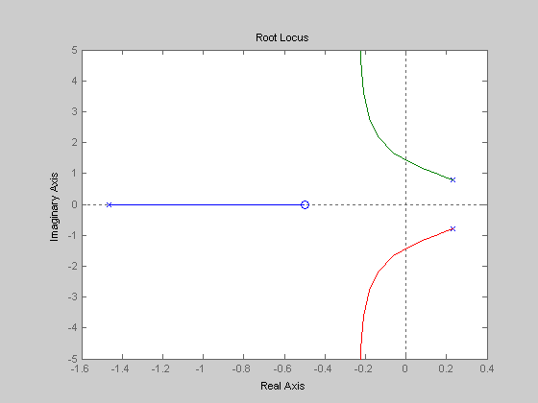

Soru 6-10
num=[0 0 0 2 2]
den=[1 7 10 0 0]
K=[0:0.2:1000]
r=rlocus(num,den,K)
plot(r,'o')
v=[-5 5 -10 10]; axis(v)
grid
title('Root-Locus Plot of problem 6-10')
xlabel('Real Axis')
ylabel('Imag Axis')
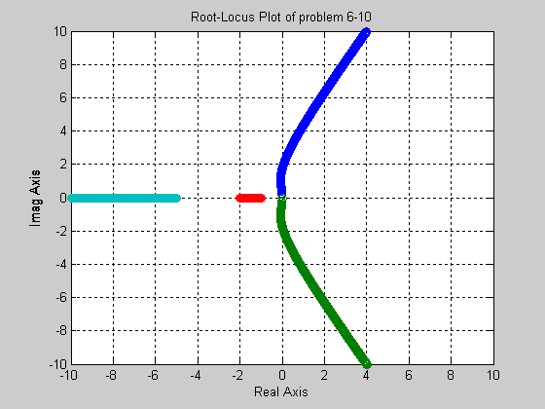
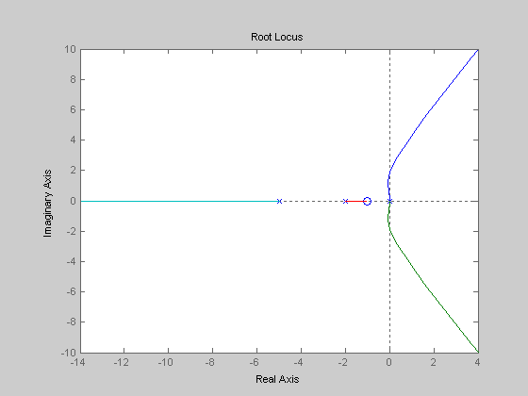

Soru 6-12
num=[0 0 0 1 1]
den=[1 4 11 14 10]
K=[0:0.2:1000]
r=rlocus(num,den,K)
plot(r,'o')
v=[-5 1 -5 5]; axis(v)
grid
title('Root-Locus Plot of problem 6-12')
xlabel('Real Axis')
ylabel('Imag Axis')
