7.17 Only one device at a time can be serviced on a selector channel. Thus,

Maximum rate = 800 + 800 + 2 × 6.6 + 2 × 1.2 + 10 × 1 = 1625.6 KBytes/sec

7.19 For each case, compute the fraction g of transmitted bits that are data bits. Then the maximum effective data rate ER is

ER = gR

a. There are 7 data bits, 1 start bit, 1.5 stop bits, and 1 parity bit.

g = 7/(1+7+1+1.5)= 7/10.5
ER = 0.67 × R

b. Each frame contains 48 + 128 = 176 bits. The number of characters is 128/8 = 16, and the number of data bits is 16 × 7 = 112.

ER= (112/176)× R = 0.64 × R

c. Each frame contains 48 = 1024 bits. The number of characters is 1024/8 = 128, and the number of data bits is 128 × 7 = 896.

ER= (896/1072)× R = 0.84 × R

d. With 9 control characters and 16 information characters, each frame contains (9 + 16) × 8 = 200 bits. The number of data bits is 16 × 7 = 112 bits.

ER= (112/200)× R = 0.56 × R

e. With 9 control characters and 128 information characters, each frame contains (9 + 128) × 8 = 1096 bits. The number of data bits is 128 × 7 = 896 bits.
7.20 a. Assume that the women are working, or sleeping, or otherwise engaged. The first time the alarm goes off, it alerts both that it is time to work on apples. The next alarm signal causes apple-server to pick up an apple an throw it over the fence. The third alarm is a signal to Apple-eater that he can pick up and eat the apple. The transfer of apples is in strict synchronization with the alarm clock, which should be set to exactly match Apple-eater's needs. This procedure is analogous to standard synchronous transfer of data between a device and a computer. It can be compared to an I/O read operation on a typical bus-based system. The timing diagram is as follows:

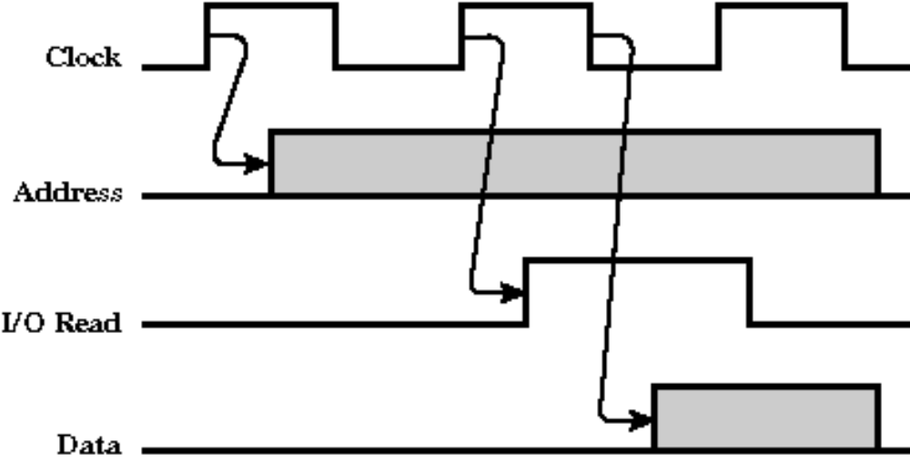

On the first clock signal, the port address is output to the address bus. On the second signal, the I/O Read line is activated, causing the selected port to place its data on the data bus. On the third clock signal, the CPU reads the data.
A potential problem with synchronous I/O will occur if Apple-eater's needs change. If he must eat at a slower or faster rate than the clock rate, he will either have too many apples or too few.

b. The women agree that Apple-server will pick and throw over an apple whenever he sees Apple-eater's flag waving. One problem with this approach is that if Apple-eater leaves his flag up, Apple-server will see it all the time and will inundate her friend with apples. This problem can be avoided by giving Apple-server a flag and providing for the following sequence:
1. Apple-eater raises her "hungry" flag when ready for an apple.
2. Apple-server sees the flag and tosses over an apple.
3. Apple-server briefly waves her "apple-sent" flag
4. Apple-eater sees the "apple-sent" flag, takes down her "hungry" flag, and grabs the apple.
5. Apple-eater keeps her "hungry" flag stays down until she needs another apple.

This procedure is analogous to asynchronous I/O. Unfortunately, Apple-server may be doing something other than watching for her friend's flag (like sleeping!). In that case, she will not see the flag, and Apple-eater will go hungry. One solution is to not permit apple-server to do anything but look for her friend's flag. This is a polling, or wait-loop, approach, which is clearly inefficient.

c. Assume that the string that goes over the fence and is tied to Apple-server's wrist. Apple-eater can pull the string when she needs an apple. When Apple-server feels a tug on the string, she stops what she is doing and throws over an apple. The string corresponds to an interrupt signal and allows Apple-server to use her time more efficiently. Moreover, if Apple-server is doing something really important, she can temporarily untie the string, disabling the interrupt.

7.21

