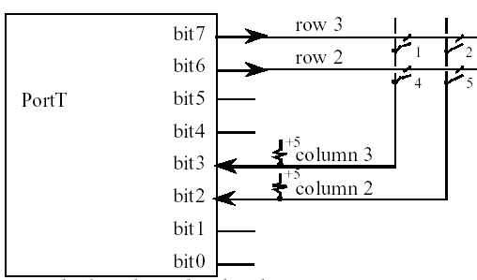

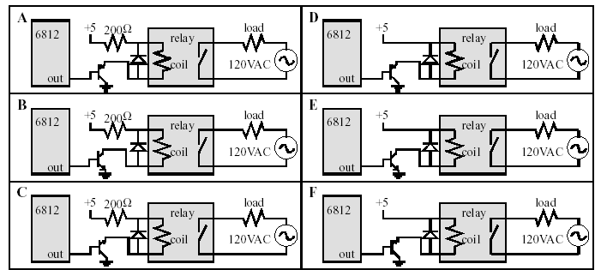

Scanned display

The hardware has 64 by 8 colored LEDs (red, yellow, green)
512 LEDs a direct interface would take 1024 output pins
without SPI/encoder you would need 136 output pins
4⁵¹² or about 10³⁰⁸ possible patterns Hardware 128 bit shift register with outputs connected to the columns
3 to 8 encoder with outputs connected to the rows required just 8 output pins
128 columns by 8 rows (2 columns per dot) LED is active if its column is active and its row is active

