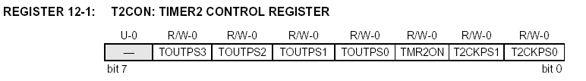

bit 7 Unimplemented: Read as '0'
bit 6-3 TOUTPS3:TOUTPS0: Timer2 Output Postscale Select bits
0000 = 1:1 Postscale
0001 = 1:2 Postscale
•
•
•
1111 = 1:16 Postscale
bit 2 TMR2ON: Timer2 On bit
1 = Timer2 is on
0 = Timer2 is off
bit 1-0 T2CKPS1:T2CKPS0: Timer2 Clock Prescale Select bits
00 = Prescaler is 1
01 = Prescaler is 4
1x = Prescaler is 16

CCP1CON REGISTER/CCP2CON REGISTER

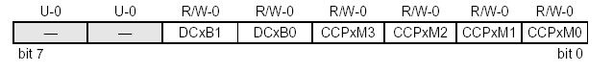
bit 7-6 Unimplemented: Read as '0'
bit 5-4 DCxB1:DCxB0: PWM Duty Cycle bit1 and bit0
PWM mode:
These bits are the two LSbs (bit1 and bit0) of the 10-bit PWM duty cycle. The upper eight bits
(DCx9:DCx2) of the duty cycle are found in CCPRxL.
bit 3-0 CCPxM3:CCPxM0: CCPx Mode Select bits
0000 = Capture/Compare/PWM disabled (resets CCPx module)
0001 = Reserved
0010 = Compare mode, toggle output on match (CCPxIF bit is set)
0011 = Reserved
0100 = Capture mode, every falling edge
0101 = Capture mode, every rising edge
0110 = Capture mode, every 4th rising edge
0111 = Capture mode, every 16th rising edge
1000 = Compare mode,
Initialize CCP pin Low, on compare match force CCP pin High (CCPIF bit is set)
1001 = Compare mode,
Initialize CCP pin High, on compare match force CCP pin Low (CCPIF bit is set)
1010 = Compare mode,
Generate software interrupt on compare match (CCPIF bit is set, CCP pin is unaffected)
1011 = Compare mode,
Trigger special event (CCPIF bit is set)
11xx = PWM mode

The PWM period is specified by writing to the PR2 register. The PWM period can be calculated using the
following formula:

PWM period = (PR2) + 1] • 4 • TOSC • (TMR2 prescale value)

PWM frequency is defined as 1 / [PWM period].

When TMR2 is equal to PR2, the following three events occur on the next increment cycle:

