1-A potentiometer is to be used to measure the position of a rotating robot link (as a voltage
divider). The power supply connected across the potentiometer is 5.0 V, and the total wiper
travel is 300 degrees. The wiper arm is directly connected to the rotational joint so that a given
rotation of the joint corresponds to an equal rotation of the wiper arm.
a) If the joint is at 42 degrees, what voltage will be output from the potentiometer?
b) If the joint has been moved, and the potentiometer output is 2.765V, what is the
position of the potentiometer?
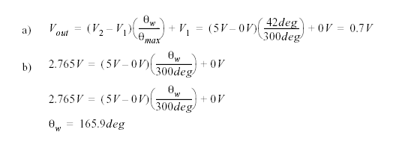
7. A motor has an encoder mounted on it. The motor is driving a reducing gear box with a 50:1
ratio. If the position of the geared down shaft needs to be positioned to 0.1 degrees, what is the
minimum resolution of the incremental encoder?

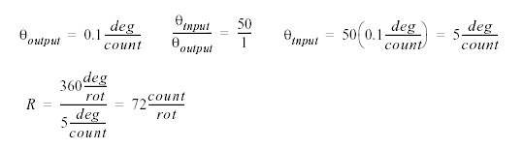

An analog voltage that has a range of -10V to 10V and is to be read to a precision of +/-0.05V.
How is the minimum number of bits required for the A/D converter?

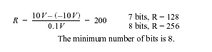
an A/D converter will convert an analog input voltage (or current) to an integer value. A D/A
output will convert an integer value to an output voltage.

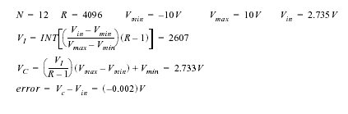

Case Studies Using A/D Converters
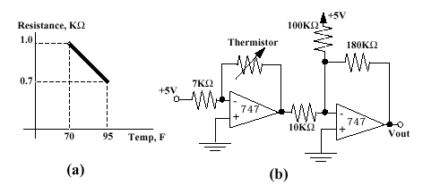
Question: What is the output voltage for the circuit on the right at 70 degrees Fahrenheit?
For the following photocell circuit, choose the resistance values to deliver a 0V offset and a 5V span for the range of 2-10 lumens.

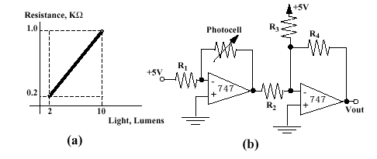
For the following robotic arm, write a subroutine that wil

