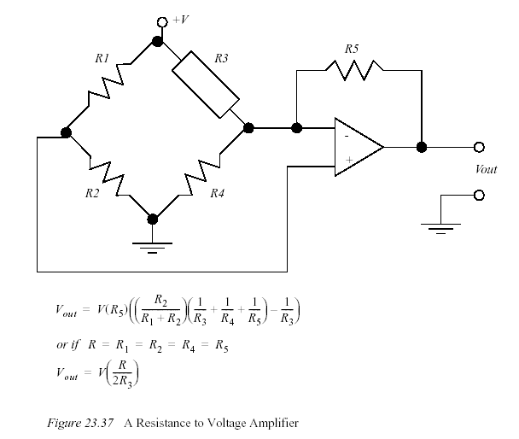



What is the resolution of an absolute optical encoder that has six binary tracks? nine tracks?
twelve tracks?

Cevap: 360°/64steps, 360°/512steps, 360°/4096steps

A potentiometer is to be used to measure the position of a rotating robot link (as a voltage
divider). The power supply connected across the potentiometer is 5.0 V, and the total wiper
travel is 300 degrees. The wiper arm is directly connected to the rotational joint so that a given
rotation of the joint corresponds to an equal rotation of the wiper arm.
a) If the joint is at 42 degrees, what voltage will be output from the potentiometer?
b) If the joint has been moved, and the potentiometer output is 2.765V, what is the
position of the potentiometer?

Cevap:

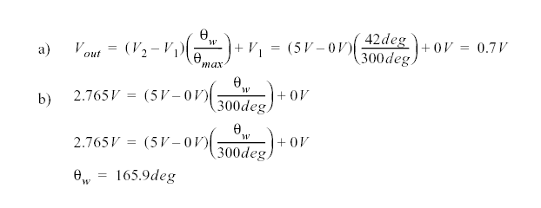
A motor has an encoder mounted on it. The motor is driving a reducing gear box with a 50:1
ratio. If the position of the geared down shaft needs to be positioned to 0.1 degrees, what is the minimum resolution of the incremental encoder?
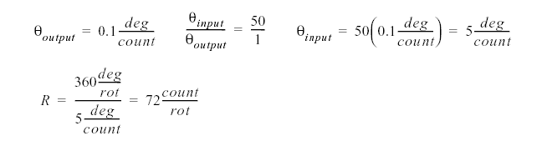

A measurement of temperature using a sensor that outputs 6.5 mV/oC must measure
to 100oC. A 6-bit ADC with a 10 V reference is used. (a) Develop a circuit to interface
the sensor and the ADC. (b) Find the temperature resolution.

Q7. Signal conditioning analysis shows that the following equation must relate output voltage to input voltage:

Design circuits to do this using (a) a summing amplifier and (b) a differential amplifier.

Q8-A control system needs the average of temperature from three locations. Sensors make the
temperature information available as voltages, V₁ , 2 V and 3 V . Develop an op-amp circuit that outputs the average of these voltages.

Q9. A sensor outputs a voltage ranging from –2.4 to 1.1 V. For interface to an analog-to-digital converter, this needs to be 0 to 2.5 V. Develop the required signal conditioning.

Q10. A temperature is to be measured using a sensor whose resistance varies linearly with the
temperature from 280 . to 1060 .. Develop analog signal conditioning that provides a voltage
varying linearly from –5 to +5 V.

Calculate the transfer function or resolution for a
potentiometer assuming a 230 degree rotation
for a zero to five volt output.
z Determine the input rotation required for a pot
output voltage of 3.73 volts for the potentiometer
in the example above.

Genel amaçlı microcontroller de hangi kesmeler (interrupt) bulunur

CCP modulu genel ifadesini açıklayınız açıklayınız

Bir Analog fan kontrol devresi tasarlayınız. Sensorun transfer fonksiyonu ….. olduğuna göre sıcaklık 25 dereceyi geçince fanın motoru çalışacaktır. Sıcaklık 25 derecenin altında ise fan çalışmayacaktır. Motorun sürücü devresi için bir transistör kullanılacaktır

Problem 1. An absolute optical encoder disk has eight tracks and eight light-source/photo-detector pairs providing an 8-bit output.

(a) What is the angular resolution of the encoder?
(b) Suppose the output pattern is 10101101. What is the angular position of the shaft?
(c) If the required angular resolution was three times higher than the available resolution how could you still utilize this 8-bit device?

Objects of three different heights are transported by a conveyor. You are to design a simple sensing system which will allow the identification/classification of these objects.

(a) Sketch the configuration of your proposed system.
(b) Explain its principle of operation and justify your solution.

Problem 7. A D/A converter has a six-binary-digit precision. In three successive sampling instants 0.5 s apart, the data contained in the binary register are:

Instant Binary Data

1 101000
2 101010
3 101101

Determine the D/A's output voltage at these instants.

