Case Studies Using A/D Converters
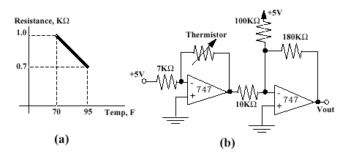
Question: What is the output voltage for the circuit on the right at 70 degrees Fahrenheit?
For the following photocell circuit, choose the resistance values to deliver a 0V offset and a 5V span for the range of 2-10 lumens.

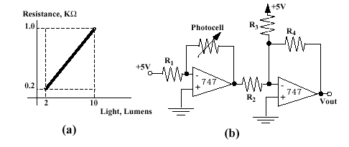
For the following robotic arm, write a subroutine that wil

