Serial communication:

Microprocessors are by nature parallel machines; that is, data moves from point to point within the machine in parallel data groups (8, 16, 32, or 64 bits at a time). The alternative is to move the data serially-one bit at a time. Obviously this will be slower (32 clock pulses will be required to receive or transmit a 32-bit data group), but only a single wire (two, counting a common ground) between receiver and transmitter will be required. Serial communication is One of the oldest, simplest, and most widely used forms of communication in the world.

Serial communication vs. Parallel communication

Serial
• Cheap
•Slow
• Uses one line to transmit
and one to receive
– Modems
– Printers
– Microcontroller
• Longer transmission
distance
Parallel
• Expensive
•Fast
• Requires multiple lines in
order to simultaneously
transmit data bits
• Short transmission
distance

SERIAL INTERFACE:

Serial interface are used to exchange data with the external world. Many microcontrollers have both asynchronous and synchronous communications peripherals built in. Usually, an asynchronous interface is called a serial communication interface (SCI or UART) while the synchronous interface is called a serial peripheral interface (SPI). A typical SCI application is to connect a PC for debugging purpose while a typical SPI application is to connect an ex-ternal EEPROM. A synchronous bus includes a separate line for the clock signal which simplifies the transmitter and receiver but is more susceptible to noise when used over long distances. With an asyn-chronous bus the transmitter and receiver clocks are independent, and a resynchronization is performed for each byte at the start bit.

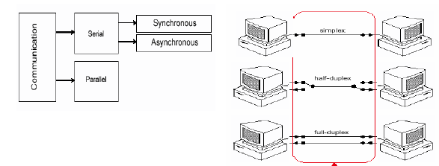
Transmisstion methods
Simplex: Data in a simplex channel is always one way Simplex channels are not often used because it is not possible to send back error or control signals to the transmit end. Its like a one way street. An example of simplex is television

Half Duplex: A half duplex channel can send and receive, but not at the same time; only one end transmits at a time, the other end receives Its like a one-lane bridge where two way traffic must give way in order to cross.

Full Duplex: Data can go both ways at the same time

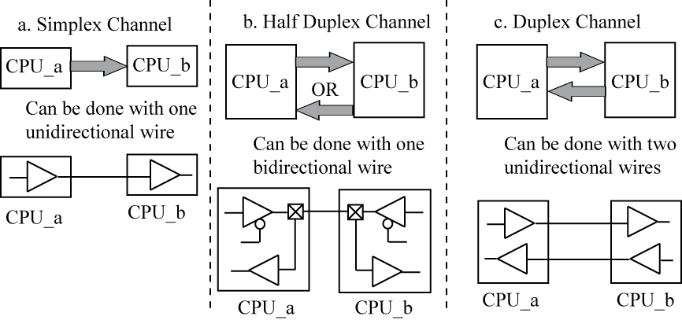

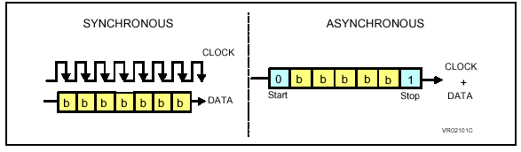
Synchronous and Asynchronous Communication Principles

Synchronous Transmission:

In synchronous transmission, the clocks at the transmission and reception ends must be permanently synchronized by either
- A)Transmitting the clock signal on a separate wire (too expensive), and (This methods has a delay problem regarding to wires)
- B) Embedding the clock signal in the data stream (preferred).
receiver (CPU #2) extracts clock from data stream or uses a Phase- Locked-Loop (PLL) and changes in the data stream to synchronize internal clock (phase alignment) to data stream. Synchronous serial IO can achieve high speeds; all new high speed serial standards are synchronous. (IEEE 1394, FireWire).

Synchronous serial IO can achieve high speeds; Asynchronous Serial I/O is used in older standards, is easy to implement, but is slower than synchronous serial standards

Procedure Synchronous Transmission
- To initiate transmission, the transmitter first sends out synchronization characters to the receiver
- The receiver reads the synchronization bit pattern and compares it with a known sync pattern. Once they are identified as bieing the same, the receiver begins to read character data off the communications line
- Transfer of data continues until the complete block of data is received or synchronization is lost
- If large blocks of data are being sent, the synchronization characters may be periodically present to assure that synchronization is maintained

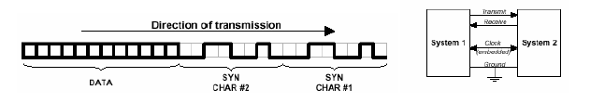
Asynchronous Transmission
In asynchronous transmission there is no need for the clocks to be synchronized Data to be transmitted is sent one character at a time At the received end of the transmission synchronization is performed by examining synchronization bits that are included at the beginning and end of the character . In an asynchronous communications system, the two devices communicating use the same clock frequency, but may have different phases. This makes communication more difficult, but it reduces the complexity of the interfacing hardware.

The format of a typical asynchronous character is the following ;

Data sent LSb to MSb.On the PIC microcontroller, will use 8 data bits.

Odd parity – parity bit value makes the total number of ‘1’ bits in the frame odd
Example: – For 7- bit data value 0x56 (1010110), odd parity bit = ‘1’

Even parity – parity bit value makes the total number of ‘1’ bits in the frame even

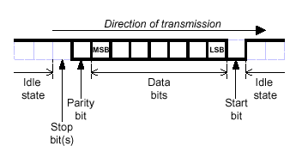
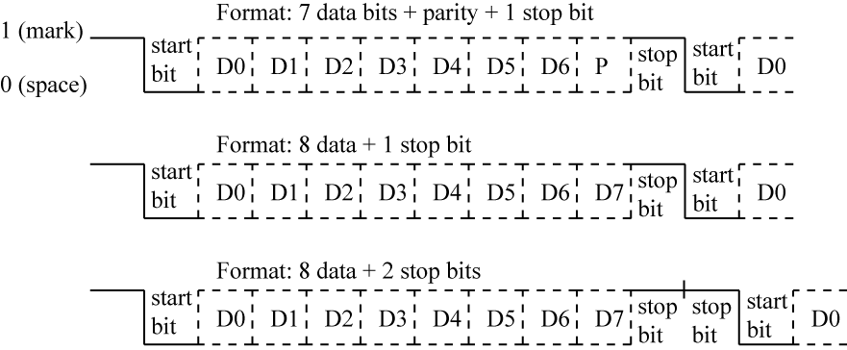

Example:

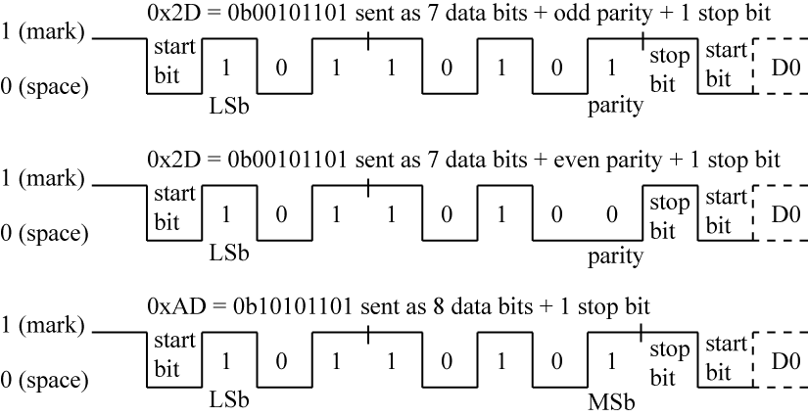
Serial data transfer speed;

Baud Rate vs Bits Per Second
• Baud rate is the rate at which signaling events are sent
• Bits per second (bps) is the number of bits transferred per second (any type of bits, data or overhead bits)
• If only a ‘1’ or ‘0’ is sent for each signaling event, then baud rate = bps

Serial data speed is the number of data bits transmitted per second (BPS). Baud rate is the total number of all bits transmitted, including parity and framing bits. Thus, baud rate is
always greater than the data bit rate. Since each frame contains a certain number of framing bits (start, stop, parity) and a single character (typically ASCII code), we can also determine the number of characters per second being transmitted over the interface.
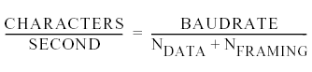
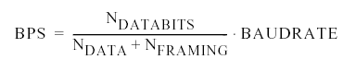

Problem: How long would it take to transmit 800 Bytes of data given a continuous transmission with a Baud rate of 9600 and total of 8 data bits per data word?

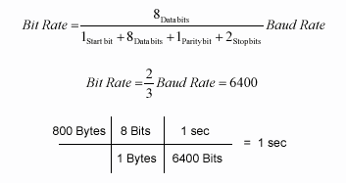

Example Transmission Time:

Problem: The letter A is transmitted by eight data bits, with even parity bit, one stop bit. Solve: Sketch the output,
The ASCII code for letter A is $41 = % 0100 0001, output is

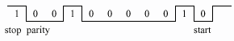
Even parity = 0, as the number of marks = 2

Basic blocks of an asynchronous transmitter chip (uart chip): Hardware Operations

 Parallel / serial conversion
 Clock synchronization and Data sampling
 Baud rate generator
 Parity generator and checking

Baud Rate Generator: It is a frequency divider that provides two internal clocks. One is used for transmitting the serial data and its frequency should match the required baud rate. The other clock usually runs 8 to 16 times faster that transmitting clock. The over sampling of input allows precise detection of incoming data. The baud rate should be user programmable.
Transmitter: It receives data in parallel form. It frames the data in proper format with start and stop bit information. It then sends serial data on TX line under the control of transmitting clock. You are free to make your design assumptions.

Receiver: It receives data in serial form on RX line and stores it in the receiver buffer register. When all data bits are received, they are presented to the Data bus in parallel format.

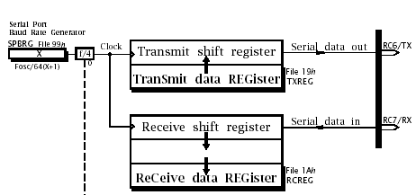
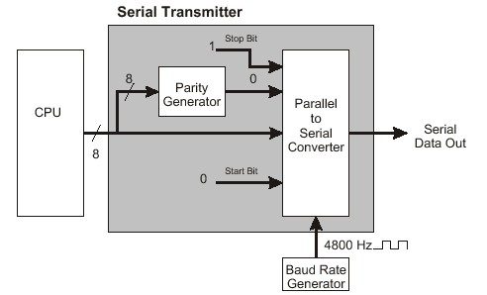

SCI (Serial communication interface ) related Registers (General microcontroller)

There are four registers for the MCU SCI (in generally):
- Baud Rate Control Register (BAUD)
- SCI Control Registers (SCCR1, SCCR2)
- SCI Status Register (SCSR)
4. SCI Data Register (SCDR)

Uart (Universal Asynchronous Receiver Transmitter)

The semiconductor companies have developed the Universal Asynchronous Receiver/Transmitter chip, or UART. Typically this chip features a separete serial transmitter and serial receiver in the same package. Internal registers allow the serial data parameters to be programmed and changed as necessary. Status registers allow the BUSY/READY state of the receiver and transmitter to be monitored. Other status indicators show when a framing error (invalid start bit), parity error, or overrun condition (character received before the previous character has been read) has occurred.
The UART requires an accurate clock single, which then determines the data for the port. Most UARTs use a single with a frequency that is 16 times the intended data rate-this effectively breaks each bit time into 16 ‘’slices’’ and allows the center of the bit to be more accurately located. For example, to operate at 1200 bps, a 19.2 KHz clock single should be connected to the UART’s transmitter and receiver clock inputs.
It is interesting to note that a serial port (the UART) appears to the microprocessor to be a conventional parallel port. When the transmitter buffer is empty, all of the bits in the word to be transmitted are output to the port at once (in parallel). Similarly, all bits of the received word are input at once when the received data is ready.
The job of converting the data from serial to parallel, or from parallel to serial, has been transferred to the UART. This is interesting becouse we usually think of using the microprocessor to replace hardware with software. However, the UART is an example of a case in which it is more efficient to replace software with hardware. The National Semiconductor PC16550D UART chip popular in most PCs today. New microcontrollers have internal UART chips.

Serial Data Transfer in microcontroller:

In the micro-controllers (MCU), there are two types of serial data transfer systems:
• Serial Communication Interface (SCI): Aynchronous : - connected to PC for relatively long distance data transfer.
• Serial Peripheral Interface (SPI)and I²C :Synchronous : connected to on-board devices for fast data transfer.

Example:

The PIC16F877 includes peripherals which will independently perform serial communications: The Master Synchronous Serial Port (MSSP) for synchronous (I2C and SPI) communications, and the a Universal Synchronous Asynchronous Receiver Transmitter (USART) for synchronous/asynchronous serial communications (RS232).
RC6/TX is transmitter pin and RC7/RX is reciever pin in a example microcontroller. There is two shift register for data.

Connecting a microcontroller to a PC for SCI :

In order to connect a microcontroller to a serial port on a PC computer, we need to adjust the level of the signals so communicating can take place. The signal level on a PC is -10V for logic zero, and +10V for logic one. Since the signal level on the microcontroller is +5V for logic one, and 0V for logic zero, we need an intermediary stage that will convert the levels. One chip specially designed for this task is MAX232. This chip receives signals from -10 to +10V and converts them into 0 and 5V.

USART Registers in 18fxx2:

• RCREG – holds a received character; read this to get character
• TXREG – write to this register to send a character
• RCSTA – contains status bits for received character
• SPBRG and TXSTA control baud rate
– TXSTA status bits also select between async/sync IO, enable TX transmission
• PIR1 register contains status bits

Uart block generates transmit interrupt flag (TXIF) and receive interrupt flag in serial communication, for example:
TXIF (transmit interrupt flag), ‘1’ if TXREG is empty
RCIF (receive interrupt flag), ‘1’ if RCREG is full

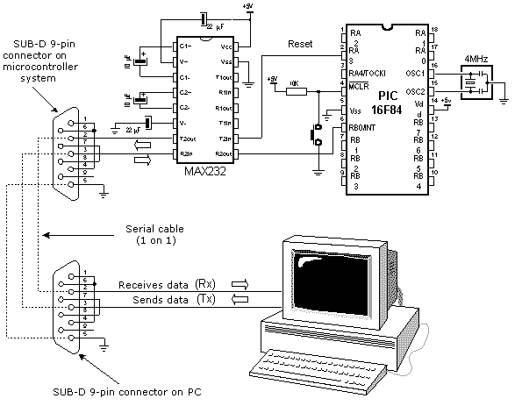
Connecting a microcontroller to a PC via a MAX232 line interface chip

Glossary:

SCI - Serial Communication Interface (asynchronous serial communication interface)
SPI - Serial Peripheral Interface (synchronous serial communication interface
I2C protocol :Background Inter-Integrated Circuit Protocol

UART. A UART (Universal Asynchronous Receiver Transmitter) is a serial port adapter for asynchronous serial communications.
USART. A USART (Universal Synchronous / Asynchronous Receiver Transmitter) is a serial port adapter for either asynchronous or synchronous serial Communications

Serial Port Programming in PIC18:

- RCREG – Holds a received character; read this to get character
- TXREG – write to this register to send a character
- RCSTA – Receive status and control register.Enables the serial port to receive data
- SPBRG - Baud rate generator
- TXSTA - Transmit status register and control register and also select between async/sync IO, select frame size

SPBRG Register : The value loaded in this ragister define the baud rate depended on crystal frequency : Desired baud rate = Fosc/(64X+64), where X is the value loaded in SPBGR register
Example : if Fosc is 1n MHz we have: Desired baude rate = Fosc(64(X+1), The solution results as:
X =(156250 /desired baud rate)-1
The baud rate in PIC18 is programmable

Serial communication (Uart) and interrupt:
There are two bit in interrupt request register for UART:
- TXIF (transmit interrupt flag)
- RCIF (receive interrupt flag)

Programming the PIC18 to transfer data serially:

In the programming the PIC18 to transfer character bytes serially, the following steps must be taken:
1. The TXSTA register is loaded with the value 20H, indicating asynchronous mode with 8-bit data frame, low baud rate, and transmit enabled.
2. Make TX pin of PORTC (RC6) output for data to come out of the PIC.
3. The SPBRG is loaded with baud rate generator value.
4. SPEN bit in the RCSTA register is set HIGH to enable the serial port of the PIC18.
5. The character byte to be transmitted serially is written into the TXREG register.
6. Monitor the TXIF bit of the PIR1 register to make sure UART is ready for next yte.
7. To transfer the next character, go to Step 5.

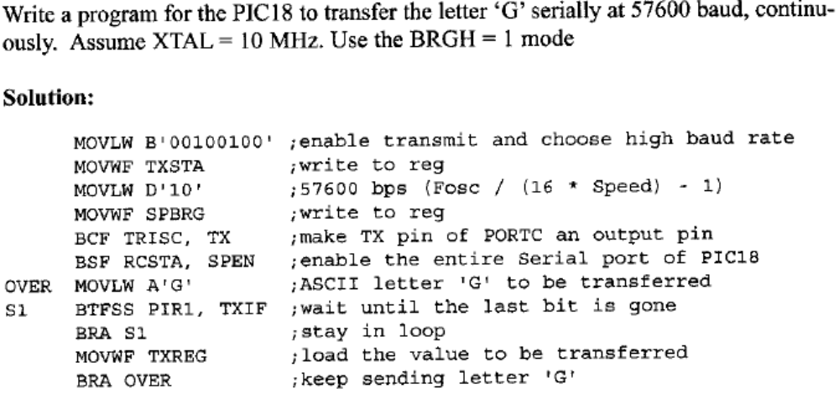

C code:

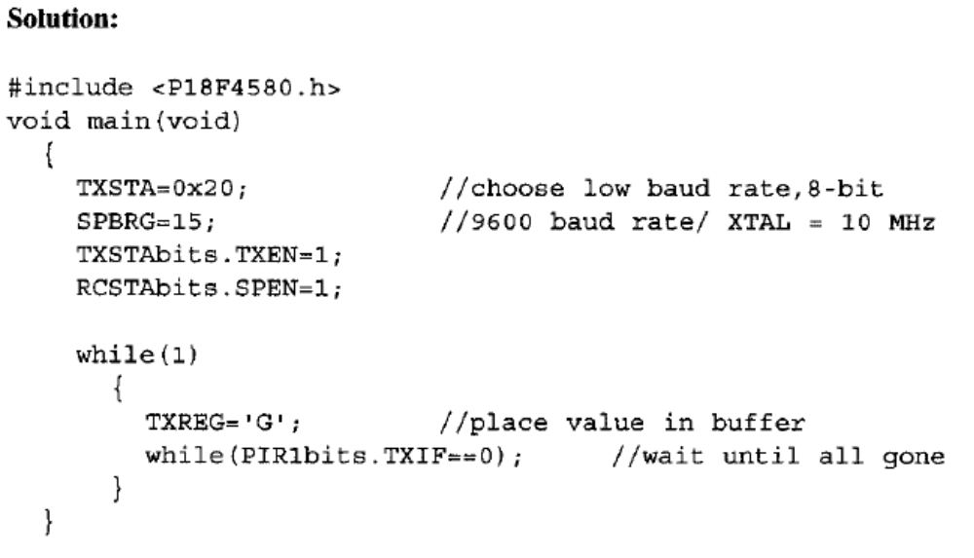

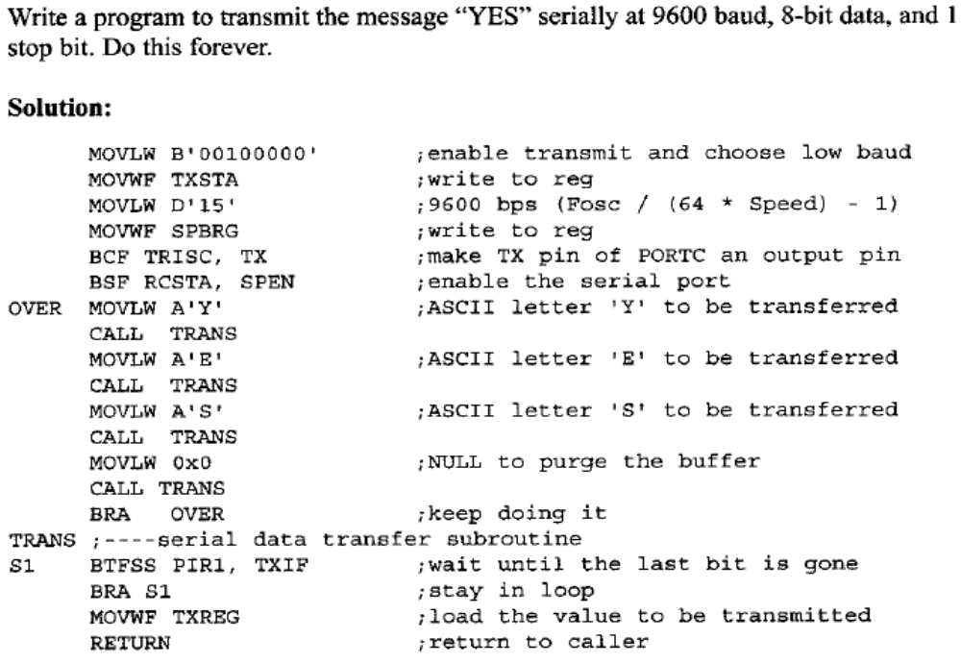

C code:

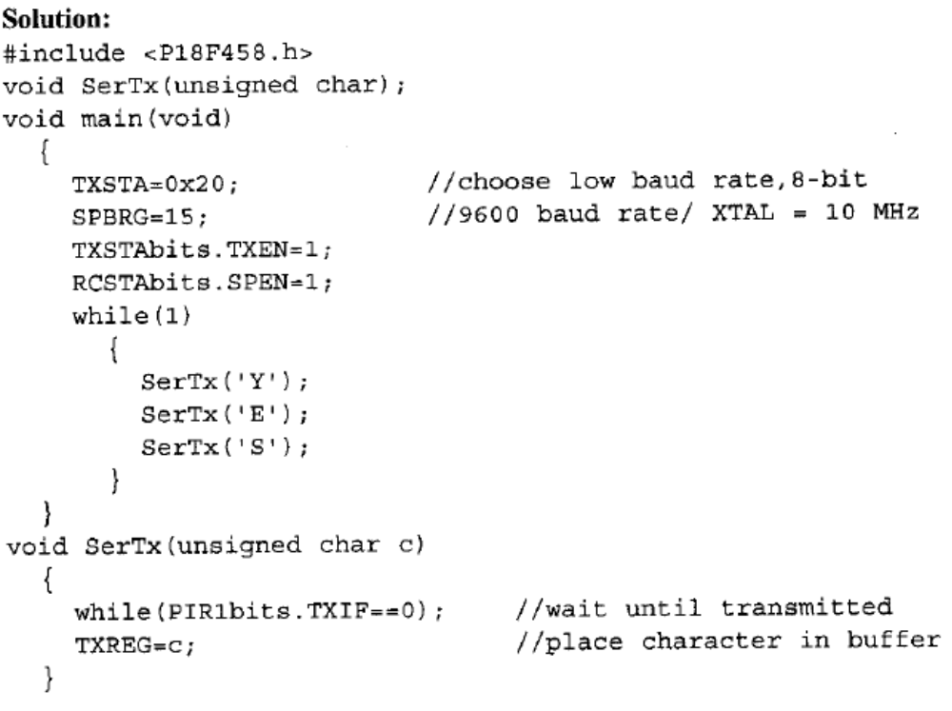
Importance of the TXIF flag:

To understand the importance of the role of TXIF, look at the following sequence of steps that the PIC18 goes through in transmitting a character via TX:
- The byte character to be transmitted is written into the TXREG register.
- 2. The TXIF flag is set to 1 internally to indicate that TXREG has a byte and will not accept another byte until this one is transmitted.
- The TSR (Transmit Shift Register) reads the byte from TXREG and begins to transfer the byte starting with the start bit.
- The TXIF is cleared to indicate that the last byte is being transmitted and TXREG is ready to accept another byte.
- The 8-bit character is transferred one bit at a time.
- By monitoring the TXIF flag, we make sure that we are not overloading the TXREG register. If we write another byte into the TXREG register before the TSR has fetched the last one, the old byte could be lost before it is transmitted.

From the above discussion we conclude that by checking the TXIF flag bit, we Know whether or not the PIC18 is ready to transfer another byte.

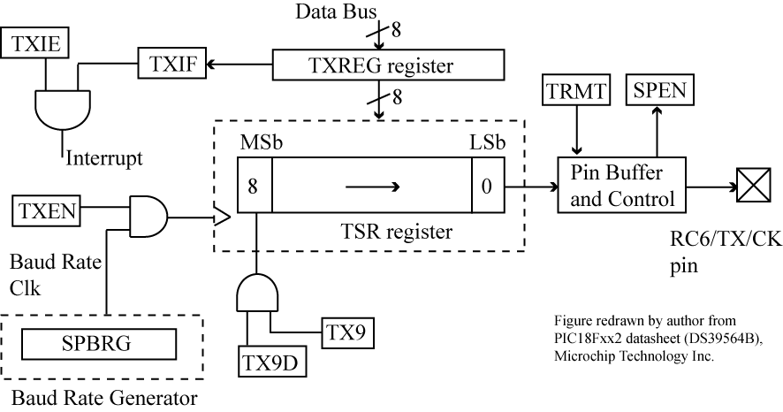

USART transmitter block diagram

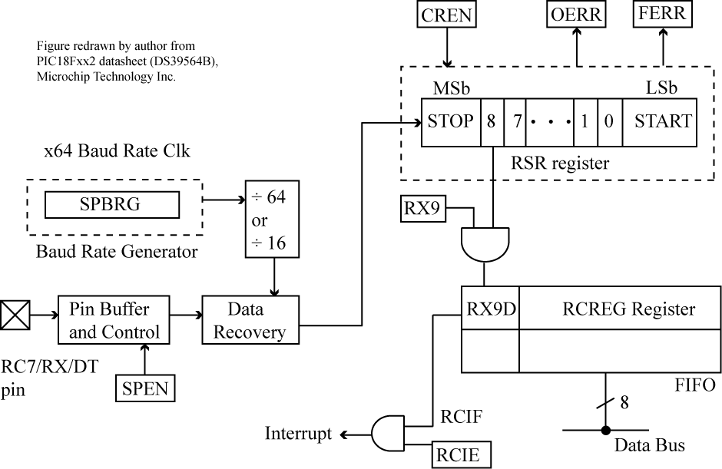

USART receiver block diagram

Programming the PIC18 to receive date serially:

In programming the PIC18 to receive character bytes serially, the following steps must be taken:
- The RCSTA register is loaded with the value 90H, to enable the continuous receive in addition to the 8-bit data size option.
- The TXSTA register is loaded with the value 00H, to choose the low baud rate option.
- SPBRG is loaded with one of the values in Table 10-4 to set the baud rate (assuming XTAL = 10 MHZ).
- Make the RX pin of PORTC (RC7) an input for data to come into the PIC18.
- The RCIF flag bit of the PIR 1 register is monitored for a HIGH to see if an entire character has been received yet.
- When RCIF is raised, the RCREG register has the byte. Its contents are moved into a safe place.
- To receive the next character, go to step 5.

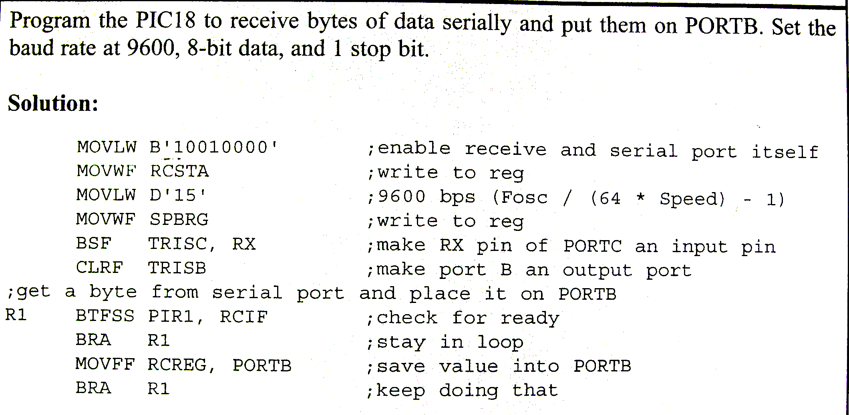

Importance of the RCIF flag bit

In receiving bits via its RX pin, the PIC18 goes through the following steps:
- It receives the start bit indicating that the next bits is the first bit of the character byte it is about to receive.
- The 8-bit character is received one bit at time. When the last bit is received, a byte is formed and placed in RCREG.
- The stop bit is received. It is during receiving the stop bit that the PIC18 makes RCIF = 1, indicating that an entire character byte has been received and must be picked up before it gets overwritten by another incoming character.
- By checking the RCIF flag bit when it is raised, we know that a character has been received and is sitting in the RCREG register. We copy the RCREG contents to a safe place in some other register or memory before it is lost
- After the RCREG contents are read (copied) into a safe place, the RCIF flag bit is forced to 0 by the UART itself. This allows the next received character byte to be placed in RCREG, and also prevents the same byte from being picked up multiple times.

From the above discussion we conclude that by checking the RCIFI flag bit we know whether or not the PIC18 has received a character byte. If we fail to copy RCRECG into a safe place, we risk the loss of the received byte.

