Synchrnous Serial IO : (onboard application)
A protocol is a set of rules which governs how data is sent from one point to another. In data communications, there are widely accepted protocols for sending data. Both the sender and receiver must use the same protocol when communicating,

Threre are 2 protocol for onboard synchrnous application:

I2C protocol or I2C Bus(Inter-Integrated Circuit Protocol)
SPI - Serial Peripheral Interface (synchronous serial communication interface

The Master Synchronous Serial Port (MSSP) subsystem in microcontrollers ( for example PIC 18XX) supports two industrystandard serial protocols, namely the Serial Peripheral Interface (SPI) and Inter IC (I2C) bus.

I2C protocol or I2C Bus(Inter-Integrated Circuit Protocol)

The I2C bus is a simple 2 wire serial interface developed by Philips. It was developed for 8 bit applications and is widely used in consumer electronics, automotive and industrial applications. In addition to microcontrollers,.

I2C is a 2-wire, half-duplex, serial bus, as shown in Figure. The two I2C signals are serial clock (SCL) and serial data (SDA). Both lines are bidirectional and must be connected to Vcc via pull-up resistors. The device initiating data transfers and providing the clock signal on the bus is called a "master". A device being addressed by the master is called a "slave". Originally intended for operation on one single board / PCB .The SCL and SDA pins are open collector in serial devices:

Speed :100 kbit/s (and up to 3.4Mbit/s in the high speed mode)

Today, a variety of devices are available with I2C Interfaces
▪Microcontroller, EEPROM, Real-Timer, interface chips, LCD driver, A/D converter
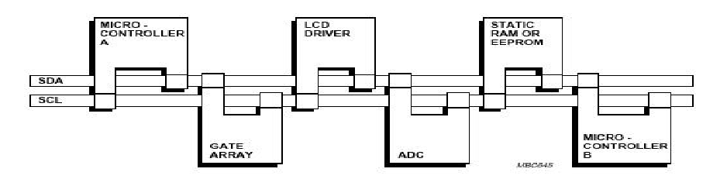

Serial data line (SDA):
A bi-directional line used to transfer address and data into and out of the device

Serial clock line (SCL):
An input clock line used to synchronize the data transfer to and from the device

Speeds:
- Standard I2C mode up to 100KHz
- Fast I2C mode up to 400KHz
I2C Features:

• Multiple receivers do not require separate select lines as in SPI
– At start of each I2C transaction a 7 or 10 bit device address is sent
– Each device listens – if device address matches internal address, then device responds
• SDA (data line) is bidirectional, communication is half duplex
• SDA, SCLK are open-drain, require external pullups
– Allows multiple bus masters

Adressing:

In I2C protocol, each device has a 7-bit or 10 bit address whose upper 4 bits (XXXX) are device specific and encoded within the device. The next 3 bits of the 7-bit address are typically personalized by external pins that are connected to either Vdd or ground to provide logic 1 or logic 0, respectively. The address is always sent as the first byte of an I2C bus transaction, which is initiated by the bus master. The least significant bit of the address byte indicates the direction of the transfer. A “0” is a write operation (transfer from master to slave), while a “1” is a read (transfer from slave to master). Each I2C peripheral device decodes the address byte to determine if it is the target of the transmission, removing the need for individual chip select lines. Adding another I2C device to the bus does not require using an additional port on the PIC.

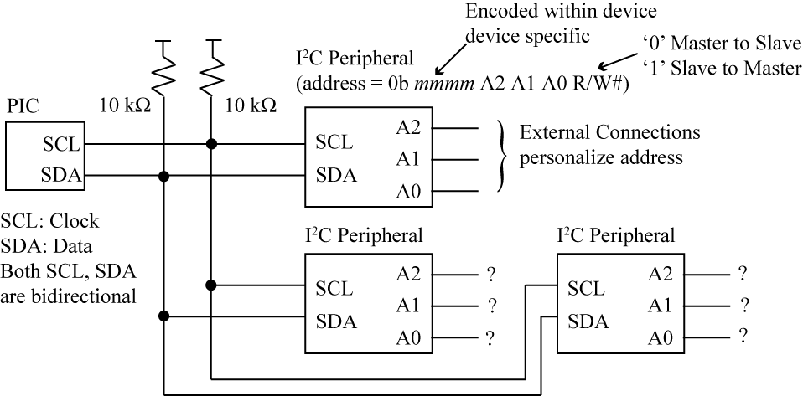

Start and Stop Conditions:
Start Condition: The master signals the beginning of a transfer by sending a 1-to-0 transition while SCL is high.
Stop Condition: A 0-to-1 transition issued by the master while SCL is high, signals the end of a transfer.

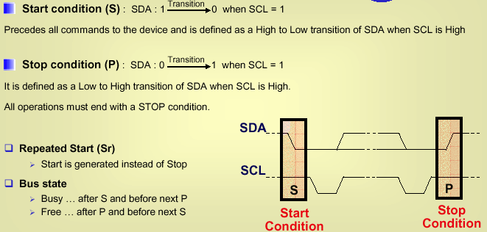

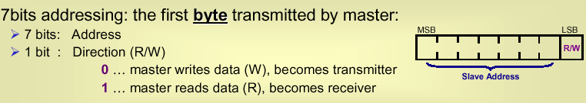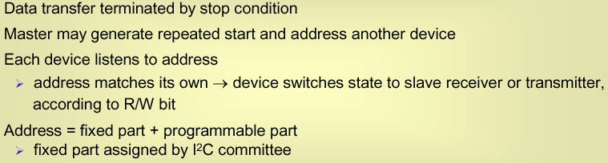

Acknowledgement
After a successful data transfer,each receiving device Master/Slave )is required to generate an acknowledge: pull SDA data line low for one clock pulse after reception of a byte

Acknowledgement from a slave: The slave pulls SDA line low immediately after reception of the 8th bit transmitted as soon as the master pulls SCL low to complete the transmission of the bit (1) SDA will be pulled low by the slave(2) The master now issues a clock pulse on the SCL line(3) The slave will release the SDA line upon completion of this clock pulse(4)
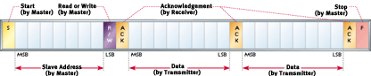
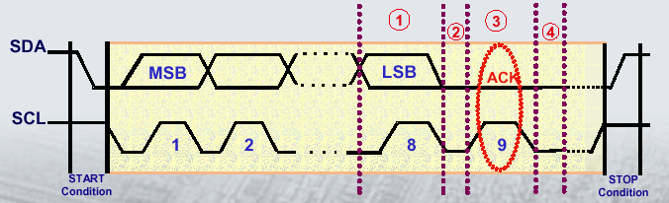

The master always provides the SCL signal and initiates an I2C transaction.
The start condition, a high-to-low transition on SDA while SCL is high, signals the beginning of an I2C data transfer. The first byte after a start condition is always the address byte used to select a particular I2C peripheral. Multiple bytes can be sent within an I2C transaction with each byte sent MSb first. SDA data is stable while SCL is high and changes while SCL is low. Each byte transmission ends with a 9th bit time in which the transmitter stops driving the SDA line so that the receiver can acknowledge the byte transmission by pulling the SDA line low. If the receiver does not drive SDA low, the SDA pullup resistor keeps SDA high and the transmitter reads a “1” for the acknowledge bit instead of a “0”. A “1” acknowledgment bit is called a not-acknowledge, or a NAK, while a “0” acknowledgment bit is called an ACK. Typically, the transmitter will interpret this as an error condition and abort
the transfer. There are multiple reasons why a receiver may not acknowledge a byte transmission; if this is the address byte, a coding mistake could result in the wrong address being used, or perhaps the receiver cannot accept new data or has experienced an internal failure. In any case, the acknowledge bit provides feedback to the transmitter on whether a byte has been received. The acknowledgment bit is nonoptional for normal transfers; each byte transmission includes an acknowledgment bit. The master provides the acknowledgment bit in the case where a slave sends a byte to the master for a read operation. After an acknowledgment bit, a slave can hold the SCL line low, which forces the master into a wait condition until the slave releases the SCL line. In this way, the slave can provide flow control on a byte-by-byte basis; this is the only time that the slave may drive the SCL line. The stop condition, defined as a low-to-high SDA transition while SCL is high, ends an I2C transaction and frees the bus, allowing it to be driven by another bus master. After the stop condition, both SCL and SDA are undriven and thus pulled high by
the pullup resistors.

Steps of interface between master and slave:

1. Master sends start condition (S) and controls the clock signal
2. Master sends a unique 7-bit slave device address
3. Master sends read/write bit (R/W) – 0 - slave receive, 1 - slave transmit
4. Receiver sends acknowledge bit (ACK)
5. Transmitter (slave or master) transmits 1 byte of data
6. Receiver issues an ACK bit for the byte received
7. Repeat 5 and 6 if more bytes need to be transmitted.
8.a) For write transaction (master transmitting), master issues stop condition (P) after last byte of data.
8.b) For read transaction (master receiving), master does not acknowledge final byte, just issues stop condition (P) to tell the slave the transmission is done

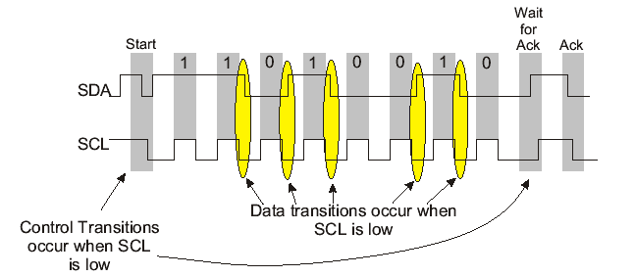

Data Transfer on the I2C Bus
- Data bits are transferred after start condition
- Transmission is byte oriented :
- byte =8 bits +one acknowledge bit
- Most significant bit (MSB)first
- Slave address is also datum
Next bytes: depends on the last bit in address byte

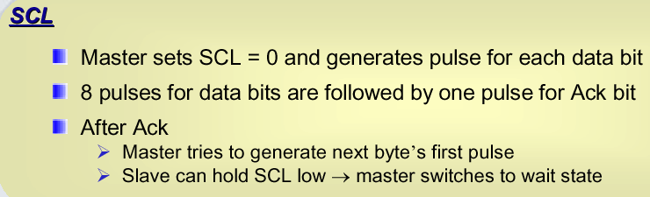
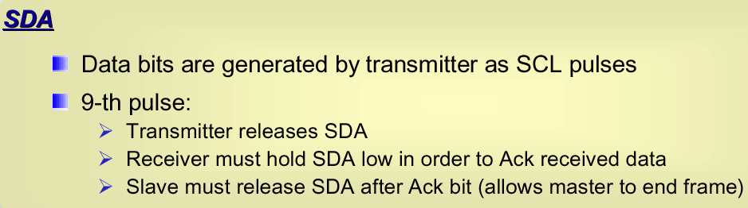

Figure shows the details of an I2C bus transfer. The idle condition is when both SDA and SCL lines are high prior to the beginning of a bus transfer.

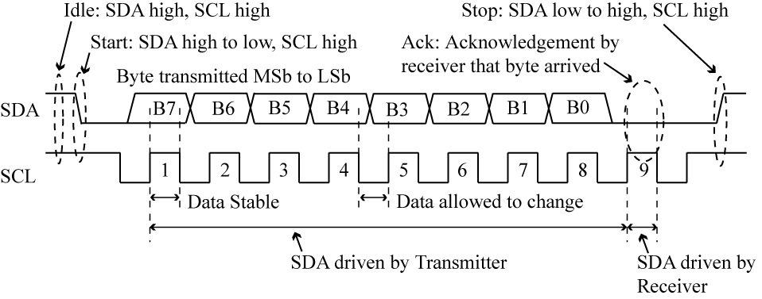

Write and read timing: (Two bytes)

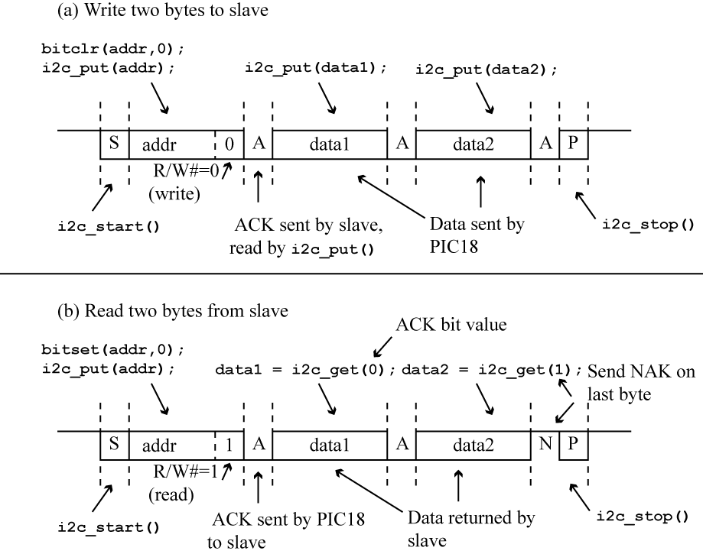

Example: I2C Serial EEPROM:
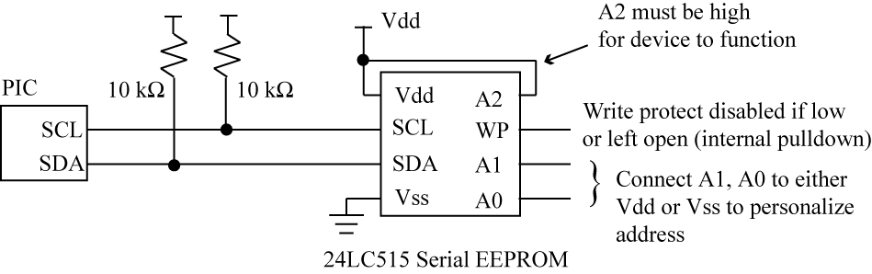

The 24LC515 512K serial EEPROM has an internal organization of 64K x 8 and uses an I2C port for communication. Figure above shows a PIC18 to 24LC515 interface using the I2C port. The write protect (WP) pin on the 24LC515 can be used to disable writes to the device; it can be left open or tied to Vss to enable writes. The A2 input is an unused input that must be tied high for the device to function correctly. The A1, A0 inputs are used to personalize the device address by connecting them to either Vdd or ground. This allows up to four 24LC515 devices to exist on the same I2C bus.
.
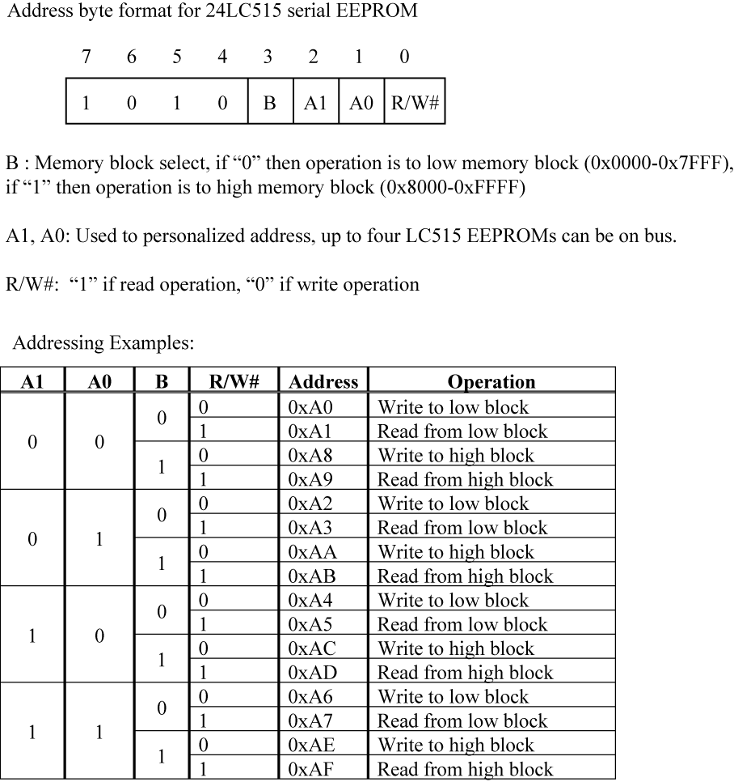

Figure shows the address byte format for the 24LC515. The upper 4 bits are fixed at “1010”. The 64K x 8 organization of the 24LC515 means that addresses are 16 bits with a range 0x0000 to 0xFFFF. However, the internal organization of the 64 x 8 memory is split into two 32K memory blocks, each with its own internal 15-bit address counter. The B (block select) bit of the address byte determines whether the current operation is to the low memory block (0x0000 through 0x7FFF) or high memory block (0x8000 through 0xFFFF). The least significant bit of the address byte is the R/W# bit as with all I2C address bytes.

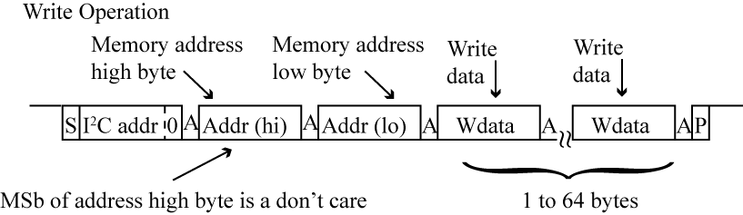

Figure shows the write operation for the 24LC515. The I2C address byteis followed by the high and low address bytes of the starting location for the write.The most significant bit of the high address byte is a don’t care as the block select bit within the I2C address byte determines which memory block is being written; these 15 address bits are written to the internal address counter for the 32K block selected by the block select bit of the address byte. The internal page size of the 24LC515 is 64 bytes, so up to 64 bytes can be written in one write operation. Page wrapping occurs in the same way as discussed in Figure 11.12 for the 25LC640 serial EEPROM, except the starting page boundary is when the lower 6 bits of the address are all zeros and the ending page boundary has the lower 6 bits as all ones.

The worst-case write completion time is 5 ms

Sequential read / Random Read

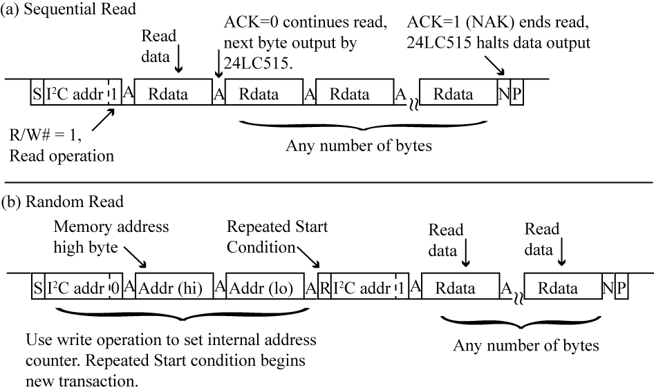

A sequential read (Figure above) returns the memory contents pointed to by the internal address counter of the 24LC515. Each data byte returned by the 24LC515 increments the internal address counter for the selected block. An acknowledgment bit of “0” returned by the PIC18 causes the 24LC515 to output another data byte. An acknowledgment bit of “1” returned by the PIC18 causes the 24LC515 to release the SDA line and to stop sending data. A sequential read can access the contents of one entire 32K memory block, either high or low, as determined by the block select bit sent in the I2C address byte at the beginning of the read transaction. When the internal address counter reaches the end of a 32K block (either 0x7FFF or 0xFFFF), it wraps around to the beginning of the block.

PIC18 I2C Registers
• Synchronous Serial Port on PIC implements I2C Registers are:
– SSPCON – control register - we will always set this to 0x28 which enables I2C MASTER mode.
– SSPCON1 – control register - used to initiate a START/STOP conditions, indicates if ACK has been received.
– SSPSTAT – status register – check this to see if byte finished transmitting, or byte has been received
– SSPBUF – read/write to this register for data transfer
– SSPADD – used to control clock rate
Serial Peripheral Interface (SPI)

The Serial Peripheral Interface, originally developed by Motorola, is a three-wire synchronous serial link that has developed into a de facto standard due to its adoption by multiple semiconductor vendors. An SPI system may consist of a master, one or more slaves, or a system in which devices may be either masters or slaves. Data is always transferred in both directions in SPI, but an SPI device interested in only transmitting data can choose to ignore the receive bytes. The exchange of data has no pre- defined protocol. This makes it ideal for data- stream applications. Data can be transferred at high speed, often into the range of the tens of megahertz. SPI does not have an acknowledgement mechanism to confirm receipt of data. Figure shows an SPI connection between a PIC and a peripheral device. An SPI port achieves full-duplex communication by shifting in data via the serial data input (SDI) pin while shifting out data through the serialdata output (SDO) pin. In master mode, the PIC initiates all transactions by supplyingthe clock via the SCK pin. Observe that unlike the USART synchronous transmission,data is sent MSb first. Data is written to the SSPBUF register to initiate either transmit or receive. For receive (PIC from peripheral) operation, dummy data is written to SSPBUF if the peripheral device does not care about incoming data on its SDI pin. For transmit (PIC to peripheral) operation, the PIC can ignore the new data shifted into the SSPBUF register if no valid data is expected. The SSPIF (Master Synchronous Serial Port Interrupt Flag, PIR1[3]) is automatically set when a transaction is complete; it must be manually reset before the next transaction is initiated. The most segnificant bit (MSB) goes first.

- SCK is generated by the master device and serves as synchronization of the datacommunication.
- Each device has its own SS line.The master pulls low on a slave's SS line to select a devicefor communication.
- MISO is one of two unidirectional serial data signals.It is an input to a master device and an output from a slave device.
- The MOSI line is the second of the two unidirectional serial data signals.
- It is an output from a master device and an input to a slave device.
There are a great variety of SPI devices that can be connected to a host microcontroller:
Converters (ADC and DAC),Memories (EEPROM and FLASH),Real Time Clocks (RTC),Sensors (temperature,pressure)Others (potentiometer, LCD controller, CAN controller…)

The basic interface consists of 4 wires:
SDI - serial data input (Master in - Slave out)
SDO - serial data output (Master out - Slave in)
SS - slave select
SCK - serial clock

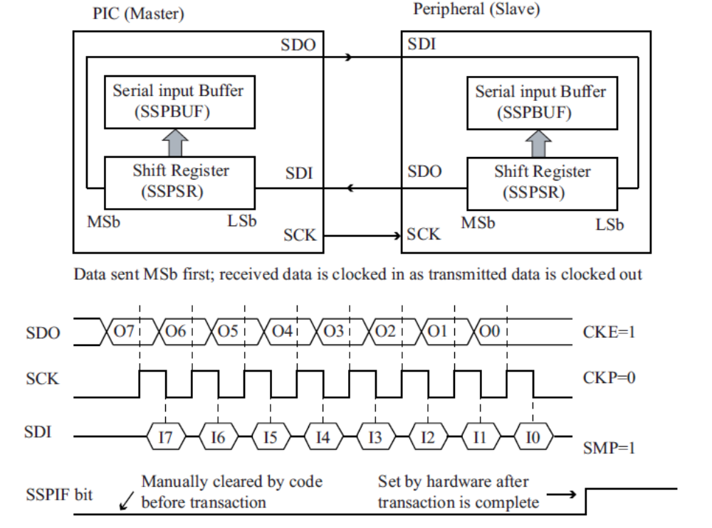

CKE (clock edge select, SSPSTAT [6]), CKP (clock polarity select, SSPCON1 [4])and SMP (input sample select, SSPSTAT[7]) are configuration bits.

In operation, the Master and Slave each have an 8-bit data register which are connected together to form a 16-bit shift register. When the slave is selected and the master sends clock pulses the bytes in the master and slave are exchanged.The number of slaves that a bus master may control is limited only by the number of select lines.

SPI Bus Timing
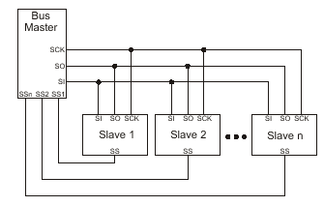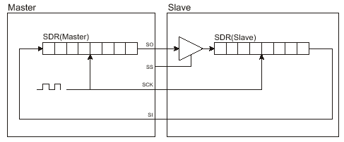

interface: Single master, multiple slave SPI implementation:

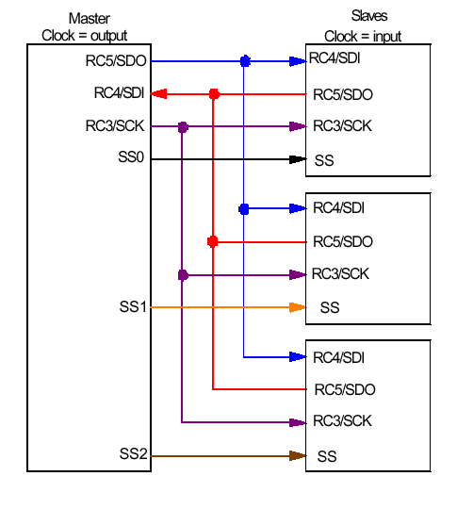

SPI single byte writing timing

The 25LC640 Serial EEPROM:
Figure shows a PIC18 to 25LC640 serial EEPROM [13] interface. The 25LC640 is a 64 Kb serial EEPROM with an internal 8K x 8 organization and uses an SPI port for communication.

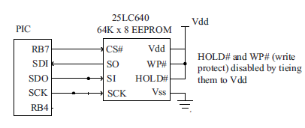
PIC to 25LC640 serial EEPROM interface

Figure gives the read operation details for the 25LC640. The first byte sent is the command byte, which has a value of 0x03.

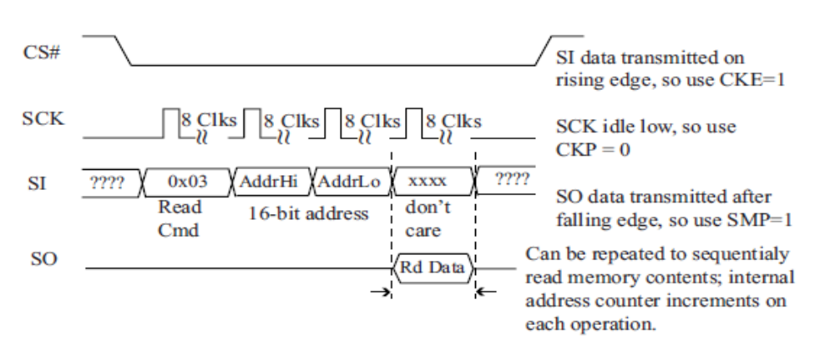

25LC640 read operation.

Figure shows the write operation sequence for the 25LC640, which consists of a write command byte (0x2), the 16-bit address, and up to 32 data bytes. The write operation is triggered after CS# is negated and has a worst-case completion time of 5 ms. Once the bytes have been received by the serial EEPROM, it takes the same amount of time to write 1 byte as 32 bytes, so it is more efficient to write as many bytes at a time as possible

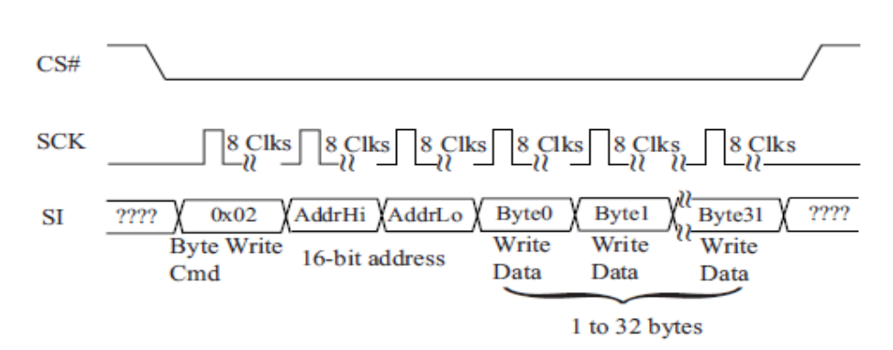
25LC640 write operation.

Input/Output Expansion by using SPI:

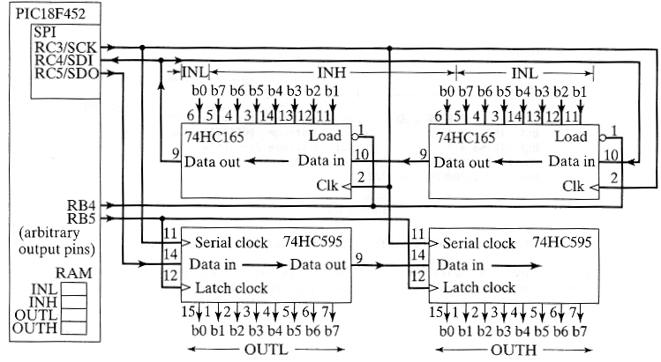

Summary
•
I2C and SPI provide good support for communication with slow peripheral devices that are accessed intermittently, mainly EEPROMs and real-time clocks
•I2C easily accommodates multiple devices on a single bus.
•SPI is faster, but gets complicated when there is more than one slave involved.

