Calculation of error in control systems
The controller provides the intelligent of the system. Look again at the block diagram of the parameter control system (Figure 1). The controller has two inputs. One indicates the desired value of the parameter. This is called the set point (SP) or r (reference). The other input signal indicates the actual value of that parameter (as measured by the sensor, conditioned and transmitted to the controller). This is called the process variable (PV) or y in block diagram. It is the purpose of the controller to provide a signal that will cause the process to be modified in such away as to keep the set point and the process variable equal. Any changes in set point or the loads on the process should cause a change in the controller’s output, to assure that PV tracks the SP.
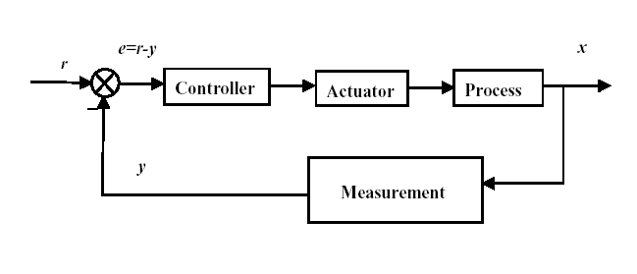

Figure 1 . Block diagram of process controller

Calculation of error by using analog devices (analog approach)
All controllers must begin by generating the error single

E = SP – PV
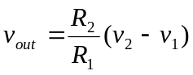The error is the difference between the set point (desired value) and the actual value. When the actual value is too small, the error is positive. A negative error indicates that the actual value of the controller parameter is above the desired value. You can produce the error signal in several ways, two of which are shown in Figure 2. The difference amplifier of Figure has an output of by setting R = R₂ = R₁,

v₂ = Vsp
v₁ = Vpv
v_{out} = V_{error} = Vsp –Vpv
You must be sure that
R >> R_{pot} (To minimize the loading of potentiometer)
To minimize loading of the potentiometer and bias current problems. Also, all four resistances must be carefully matched to prevent bias and offset problems as well as to enhance common-mode rejection (when Vsp = Vpv, V_{error} = 0).

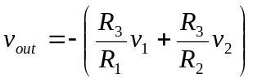The second error amplifier is an inverting summer:

By setting R = R₁ = R₂ = R₃,
v₁ = -Vsp
v₂ = Vpv
v_{out} = V_{error} = Vsp-Vpv

To assure proper operation, you must use the negative of the actual set point desired.
This is then inverted by the inverting summer. As with the difference amplifier,

R >> R_{pot}

V_{error} = Vsp-Vpv
V_{out} = -(-Vsp +Vpv) = Vsp – Vpv

Resistor R_{comp} is to compensate for the effects of bias currents and should equal the parallel combination of all resistance to the inverting terminal. The virtual ground at the inverting pin of the inverting summer isolates each input and the feedback loop. This allows you to tune each of the input resistors without affecting the other input. This is not true for the difference amplifier. Error Amplifier

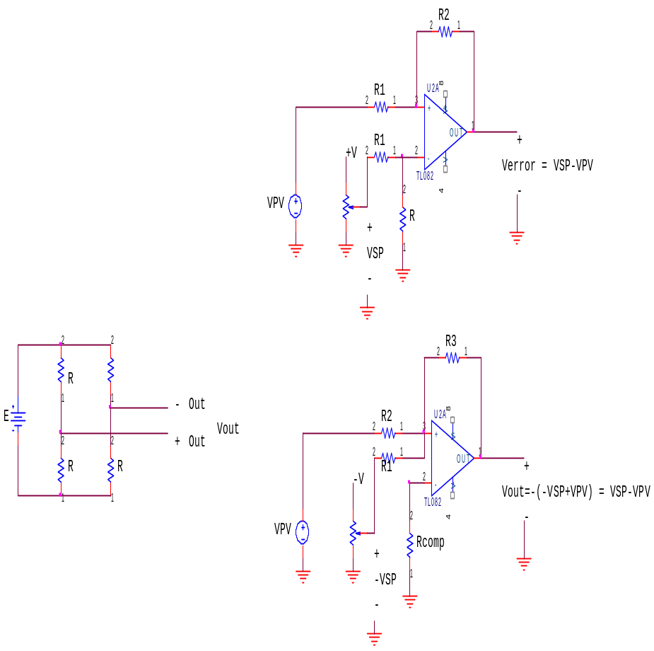
Inverting Summer
R_{pot}
Difference amplifier

Figure 2. Error calculation circuits

Error calculation in digital systems:
Convert analog values by using two analog input of microcontroller and apply the error calculation in software.

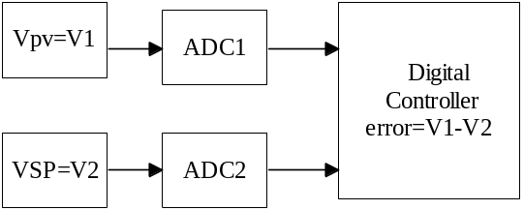
Comparators

The most elementary from of communication between the analog and digital is a device (usually an IC) called a comparator. This device, compares two analog voltages on its input terminals. Depending on which voltage is larger, the output will be a 1 (high) or a 0 (low) digital single. The comparator is extensively used for alarm singles to computers or digital processing systems. This element is also an integral part of the analog-to-digital and digital-to-analog converter. Therefore, the comparator converts an analog input signal into an output with two possible states. Hence, this can be thought of as a 1-bit analog to digital converter (A/D or ADC)

Comparator Operation

The following drawing shows the two simplest configurations for voltage comparators. The diagrams below the circuits give the output results in a graphical form. For these circuits the REFERENCE voltage is fixed at one-half of the supply voltage while the INPUT voltage is variable from zero to the supply voltage.

In theory the REFERENCE and INPUT voltages can be anywhere between zero and the supply voltage but there are practical limitations on the actual range depending on the particular device used.
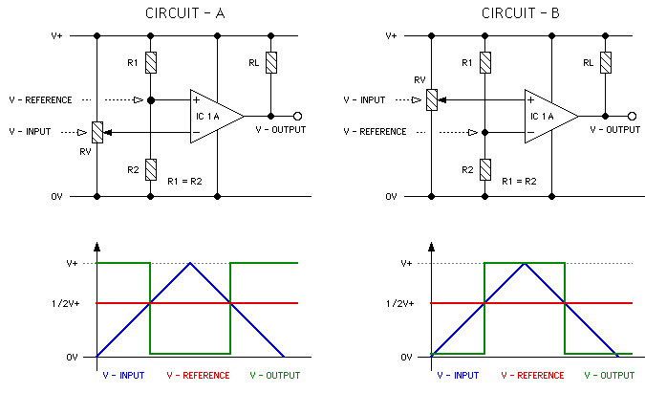

Fig.1. Comparator Operation
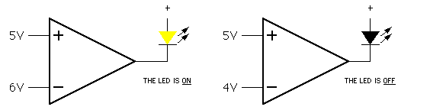
Fig.2. Simple usage of comprator with LED

Example

A process-control system specifies that temperature should never exceed 160 ⁰C if the pressure also exceeds 10 kPa. Design an alarm system to detect this condition, using temperature and pressure transducers with transfer functions of 2.2 mV/ ⁰C and 0.2V/kPa, respectively.

Solution The alarm conditions will be a temperature signal of ( 2.2 mV/⁰C ).( 160 ⁰C ) = 0.352 V coincident with a pressure signal ( 0.2V/kPa ).( 10kPa ) = 2 V. The circuit in figure 4 shows how this alarm can be implemented with comparators and one AND gate. The reference voltages could be provided from dividers.

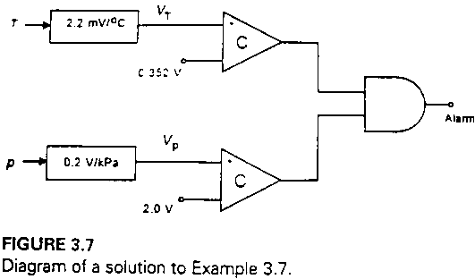
Figure 4. Diagram of solution

Open collector Comparator:

Some comparators models have a special method of providing the digital output signal. Figure shows that the output terminal of the comparator is connected internally to the collector of a transistor in the comparator. This called an open collector output.: (LM311 comparator)
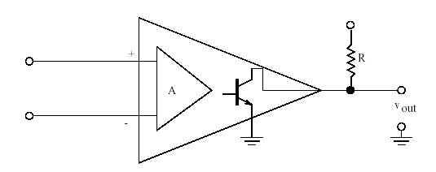

Advantagee of using open collector output:

- It is possible to use a different power supply for the output.
- It is possible to OR together several comparator’s output by connecting all open collector outputs together and then using a common pull-up resistor.

Hysteresis Comparator (Adding positive feedback)

When using comparators, there is often a problem if the single voltage has noise or approaches the reference value too slowly. The comparator output may ‘’jiggle’’ back and forth between high and low as the reference level is reached. This effect is shown in Figure 5 such fluctuation of output may cause problems with the equipment designed to interpret the comparator output signal.
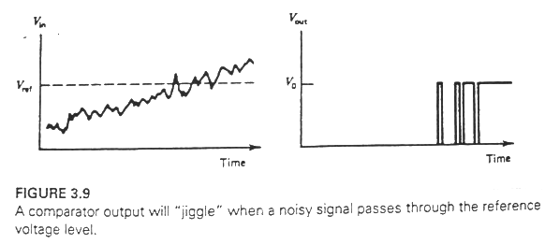
Figure 5. A comparator output will “jiggle” when a noisy signal passes through the reference voltage level

This problem can often be solved by providing a deadband or hysteresis window to the reference level around which output changes occur. Once the comparator has been triggered high, the reference level is automatically reduced so that the signal must fall to some value below the old reference before the comparator goes to the low state.

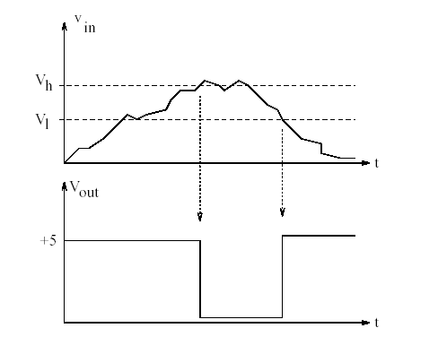

Fig.6
For better understanding what causes the hysteresis let’s analyze the circuit in Figure 8 using the same rules as in the previous section for the comparator. (Though at this point that is only an assumption but our results will ultimately show that indeed it acts similar to a comparator.) The key in understanding this circuit will again be in calculating the voltages that cause its output to switch.
The output will still be V++ or V--, depending on whether ΔV > 0 or ΔV < 0. Switching of the output will occur when the value ΔV changes sign, i.e., at ΔV = 0.

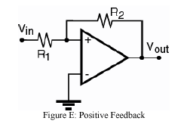

Fig.7

For the particular circuit above, ΔV = V+ since V- = 0. So,
•if V+ > 0, Vout = V₊₊,
•if V+ < 0, Vout = V₋₋.
Since Vout change its state whenever V+ crosses 0V, we need to find what value of Vin results in V+ = 0. Since V+ is a voltage divider formed
by R1 and R2 (reference element) between Vin and Vout it follows that: ( with Superposition method and R₂>> R₁)
• V₊ = (Vin R2 + Vout R1 )/(R1 + R2)
Combining these equations and solving for V+ = 0 yields Vin = -V_{out} R1/R2. Since V_{out} can only be either V++ or V--, Vout switches from V₊₊ to V₋₋when Vin = -V₊₊ R1/R2 and it switches from V₋₋ to V₊₊ when Vin = -V₋₋R1 / R2. In other words, it always takes “more effort” to reverse
the output than was initially required.

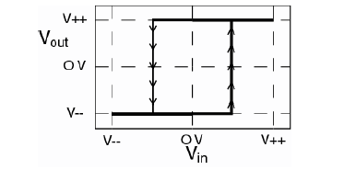
Figure 8. Vout versus Vin for the positive feedback

Another application of Hysteresis Comparator with constant reference voltage is presented in figure 9.
The condition for which the output will go high (V₀) is defined by the condition. (R_{f}>> R)
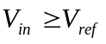Once having been driving high, the condition for the output to drop back to the low (0 V) state is given by the relation
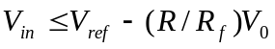the deadband or hysteresis is given by (R/R_{F})V₀, and is the us selectable by choice of the resistors,
Figure 9 shows input-output relation and equations
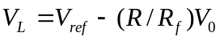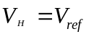

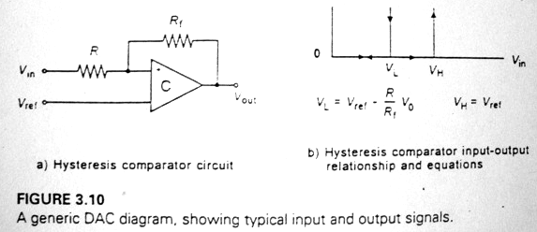

Fig.9
Example:
A sensor converts the liquid level in a tank to voltage according to the transfer function (20 mV/cm). A comparator is supposed to go high (5V) whenever the level becomes 50 cm. splashing causes the level to fluctuate by ±3 cm. develop a hysteresis comparator to protect against the effects of splashing.
Solution
The nominal reference for the comparator occurs at 50 cm, which is V_{ref} = (20 mV/cm) (50cm) = 1V. the splashing, however, cause a ‘’noise’’of (20 mV/cm).
(±3cm) = ±60 mV. This is a total range of 120 mV. We need a deadband of at least 120 mV, but let us make it 150 mV for security. Thus, we have
(R/R_{f})(5V) = 150 mV
(R/R_{f}) = 0.03
ıf we make R_{f} = 100kΩ, then R =3kΩ. thus, use of these resistors, as shown in Figure 10. with a reference of 1 V will meet the requirement.

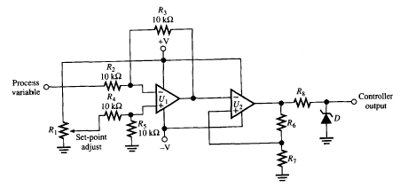
Usage of Hysteresis Comparator in simple ON/Off controller is shown in fig. 10 This circuit will be discuses later

Figure 10 simple analog ON/Off controller

Appendix:
Switching occurs when:

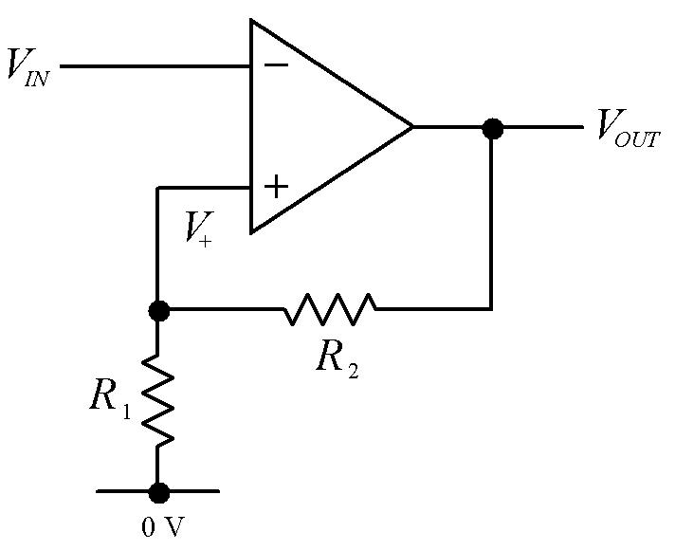

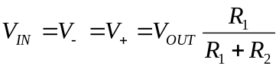
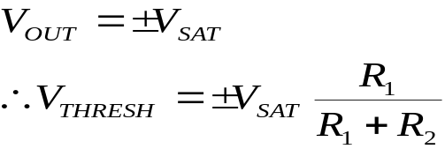
,

If the reference voltage is differenf of 0:Using Kirchoff’s current law:

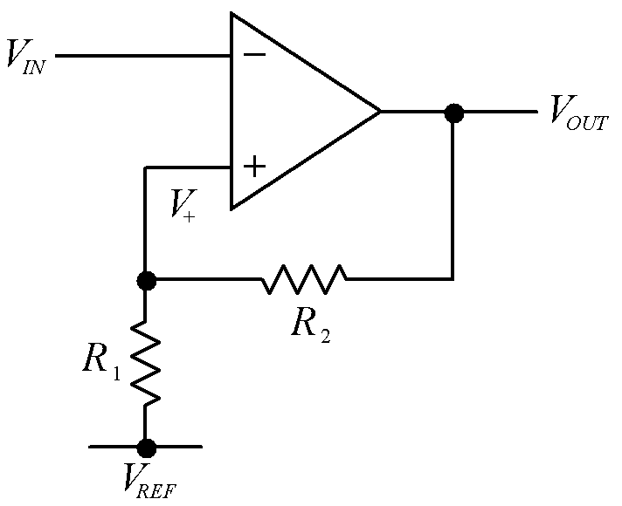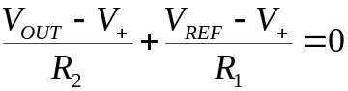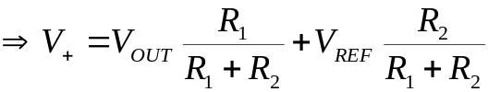

Note: One very effective way of improving the performance of the comparator is by introducing positive feedback. Positive feedback can increase the switching speed of the comparator and provide noise immunity at the same time.

A simple ON-OFF deadband (Hysteresis) by using comprator and D Flip-Flop
