Student Name: 22/10/2004
Number:

1- Explain difference between Accuracy and Sensitivity of System.

2- V_{in} changes from -2 to 7 V and from 7 to -2V plot input-output relation in the same plot.

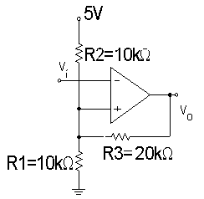

3- A 12-bit A/D converter uses successive approximation. It is driven by a 500-kHz clock. Each step in the successive approximation process requires 4 clock cycles. Estimate the conversion time.

4- Analog signal conditioning is needed so that a sensor output voltage which varies from -1.5 to +1.5 V is converted into an output variation of 0 to 5 V.

