BODE-PI için ;

0.0756 s + 0.02
C(S)= --------------------
S

Matlab kodu [C(s) için]:

>> kp=0.18

kp =

0.1800

>> ki=0.02

ki =

0.0200

>> K1=0.42

K1 =

0.4200

>> num=[K1*kp ki]

num =

0.0756 0.0200

>> den=[1 0]

den =

1 0

>> CS=tf(num,den)

Transfer function:
0.0756 s + 0.02
---------------
s

>> bode(CS)
Impulse Response:

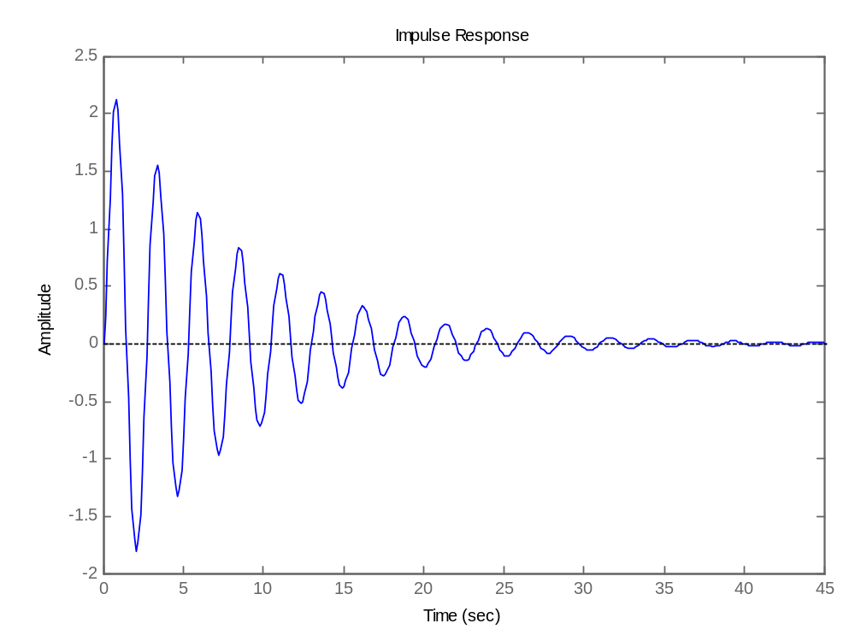

Step Response:

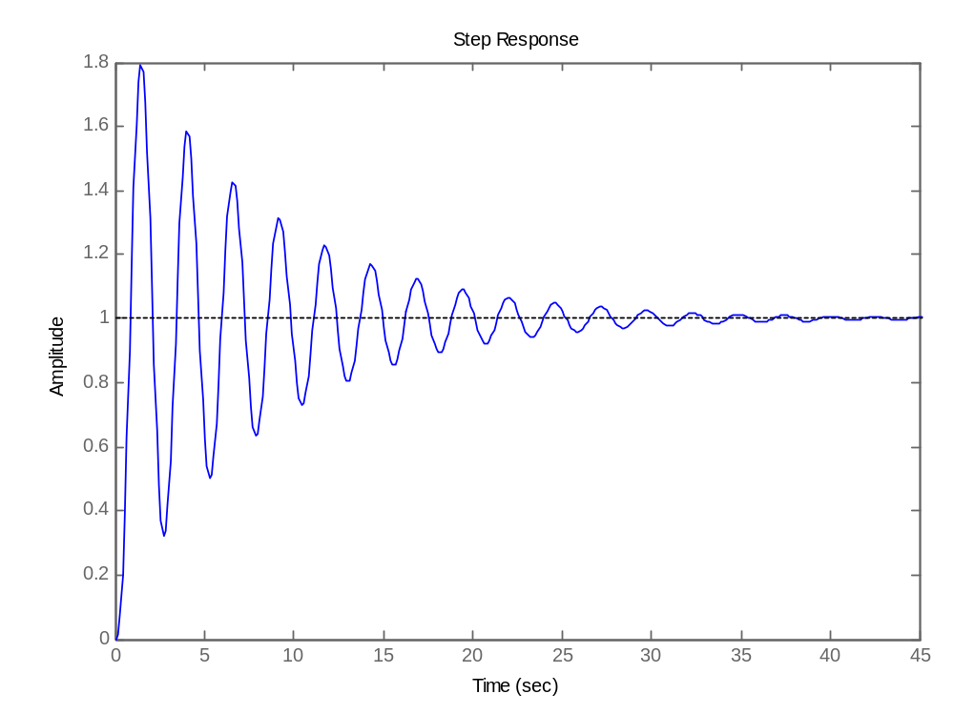
Sisotool gösterimi:

