X(s) | x(t) | x(kT) or x(k) | X(z)
1 | 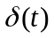 | 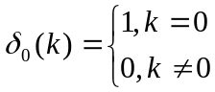 | 1
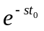 | 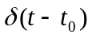 | 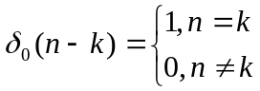 | 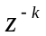
 | 1(t) | 1(k) | 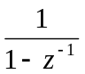
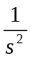 | t | kT | 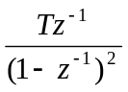
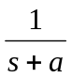 | 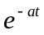 | 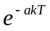 | 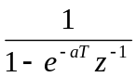
- | - | 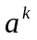 | 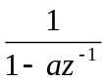
- | - | 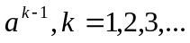 | 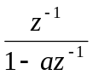
- | - | 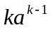 | 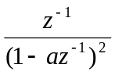
Table of z Transforms

