**EK-1 (Devrenin Proteus Çizimi)**

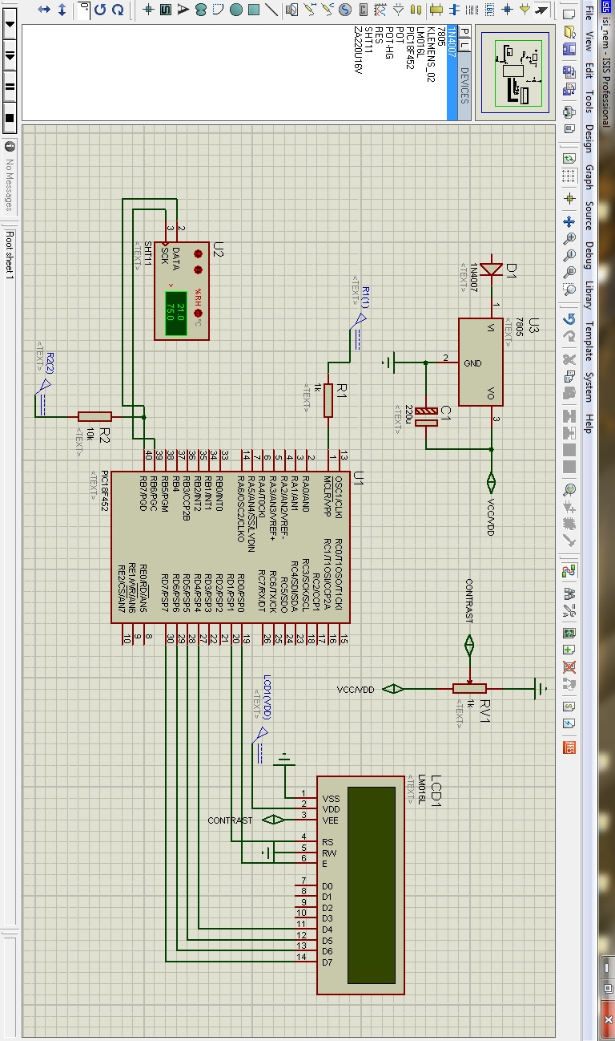

**EK-2 (Kaynak Kod)**

#include <18F452.h>

#include "SHT11.c"

#include "new_lcd.c"

#FUSES NOWDT //No Watch Dog Timer

#FUSES WDT128 //Watch Dog Timer uses 1:128 Postscale

#FUSES XT //Crystal osc

#FUSES NOPROTECT //Code not protected from reading

#FUSES NOOSCSEN //Oscillator switching is disabled

#FUSES NOBROWNOUT //No brownout reset

#FUSES BORV20 //Brownout reset at 2.0V

#FUSES NOPUT //No Power Up Timer

#FUSES NOSTVREN //Stack full/underflow will not cause reset

#FUSES NODEBUG //No Debug mode for ICD

#FUSES NOLVP //No low voltage prgming

#FUSES NOWRT //Program memory not write protected

#FUSES NOWRTD //Data EEPROM not write protected

#FUSES NOWRTB //Boot block not write protected

#FUSES NOWRTC //configuration not registers write protected

#FUSES NOCPD //No EE protection

#FUSES NOCPB //No Boot Block code protection

#FUSES NOEBTR //Memory not protected from table reads

#FUSES NOEBTRB //Boot block not protected from table reads

#device adc=8

#use delay(clock=4000000)

#define sht_data_pin PIN_b7

#define sht_clk_pin PIN_b6

float temp,humid,sicaklik,nem;

void main()

{

setup_adc_ports(NO_ANALOGS);

setup_adc(ADC_CLOCK_DIV_2);

setup_psp(PSP_DISABLED);

setup_spi(SPI_SS_DISABLED);

setup_wdt(WDT_OFF);

setup_timer_0(RTCC_INTERNAL);

setup_timer_1(T1_DISABLED);

setup_timer_2(T2_DISABLED,0,1);

setup_ccp1(CCP_OFF);

lcd_init();

delay_ms(100);

sht_init();

delay_ms(100);

while(1){

sht_rd (temp, humid);

sicaklik=(float)temp;

nem=(float)humid;

lcd_gotoxy(1,1);

printf(lcd_putc,"SICAKLIK %2.2f C",sicaklik);

lcd_gotoxy(1,2);

printf(lcd_putc,"NEM %2.2f RH",nem);

delay_ms(200);

}

}