**EK-1 (Devrenin Proteus Çizimi)**

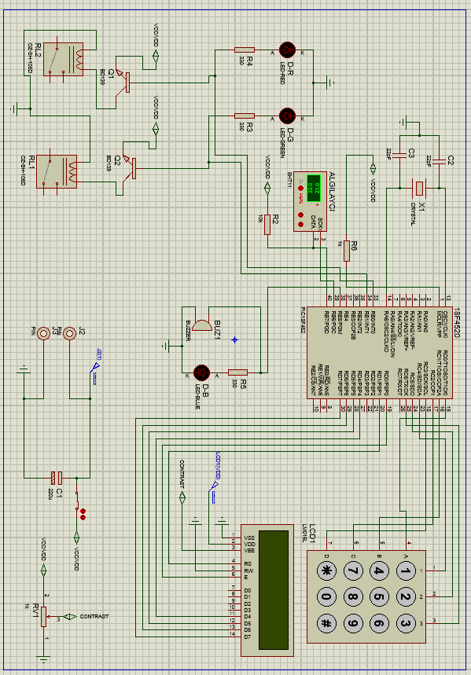

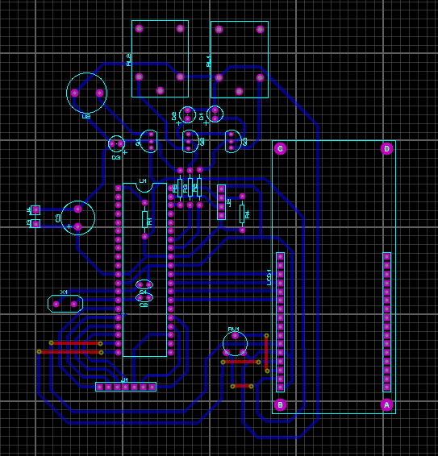

**EK-2 (Kaynak Kod)**

#include <18F452.h>

#device adc=8

#FUSES NOWDT //No Watch Dog Timer

#FUSES WDT128 //Watch Dog Timer uses 1:128 Postscale

#FUSES XT //Crystal osc <= 4mhz for PCM/PCH , 3mhz to 10 mhz for PCD

#FUSES NOPROTECT //Code not protected from reading

#FUSES NOOSCSEN //Oscillator switching is disabled, main oscillator is source

#FUSES NOBROWNOUT //No brownout reset

#FUSES BORV20 //Brownout reset at 2.0V

#FUSES NOPUT //No Power Up Timer

#FUSES NOSTVREN //Stack full/underflow will not cause reset

#FUSES NODEBUG //No Debug mode for ICD

#FUSES NOLVP //No low voltage prgming, B3(PIC16) or B5(PIC18) used for I/O

#FUSES NOWRT //Program memory not write protected

#FUSES NOWRTD //Data EEPROM not write protected

#FUSES NOWRTB //Boot block not write protected

#FUSES NOWRTC //configuration not registers write protected

#FUSES NOCPD //No EE protection

#FUSES NOCPB //No Boot Block code protection

#FUSES NOEBTR //Memory not protected from table reads

#FUSES NOEBTRB //Boot block not protected from table reads

#use delay(clock=4000000)

#include "SHT11.c"

#include "new_lcd.c"

//3x4 tuş takımı

#define sat1 pin_c0

#define sat2 pin_c1

#define sat3 pin_c2

#define sat4 pin_c3

#define sut1 pin_c4

#define sut2 pin_c5

#define sut3 pin_c6

// ısıtıcı ve soğutucu

#define isitici pin_b0

#define sogutucu pin_b1

//sht11 algılayıcı

#define sht_data_pin PIN_b7//(Data pin veya input)

#define sht_clk_pin PIN_b6

// sensor kontrol

#define ses_sensor pin_b5

float temp=0,humid=0,sicaklik=0,nem=0;

int i=1, negatif=0, flag=0, derece=25, tus=99, pres = 99;

int anticounter=10000, counterpid=0, flagmode=0, mode=0;

//fonksiyonlar

int keypad_oku() // Fonksiyon ismi

{

output_c(0x00); // D portu çıkışı sıfırlanıyor

output_high(sat1);

if (input(sut1))

{ delay_ms(20); tus=1;output_low(sat1);}

else if (input(sut2))

{ delay_ms(20); tus=2;output_low(sat1);}

else if (input(sut3))

{ delay_ms(20); tus=3;output_low(sat1);}

else

output_low(sat1);

output_high(sat2);

if (input(sut1))

{ delay_ms(20); tus=4;output_low(sat2);}

else if (input(sut2))

{ delay_ms(20); tus=5;output_low(sat2);}

else if (input(sut3))

{ delay_ms(20); tus=6;output_low(sat2);}

else

output_low(sat2);

output_high(sat3);

if (input(sut1))

{ delay_ms(20); tus=7;output_low(sat3);}

else if (input(sut2))

{ delay_ms(20); tus=8;output_low(sat3);}

else if (input(sut3))

{ delay_ms(20); tus=9;output_low(sat3);}

else

output_low(sat3);

output_high(sat4);

if (input(sut1))

{ delay_ms(20); tus=10;output_low(sat4);}

else if (input(sut2))

{ delay_ms(20); tus=0;output_low(sat4);}

else if (input(sut3))

{ delay_ms(20); tus=19;output_low(sat4);}

else

output_low(sat4);

return tus;

}

void allkeypadlow()

{

output_low(sat1);

output_low(sat2);

output_low(sat3);

output_low(sat4);

output_low(sut1);

output_low(sut2);

output_low(sut3);

tus=99;

}

void pid()

{

if(negatif == 1 && derece != 0)

{

output_low(isitici);

output_high(sogutucu);

}

else if(derece >= sicaklik-0.2 && derece <= sicaklik+0.2)

{

output_low(isitici);

output_low(sogutucu);

}

else if(derece > sicaklik )

{

output_high(isitici);

output_low(sogutucu);

}

else if(derece < sicaklik)

{

output_low(isitici);

output_high(sogutucu);

}

counterpid -= 1;

}

float absdiff(float x,float y)

{

if(x>y)

return x-y;

else

return y-x;

}

// ana program

void main()

{

setup_adc_ports(NO_ANALOGS);

setup_adc(ADC_CLOCK_DIV_2);

setup_psp(PSP_DISABLED);

setup_spi(SPI_SS_DISABLED);

setup_wdt(WDT_OFF);

setup_timer_1(T1_DISABLED);

setup_timer_2(T2_DISABLED,0,1);

setup_ccp1(CCP_OFF);

lcd_init();

delay_ms(100);

sht_init();

delay_ms(100);

set_tris_a(0x00); // A portu komple çıkış

set_tris_b(0x00);

set_tris_c(0x0f);

set_tris_d(0x00);

lcd_init(); // LCD hazırlanıyor

while(1)

{

allkeypadlow();

keypad_oku();

pres = tus;

allkeypadlow();

//kare

if(pres == 19)

{

flagmode = 1;

printf(lcd_putc,"\f");

}

while(flagmode==1)

{

lcd_gotoxy(1,1);

printf(lcd_putc,"Mod gir");

keypad_oku();

pres = tus;

if(pres == 19)

pres = 99;

allkeypadlow();

if(pres == 1)

{

lcd_gotoxy(2,2);

printf(lcd_putc,"%d",pres);

mode = 0;

delay_ms(1000);

printf(lcd_putc,"\f");

lcd_gotoxy(1,1);

printf(lcd_putc,"On-Off Ayarlandi.");

delay_ms(1000);

flagmode = 0;

}

if(pres == 2)

{

lcd_gotoxy(2,2);

printf(lcd_putc,"%d",pres);

mode = 1;

delay_ms(1000);

printf(lcd_putc,"\f");

lcd_gotoxy(1,1);

printf(lcd_putc,"PID Ayarlandi.");

delay_ms(1000);

flagmode = 0;

counterpid = absdiff(sicaklik,derece)* 10000;

}

if(pres == 3)

{

lcd_gotoxy(2,2);

printf(lcd_putc,"%d",pres);

mode = 1;

delay_ms(1000);

printf(lcd_putc,"\f");

lcd_gotoxy(1,1);

printf(lcd_putc,"P Ayarlandi.");

delay_ms(1000);

flagmode = 0;

counterpid = absdiff(sicaklik,derece)* 10000;

}

if(pres == 4)

{

lcd_gotoxy(2,2);

printf(lcd_putc,"%d",pres);

mode = 1;

delay_ms(1000);

printf(lcd_putc,"\f");

lcd_gotoxy(1,1);

printf(lcd_putc,"PI Ayarlandi.");

delay_ms(1000);

flagmode = 0;

counterpid = absdiff(sicaklik,derece)* 10000;

}

if(pres == 5)

{

flagmode = 0;

printf(lcd_putc,"\f");

lcd_gotoxy(1,1);

printf(lcd_putc,"CikiS.");

delay_ms(1000);

}

}

//yıldız

if(pres == 10)

{

flag = 1;

printf(lcd_putc,"\f");

}

while(flag==1)

{

lcd_gotoxy(1,1);

printf(lcd_putc,"SIC gir");

keypad_oku();

pres = tus;

if(pres == 10 && i == 1)

pres = 99;

allkeypadlow();

if( pres >= 0 && pres <= 9)

{

lcd_gotoxy(i,2);

if(i==1)

derece = 0;

printf(lcd_putc,"%d",pres);

delay_ms(1000);

derece = (derece*10) + pres;

i += 1;

}

else if(pres == 19)

{

printf(lcd_putc,"\f%d derece \nayarlandi.",derece);

flag = 0;

negatif = 0;

delay_ms(1000);

i=1;

printf(lcd_putc,"\f");

}

else if(pres == 10)

{

printf(lcd_putc,"\f-%d derece \nayarlandi.",derece);

flag = 0;

delay_ms(1000);

negatif = 1;

i=1;

printf(lcd_putc,"\f");

}

else{;}

}

sht_rd (temp, humid);

sicaklik=(float)temp;

nem=(float)humid;

lcd_gotoxy(1,1);

printf(lcd_putc,"SICAKLIK %2.2f C",sicaklik);

lcd_gotoxy(1,2);

printf(lcd_putc,"NEM %2.2f RH",nem);

//sensor kontrol

output_low(ses_sensor);

delay_ms(1000);

if(nem < 1)

{

output_high(ses_sensor);

delay_ms(1000);

}

if(negatif == 1 && derece != 0 && mode == 0)

{

output_low(isitici);

output_high(sogutucu);

delay_ms(1000);

}

else if(derece >= sicaklik-0.2 && derece <= sicaklik+0.2 && mode == 0)

{

output_low(isitici);

output_low(sogutucu);

delay_ms(1000);

}

else if(derece > sicaklik && mode == 0)

{

output_high(isitici);

output_low(sogutucu);

delay_ms(1000);

}

else if(derece < sicaklik && mode == 0)

{

output_low(isitici);

output_high(sogutucu);

delay_ms(1000);

}

if(mode == 2 && counterpid != 0)

{

pid();

anticounter = 10000; //bekleme süresi

}

else if(mode == 2 && counterpid == 0)

{

if(anticounter == 0)

counterpid = absdiff(sicaklik,derece)* 50000; //2 derece arasındaki farkla orantılı çalışma süresi

else

{

anticounter -= 1;

output_low(isitici);

output_low(sogutucu);

}

}

}

}