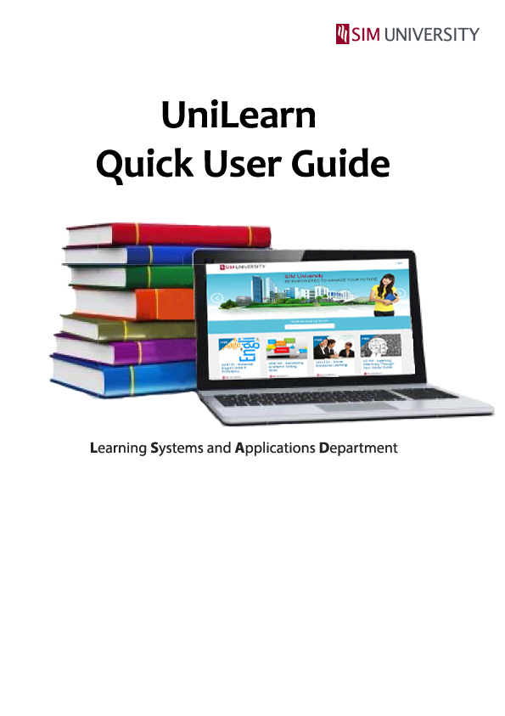

1. What is UniLearn? 1

2. Accessing UniLearn 1

3. Change Password 4

4. Technical Support 8

# What is UniLearn?

UniLearn is SIM University’s full online learning platform. It is one of the several channels for learning at UniSIM. UniLearn is created for students who seek flexibility in learning and offers opportunities to anyone for lifelong learning.

# Accessing UniLearn

To access UniLearn:-

**1**

Navigate to <http://unilearn.edu.sg> via Google Chrome browser.

**2**

Click on “**Login**”.

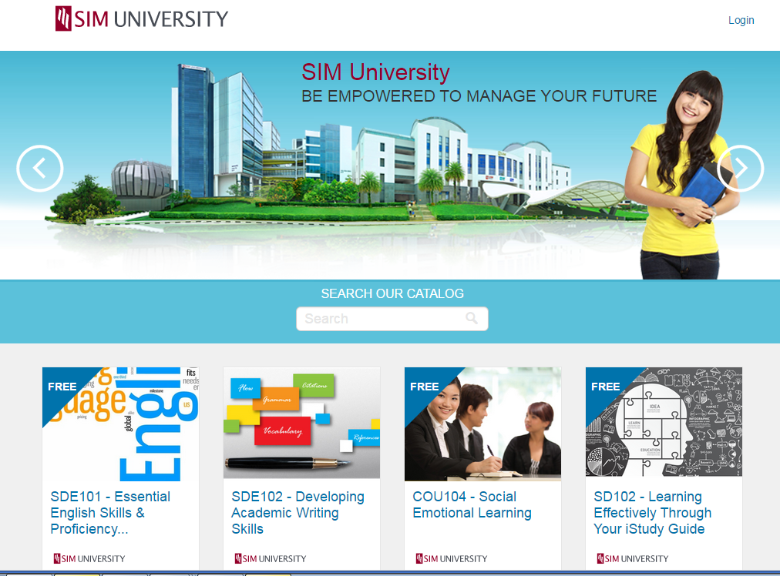

**2**

**3**

To log in, use the “**Login credentials**” provided to you via email.

**4**

Click on “**Log In**”.

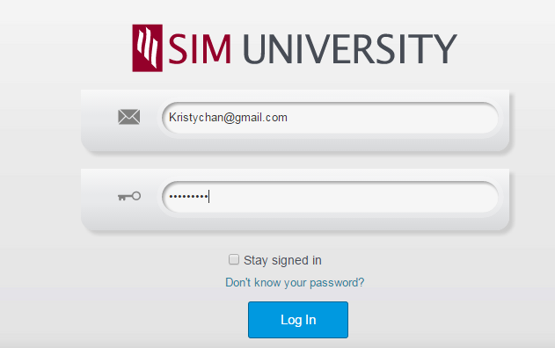

**3**

**4**

Upon successful login, you will be directed to the Dashboard. The Dashboard lists the courses that you are enrolled in.

**5**

Click on “**Begin Course**” to proceed.

**6**

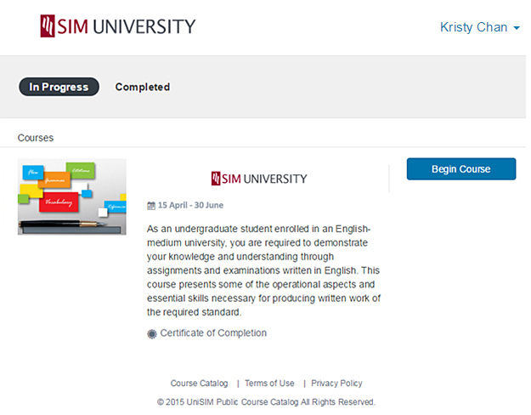

**5**

**6**

1. Change Password

To change password:-

**1**

Click on “**Settings**”.

**1**

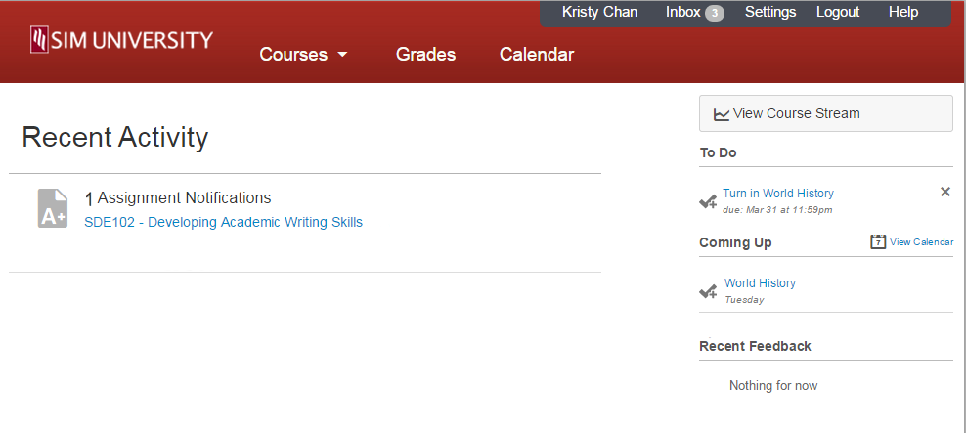

**2**

On the right panel, click on “**Edit Settings**”.

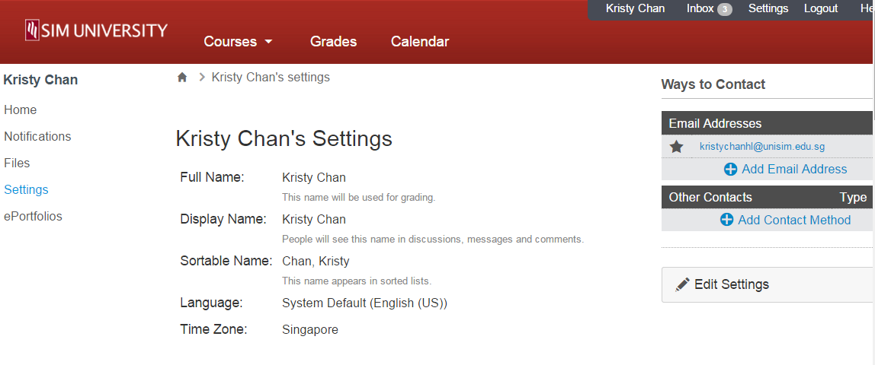

**2**

**3**

Under ‘**Password**”, tick the checkbox to change password.

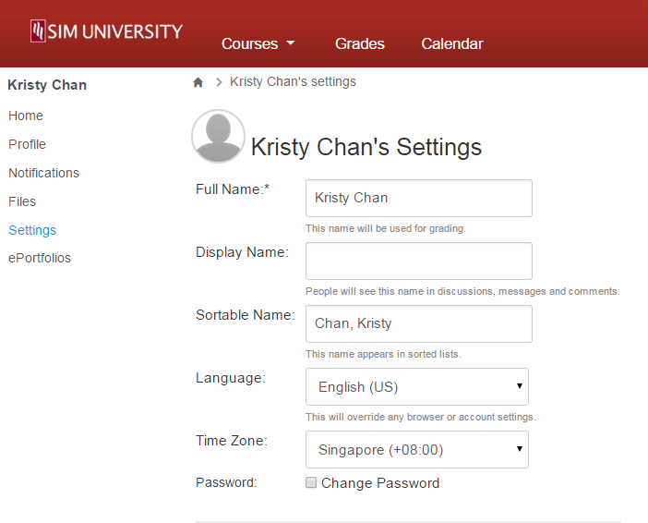

**3**

**4**

Under the ‘**Old Password**’field, enter in the old password provided to you via email.

**5**

Under the ‘**New Password’** field, enter in your desired password.

**6**

Under the ‘**Confirm Password**’ field, re-enter in the same password as entered in the “New Password” field.

**7**

Click on “**Update Settings**” to proceed.

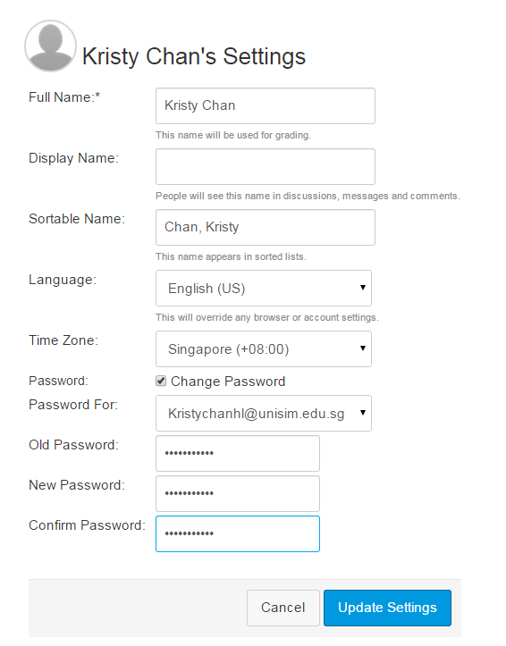

**7**

**6**

**5**

**4**

**8**

To access back to your course, click on the desired course. In this example, we will be using “**SDE102- Developing Academic Writing Skills**”.

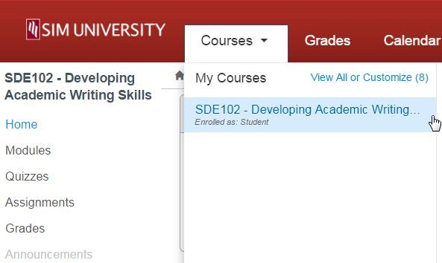

**8**

# Technical Support

How do I contact Technical Support?

* Call 6248-9111 (Press Option 1, follow by option 2)

**Operating Hours**

8.30am to 7.30pm (Mon - Fri)

9.00am to 1.00pm (Sat)

* Email: [catalog@unisim.edu.sg](mailto:catalog@unisim.edu.sg)