**You’re One in a Chameleon**

1. The linked article describes what is likely a chemotropic bacterium that can survive in the high-pressure, low-oxygen deep-sea environment. These bacteria are autotrophs, producing energy from the H2 in water that the host is then able to consume. There is not much detail on what the bacteria get out of this, but one possibility is that the gills of the host mussels provide an environment that is easier to anchor onto, and more secure from external currents. This appears to be a mutualistic relationship, with the mussels receiving energy, and the bacteria receiving a home. If this relationship were to break down, the likely result is that the host creatures would become more susceptible to variations in the gaseous output of the geothermal vents, as they would now be limited to the energy produced by sulfur eating chemotrophs.
2. Green beans are capable of developing a symbiotic relationship with nitrogen fixing bacteria known as rhizobia. This is a mutualistic relationship as these bacteria provide the main source of N2 in agriculture, and in turn, the plants provide a secure home in the form of nodules on the plant’s roots. The break down of this relationship would be potential catastrophic for humans, as N2 availability is behind only water scarcity in its effects on crop yields. This would result in an enormous drop in agricultural output, and a correspondingly huge increase in demand for fossil fuel based artificial fertilizers.
3. Termites benefit from a relationship with cellulose digesting eukaryotes called protozoa, and these protozoa in turn have an endosymbiotic relationship with an anaerobic spirochete bacterium which produces the cellulase enzyme needed to digest the cellulose. This is another mutualistic relationship, without the protozoa and its endosymbiotic bacteria, the termites would not be able to digest their main source of food, and the termites also mechanically break down the wood into a form that the smaller microbes can digest. On the small scale, this relationship breaking down would result in the host termite starving as it is unable to derive energy from its primary food source. At the large scale, cellulose is largely resistant to decomposition, and termites play an important role in the decomposition of trees and other cellulose heavy organisms.
4. 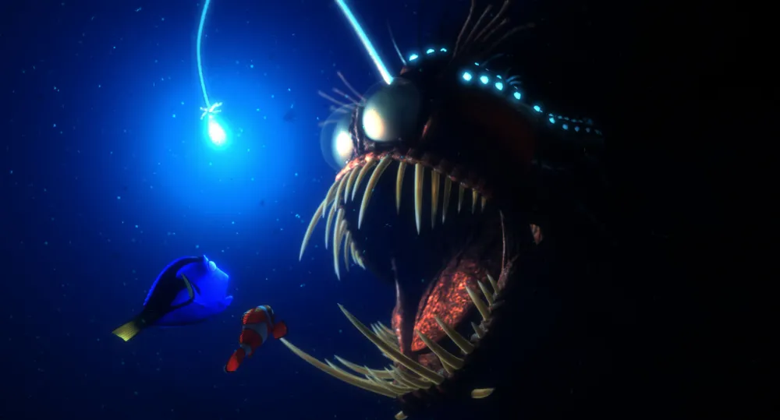The bioluminescence in angler fish is produced by a bacteria called photobacterium. This is another case of mutualism, and the photobacterium help lure prey to the angler fish, and in return, the angler fish provides protection and nutrients to the bacteria. Without this relationship Marlin would never have discovered where his disabled son was taken to.

Additionally, a reduction in this predator’s ability to hunt would have numerous repercussions in its ecosystem. As angler fish mostly feed on small deep fish, the population of these fish would increase. This could result in the crowding out of other species which they compete against.

1. Sponges have symbiotic relationships with a wide variety of both prokaryotic and eukaryotic organisms. One of these relationships is with the standard blue-green algae. This is another mutualistic relationship, as the algae provide oxygen to the sponge, and the sponge provides protection and a home to the algae. Sponges are an important part of coral ecosystems, serving as filters and able to process various minerals due to the number of organisms that they host. The loss of these relationships would have a large detrimental effect on diversity in the ecosystems.

