**Taking a Walk on the Wild Side**

Location of expedition: Swampy area near the walking trail around my apartment complex in northern Louisiana.

1. Fungi: Pear-Shaped Puffball, found growing on a damp, probably rotting, log.
2. 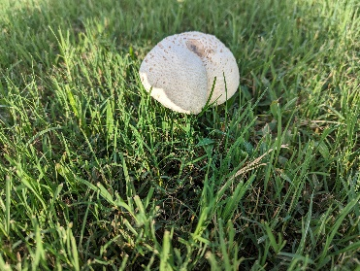Fungi: Common white cap mushroom, found in the grass, close to where I narrowly avoided some dog poop a week ago.
3. 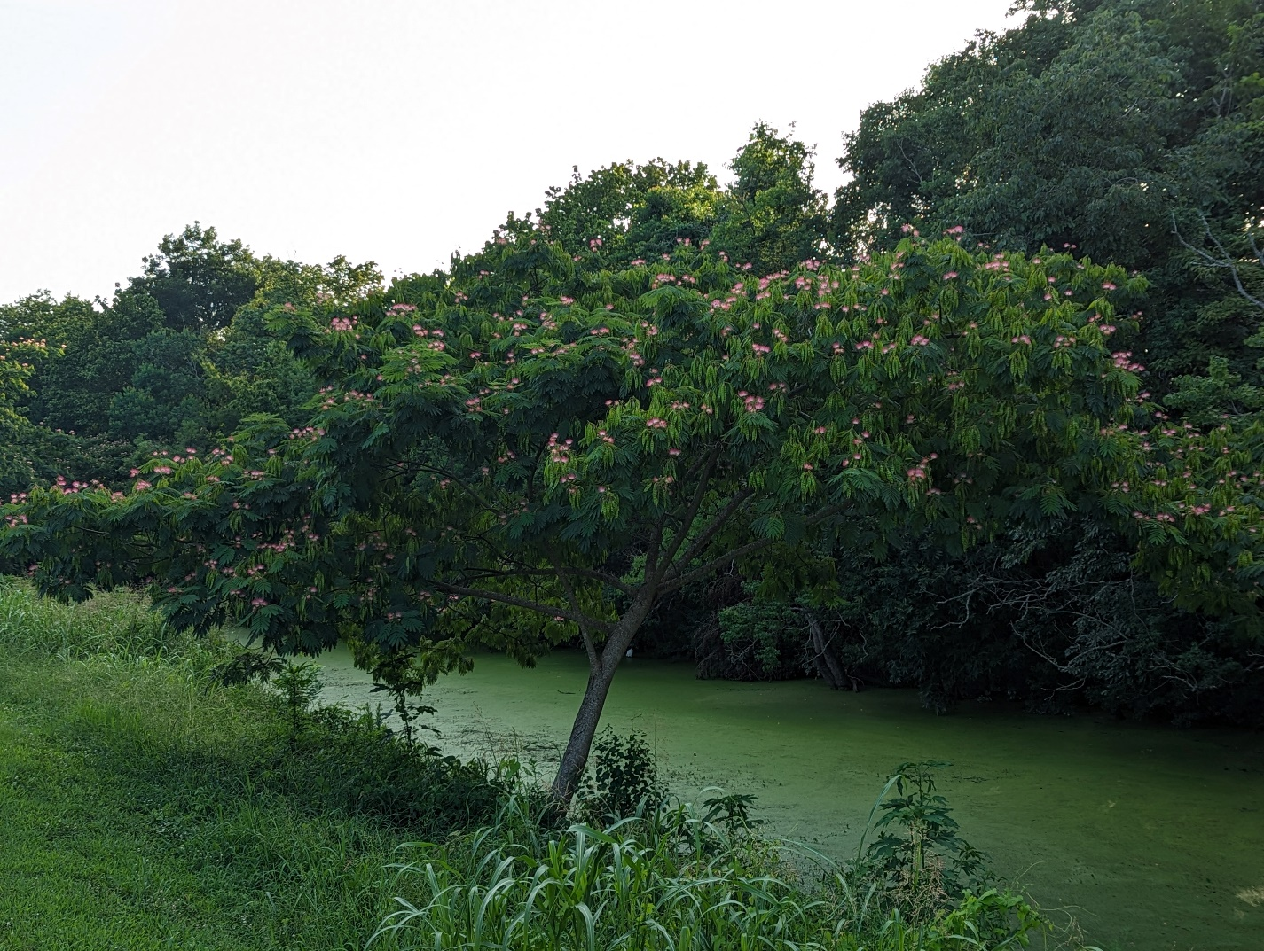Plantae, Angiosperm: Persian Silk Tree, found near our dog park in full bloom.
4. Plantae, Angiosperm: Some kind of oak tree (possibly white), found during the chlorophyll experiment trapped in growing area in the parking lot.
5. Plantae, Fern: Green fern whose leaves look oddly similar to cilantro, found peeking out of the swampy area behind the apartment complex.
6. 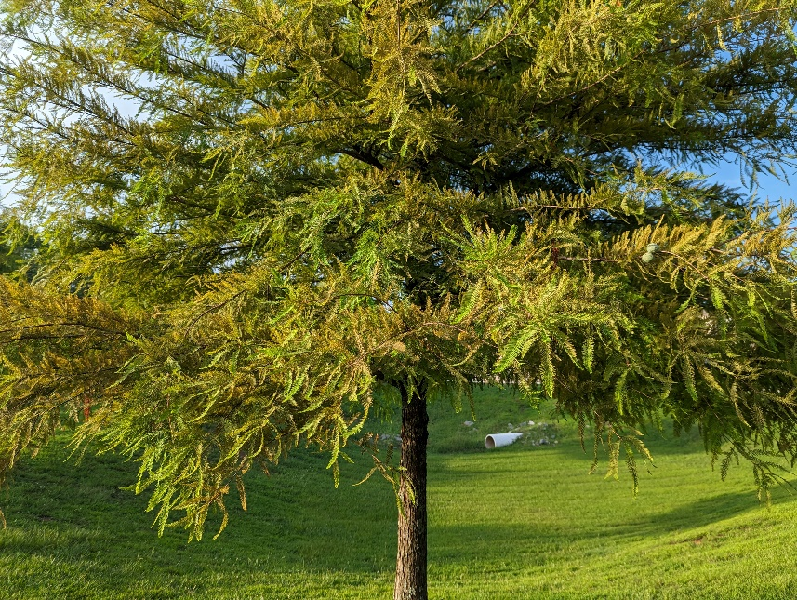Plantae, Gymnosperm: Some sort of pine tree with needles that show bilateral symmetry, found along the walking trail near the dog park.
7. Animalia, Arthropod: Moderately sized brownish jerk of a spider who keeps using my car as an anchoring point for its webs (I know he’s just trying to make a living but come on man…).
8. Animalia, Arthropod: House fly, found repeatedly flying near my dinner. Note: local house flies seem to be particularly aggressive.
9. Animalia, Annelid: Common earth worm, found littered on the sidewalk after any major rainstorm.
10. Animalia, Amphibian: 8-inch wide greenish-brownish turtle that lives in the apartment’s water feature with their family (they’re very skittish).
11. 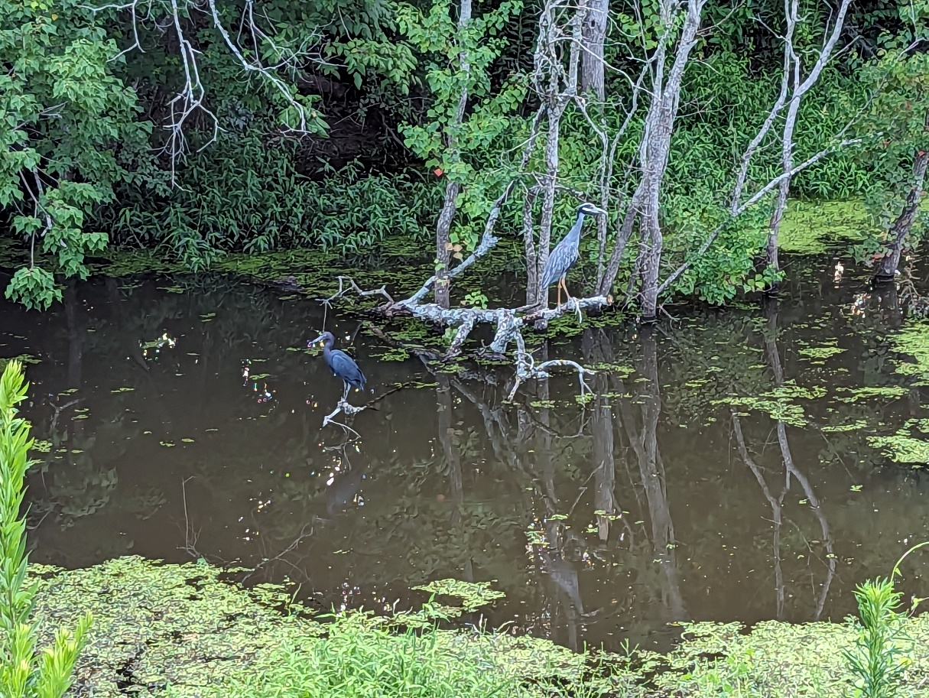Animalia, Bird: Heron of some kind (I think, blueish feathers and hangs out near the water), found chilling on a branch above the swampy water with another bird (the one on the right).
12. Animalia, Fish: Light colored, 12-14 inch long (I swear it was THIS big!) fish that lives with the turtles in the apartment water feature. Living definition of “big fish, little pond”.

Key:

Right = yes

Left = no

