**Doing Their Duty**

1. 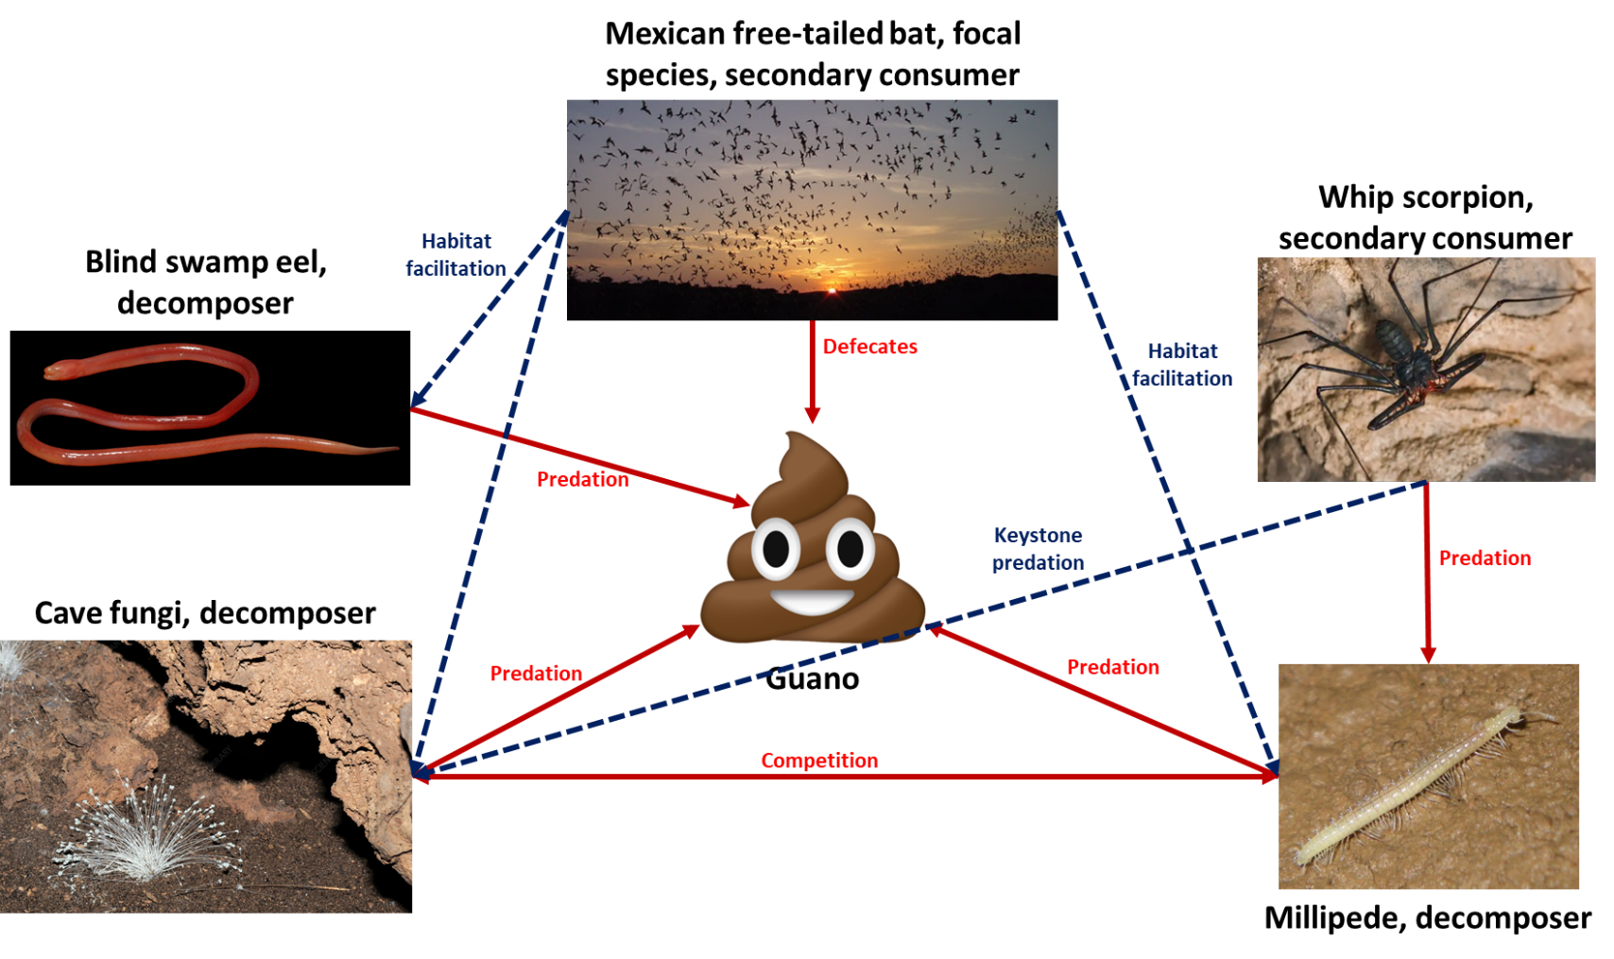
2. In caves, resources need to be brought into the system from the outside world. In this hypothetical cave ecosystem, that function is performed by the Mexican free-tailed bat, a bat that is common throughout Mexico and southern US. These bats go out into the world, prey on insects, and eventually return to the cave. Then the most important piece of this ecosystem occurs, the bats poop. A lot. Every other species in this ecosystem is reliant on this bat guano. The swamp eel, cave fungi, and the millipede all get their energy from the guano. This means that the bat has a positive, indirect effect on these decomposers. Additionally, the whip scorpion feeds on the millipede. This has the positive indirect effect of reducing the competition that the fungi face for the available guano.
3. A cave is a unique, isolated environment, so we will imagine that the invasive herbivorous insect has invaded the bats preferred hunting grounds. In the short-term, the effect that this species will have depends on how difficult it is for the bats to prey on the invaders in comparison to their existing food sources. If this short-term increase results in more food being available for the bats, this in turn would result in an increase in the bat population. In the long-term, the effects will depend on whether the invasive species is able to be limited by ecosystem predators or other effects. If they cannot be limited, they will eventually overeat the available producers, possibly resulting in the collapse of the ecosystem.
4. If the new invasive species results in more bat food, the quantity of guano would increase. This increase would result in an increase in the populations of the various decomposers that feed on the guano. In addition, the population of the whip scorpions would also increase, as the population of their prey increases. In the long-term, if the invasive species eventually wipes out the available producers, the bats will either die off or move to a different cave. In this case, the cave ecosystem would no longer have energy entering the system, and the other existing species would die off.
5. With caves being such as isolated environment, any effects on humans would likely be both small and indirect. The main effect may come from the quantity of guano that the bats produce, and if it gets transferred outside of the cave system via underground aquafers and other water flows. Guano, at least for a short period of time, was a critical fertilizer for human agriculture. It is likely guano that mixes with water impacts surrounding ecosystems in similar ways. In this situation, if the bat population and the amount of guano increases, ecosystems downstream of the cave system may have access to an increased amount of natural fertilizer, increasing the growth of producer species and enriching the surrounding environments, human or otherwise. If the bats die off or are forced to relocated, this fertilizer stream will slow and eventually stop, harming the surrounding systems. The overall impact on humans will mostly depend on the interactions between humans and the surrounding ecosystems.
6. The first direct affect would be a reduction in the wolf population. Another direct effect would come from habitat disruption in the areas where the hunters roam. A reduced wolf population would have a positive, indirect effect on the wolf prey species, increasing their numbers. An additional indirect effect results from this population increase, where the populations of producer species that the wolf prey species feed on would decrease due to the increase in the number of herbivores in the environment. The main factor to consider before implementing this would be ecosystem balance. If after careful analysis it is determined that the wolf population has brought the population numbers of their prey species close to dangerously low levels, it may be beneficial to implement. Decisions like this tend to have unintended consequences because the systems that we are seeking to influence are so complex that it is functionally impossible to accurately predict the outcome of any particular action. This complexity arises both from a nearly uncountable number of known interactions, but also the potentially enormous amounts of unknown interaction.