**Paper Chromatography**

My hypothesis for this experiment is that plant cells contain mostly chlorophyll a pigments, with a mix of other accessory pigments. The null hypothesis is that plant cells contain only a single pigment. The experiment will be run with a locally-sourced oak leaf, possibly a [white oak](https://www.lsuagcenter.com/NR/rdonlyres/BA8FFA18-B7CD-4D98-88FF-AF234D5F9ACD/18437/pub1669LeafKey.pdf), and will utilize paper chromatography to extract and separate any pigments present in the plant cells. Different pigments are chemically distinct from one another, and it is likely that they will travel a different distance from the source during this experiment. Should multiple pigments be present, we expect multiple stains on the filter paper, whereas only one stain is expected if only a single pigment is present.

There are three categories of pigments that can be found in plant cells, chlorophylls, carotenoids, and xanthophyllins. Chlorophylls are the primary pigments in plants and are the reason that we perceive them as being green. These pigments, chlorophyll a and chlorophyll b, absorb light with a wavelength below green (< ~500 nm) and light with a wavelength above green (> ~550-600 nm). Not absorbing green wavelengths is the reason they reflect green light. Carotenoids, such as ß-carotene and lycopene, absorb visible light below ~550 nm. This leaves yellow, orange, and reddish wavelengths to be reflected, giving their namesake its famous orangish color, and tomatoes their vibrant red color. The final group, xanthophyllins, consisting of zeaxanthin and lutein, absorb similar wavelengths as carotenoids, thus appearing to us in yellow, orange, and reddish colors. In general, the wavelengths that are not absorbed by the pigment are reflected outwards, and this is the color that we perceive them as being.

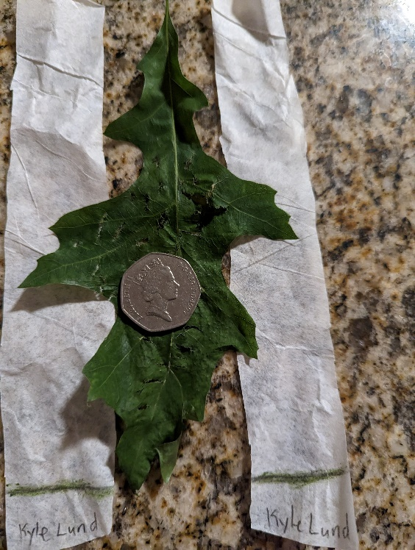Experiment photos:

Start and in glass:

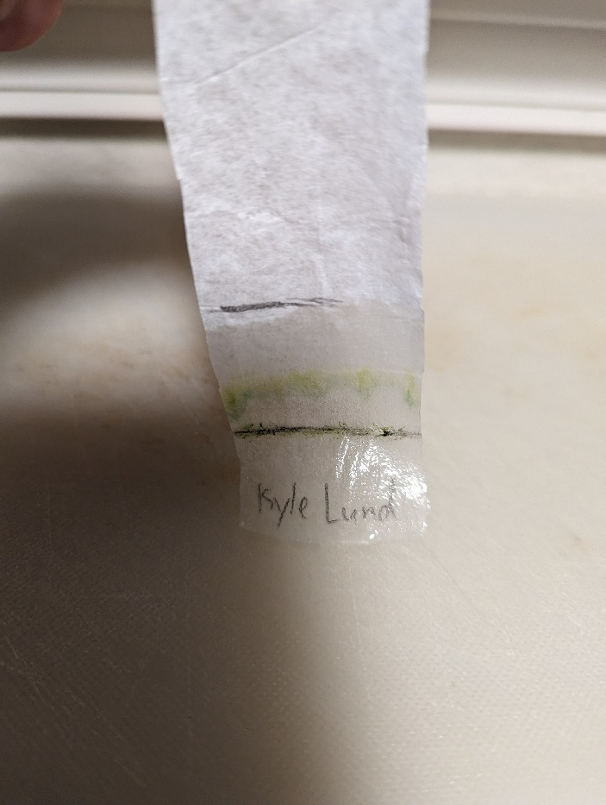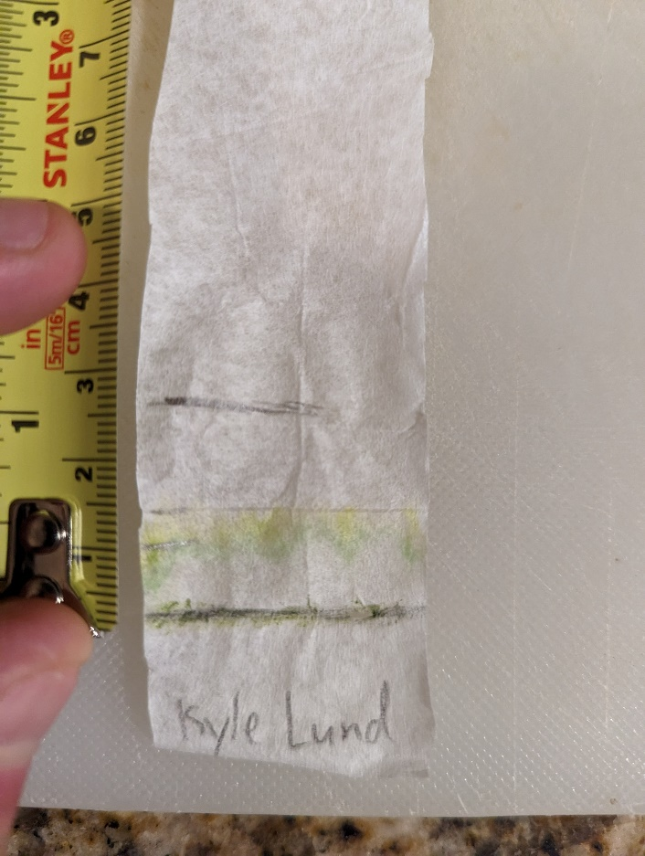Best result after soaking in 91% isopropyl alcohol for 30 minutes:

|  |  |  |
| --- | --- | --- |
|  | Distance Traveled | Ratio |
| Alcohol | 2.7 cm | N/A |
| Chlorophyll a | 1.1 cm | 0.41 |
| Lutein | 1.6 cm | 0.59 |

The chromatography resulted in the separation of two different pigments. The ratios for these were 0.41 for the green pigment, and 0.59 for the yellow pigment. Based on the colors and the relative travel distance, I identified the green pigment as chlorophyll a and the yellow pigment as lutein.

Based on the results of this experiment, I would reject the null hypothesis. The results of the experiment clearly show that while chlorophyll a comprises the bulk of the sample’s pigment, a noticeable amount of lutein was also present in the leaves of this particular tree.

Pigment movement in this experiment should be governed by a combination of how soluble the pigment is in the alcoholic solution and by their molecular weights. Less soluble and heavier pigments like the various chlorophylls do not move as far as more soluble, lighter pigments such as carotene and lutein.

If growing a plant in a green house, the optimal wavelength of light to be emitted would match the peak light absorption wavelength for the plant or plants that are being grown. For most plants, that would correspond to the peak of chlorophyll a at around 430 nm. A light source that emits lights between 430 and 500 nm would cover the peak absorption wavelengths for all pigments discussed and could result in better performance than that light at precisely 430 nm.

In autumn, when leaves turn from green to various shades of yellow and red, it would make sense that the chlorophylls are the first pigments to be broken down. As these pigments break down, light absorption and reflection wavelengths become dominated by the remaining accessory pigments, mainly carotenoids and xanthophyllins. This results in the leaves reflecting wavelengths associated with these pigments, mainly yellow, orange, and reddish colors, matching what is seen during the fall.