1. Note: It’s unclear from the data what “Size” means.   
   If “Size” is the number of requests, the answer is 4935  
   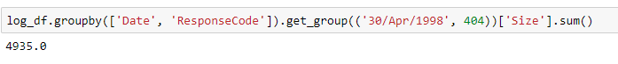  
     
   If size is something else (like the number of bytes of an individual request) the answer is 17  
   A screenshot of a computer code

   Description automatically generated
2. A screenshot of a graph

   Description automatically generated
3. A screenshot of a computer

   Description automatically generated  
     
   A screen shot of a computer

   Description automatically generated  
     
     
   A screenshot of a graph

   Description automatically generated  
     
   A screenshot of a computer

   Description automatically generated  
     
   A screenshot of a computer

   Description automatically generated  
     
   A screen shot of a computer

   Description automatically generated  
     
   