Question 1

Chen’s

Note: I couldn’t figure out how to make the double line that represents total participation. To make up for that, here’s a list of the relationships which would have total participation:

* Every Appointment is attended to by both a doctor and a patient
* Every patient has a medical record, and each medical record is about a specific patient
* Every nurse and every doctor belong to a department
* Every prescription is derived from a medical record

Crow’s Foot

Question 2

Chen’s

As before, here’s the total participation lists:

* Each inspection is for one and only one bicycle
* Each rental is for one and only one bicycle (this is an assumption, would change if group rentals are involved) and is created by one and only one user
* Each payment is done by one and only one user
* Each feedback is for one and only one bicycle and is provided by one and only one user

Crow’s Foot

Question 3

1. BankBranch is a weak entity set because the BranchNo attribute does not uniquely identify a member of this set. For example, Bank of America and Chase could both have branches with a BranchNo of 1. Only by the combination of the bank and the BranchNo can each branch be uniquely identified.
2. Each bank branch belongs to a bank and each bank has bank branches. The double line represents total participation and is not optional for the line from BankBranch towards Bank. The Bank to BankBranch line also represents a total participation, and this one is optional as Bank is strong entity set (also, it is theoretically possible for a bank that was just created or an online only bank to not have any branches).
3. Has (Customer – has – Account):  
   - Each account is associated with 1:n customers. The minimum being one is due to the total participation lines between the Account entity and the has relationship.  
   - Each customer has 0:m accounts, as indicated by the “m” and the single line.  
     
   ManagesA (Account – ManagesA – BankBranch):  
   - Each account is managed by one and only one bank branch. This is indicated by the “1” between ManagesA and BankBranch. Total participation is also indicated by the double lines.  
   - Each BankBranch manages between 0:n accounts, as indicated by the “n” and the single line.  
     
   Takes (Customer – Takes – Loan):  
   - Each customer has between 0:m loans, as indicated by the “m” and the single line.  
   - Each loan is takes on by between 1:n customers, as indicated by the “n” and the double lines for total participation.  
     
   ManagesB (Loan – ManagesB – BankBranch):  
   - Each BankBranch manages between 0:n loans, as indicated by the “n”.  
   - Each Loan is managed by one and only one bank branch. This is indicated by the “1”. Total participation is also indicated by the double lines.  
     
   BelongsTo (BankBranch – BelongsTo – Bank):  
   - Each BankBranch belongs to one and only one bank branch. This is indicated by the “1”. Total participation is also indicated by the double lines.  
   - Each Bank owns between 1:n BankBranches as indicated by the n, total participation is indicated by the double lines.
4. 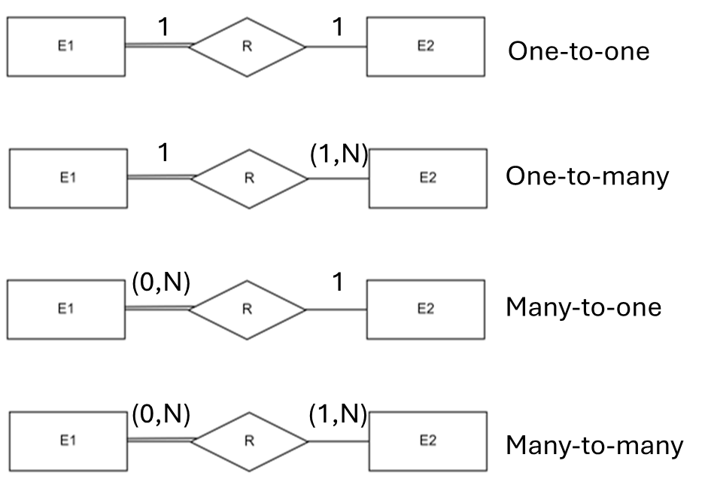

Question 4, Part A  
Task 1)

A composite key with OrderNumber and OrderLineNumber was selected as the primary key. OrderNumber was chosen as the Kaggle documentation states: “This column represents the unique identification number assigned to each order”. OrderLineNumber was combined with this because based off of the insert commands each tuple corresponds to a line number on a specific order. So both of these are needed in combination to create a unique key.

Task 2)

View of table

Selecting all from table

Task 3)

Task 4)

B)

With the small amount of data (both in terms of tuples and attributes) present in the table, the best overview of the data is gained simply by using a SELECT \* statement and viewing the entirety of the table. If there were more attributes present, limiting the attribute selection to only the essential information would have been beneficial. If there were more tuples present, it would have been beneficial to group the data in some way. A later question deals with summary statistics such as average, max, and min, so a different option would be to use GROUP BY on the OrderNo and consolidate the data for each order.

C)

D)

E)

F)

G)

H)

I)

J)

