For all test cases I utilized the IO based catch tests as specified in the readme.md from project 1

Test Case 1: g++ -std=c++14 -Werror -Wuninitialized -o build/test_io src/*.cpp && build/test_io < test-io/input-files/1.txt > test-io/output-files/1.txt && diff -w test-io/expected-output-files/1.txt test-io/output-files/1.txt

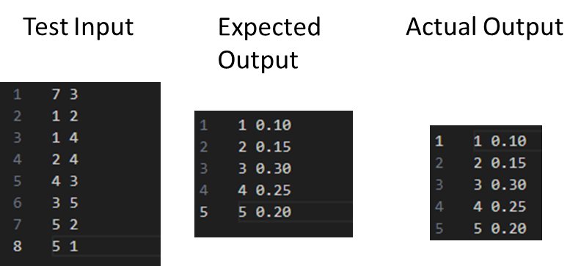

Test Case 2: g++ -std=c++14 -Werror -Wuninitialized -o build/test_io src/*.cpp && build/test_io < test-io/input-files/2.txt > test-io/output-files/2.txt && diff -w test-io/expected-output-files/2.txt test-io/output-files/2.txt

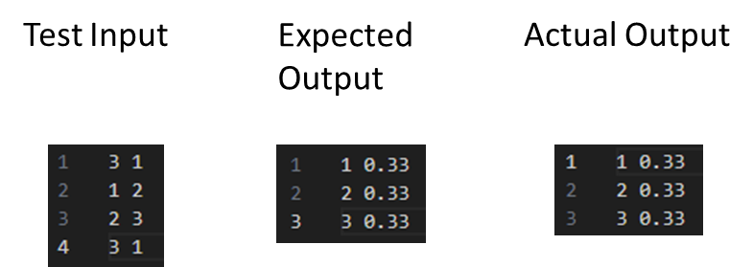

Test Case 3: g++ -std=c++14 -Werror -Wuninitialized -o build/test_io src/*.cpp && build/test_io < test-io/input-files/3.txt > test-io/output-files/3.txt && diff -w test-io/expected-output-files/3.txt test-io/output-files/3.txt

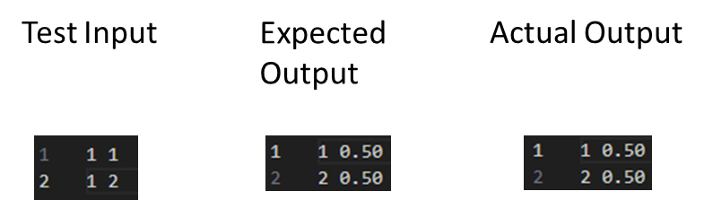

Test Case 4: g++ -std=c++14 -Werror -Wuninitialized -o build/test_io src/*.cpp && build/test_io < test-io/input-files/4.txt > test-io/output-files/4.txt && diff -w test-io/expected-output-files/4.txt test-io/output-files/4.txt

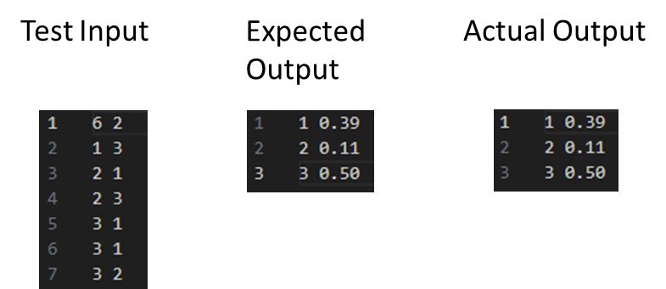

Test Case 5: g++ -std=c++14 -Werror -Wuninitialized -o build/test_io src/*.cpp && build/test_io < test-io/input-files/5.txt > test-io/output-files/5.txt && diff -w test-io/expected-output-files/5.txt test-io/output-files/5.txt

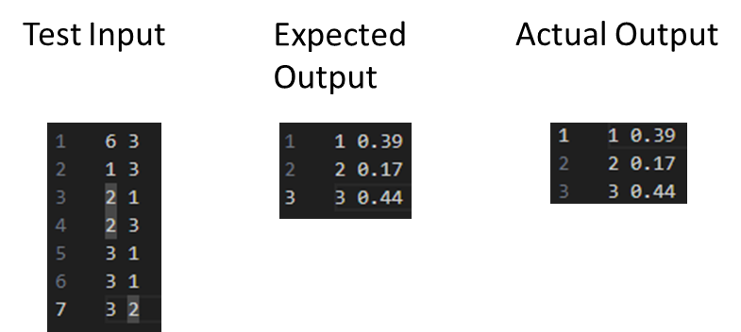

Test Case 6: g++ -std=c++14 -Werror -Wuninitialized -o build/test_io src/*.cpp && build/test_io < test-io/input-files/6.txt > test-io/output-files/6.txt && diff -w test-io/expected-output-files/6.txt test-io/output-files/6.txt

