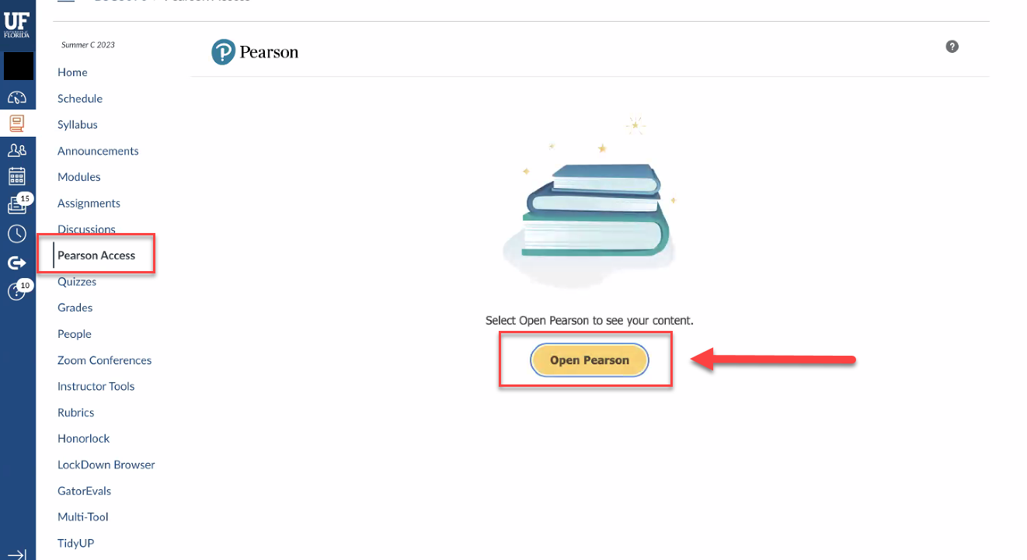

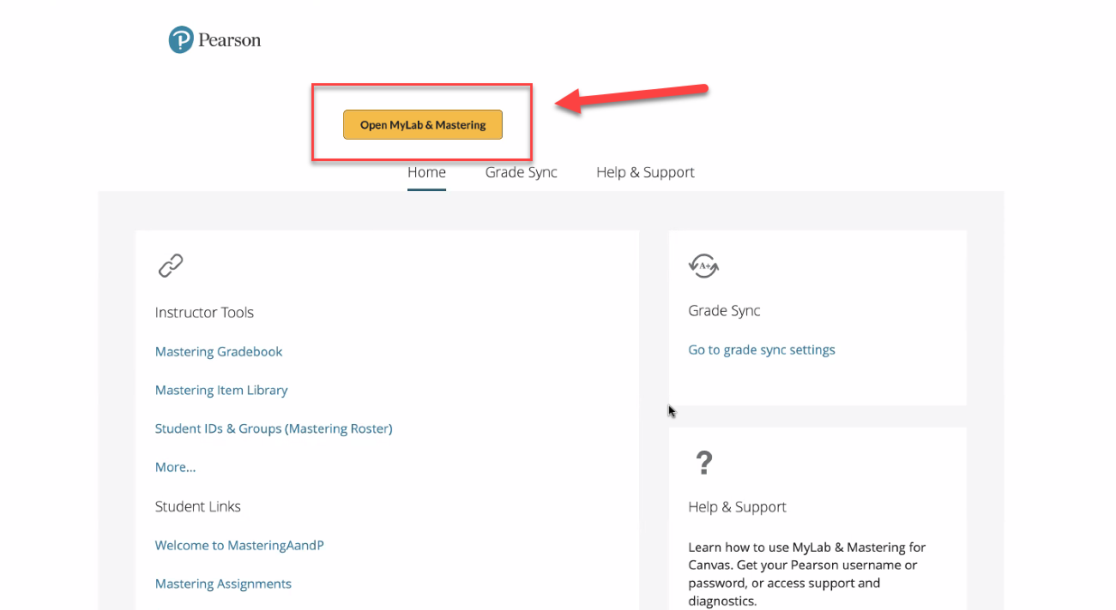

Agree to the User Agreement, by clicking “I Agree” at the bottom of the page.

Enter the **access code** provided by UF when you opted into the course fee Click Next.

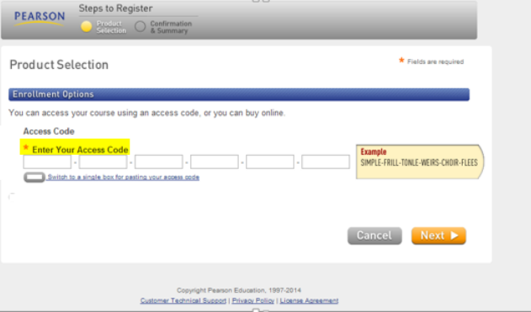

Once you have entered your access code, you will receive the confirmation below that you have successfully subscribed to your MyLab. Click Return to Course.

***NOTE: If you are having trouble signing into your Pearson account, it may be that a previous account was in a different system. You can always create a new username that can still be tied to the same email address. If you create a new username and get a popup saying “You may already have an account” just close the popup and continue to register with the new username. At this point you may begin work in you course. Please note, if you encounter a blank screen when attempting to open your MyLab or Mastering course, you may need to allow Pop-ups from the MyLab site if your browser isn’t already set to do so. If you are having technical difficulties with the Pearson MyLab or Mastering products, contact Pearson technical support at https://support.pearson.com/getsupport/s/contactsuppor