University of Florida
An Equitable Future
Exploring Post-Scarcity, Demographic Challenges, and Authoritarian Solutions
Kyle Lund, 29501039
7-9-2025

Position Statement
Achieving global equity, defined as equality of outcomes, requires a transformative approach that challenges existing economic and political systems. While welfare states provide some level of redistribution, they face significant demographic and financial challenges that threaten their sustainability. Post-scarcity automation offers a promising solution, but its success depends on overcoming entrenched political and economic interests. Authoritarian communism, though theoretically focused on equity, fails by disrupting the natural incentive structures of work and requiring forceful enforcement. A more equitable world will likely require a combination of strategies, integrating elements of welfare states, technological advancements, and redistributive models, while addressing their inherent limitations to create a sustainable and fair global system.

Introduction
The global economy is characterized by a core-periphery relationship, where industrialized, wealthy nations dominate and shape the economic destinies of poorer, less developed countries. This imbalance arises largely from differences in productivity between the two regions. Core nations have higher levels of technological advancement and skilled labor, which results in capital accumulation and enables them to produce goods and services more efficiently. In contrast, peripheral nations tend to have lower productivity, often relying on resource extraction or low-wage manufacturing to drive their economies. These disparities create a vicious cycle where the core regions maintain economic dominance, while peripheral countries struggle to achieve similar levels of development and economic stability.
Despite this stark inequality, the question remains: Can a more equitable world be achieved in practice? As the global community confronts the challenges of technological advancement, demographic shifts, several potential solutions are emerging. This essay explores three distinct approaches to increasing equity.
The first option are welfare states, nations which utilize wealth redistribution to provide social services like universal healthcare, education, and pensions. This option offers a more gradual movement toward equity within existing political frameworks. However, demographic challenges such as aging populations, declining birth rates, and the rising dependency ratio pose significant threats to the sustainability of welfare states. The potential failure of these systems could deepen existing inequalities, making it essential to explore alternatives.
Next, this essay evaluates the potential of post-scarcity automation, where technological progress, particularly in AI and robotics, could eliminate the need for labor and create an abundance of goods and services. By reducing the need for human labor, automation could allow for universal basic income (UBI) and a more equitable distribution of wealth. However, the distribution of technological benefits poses major challenges in ensuring that equity is achieved, rather than exacerbating existing wealth gaps.
Finally, communism presents the most likely solution by ensuring centralized control and redistribution of resources, effectively eliminating private property and reducing wealth disparities. While communism promises equality in outcomes, the historical implementation of such systems raises serious concerns regarding political repression, economic inefficiency, and human rights violations, making it clear that such an approach could not achieve the desired equity without sacrificing individual freedoms.
This essay will critically evaluate each of these paths to equity, considering the political, economic, and demographic obstacles that may limit their effectiveness.

Core-Periphery Dynamics in Daily Life
In our interconnected world, the core-periphery relationship manifests in various aspects of daily life, especially in the goods we consume, the technologies we rely on, and the media that shape our cultural experiences. From clothes to electronics, the products we use are often linked to extensive global commodity chains that reflect deep economic divides. The use of peripheral regions for labor and raw materials highlights the ongoing inequalities in the global economy.

Consumer Goods and Technology
The goods we consume every day are prime examples of how core-periphery dynamics play out in global trade. Many of these products are manufactured in peripheral regions where labor is cheap and environmental regulations are often lax. For instance, the smartphones we use, the fast fashion we wear, and the electronic gadgets we rely on are typically produced in countries with low wages and limited labor protections.
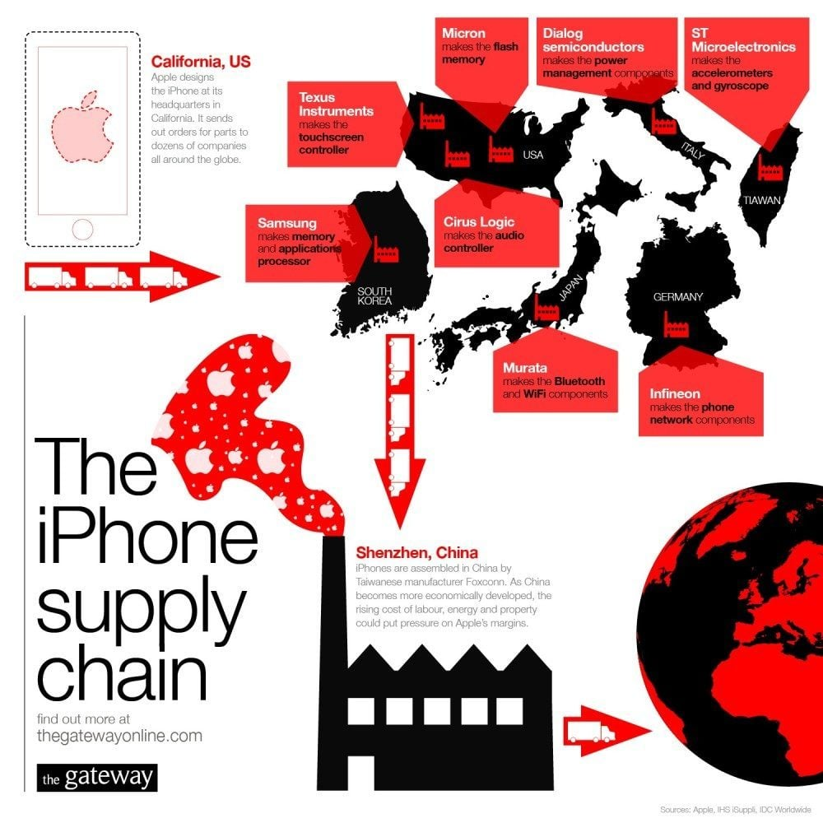
One tangible example of this are fashion brands, like Nike or H&M, who outsource the production of cheap clothing to countries like Bangladesh, Vietnam, and Indonesia, where workers earn low relative wages. Similarly, technology supply chains, like those involving companies such as Apple and Samsung, are heavily dependent on workers in countries like China and India, where labor is cheap. Companies like Foxconn, which manufacture the components of popular electronics like the iPhone, have been infamous for labor exploitation and poor working conditions. The profits from these goods flow primarily to core countries, where the companies are headquartered.
Figure 1: Apple Supply Chain. Source: PAT Research
The image on the previous page illustrates the global supply chain behind the production of an iPhone, highlighting the relationship between core and peripheral regions. Apple, headquartered in California (core), designs the iPhone and coordinates production with various companies around the world. Key components are sourced from core countries like the US (Texas Instruments, Micron), Germany, and Taiwan, while peripheral regions, such as China in this example, provide cheap labor for assembly. This mirrors the core-periphery relationship, where high value-add activities remain concentrated in the core, while the periphery contributes through cheap labor and resource extraction.

Raw Materials and Energy
Peripheral nations are also vital suppliers of raw materials and energy that fuel the industrialization of core nations. Extractive industries are often concentrated in the global South. These materials are then transported to the core nations, where they are processed into finished goods or used in industrial production. For instance, oil extracted from countries like Nigeria, or minerals mined in the Democratic Republic of Congo (such as cobalt, used in electronics), are crucial to powering the industries of core nations. Yet, the wealth generated from these resources often stays in the hands of multinational corporations or corrupt governments, leaving local communities in poverty.
In an effort to offer the lowest price, these resource-rich countries often perpetuate a cycle of environmental degradation, where deforestation, pollution, and loss of biodiversity are the unfortunate consequences of resource extraction. Meanwhile, core countries enjoy the benefits of cheap energy and raw materials without bearing the environmental costs of their consumption.

Cultural Influence and Media
The influence of Western culture and media is another significant way in which the core-periphery dynamics manifest in daily life. Core nations, particularly the United States, exercise immense cultural power through media, entertainment, and advertising, often overshadowing the cultural expressions and values of peripheral regions. From Hollywood movies to global social media platforms like Instagram or TikTok, core nations not only dominate the global narrative but also shape the ideals and behaviors of people worldwide.
The global success of Hollywood films or the dominance of American music in international charts reflects how core nations export their cultural values, narratives, and lifestyles to the periphery. People in peripheral nations often look to Western media for aspiration, despite the fact that their own local cultures, languages, and traditions may be marginalized in the process. Advertising campaigns also reinforce values such as consumerism and individualism, which can influence global perceptions of wealth and success. This cultural hegemony reinforces the notion that core nations set the standards of what is desirable, often overshadowing local identities.
In conclusion, the core-periphery dynamics that shape daily life show how global trade, production, and culture are affected by these dynamics. Whether through consumer goods, raw materials, or cultural influence, the more productive activities undertaken by core nations result in a faster rate of growth while negative externalities, such as pollution, are pushed to the periphery. This imbalance not only manifest in the tangible products we consume but also in the social, economic, and cultural power that core nations continue to wield on the global stage. By examining these dynamics, we gain insight into the forces that shape global wealth and power distribution.

A More Equitable World
Achieving global equity requires profound systemic changes to economic, political, and social structures. The current world order has persisted for centuries, and questions around how to achieve equity, defined as equal outcomes rather than equal opportunities, remain central to debates on global justice. This section explores three potential paths toward equity: welfare states, post-scarcity automation, and communism. While each approach holds potential, all face significant barriers to successful implementation.

Welfare States
Welfare states have long been a foundational method for increasing equity in many developed nations, focusing on wealth redistribution through services like healthcare, pensions, and unemployment benefits. These systems are designed to provide citizens with a basic standard of living, ensuring access to essential services and reducing poverty. However, as many countries face demographic shifts, including aging populations and declining birth rates, welfare states are coming under increasing pressure. (European Commission, 2024)
Aging populations are a significant concern in countries like Japan, Germany, and Italy, where the proportion of elderly citizens is rising rapidly (European Commission, 2025a). In the United States, the Social Security system is facing similar challenges as the baby boomer generation retires, creating a higher demand for retirement benefits. This shift places a considerable financial burden on welfare systems, which are already struggling to maintain services. For instance, Social Security in the US relies on a pay-as-you-go system, where current workers fund the benefits of retirees. With fewer workers entering the labor force and more people drawing benefits, the system faces unsustainable financial strain. (Covered Workers and Beneficiaries — 2025 OASDI Trustees Report, n.d.)
In the EU, a similar issue arises with a shrinking workforce that is increasingly unable to support the growing number of retirees. This declining worker-to-beneficiary ratio threatens the viability of welfare systems in many European countries, as the working-age population shrinks while the dependent elderly population increases. The shift from a younger to an older demographic means that fewer individuals are contributing to social programs, placing an increasing burden on governments to fund pensions and healthcare. (European Commission, 2023)
Furthermore, declining birth rates exacerbate this issue. Many developed nations have fertility rates below replacement levels (2.1 children per woman), resulting in a shrinking youth population and fewer people entering the workforce to support an aging population. While some countries have introduced policies such as tax incentives, parental benefits, and subsidies to encourage higher birth rates, these efforts are unlikely to succeed as fertility is inversely correlated with wealth. As a result, welfare states are becoming more financially strained, facing challenges in maintaining their social contract. (European Commission, 2025)
In response, governments have attempted to implement various solutions. One common stopgap is raising the retirement age to delay the payout of pensions, but this raises its own challenges, particularly for older workers in physically demanding jobs or those who face health issues. Increasing taxes is another option. This is a valid short-term solution, though it involves increasing the per-worker burden in addition to the requirements that result from an increasing beneficiary-to-worker ration. This solution can also lead to brain drain or capital flight, further exacerbating the situation. Immigration is another potential solution to replenishing the workforce, but it comes with political resistance and concerns about integration, the erosion of the local culture, and the sustainability of public services in the face of increased demand.
Despite these adaptations, the future of welfare states is uncertain. As the beneficiary-to-worker ratio continues to increase, welfare systems face growing fiscal insolvency, which could lead to increased taxes, public debt, an inability to support those who have become dependent on these programs, and social unrest. If these systems cannot adapt to demographic shifts, they may struggle to maintain the equitable outcomes they were designed to create, ultimately deepening global inequities.

Post-Scarcity Automation as a Path to Equity
An alternative to the welfare state model is post-scarcity automation, a concept based on the idea that technological advancements, particularly in artificial intelligence (AI) and robotics, could radically alter the global economic landscape. In a post-scarcity world, automation would reduce the need for human labor in many industries, leading to a surplus of goods and services that could be distributed universally, thereby eradicating scarcity.
According to the post-scarcity theory, automation could result in abundant production with minimal labor, driving down costs and making goods more accessible to everyone. This abundance could allow for the introduction of policies like universal basic income (UBI), where individuals receive a guaranteed income regardless of their employment status, as the wealth generated by automation would sustain the economic system. The potential for reduced working hours and more leisure time could significantly improve quality of life, with people no longer tied to long hours of labor simply to meet their basic needs. (Lakeland & Lakeland, 2024)
However, the path to post-scarcity automation is fraught with challenges. While automation may seem promising, the redistribution of wealth generated by technological advances is a significant hurdle. In today’s global economy technological advancements are developed by those who will benefit from it, resulting in the profits from automation being concentrated in the hands of those who create them. In addition, the displacement of workers, particularly in peripheral regions that rely heavily on low-wage labor, could lead to widespread job loss and social unrest.
We can already see some examples today. In the manufacturing sector, automation is already replacing human labor in tasks like assembly and quality control (Rootstock Rootstock Software, 2024). In healthcare, AI-driven diagnostic tools and robotic surgeries are becoming increasingly widespread, promising more efficient and cost-effective medical care (Robotic Surgery - Mayo Clinic, n.d.). Yet, the societal impact of such automation, particularly for workers in low-wage, labor-intensive industries, remains uncertain, as the benefits of automation may not be equitably distributed.
Despite its potential, the political and economic resistance to automation is significant. Many governments and corporations benefit from the status quo, where labor remains a cheap resource for production. In this context, achieving an equitable distribution of automation's wealth would require massive political and social changes, which may be difficult to achieve in the current economic system.

Communism as a Path to Equity
Finally, communism presents another theoretical path toward equity, one that seeks to eliminate inequity through centralized control, elimination of personal freedoms and private property, and the redistribution of wealth. In a communist system, private property is abolished, and the political class controls the economy, redistributing resources in an attempt to ensure that all citizens have equal access to basic needs such as food, shelter, and healthcare.
Historically, communist regimes such as the Soviet Union and Maoist China attempted to implement this model, with no success. Under central planning, resources and industries were collectivized, and the state sought to provide for the basic needs of all citizens. However, these systems were often marked by inefficiency, corruption, and political repression. The state's centralized control of the economy led to the suppression of individual freedoms, limited political participation, mass starvation, and a lack of economic innovation. Additionally, the top-down structure of these regimes often failed to accurately reflect the needs of local populations, resulting in shortages, inefficiencies, and widespread discontent.
One of the key challenges of communism is that it undermines the incentive structure of work, which is crucial for productivity and innovation. In a system where the state guarantees basic needs regardless of individual effort, there is little motivation for people to contribute meaningfully to society. This leads to a race to the bottom, where citizens try to contribute as little as possible, knowing their needs will still be met. While communism aims for equality of outcomes, it fails to account for the fact that the system is composed of humans, who often need personal incentives to work hard, innovate, and push society forward.
One inherent challenge of communism is that it requires equity to be enforced through force, as it goes against humans' natural sense of fairness. Studies in developmental psychology reveal that even very young children have an intuitive understanding of fairness. For example, in one study with 21-month-old infants, the babies expected an experimenter to reward both individuals equally when both had contributed equally to a shared task, but when one person did all the work while the other did nothing, equal rewords displeased them (Sloane et al., 2012). These findings suggest that humans have an innate sense of fairness, and when forced to accept unequal outcomes without merit-based contribution, individuals tend to perceive the system as unjust. Communism, in its attempt to enforce equality of outcomes, disrupts this natural sense of fairness, necessitating violent enforcement to maintain compliance and suppress dissent, which ultimately undermines the incentive for individuals to work hard and contribute productively.
While communism may theoretically achieve equality of outcomes, historical examples suggest that it can also lead to gross inefficiencies, economic stagnation, and political repression. As seen in the collapse of the Soviet Union and the ongoing struggles in Cuba and North Korea, authoritarian regimes often fail to deliver the promised economic benefits and instead lead to social unrest and human rights abuses.

Solutions Summary
While there are several potential paths to achieving a more equitable world, each faces significant barriers. Welfare states, while aiming to reduce inequities, are increasingly threatened by demographic shifts and financial instability. Post-scarcity automation offers a promising vision of abundance but requires overcoming entrenched economic and political interests to ensure that the benefits are distributed equitably. Finally, communism, although focused on equity of outcomes, has historically led to economic inefficiency and political repression, raising questions about its viability as a model for achieving true equity. Achieving global equity may require a combination of these approaches, adapted to the challenges and opportunities of the 21st century.

Conclusion
Achieving a more equitable world requires profound changes to global economic, political, and social systems. While welfare states have helped increase equity in their societies, they are increasingly strained by demographic shifts like aging populations and declining birth rates. Post-scarcity automation offers a vision of abundance, but it faces challenges such as political resistance, wealth concentration, and potential job displacement. Communism, while aiming for equality of outcomes, undermines human incentives, disrupts productivity, and requires force to maintain compliance. The natural human sense of fairness resists enforced equity, making such systems difficult to sustain.
Ultimately, no single approach offers a perfect solution. Achieving equity may require a blend of these systems, addressing their weaknesses while promoting innovation, fairness, and sustainability without sacrificing individual freedoms or deepening global inequities.

Word Count: 3194

References
Covered workers and beneficiaries — 2025 OASDI Trustees report. (n.d.). https://www.ssa.gov/oact/TR/2025/lr4b3.html
European Commission. (2025, February). Fertility statistics. Eurostat. Retrieved July 9, 2025, from https://ec.europa.eu/eurostat/statistics-explained/index.php?title=Fertility_statistics
European Commission. (2025a, February). Population structure and ageing. Eurostat. Retrieved July 9, 2025, from https://ec.europa.eu/eurostat/statistics-explained/index.php?title=Population_structure_and_ageing
European Commission. (2023). The Future of Social Protection: And of the Welfare State in the EU. Retrieved July 9, 2025, from https://wecglobal.org/uploads/2023/02/EU-HLG-Social-Protection-Report.pdf
European Commission. (2024, November). Social protection statistics - social benefits. Eurostat. Retrieved July 9, 2025, from https://ec.europa.eu/eurostat/statistics-explained/index.php?title=Social_protection_statistics_-_social_benefits
Lakeland, N., & Lakeland, N. (2024, January 8). Exploring Post-Scarcity. NIESR. https://niesr.ac.uk/blog/exploring-post-scarcity
Robotic surgery - Mayo Clinic. (n.d.). https://www.mayoclinic.org/tests-procedures/robotic-surgery/about/pac-20394974
Rootstock Rootstock Software. (2024, June 30). Top Trends in Manufacturing Automation. Rootstock. Retrieved July 9, 2025, from https://www.rootstock.com/cloud-erp-blog/top-trends-in-manufacturing-automation/
Sloane, S., Baillargeon, R., & Premack, D. (2012). Do infants have a sense of fairness? Psychological Science, 23(2), 196–204. https://doi.org/10.1177/0956797611422072
The IPhone Supply Chain. (n.d.). PAT Research. Retrieved July 9, 2025, from https://www.predictiveanalyticstoday.com/iphone-supply-chain/

