Exercise 12.46
A study was done to determine whether the gender of the credit card holder was an important factor in generating proﬁt for a certain credit card company. The variables considered were income, the number of family members, and the gender of the card holder. The data are as follows:

Profit | Income | Gender | Family Members
157 | 45000 | M | 1
-181 | 55000 | M | 2
-253 | 45800 | M | 4
158 | 38000 | M | 3
75 | 75000 | M | 4
202 | 99750 | M | 4
-451 | 28000 | M | 1
146 | 39000 | M | 2
89 | 54350 | M | 1
-357 | 32500 | M | 1
522 | 36750 | F | 1
78 | 42500 | F | 3
5 | 34250 | F | 2
-177 | 36750 | F | 3
123 | 24500 | F | 2
251 | 27500 | F | 1
-56 | 18000 | F | 1
453 | 24500 | F | 1
288 | 88750 | F | 1
-104 | 19750 | F | 2

(a) Fit a linear regression model using the variables available. Based on the ﬁtted model, would the company prefer male or female customers?
(b) Would you say that income was an important factor in explaining the variability in proﬁt?
(c) Determine if the Gender * Income interaction term is significant.

Solution
To begin, we had to import the data into R, convert the Gender column to a factor, and create an LM object using the lm module. This was done with the following code:


This resulted in the summary shown below:
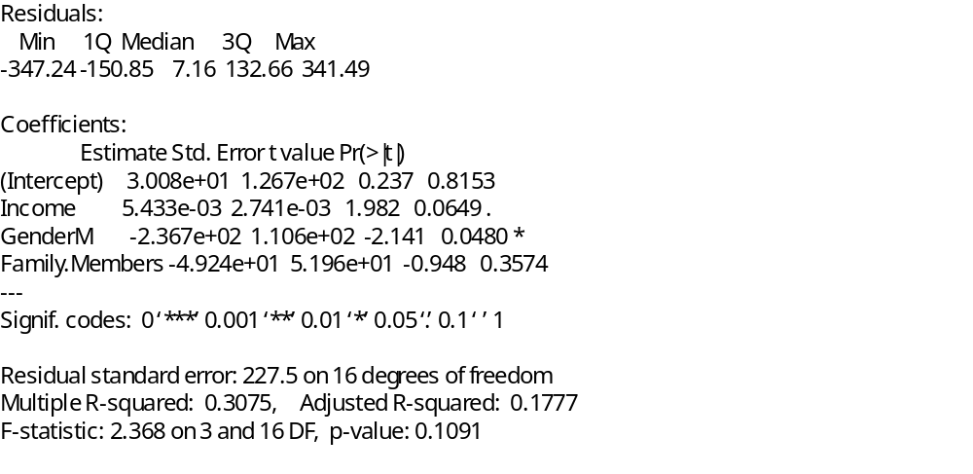
Part (a)
The factor for Gender was labeled as GenderM, signifying that males would have a 1 in this column, and females would have a 0. Additionally, the coefficient listed in the summary for Gender is negative. Combining these two, there will be a reduction in profit when the Gender column is 1, in other words, male. Based on this, the company would prefer female customers.

For further evidence (and to confirm the summary was being read correctly), predictions were performed on two hypothetical people, one male and one female, with other predictors held constant. The code and the results are shown below:

This shows that for a person with an income of $50,000 and two family members, the company would lose $33 if the customer was male but would make $203 if the customer was female.

Part (b)
From the summary, the p-value for the Income predictor in the full model is 0.0649. While not officially significant based on the definition of the p-value being less than the standard alpha value of 0.05, the best factor in this model, Gender, is only a little lower at 0.048. Based on this, we would say that Income is indeed an important factor in this model for explaining the variability in proﬁt.

Part(c)
To answer this question, we had to create a new lm object which included this new interaction. This code and the summary results are shown below:
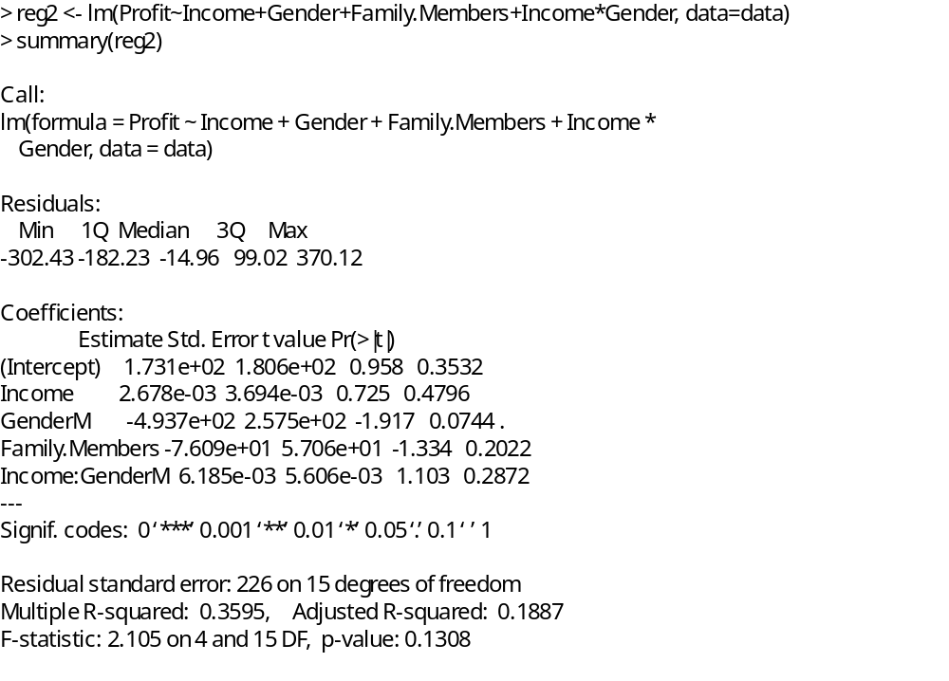
Unfortunately, in this new model, both the standard R-Squared and the adjusted R-Squared increased with the addition of this interaction term. That would indicate that adding this term to the full model is not beneficial and the term is not significant in the full model.

Having said that, this interaction on its own seems to improve the model. This is shown in the code and summary below:
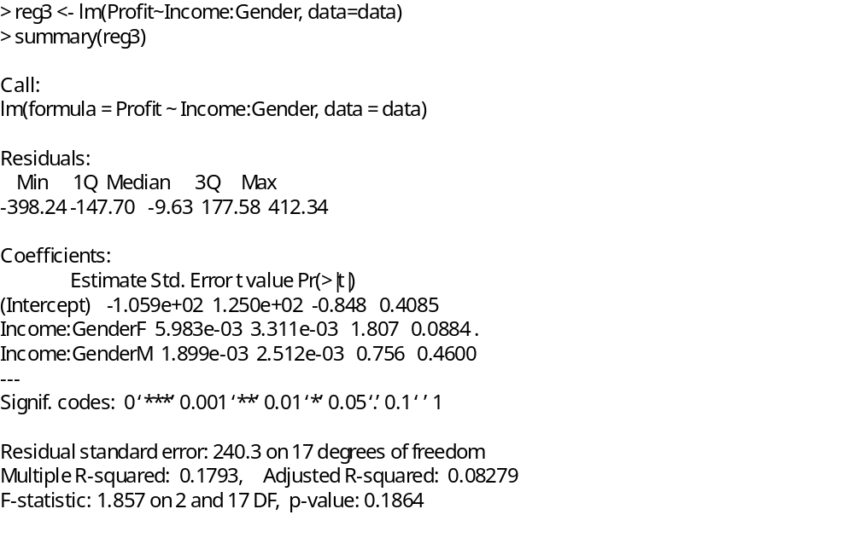
Only have predictors for Income * GenderM and Income * GenderF resulted in an adjusted R-Squared value of only 0.08279, less than half of the value that resulted from adding this interaction to the full model.

Which means, when all is said and done, the answer to this question is “it depends”. In the full model, this interaction term is not significant, but on its own it is.

Summary
In this exercise, we created models for a regression analysis with multiple factors and analyzed the results. In the first part, we concluded that the company would prefer female over male customers based on the coefficient from the regression analysis. In the second part, we analyzed the importance of a predictor, and in the final part, we included an interaction term into both the full model and its own model, and analyzed whether this term was effective or not.

