Exercise 13.6
A study measured the sorption (either absorption or adsorption) rates of three diﬀerent types of organic chemical solvents. These solvents are used to clean industrial fabricated-metal parts and are potential hazardous waste. Independent samples from each type of solvent were tested, and their sorption rates were recorded as a mole percentage. (See McClave, Dietrich, and Sincich, 1997.)
Aromatics | Chloroalkanes | Esters
1.06 | 1.58 | 0.29
0.79 | 1.45 | 0.06
0.82 | 0.57 | 0.44
0.89 | 1.16 | 0.55
1.05 | 1.12 | 0.61
0.95 | 0.91 | 0.43
0.65 | 0.83 | 0.51
1.15 | 0.43 | 0.1
1.12 |  | 0.53
 |  | 0.34
 |  | 0.06
 |  | 0.09
 |  | 0.17
 |  | 0.17
 |  | 0.6

Is there a signiﬁcant diﬀerence in the mean sorption rates for the three solvents? Use a P-value for your conclusions. Which solvent would you use? Additionally, use Levene's test too to check homogeneity of variance.

Solution
To begin, we must state the hypotheses.
$$H_{0}: μ_{1}=μ_{2}=μ_{3}$$
$$H_{A}:The means are not all equal$$
Next, data must be loaded into R in the proper format. This is accomplished with the following code:
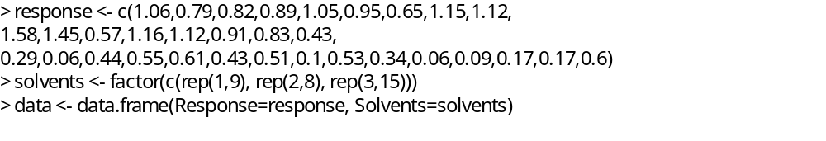
Part (a) – Levene Test
The Levene Test is used to test the null hypothesis that the variances are equal across groups, against the alternative hypothesis that the variances are not equal across groups. This is done by using the leveneTest function from the car library in R. The code and the results are shown below:
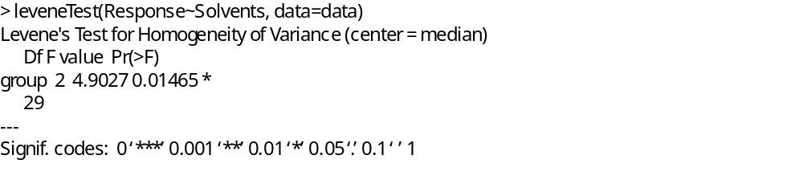
For the data provided, the p-value of 0.01465 is less than the standard level of significance of 0.05, indicating that we should reject the null hypothesis and conclude that there is sufficient evidence that the variances of the three groups are not all equal.

Part (b) – ANOVA
To test our original hypothesis, we utilize the aov function in R to run an ANOVA analysis on the provided data. The code and the results of this are shown below:
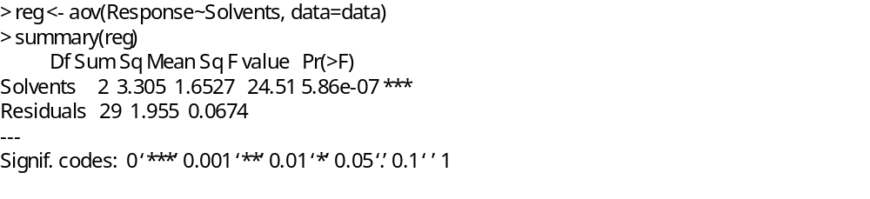
For this analysis, the test statistic of 24.51 and a p-value close to zero indicate that we should reject the null hypothesis and conclude that there is sufficient evidence that the mean sorption of the three groups are not all equal.

Part (c) – Solvent Selection
Calculating means of the three groups can be accomplished simply using excel. This resulted in the Aromatics having a mean sorption of 0.942, the Chloroalkanes have a mean of 1.006, and the Esters having a mean of 0.33. Assuming that we desire the selection of the solvent with the highest sorption rate, we would select the Chloroalkanes solvents for use.

Exercise 13.1
Six different machines are being considered for use in manufacturing rubber seals. The machines are being compared with respect to tensile strength of the product. A random sample of four seals from each machine is used to determine whether the mean tensile strength vaies from machine to machine. The following are the tensile-strength measurements in kilograms per square centimeter $×{10}^{-1}$.
Machine
1 | 2 | 3 | 4 | 5 | 6
17.5 | 16.4 | 20.3 | 14.6 | 17.5 | 18.3
16.9 | 19.2 | 15.7 | 16.7 | 19.2 | 16.2
15.8 | 17.7 | 17.8 | 20.8 | 16.5 | 17.5
18.6 | 15.4 | 18.9 | 18.9 | 20.5 | 20.1
Perform the analysis of variance at the 0.05 level of significance and indicate whether or not the mean tensile strengths differ significantly for the six machines.

Solution
Once again we start with stating the hypotheses and importing the data into R.
$$H_{0}: μ_{1}=μ_{2}=μ_{3}=μ_{4}=μ_{5}=μ_{6}$$
$$H_{A}:The means are not all equal$$
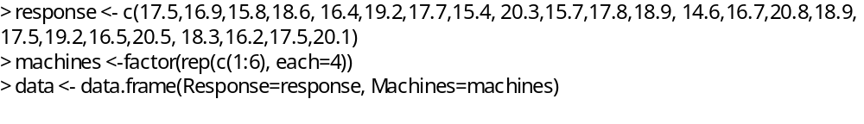
We then create the ANOVA model and run the TukeyHSD test on this model at the 0.95 level of significance as shown below:
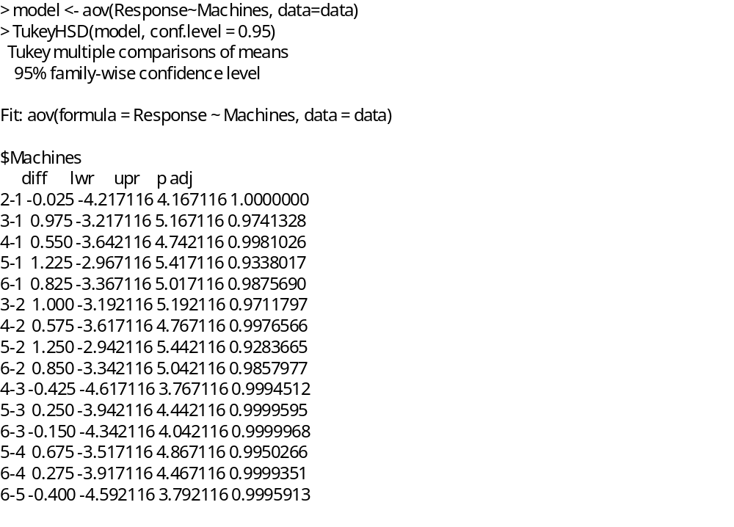
Examining the p-values of the pairwise comparisons, we find that most p-values are close to 1, and none are below 0.05. Because of this, we fail to reject the null hypothesis and conclude that the means of the six machines are not significantly different.

We can confirm this another way by examining the summary of the created model as shown below:
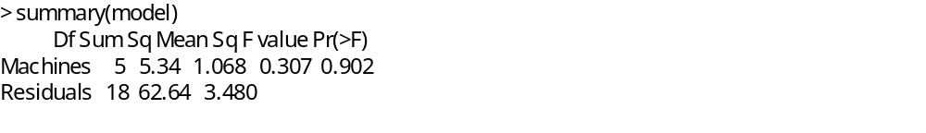
The p-value shown here (0.902) would also lead us to conclude that there is no significant difference between the six machines.

Summary
In this exercise we performed an analysis of variance using two different methods on two different datasets. In the first exercise, we performed a one-way ANOVA analysis and determined that there was a significant difference between the possible solvent and then selected the preferred one. In the second exercise, we performed pairwise comparisons using the Tukey test and determined that there was no significant difference between the means of the different machines.

