Problem
Using the datafile "mydata.csv "
- Create a scatterplot of y vs x
- Fit a simple linear regression model using y as the response and plot the regression line (with the data)
- Test whether x is a significant predictor and create a 95% CI around the slope coefficient.
- Report and interpret the coefficient of determination.
- For x=20, create a CI for E(Y|X=20).
- For x=150, can you use the model to estimate E(Y|X=150)? Discuss.
- Does the model appear to be linear with respect to x? Discuss, and if not, provide alternative model and repeat steps 1-6. HINTS:
  - Did you transform the response or the predictor only? Explain your choice. Recall that Yi∼(independent)N(β0+β1xi,σ) so transforming Y may not only impact fit (β0+β1xi), but also normality, independence, homogeneity of variance as well.
  - If a better fit such as (β0+β1xi+β2xipower ) to some power, i.e. a transformation only on the predictor addresses the issue that is preferred.
  - If you transformed the predictor as in (b), the also plot the scatterplot of y vs x and then fit the "new" updated model, as in (b).

Solution
Part (1) – Scatterplot
The data was important and a scatterplot created using the following code:

This resulted in the following scatter plot:
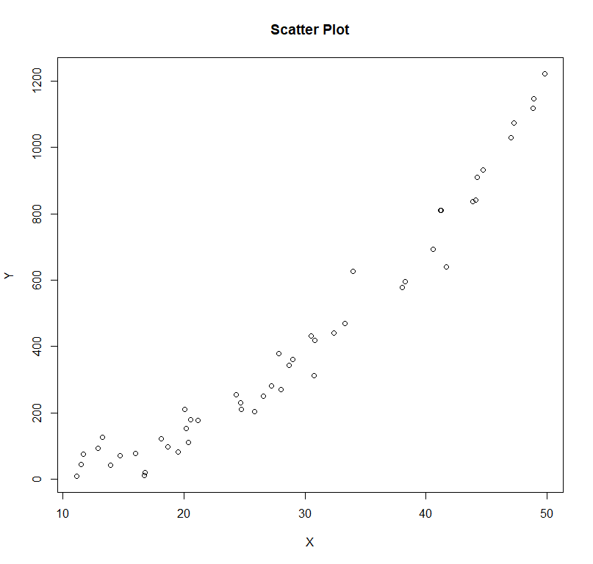
Part (2) – Model Creation
A simple linear regression model with response y and predictor x was created with the following code:
The updated scatter plot with the added linear regression line was created with the following code:

This resulted in the following chart:
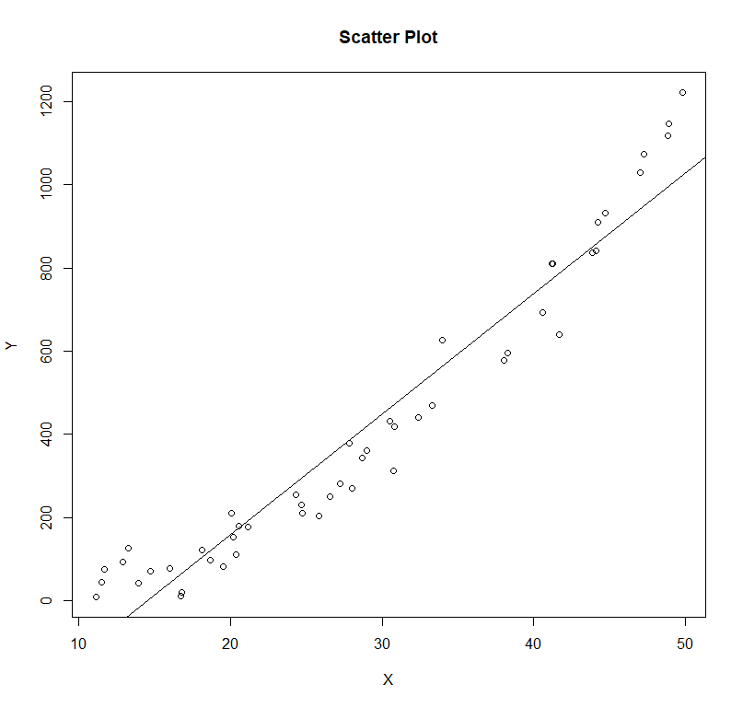
Part (3) – Significance and Confidence Interval
The significance of the predictor x can be determined from a summary of the lm object. The code and results of which are shown below:
The computed p-value for the predictor x is 2e-16, which is significant. The code for computing the confidence interval for the slope of the regression line and the results are shown below:
Therefore, the 95% confidence interval for the slope coefficient is 26.74015 to 31.20909.

Part (4) – Coefficient of Determination
The coefficient of determination, or the R-Squared value, was shown in the summary above to be 0.9354 for this model. In general, the R-Squared value ranges from 1 to -1, where 1 is a perfect positive linear correlation, -1 is a perfect negative linear correlation, and 0 is no correlation. The value of 0.9354 indicated that there is a strong positive linear correlation between the predictor x and response y.

Part (5) – Confidence Interval
To create a confidence interval for y at a specific value of x, we first confirm that the predictor value is valid, meaning the value is inside the range of the given data for the predictor. In this case, the range of x is from around 11 to around 50. Next, we create a data frame to hold the prediction data, and then use the predict.lm function, specifying that the interval will be a confidence as opposed to a prediction interval. The code for this and the results are shown below:
Based on this data, the 95% confidence interval for y at an x value of 20 is 126.2353 to 192.0172.

Part (6) – X=150
As discussed briefly in part 5, we cannot extrapolate the model past the min and max of the data for its predictors, as the model may behavior much differently in these regions. Therefore, we cannot use this model to estimate a y value for an x value of 150.

Part (7) – Linearity
While the lm object calculated a strong R-Squared value of 0.9354, visually, the model appears to be somewhat exponential. Creating a new model with just an $x^{2}$ term resulted in the following code and results for repeating the previous parts:
- 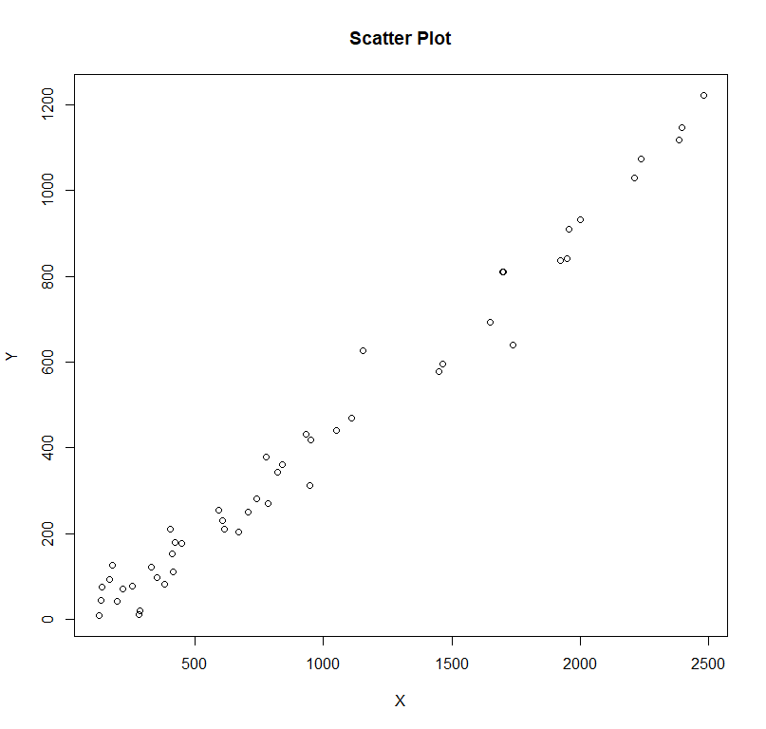
- Summary shown above, new scatter plot with regression line shown below:
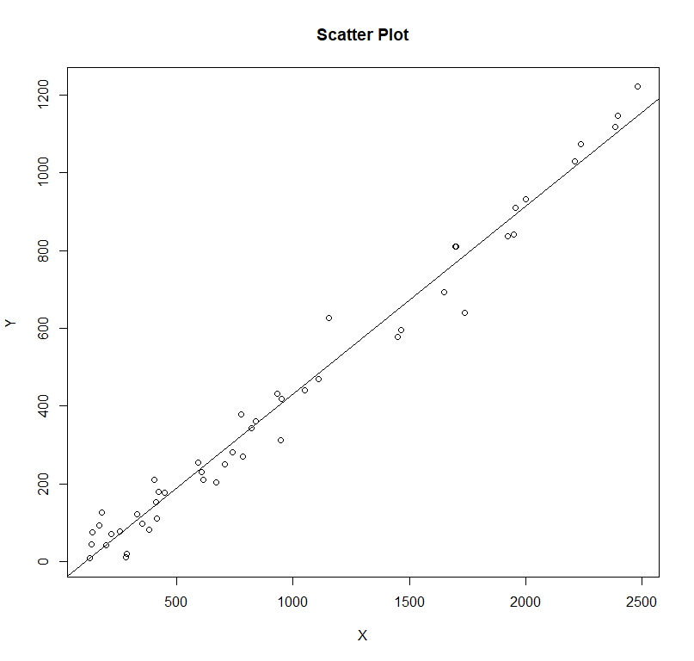
- As shown in the summary above, $x^{2}$ is still a significant term.
- The new R-Squared value is 0.9784, indicating that this model has a better fit than the previous model.
- This confidence interval is 121.6421 to 159.9354.
- Still no, for the same reasons as discussed previously.

Part (7) – Discussion
Only the predictor was transformed. We could have chosen to do a log transformation on the response variable, but visual inspection of the original scatter plot showed that it was likely a good fit for a polynomial transformation. The selected transformation did fix the main issue of the original model, namely the lack of a homogeneity of the variance. In the original model, the residuals for both high and low values of x were mostly positive, and residuals for values in the middle of the range were almost all negative. The new model has a good mix of positive and negative residuals throughout the range. The only exception is at the high end of the range for $x^{2}$, where residuals remain positive, though much smaller than before.

Summary
In this exercise we worked through a simple linear regression analysis, where we fit a model, analyzed the results, and created a confidence interval. We then performed a data transformation to improve the fit of the model, performed all of the previous steps, and analyzed why and how this change improved the model.

