Problem
Consider the following data:
Site 1 | Site 2 | Site 3 | Site 4
93 | 85 | 100 | 96
120 | 45 | 75 | 58
65 | 80 | 65 | 95
105 | 28 | 40 | 90
115 | 75 | 73 | 65
82 | 70 | 65 | 80
99 | 65 | 50 | 85
87 | 55 | 30 | 95
100 | 50 | 45 | 82
990 | 40 | 50
78 |  | 45
95 |  | 55
93
88
110

These figures provide the depths (in centimeters) at which important archaeological finds were made at four sites in New Mexico (see Woosley and Mcintyre, 1996). Store these data in your R workspace, with one vector containing depth and the other vector containing the site of each observation.
a. Produce side-by-side boxplots of the depths split by group and use additional points to mark the locations of the sample means.
b. Assuming independence, execute diagnostic checks for normality and equality of variances.
c. Perform and conclude a one-way ANOVA test for evidence of a difference between the means.

Solution
Part (a) – Box Plot
The data was imported and a box plot created using the following code:
This resulted in the box plot shown below:
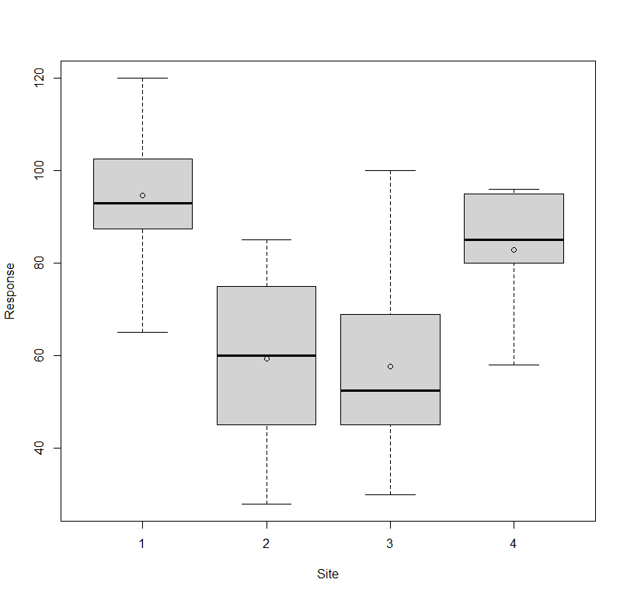

Part (b) – Normality and Equality of Variances
To check for normality, we utilze a QQplot, the code for which and the resulting chart is shown below:
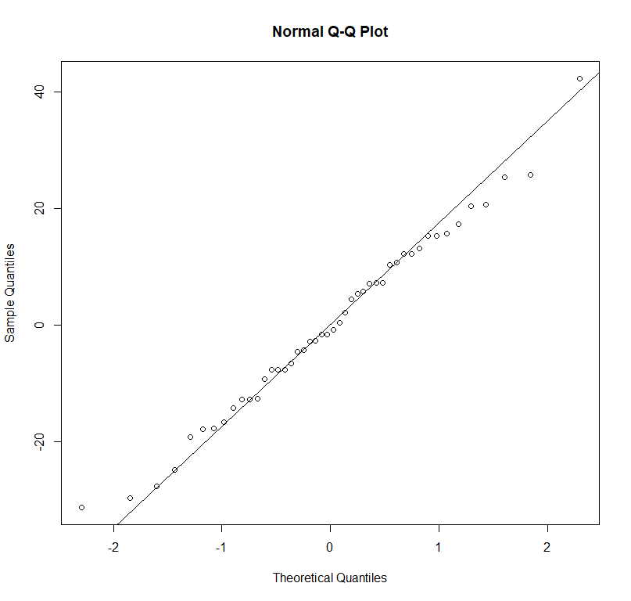

The data appears to mostly follow the desired qqline, meaning that we can assume that the data is normally distributed. To check for equality of variances, we use a levene test as shown in the code below:
From this test, we see that the p-value is 0.5021, indicating that we fail to reject the null hypothesis and conclude that the variances are not significantly different.

Part (c) – One-Way ANOVA
To perform a one-way ANOVA analysis, we utilize the aov function. The code and results are shown below:
The p-value for this test approaches 0. Therefore, we can reject the null hypothesis and conclude that there is sufficient evidence that the means of the four sites are not equal.

Summary
In this exercise we compared and analyzed data which originated from four separate sites. We first plotted the data in a box chart. We then checked the necessary assumptions for normality and equality of variances, concluding that the data was normal and the variances were not significantly different. Finally, we performed a one-way ANOVA to determine whether the means of the data for the four sites were significantly different, concluding that we had enough evidence to determine that there was likely a difference.

