Use cases:

Copy file from us-east-1 bucket to us-east-2 on PUT trigger on us-east-1 bucket.

Delete file from us-east-2 bucket on DELETE trigger on us-east-1 bucket.

1. Create three buckets 1) useast1novabucket (Northern VA region) 2) useast2ohiobucket (Ohio Region) 3) myjarnovabucket to hold the jar for lambda function. Myjarnovabucket is required since the upload threshold to lambda has exceeded due to the size of the jar.

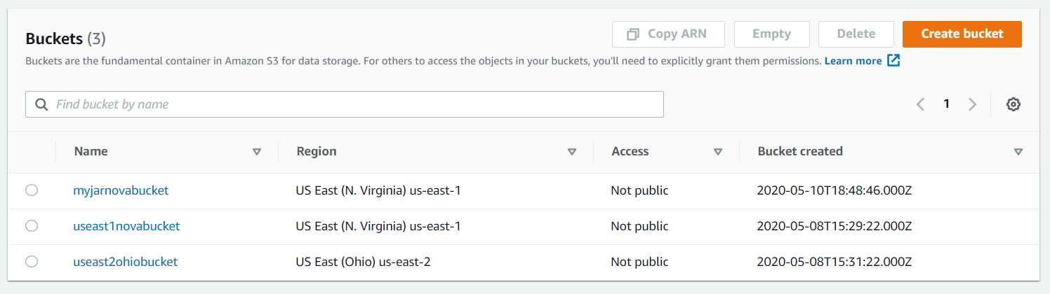

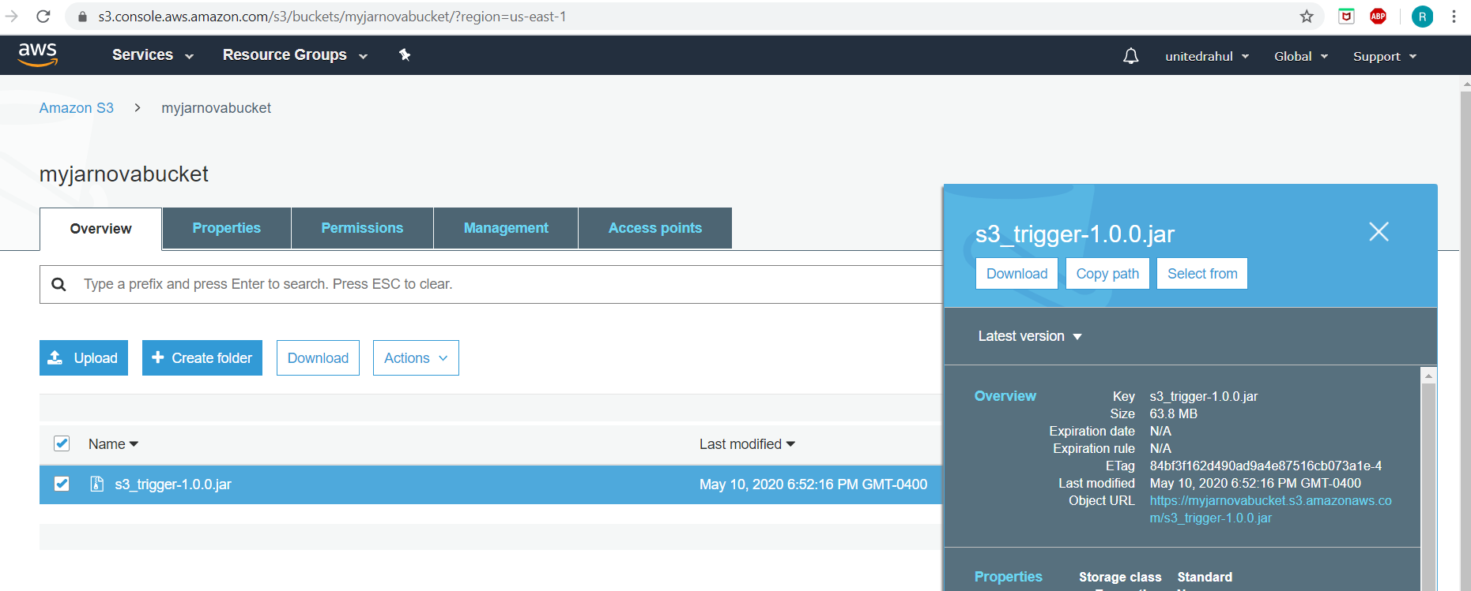

1. Create Lambda function with Java Run time

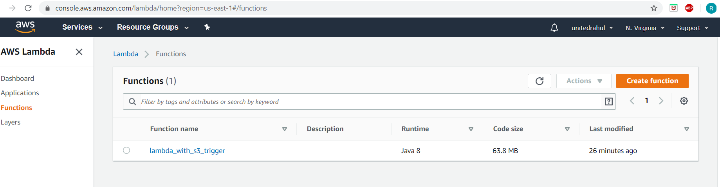

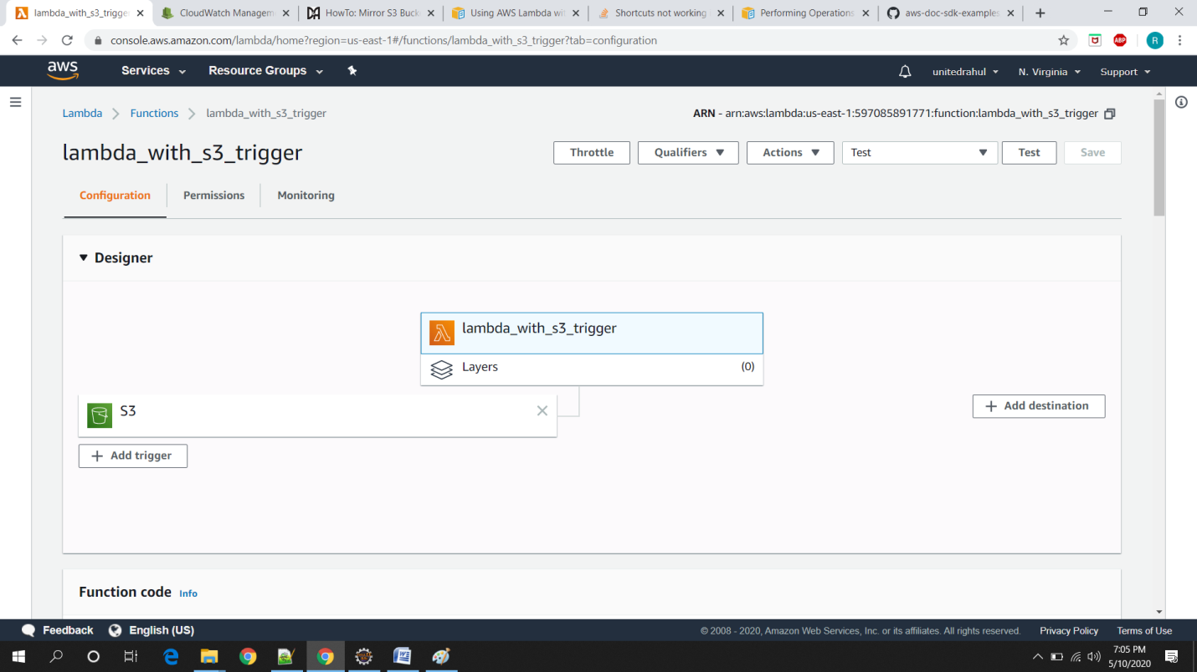

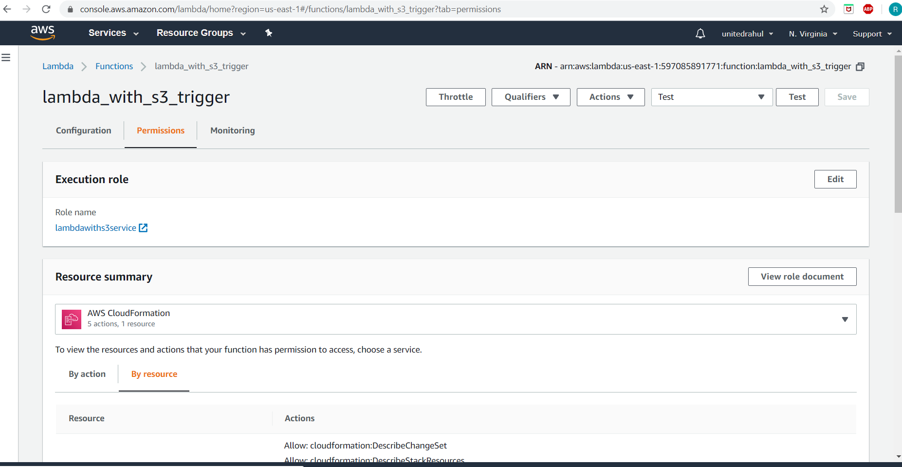

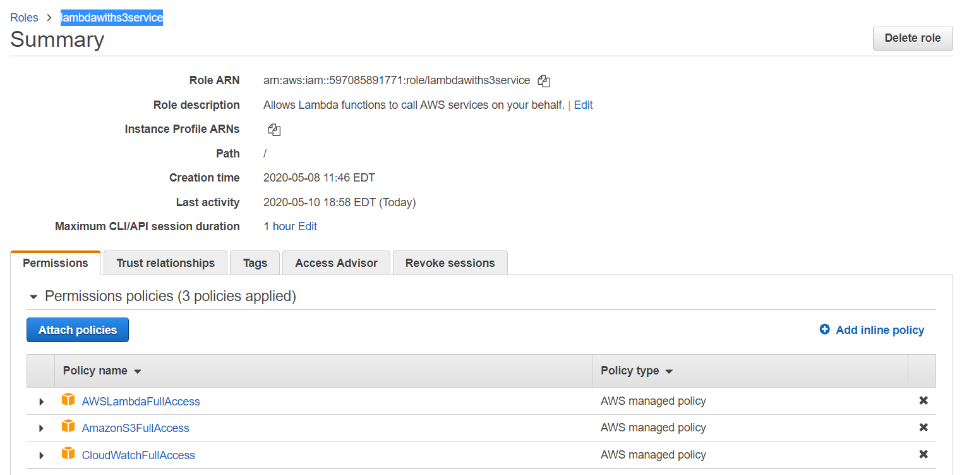

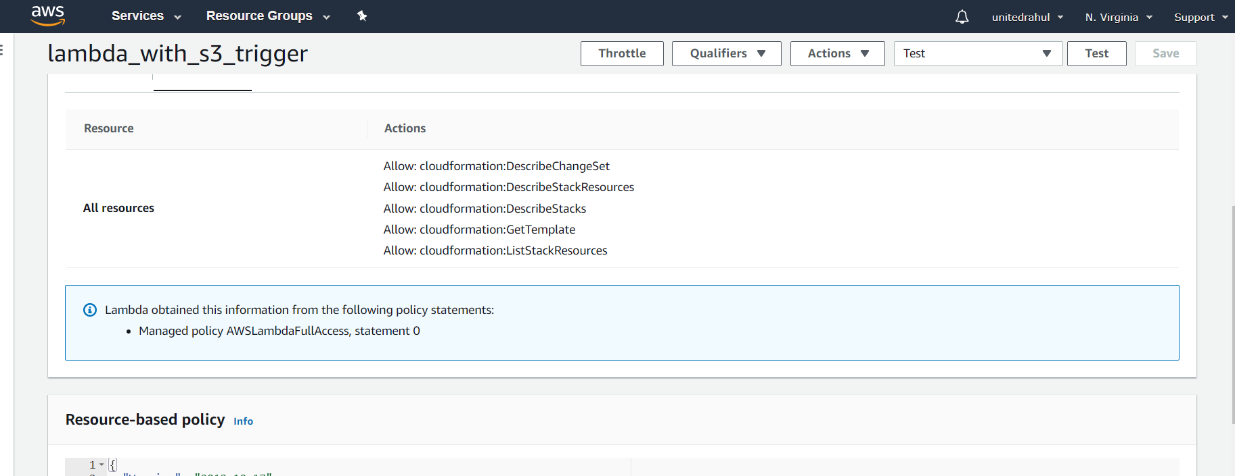

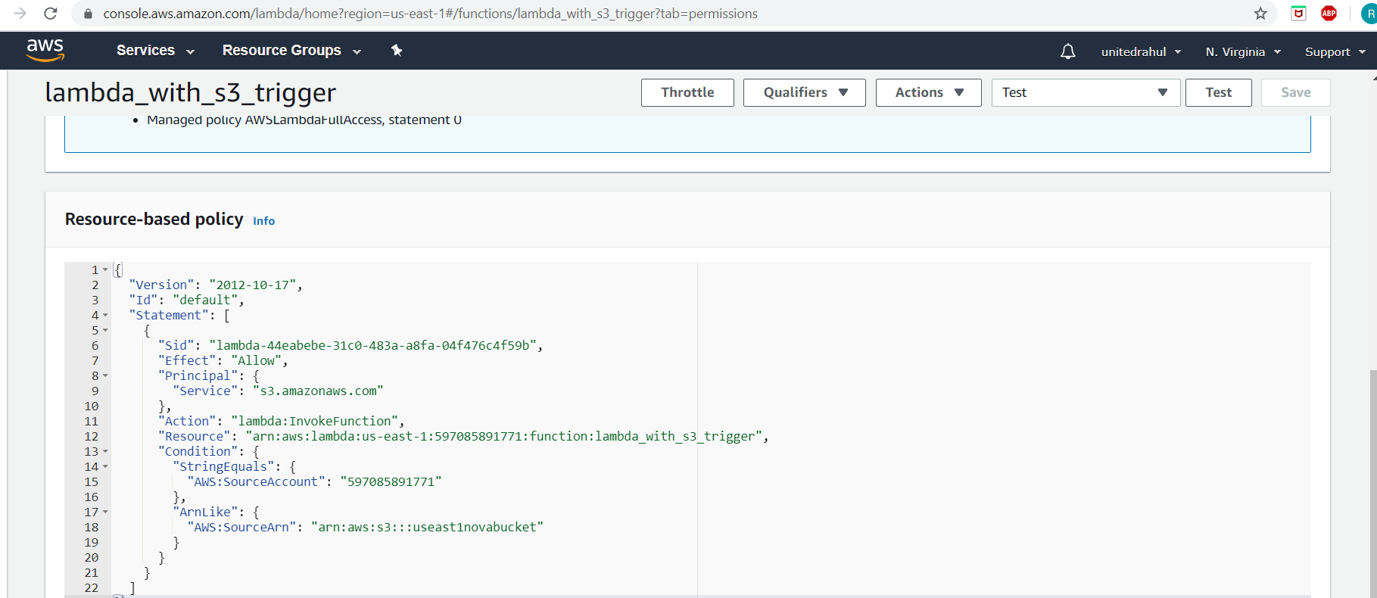

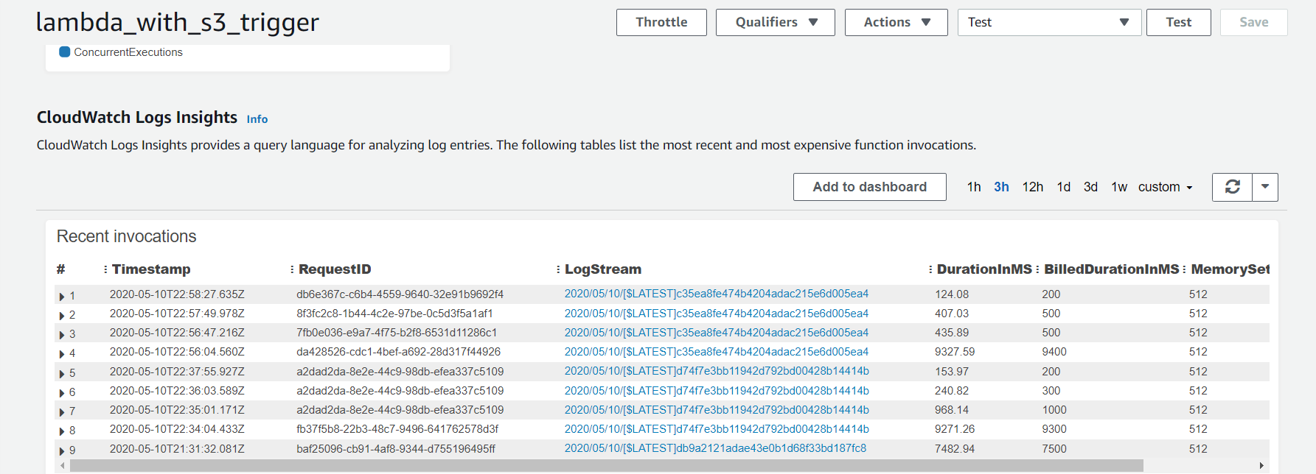

1. On useast1novabucket, configure event with lambda for PUT and DELETE

This event (PUT or DELETE) on the bucket triggers the [lambda_with_s3_trigger](https://console.aws.amazon.com/lambda/home?region=us-east-1#/functions/lambda_with_s3_trigger).

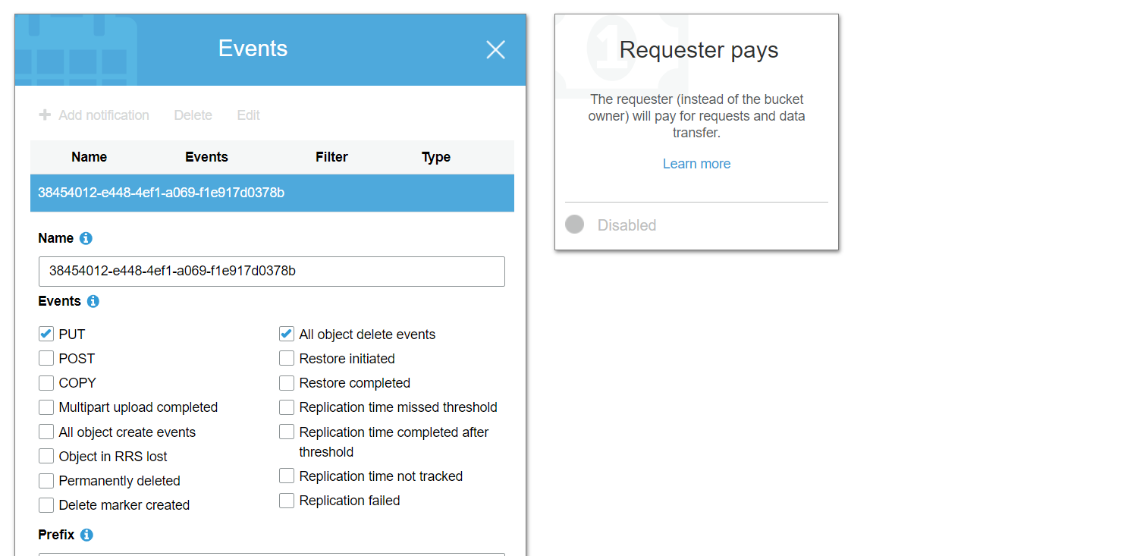

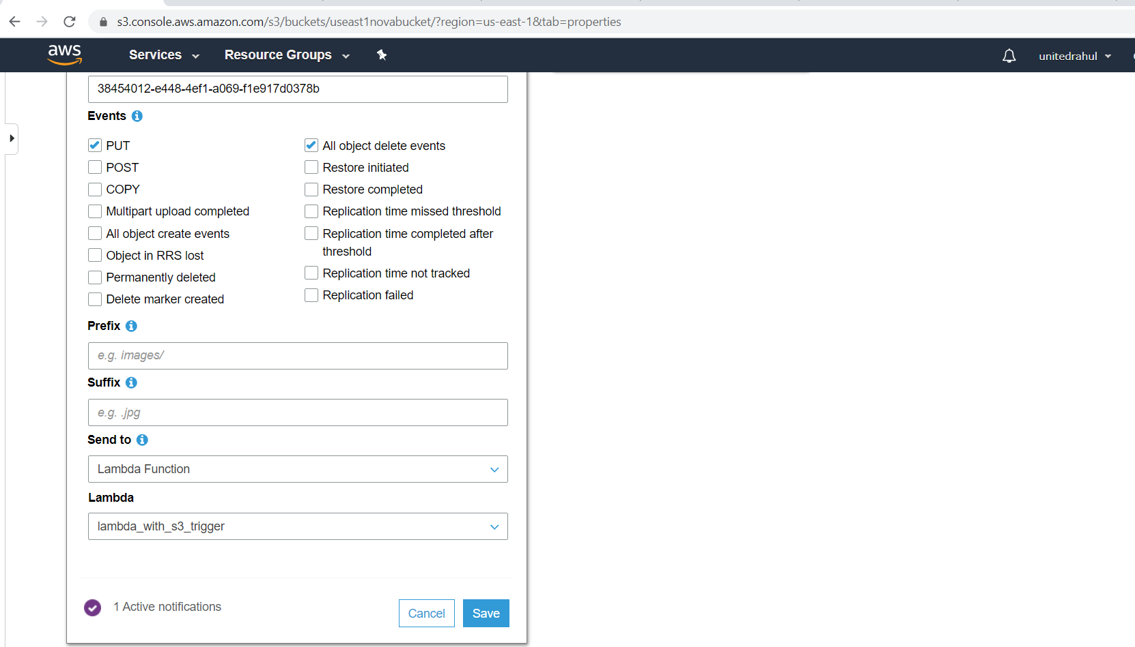

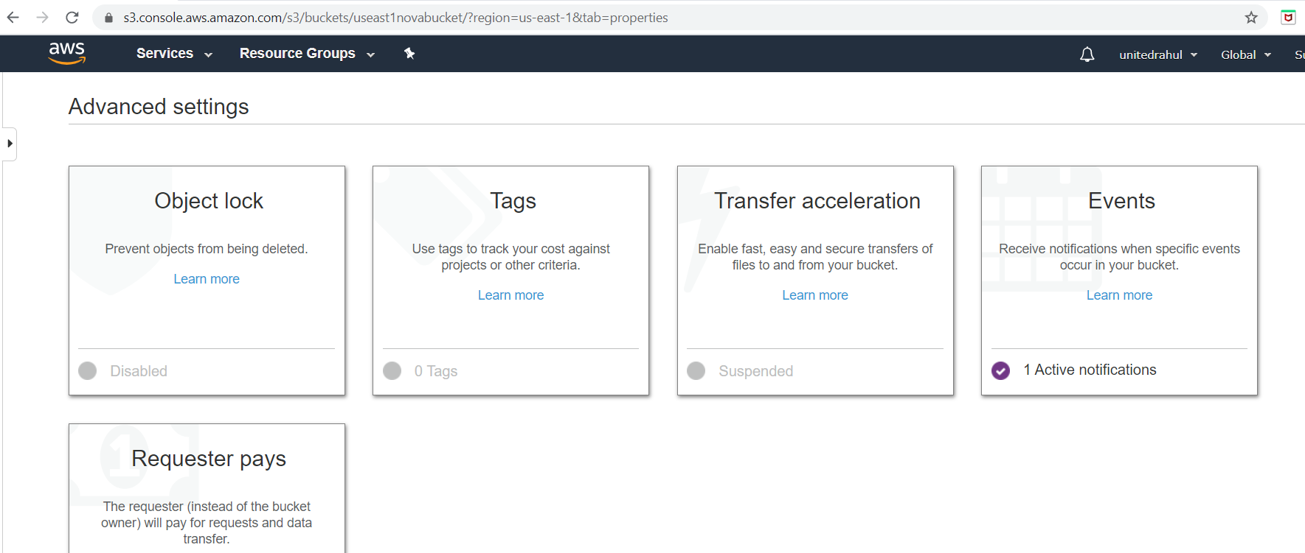

1. Configure LAMBDA Java function:

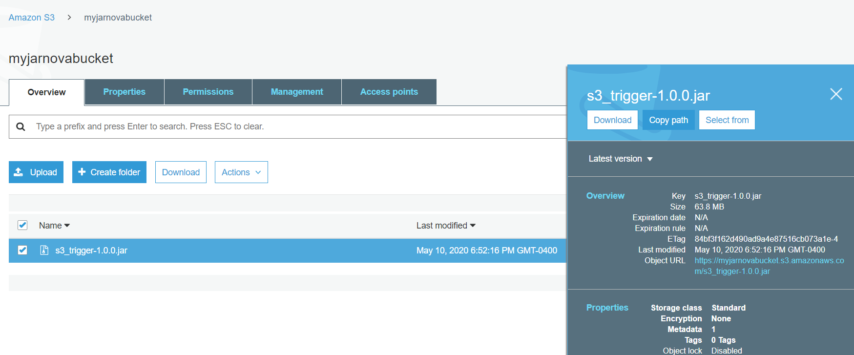

Copy the function path into LAMBDA:

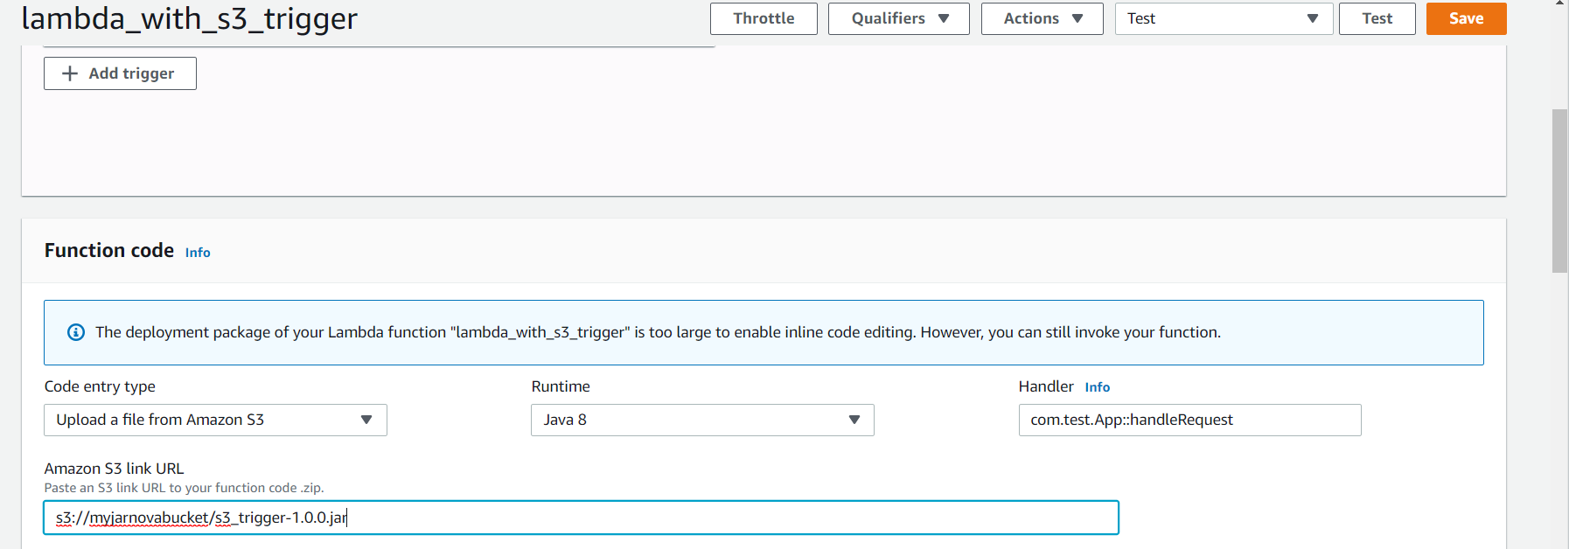

Save after upload.

1. Build the source code in Eclipse:

