**Celestial Tools: Set and Drift Form**

**Basic Set and Drift Data:**

The most basic function assumes you have a current DR position and a Current Fix. Your Set and Drift is the direction from DR to Fix location and the Drift amount is the distance between the two.

Enter only the current DR (assumed) location (latitude and longitude) and the current Fix location (latitude and longitude) and click “Calculate Set & Drift” button:

If any of the distances is less than 60nm, the blue Plot button will appear. If you click it using this example data you will see:

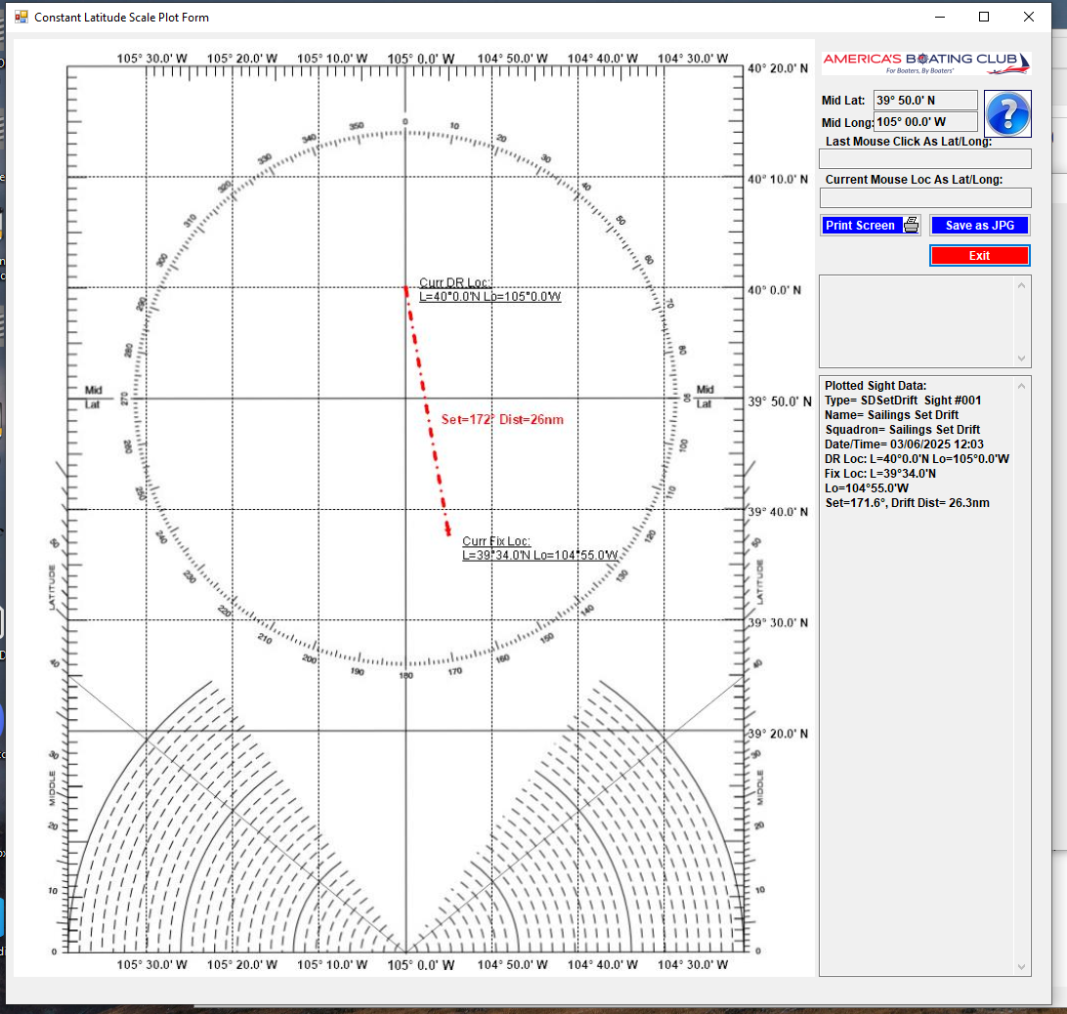

**Calculate Set and Drift from Current DR, Fix, and Previous Fix positions**

This function builds on the basic inputs and add a Previous Fix location:

Plotted these inputs looks like this:

**Calculate Set and Drift from Current DR, Fix, and Previous Fix positions and Elapsed Run Time:**

Now add in an elapsed run time of 3 hr 24 min, and your output will look like this:

Plotted these inputs look like this:

**Calculate Set and Drift from Current DR, Fix, and Previous Fix positions and Previous & Current Date Times:**

Plotted:

Those are the basic functions of the Set and Drift form.