ECE3700J Introduction to Computer Organization
Homework 3
Assigned: October 13, 2022
Due: 2:00pm on October 20, 2022
Submit a PDF file on Canvas

All questions refer to the following figure.

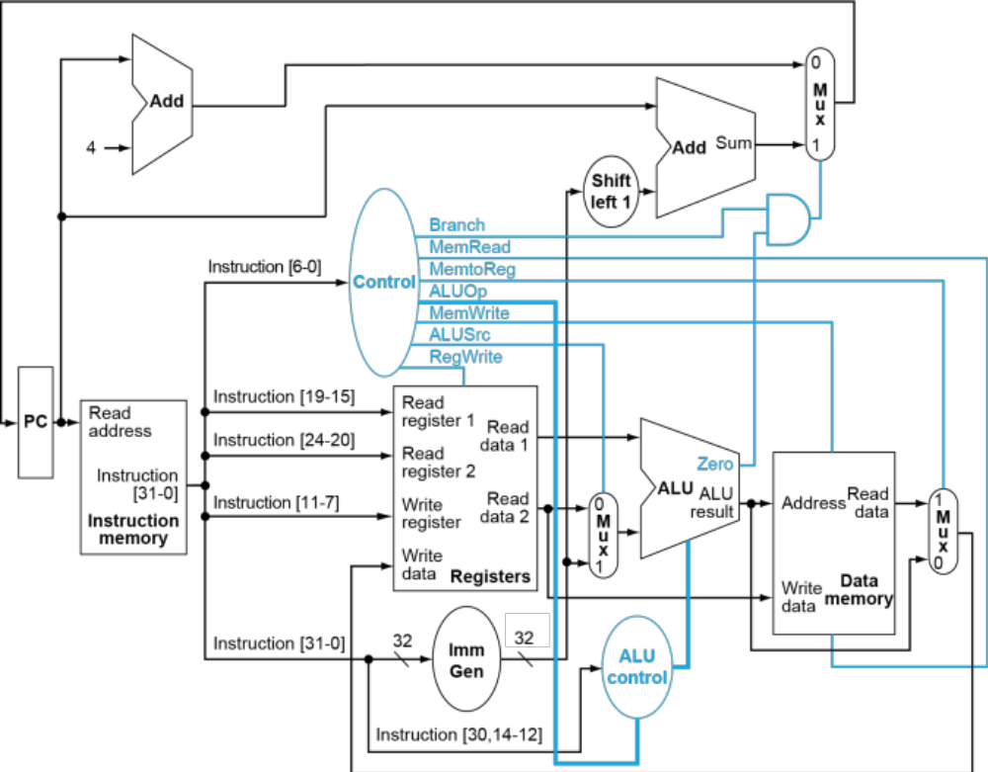

- (30 points) Given RISC-V assembly instruction sequence:
bne x22, x23, Else
add x19, x20, x21
beq x0,x0,Exit
Else: lw x19, 0(x20)
Exit: …
Assuming the memory location of the first instruction (bne) is 0x1000F400, what are the values of the following control signals for each of the instructions?

Ctrl Signals  Instruction | Branch | MemRead | MemtoReg | ALUOp | MemWrite | ALUSrc | RegWrite | Zero | ImmGen Output
add | 0 | 0 | 0 | 10 | 0 | 0 | 1 | X | X
beq | 1 | 0 | 0 | 01 | 0 | 0 | 0 | 1 | 0x00000004
lw | 0 | 1 | 1 | 00 | 0 | 1 | 1 | X | 0x00000000

- (10 points) Given following assembly instruction:
sw rs2, imm12(rs1)

- Which resources (blocks) perform a useful function for this instruction? (3 points)

PC, Instruction memory, Registers, ALU, Data Memory, Imm Gen, ALU Control.

- Which resources (blocks) produce no output for this instruction? Which resources produce output that is not used? (7 points)

No output: Data Memory.
Not used: PC+imm12

- (10 points) Consider the following instruction mix:
R-type | I-type (non-lw) | Load | Store | Branch | Jump
20% | 28% | 25% | 10% | 15% | 2%

- What fraction of all instructions use data memory? (3 points)
25%+10%=35%
- What fraction of all instructions use instruction memory? (2 points)
100%
- What fraction of all instructions use the sign extend? (5 points)
1-20%=80%
- (10 points) When silicon chips are fabricated, defects in materials (e.g., silicon) and manufacturing errors can result in defective circuits. A very common defect is for one signal wire to get “broken” and always read a logical 0. This is often called a “stuck-at-0” fault.
- Which instructions fail to operate correctly if the MemToReg wire is stuck at 0? (5 points)
Load instructions.
- Which instructions fail to operate correctly if the ALUSrc wire is stuck at 0? (5 points)
I-type, S-type.

- (30 points) Problems in this exercise assume that the logic blocks used to implement a processor’s datapath have the following latencies:

I-Mem / D-Mem | Register File | Mux | ALU | Adder | Single gate | Register Read | Register Setup | Sign extend | Control
250 ps | 150 ps | 25 ps | 200 ps | 150 ps | 5 ps | 30 ps | 20 ps | 30 ps | 100 ps

In above table, “Register Read” is the time needed after the rising clock edge for the new register value to appear on the output. This value applies to the PC only. “Register Setup” is the amount of time a register’s data input must be stable before the rising edge of the clock. This value applies to both the PC and Register File.

- What is the latency of an R-type instruction (i.e., how long must the clock period be to ensure that this instruction works correctly)? (5 points)
30+250+150+25+200+25+20=700ps
- What is the latency of lw? (5 points)
30+250+150+25+200+250+25+20=950ps
- What is the latency of sw? (5 points)
30+250+150+25+200+250=905ps
- What is the latency of beq? (5 points)
30+250+150+25+200+5+25+20=705ps
- What is the latency of an arithmetic, logical, or shift I-type (non-load) instruction? (5 points)
30+250+150+25+200+25+20=700ps
- What is the minimum clock period for this CPU? (5 points)
950ps

- (10 points) Modify the single-cycle processor datapath to support the jal instruction:
Since we can already jump with immediate number, all we should add is to save PC address to registers. Thus we connect wire from PC+4 to the MUX before write_data on the register file which controlled by MemtoReg, and change the control signal to WriteRegOp, 00-ALU result, 01-Read_Data from Data Memory, 10/11-PC+4.

