Quick-Start Guide

## Requirements

For single molecule tracking

* Single molecule data
* Localization software
  + Picasso
  + SMAP
* Tracking software
  + Swift
  + Tardis
  + NOBIAS
  + U-Track 3D

For the use of Third Peak

* Matlab 2023a if using the Github repository.
* Matlab Runtime 2023a.
* Windows 10 or above if using the compiled program.

Optional for DeepSPT

* Python 3.8
* DeepSPT package

## 2 Installation

The files for Third Peak can be found here:

<https://github.com/unithmueller/ThirdPeak>

For Windows:

* Install the Matlab Runtime 2023a

<https://de.mathworks.com/products/compiler/matlab-runtime.html>

* Install Third Peak by the latest .exe from the releases tab

For Mac:

* Install the Matlab Runtime 2023a

<https://de.mathworks.com/products/compiler/matlab-runtime.html>

* Install ThirdPeak

Directly from Matlab:

* Open Matlab, go to the APPS tab and select “Install App”
* Select the ThirdPeak.mlappinstall

or

* Select the Third Peak directory cloned or downloaded from Github
* Add the Path and Subfolders to the Matlab environment
* Navigate to the GUI folder and open SelectionWindow.mlapp

For DeepSPT

I would recommend using anaconda/conda as a python runtime environment management software. DeepSPT requires Python 3.8 due to some package dependencies, but this could break current python environments. After setting up the environment for python 3.8, install the dependencies for DeepSPT.

In the AdditionalScripts folder of ThirdPeak is a DeepSPT folder that contains several text files that needs to be edited to fit the local environment.

* PythonDeepSPTEnvironmentPath contains the path to the python executable which is part of the DeepSPT environment in anaconda/conda
* DeepSPTLocationPath contains the path to the cloned Repository
* hMM_used contains the path to the fingerprinting model that should be used
* mode contains the mode selection for python; 0 represents the standard analysis and is currently the only implemented option
* Downstream_LSM_used can contain a path to a custom model to determine diffusion type changepoints as shown in the associated publication of the Hatzakis lab
* Dowstream_MLP-used can contain a path to a custom model to determine differently diffusing particles as shown in the associated publication of the Hatzakis lab

## 4 Running the software

For Windows:

* Start the software using the .exe in the installation or folder or the icon on your desktop

For Mac:

* Open the terminal
* Move to the directory where ThirdPeak is located inside the terminal
* Type “/run_ThirdPeak.sh<MatlabRuntimeDirectory>”.

Directly from Matlab:

* After opening the SelectionWindow.mlapp, press start in the AppDesinger window

Or

* Got to the APPS tab and select Third Peak from the available apps

## 5 Running the software

* Ein Bild, das Screenshot, Text, Software, Multimedia-Software enthält.

  Automatisch generierte BeschreibungSelect preprocessing
* Ein Bild, das Text, Screenshot, Software, Zahl enthält.

  Automatisch generierte BeschreibungSelect Settings
* Use SMAP-Localisation and the standard values for the Data constellation, press Set Settings
* Click: Select Files with the Single Folder Mode
* Navigate to TestDataAndSettings/Trypanosome/SMAP and select “Red_38_MMStack_Default.ome_sml.mat”
* One file should be loaded
* Ein Bild, das Text, Screenshot, Software, Zahl enthält.

  Automatisch generierte BeschreibungSelect manual polymask and filter by precision, XY 60nm, Z 100nm
* Leave out drift correct
* Ein Bild, das Text, Screenshot, Software, Zahl enthält.

  Automatisch generierte BeschreibungSelect “Enable Tracking” and use the default properties
* Ein Bild, das Text, Screenshot, Software, Zahl enthält.

  Automatisch generierte BeschreibungChoose a save location and click on start processing
* When performing the manual masking, press enter once and use the mouse to click around the cell shape. Double-click to finish
* The same image will open again, press enter twice to stop masking this cell or mark a different region, in case multiple cells are present in one image
* The next file should open. Repat this process until no new file opens
* The processing bar will continue running. Some figures will open and close visualizing properties of the data
* The preprocessing should follow through without additional inputs

Ein Bild, das Screenshot, Text, Software, Multimedia-Software enthält.

* Select validation
* Select Settings
* Use Swift-Alldata as the format, keep the rest, Press Set Settings
* Browse for the image data, TestDataAndSettings/Trypanosome/Image/Red_31_MMSTack_Default
* Ein Bild, das Text, Screenshot, Software, Multimedia-Software enthält.

  Automatisch generierte BeschreibungBrowse Trackdata, TestDataAndSettings/Trypanosome/Tracks/v31.tracked.csv
* Explore the data, use the arrow keys to navigate in time

Ein Bild, das Screenshot, Text, Software, Multimedia-Software enthält.

* 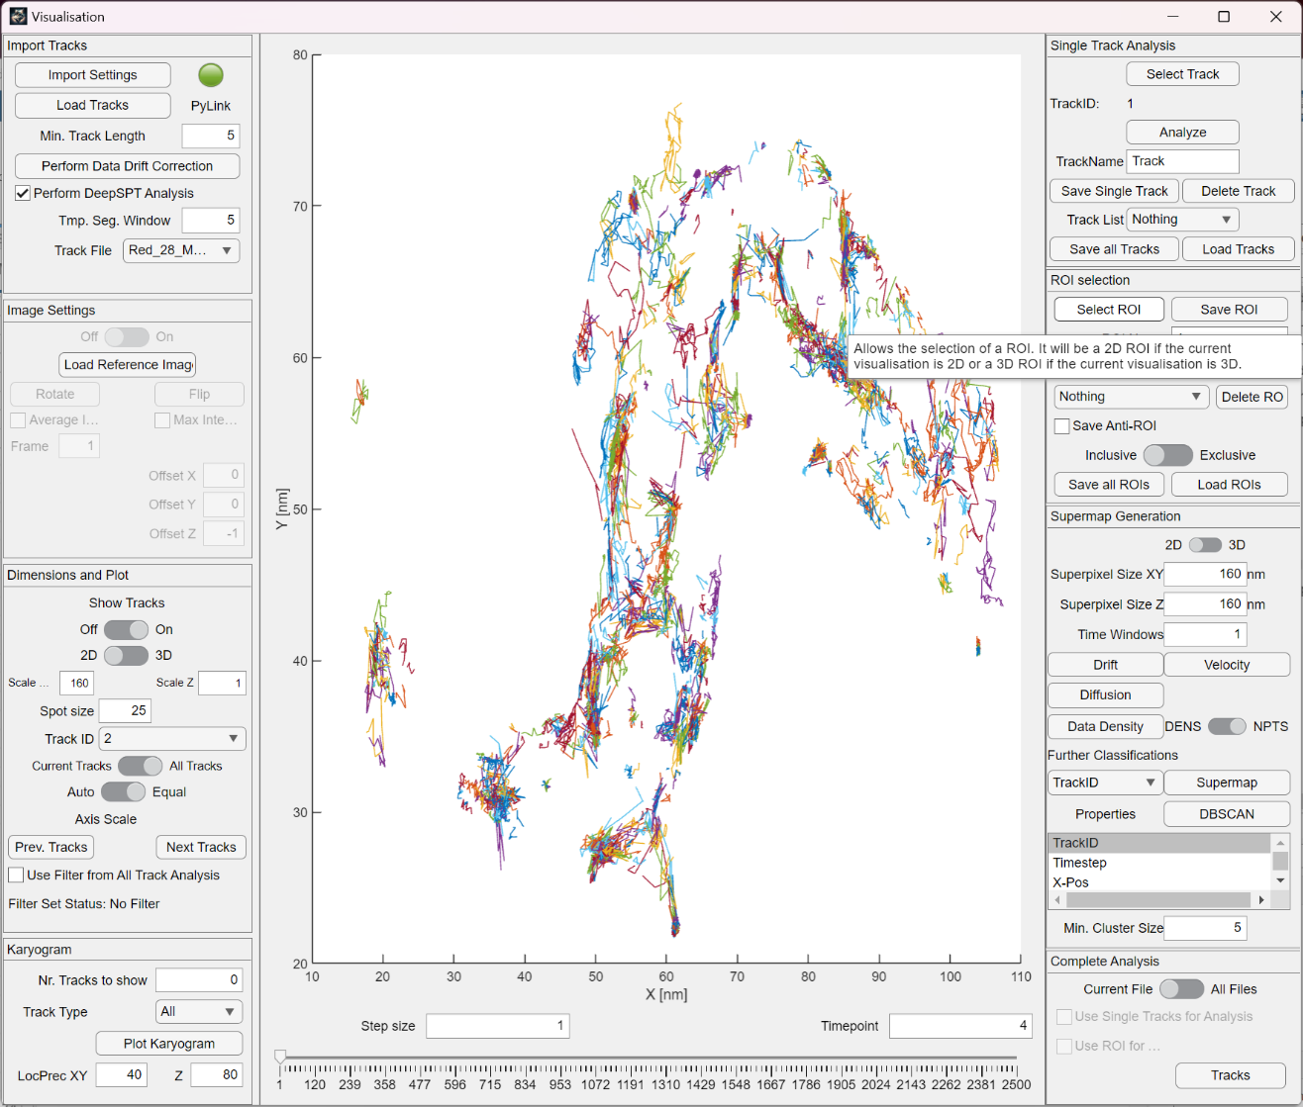Select visualisation
* Select import settings, use the default values, Set settings
* Select Load Tracks and load TestDataAndSettings/Trypanosome/Tracks/v31.tracked.csv
* Generate a heatmap by changing the superpixelsize to 320nm and select diffusion
* Alternatively select a property from the drop-down menu under Further classifications, then press Supermap
* Select one or multiple values from the selection menu and then press DBSCAN to cluster the data based on the selected properties. It will use the same settings a the supermap generation for the pixel and time window values
* Press Tracks under complete Analysis
* Explore the different track properties