Read the state | Significance
RecvHighROS.levelFlag | the flag of control level, high level:0x00, low level:0xff
RecvHighROS.mode | the running mode: standing:1, walking:2 .  It takes about a second to switch modes.
RecvHighROS.imu | include gyroscope, accelerometer, thermometer and solved euler angle  and quaternion
RecvHighROS.forwardSpeed | the speed of forward walking about the body
RecvHighROS.sideSpeed | the speed of sideward walking about the body
RecvHighROS.rotateSpeed | the speed of self rotating about the body
RecvHighROS.bodyHeight | the current height about the body
RecvHighROS.updownSpeed | the speed of standing or squating
RecvHighROS.forwardPosition | the forward position from odometry
RecvHighROS.sidePosition | the sideward position from odometry
RecvHighROS.footPosition2Body | the foot position about the body
RecvHighROS.footSpeed2Body | the foot speed about the body
RecvHighROS.footForce | the foot force
RecvHighROS.tick | reference time since robot boot
RecvHighROS.crc | check code
Send command
SendHighROS.levelFlag | ditto
SendHighROS.mode | ditto
SendHighROS.forwardSpeed | Move backward/frontward command, value range (-1 ~ 1), corresponding  to the piecewise linear proportional value of (-0.7 ~ 1m/s) (0 is taken as the  dividing point), the maximum forward speed is 1m/s, and the maximum  backward speed is 0.7m/s
SendHighROS.sideSpeed | Move rightward/leftward command, value range (-1 ~ 1), corresponding to  the linear proportional value of (-0.4 ~ 0.4 m/s)
SendHighROS.rotateSpeed | Turn right/left command, value range (-1 ~ 1), corresponds to a linear  proportional value of (-120 ~ 120 degrees per second)
SendHighROS.bodyHeight | Adjust body height command, value range ( -1 ~ 1), corresponding to the  piecewise linear proportional value of (0.3~0.45m) (take 0.41m as the  dividing point, as the default height)
SendHighROS.yaw | Yaw command, value range (-1 ~ 1), corresponding to the linear  proportional value of ( -28~28 degrees)
SendHighROS.pitch | Pitch command, value range (-1 ~ 1), corresponding to the linear  proportional value of ( -20~20 degrees)
SendHighROS.roll | Roll command, value range (-1 ~ 1), corresponding to the linear  proportional value of ( -20 ~ 20 degrees)
SendHighROS.led | reserved
SendHighROS.crc | ditto

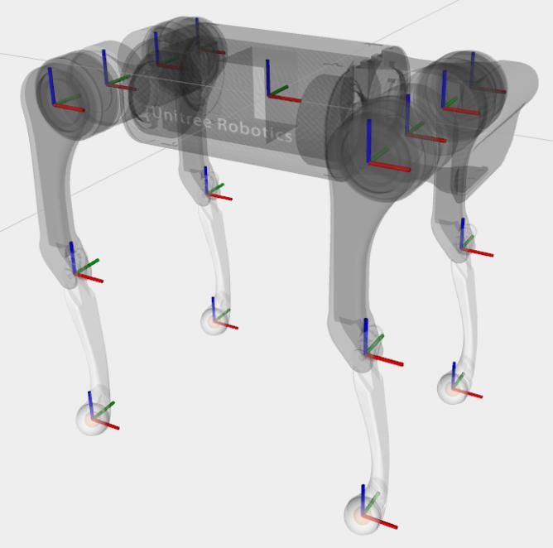
The picture below depicts the coordinate frames direction. Red axis is x-axis, green is y-, and blue is z-axis. The robot is heading to the right.

Example of the high-level controller code can be seen in lines 50 – 134 in “teleQuad/src/tele_quadruped/unitree_ros_to_real/unitree_legged_real/src/exe/walk_mode.cpp”.

Have fun!

