|  |  |
| --- | --- |
| ***Read the state*** | **Significance** |
| RecvHighROS.levelFlag | the flag of control level, high level:0x00, low level:0xff |
| RecvHighROS.mode | the running mode: standing:1, walking:2 .  It takes about a second to switch modes. |
| RecvHighROS.imu | include gyroscope, accelerometer, thermometer and solved euler angle  and quaternion |
| RecvHighROS.forwardSpeed | the speed of forward walking about the body |
| RecvHighROS.sideSpeed | the speed of sideward walking about the body |
| RecvHighROS.rotateSpeed | the speed of self rotating about the body |
| RecvHighROS.bodyHeight | the current height about the body |
| RecvHighROS.updownSpeed | the speed of standing or squating |
| RecvHighROS.forwardPosition | the forward position from odometry |
| RecvHighROS.sidePosition | the sideward position from odometry |
| RecvHighROS.footPosition2Body | the foot position about the body |
| RecvHighROS.footSpeed2Body | the foot speed about the body |
| RecvHighROS.footForce | the foot force |
| RecvHighROS.tick | reference time since robot boot |
| RecvHighROS.crc | check code |
| ***Send command*** |  |
| SendHighROS.levelFlag | ditto |
| SendHighROS.mode | ditto |
| SendHighROS.forwardSpeed | Move backward/frontward command, value range (-1 ~ 1), corresponding  to the piecewise linear proportional value of (-0.7 ~ 1m/s) (0 is taken as the  dividing point), the maximum forward speed is 1m/s, and the maximum  backward speed is 0.7m/s |
| SendHighROS.sideSpeed | Move rightward/leftward command, value range (-1 ~ 1), corresponding to  the linear proportional value of (-0.4 ~ 0.4 m/s) |
| SendHighROS.rotateSpeed | Turn right/left command, value range (-1 ~ 1), corresponds to a linear  proportional value of (-120 ~ 120 degrees per second) |
| SendHighROS.bodyHeight | Adjust body height command, value range ( -1 ~ 1), corresponding to the  piecewise linear proportional value of (0.3~0.45m) (take 0.41m as the  dividing point, as the default height) |
| SendHighROS.yaw | Yaw command, value range (-1 ~ 1), corresponding to the linear  proportional value of ( -28~28 degrees) |
| SendHighROS.pitch | Pitch command, value range (-1 ~ 1), corresponding to the linear  proportional value of ( -20~20 degrees) |
| SendHighROS.roll | Roll command, value range (-1 ~ 1), corresponding to the linear  proportional value of ( -20 ~ 20 degrees) |
| SendHighROS.led | reserved |
| SendHighROS.crc | ditto |

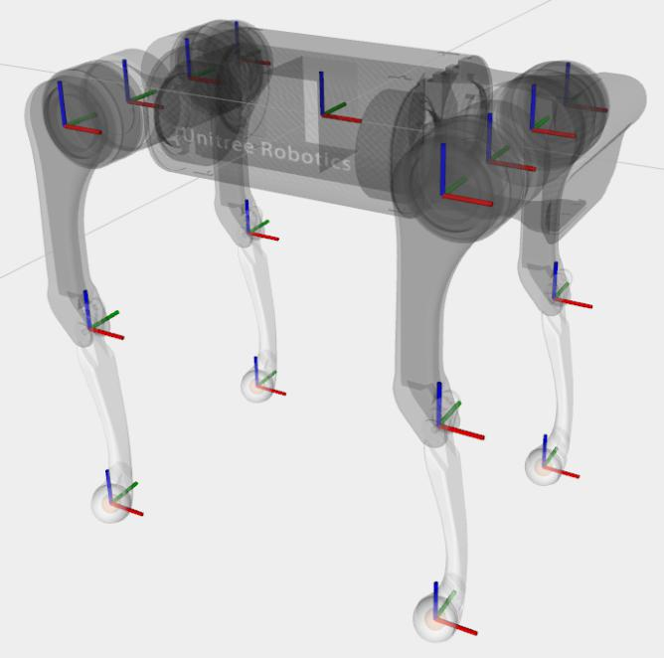The picture below depicts the coordinate frames direction. Red axis is x-axis, green is y-, and blue is z-axis. The robot is heading to the right.

Example of the high-level controller code can be seen in lines 50 – 134 in “teleQuad/src/tele_quadruped/unitree_ros_to_real/unitree_legged_real/src/exe/walk_mode.cpp”.

Have fun!