Guidelines for the Use of Units Markup Language
Draft Version 0.4

OASIS UnitsML Technical Committee
Robert A Dragoset¹, Chair
¹Physics Laboratory, National Institute of Standards and Technology, Gaithersburg, MD, U. S.A.

1. Introduction with contact information 3
2. Normative References 3
3. Terms and Definitions 4
4. Symbols and Abbreviations 4
5. Introduction to Physical Quantities and Scientific Units of Measure 4
6. Design Approach 5
6.1. NDR 5
7. UnitsML Schema 6
7.1. UnitSet & QuantitySet 6
7.2. Unit/ @unitID & @symbol 6
7.3. Unit/ System 6
7.4. Unit/ CodeListValues 7
7.5. Unit/ RootUnits 7
7.6. Unit/ Conversions 7
7.7. Quantity/ Dimension 7
8. Methods of using UnitsML with other schemas 7
8.0. Reference a unique unit ID 8
8.1. Refer to the UnitsML schema 9
8.2. <include> the UnitsML schema 11
8.3. <import> the UnitsML schema 12
8.4. <redefine> the elements of UnitsML 14
9. Relationship of UnitsML to UnitsDB 16
10. Future work 16
11. Notices 16
12. References 16

Introduction with contact information
Units Markup Language (UnitsML) was developed for encoding scientific units of measure in XML. The language is part of a project that is composed of three components: an XML schema (UnitsML), a database containing detailed information on SI (International System of Units (Système International d’Unités)) and non-SI scientific units of measure, and tools to facilitate the incorporation of UnitsML into other markup languages. The development and deployment of a markup language for units will allow for the unambiguous storage, exchange, and processing of numeric data, thus facilitating the collaboration and sharing of information over the Internet. It is anticipated that UnitsML markup will be used by the developers of other markup languages to address the needs of specific communities (e.g. mathematics, chemistry, materials science, etc.). Use of UnitsML in other markup languages will reduce duplication of effort and improve compatibility among specifications that represent numerical data.
The XML schema under development for UnitsML allows for the ability to represent scientific units of measure in XML and will be used for validating XML documents that use UnitsML. The UnitsML schema is not intended to be a standalone schema, but rather to be used in combination with other specific schemas through the use of namespaces. SI units can be represented through the use of base units (e.g., meter, second), special derived units (e.g., joule, volt), and any combination of these units with appropriate prefixes and exponential powers (e.g., mm · s-2). In addition, commonly used derived SI units (e.g., square meter, meter per second) and non-SI units (e.g., minute, ångström, and inch) will be explicitly supported for reference within XML documents.
A database (UnitsDB) is under development at the National Institute of Standards and Technology (NIST) to contain detailed units and dimensionality information for an extensive number of SI units and common, non-SI units available for access by users of UnitsML. The database includes information needed to reference units in an XML document, and specifically includes unique identifiers, and can include various unit symbols, language-specific unit names, and representations in terms of other units (including conversion factors). In addition to scientific units, the database will include information about quantities - the measurable, countable, or comparable properties or aspects of a thing, e.g., length.
Contact Information:

Normative References
ISO 31 – Quantities and Units
SI – International System of Units
UBL NDR
XML
XML Schema

Terms and Definitions
Measured Quantity
Non-SI Units
SI Units
Unit Conversion
Unit Prefix
Unit of Measure
UnitsML
UnitsDB
XSD file

Symbols and Abbreviations
ASCII American Standard Code for Information Interchange
DTD Document Type Definition
ID Identifier
ML Markup language
URI Uniform Resource Identifier
SI The International System of Units
http://www.bipm.fr/en/si/
http://physics.nist.gov/cuu/Units/

Introduction to Physical Quantities and Scientific Units of Measure
One definition of a physical quantity is the measurable property of a thing. Examples of physical quantities are length, mass, and velocity. The value of a quantity is its magnitude expressed as the product of a number and a scientific unit of measure, and the number multiplying the unit is the numerical value of the quantity expressed in that unit of measure.
Any quantity can be expressed in terms of other quantities through a mathematical representation. It is convenient to define a set of base quantities through which all other quantities, called derived quantities, can be expressed. ISO 31 follows this convention and defines seven base quantities: length, mass, time, electric current, thermodynamic temperature, amount of substance and luminous intensity. In the SI, the seven base unit names and symbols used for expressing values of the seven base quantities are given in Table 1.

Base Quantity | SI Base Unit
Base Quantity | Name | Symbol
length | meter | m
mass | kilogram | kg
time | second | s
electric current | ampere | A
thermodynamic temperature | kelvin | K
amount of substance | mole | mol
luminous intensity | candela | cd
Table 1: Seven base quantities and the corresponding SI base unit names and symbols.
[Note: The U.S. spelling is used for meter.]
There is one common usage of expressing the relationship between quantities and units that is technically incorrect and can lead to confusion. Frequently, an aspect of a physical quantity is treated as if it is a unit of measure. For example, the expression emission rate = 1.36 e/s, where ‘e’ represents electron, treats ‘electron’ as a unit. The correct expression should be electron emission rate = 1.36 s⁻¹, or electron emission rate = 1.36 /s. Even though the UnitsML schema allows for the inclusion of unique items as units, this practice is strongly discouraged.

Design Approach
UnitsML was designed with the idea that scientific units of measure should be easily, yet unambiguously, tagged within an XML document. The UnitsML schema was not intended to describe independent XML documents, unless the document is simply a list of units of measure. The schema is intended to be incorporated into other schemas in order to handle the markup of units in a uniform manner across all disciplines.
There are two aspects to the markup of scientific units of measure. The first is the UnitsML schema defining the XML structure of units of measure contained within XML documents. In conjunction with the schema, there is a database (called UnitsDB) containing units of measure information that is under development.

NDR
The Naming and Design Rules (NDR) that have been applied to the UnitsML schema is a subset of the UBL (Universal Business Language) NDR. The UnitsML NDR draft version is available at: http://www.oasis-open.org/committees/download.php/20208/NDRs-draft_for_UnitsML_schema_0.4.1.pdf

UnitsML Schema
Complete documentation for the UnitsML schema can be found at: ??? This section provides a general discussion about the schema and descriptions and explanations on specific elements and attributes contained in the schema. The schema is not meant to be used for standalone documents unless those documents are merely lists of units. The schema was designed to be used in conjunction with schemas from other XML implementations. See Section 8 for specific methods of using UnitsML with other schemas.

UnitSet & QuantitySet
All of the UnitsML schema elements are global. This allows all or part of the schema to be incorporated into another schema. The root element of the schema (UnitsML) contains two child elements: the UnitSet, a container for scientific units of measure, and the QuantitySet, a container for physical quantities. Each of these child elements each contain one element (with unbounded occurrences) for describing a single unit or quantity: UnitSet/Unit and QuantitySet/Quantity. If all of the unit and quantity information is contained in a separate document or in a separate section of a larger document, it is recommended that the UnitSet and QuantitySet elements be used containing descriptions of all units and quantities. However, if the unit and quantity information is interspersed throughout the parent document, then the Unit and Quantity elements should be used for each representation of a single unit or quantity. This would reduce the possibility of assigning multiple units to a single numerical value of a measured quantity.

Unit/ @unitID & @symbol
The Unit element contains three attributes (@) and eleven child elements. Unit/ @unitID is used to provide a unique method of identifying a single unit. There are two types of IDs that can be used: a “license plate” style that contains a numbering system, and a “symbol” that contains semantic information about the unit, e.g., “m” for meter. The NIST-developed UnitsDB will provide a unique number for each unit in the database, e.g., NISTu123, which will be provided as the unitID attribute. However, a unique symbol will also be provided in the symbol attribute. Since XML does not allow two IDs to be set for one element, @symbol is not an ID. However, the user may choose to use a unit symbol as the value of the @unitID.
It is not expected that UnitsDB will be populated with every possible unit, considering the use of prefixes. For example, millimeter per microsecond squared will probably not be in the database. However, a user can define this unit (using Unit/ RootUnits described below) and identify it with a unique ID, e.g., “mm.us^-2” or “CompanyUnit37”.

Unit/ System
The optional Unit/ System element contains information about a specific unit system in which the unit resides. This element is unbounded because a unit can reside in multiple unit systems, e.g., the second is in most unit systems. Although we strongly encourage the use of the SI, we recognize the fact that other unit systems (e.g., the inch-pound unit system) are still in common usage.

Unit/ CodeListValues
The optional Unit/ CodeListValues element contains one, unbounded CodeListValue element for providing interoperability between communities that specify different unique identifiers for the same element. For example, different unit code lists may use both “MTR” and “MET” for the meter. For each unit code, there are optional attributes for specifying the organization responsible for a specific code list and for specifying related information.

Unit/ RootUnits
The optional Unit/ RootUnits element provides a mechanism for defining a derived unit in terms of its components. In this way, for the example given previously, “mm.us^-2” can be represented as a meter with prefix milli to the power “1” and a second with prefix micro to the power “-2”. The RootUnits element contains two child elements: EnumeratedRootUnit and ExternalRootUnit. It is strongly recommended that, if possible, the EnumeratedRootUnit element be used in that the choices for the units is limited to a rather extensive list of enumerated values. It is anticipated that all of the units in the enumerated list will be contained in the UnitsDB. The ExternalRootUnit element should only be used in the circumstance where a root unit is not contained in the enumerated list. For example, the unit “jigger”, equal to 1.5 U.S. liquid ounces, is not in the enumerated list. In order to provide the root units for “jiggers per hour”, one would need to use the ExternalRootUnit element.

Unit/ Conversions
The optional Unit/ Conversions element contains two child elements: Float64ConversionFrom and SpecialConversionFrom. The Float64ConversionFrom element is used for providing factors for a linear conversion equation from another unit; y = d + ((b / c) (x + a)). A reference to the initial unit “x” is required and all other conversion factors (a, b, c & d) are optional, with default values of 0 or 1, as appropriate. Note: The related "conversion to" equation is a simple inversion of the above equation; i.e., x = ((c / b) (y - d)) - a. The SpecialConversionFrom element is provided for the case where the conversion between units is not defined by a linear expression. In this case, a text field is provided for describing the conversion routine from the initial unit.

Quantity/ Dimension
The optional Quantity/ Dimension element is used to specify the dimension of a specific quantity in terms of the seven base dimensions: length, mass, time, electric current, thermodynamic temperature, amount of substance and luminous intensity. The dimension of a particular unit can be provided by using the Unit/ QuantityReference element to reference a specific quantity that includes the dimensional information.

Methods of using UnitsML with other schemas
There are several methods that UnitsML can be used within XML documents described by other schema-based markup languages. The first example below does not actually make use of UnitsML, but merely references a unique unit ID. The other examples demonstrate methods of incorporating UnitsML into other schema-based markup languages. The W3C’s finalization of the XML Schema specification allows greater flexibility and specificity in defining constraints than are available with DTDs. A simple schema was designed to illustrate the various methods of incorporating UnitsML into another markup language.
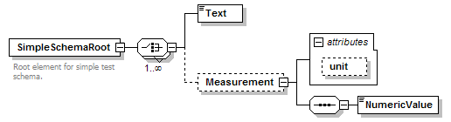
<?xml version="1.0" encoding="UTF-8"?>
<xs:schema xmlns:xs="http://www.w3.org/2001/XMLSchema"
elementFormDefault="qualified"
attributeFormDefault="unqualified">
<xs:element name="SimpleSchemaRoot">
<xs:annotation>
<xs:documentation>Root element for simple test schema.</xs:documentation>
</xs:annotation>
<xs:complexType>
<xs:choice maxOccurs="unbounded">
<xs:element name="Text" type="xs:string"/>
<xs:element name="Measurement" minOccurs="0">
<xs:complexType>
<xs:sequence>
<xs:element name="NumericValue" type="xs:double"/>
</xs:sequence>
<xs:attribute name="unit" type="xs:token"/>
</xs:complexType>
</xs:element>
</xs:choice>
</xs:complexType>
</xs:element>
</xs:schema>

Reference a unique unit ID
One of the simplest methods of distinguishing a scientific unit of measure is to provide a unique ID for the desired unit, e.g., m or meter. Another approach would be to reference the unique ID from an authoritative source. For this method, in the simple schema provided above, the unit attribute would need to be changed from type="xs:token" to type="xs:anyURI". This would allow an external source, e.g., a file or database, to provide additional information about the specific unit. If this method is chosen, the UnitsML schema is not needed, even if the referenced database is UnitsDB. However, the schema for the XML output from UnitsDB for a single unit would be UnitsML. The instance document below illustrates this method.
<?xml version="1.0" encoding="UTF-8"?>
<SimpleSchemaRoot xsi:noNamespaceSchemaLocation="SimpleSchema.xsd"
xmlns:xsi="http://www.w3.org/2001/XMLSchema-instance">
<Text>The width of the room is: </Text>
<Measurement unit="#m">
<NumericValue>3.14159</NumericValue>
</Measurement>
<Text>This is more text related to the test.</Text>
</SimpleSchemaRoot>

Refer to the UnitsML schema
One important part of using schemas is being able to reference them within other XML documents. Making a reference from within an XML document requires a declaration of the XML schema instance namespace, a prefix mapping (xsi), and associated URI to give access to the attributes needed for referencing the XML schemas. If needed, there can be defined a default namespace to provide a home for all non-prefixed elements in the document. Once the XML schema instance namespace is available, one can provide the schemaLocation attribute within it. The schemaLocation attribute consists of two values. The first value, or argument, is the namespace, which must be unique, and the second is the actual resolvable schema location. In this case, the first referenced schema location is the host schema and the second the UnitsML schema. In the same way, we could reference additional schemas. There are many more options for referencing schemas, using them with and without namespaces. These options are documented in the W3C XML Schema specification.
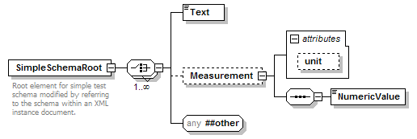
There were three changes made to the simple schema (shown below as a diagram and text) in this case of referring to the UnitsML schema, but only two are required. 1) The <any> element was added to allow elements to be included from other schemas (e.g., UnitsML) through the use of namespaces; 2) the unit attribute was changed from type="xs:token" to type="xs:anyURI", as done in example 7.0.; and 3) an optional target namespace was added to easily distinguish the “simple” and “unitsml” tags in the XML instance document.

<?xml version="1.0" encoding="UTF-8"?>
<xs:schema xmlns="http://unitsml.nist.gov/simple"
xmlns:xs="http://www.w3.org/2001/XMLSchema"
targetNamespace="http://unitsml.nist.gov/simple"
elementFormDefault="qualified"
attributeFormDefault="unqualified">
<xs:element name="SimpleSchemaRoot">
<xs:annotation>
<xs:documentation>Root element for simple test schema modified by referring
to the schema within an XML instance document.</xs:documentation>
</xs:annotation>
<xs:complexType>
<xs:choice maxOccurs="unbounded">
<xs:element name="Text" type="xs:string"/>
<xs:element name="Measurement" minOccurs="0">
<xs:complexType>
<xs:sequence>
<xs:element name="NumericValue" type="xs:double"/>
</xs:sequence>
<xs:attribute name="unit" type="xs:anyURI"/>
</xs:complexType>
</xs:element>
<xs:any namespace="##other" processContents="skip"/>
</xs:choice>
</xs:complexType>
</xs:element>
</xs:schema>

The instance document (shown below) utilizes two namespaces, “simple” and “unitsml”, to distinguish the portions of the document corresponding to the appropriate schema, SimpleSchema.xsd or unitsmlSchema-0.9.7.xsd, respectively.
<?xml version="1.0" encoding="UTF-8"?>
<simple:SimpleSchemaRoot
xmlns:xsi="http://www.w3.org/2001/XMLSchema-instance"
xmlns:simple="http://unitsml.nist.gov/simple"
xmlns:unitsml="urn:oasis:names:tc:unitsml:schema:xsd:UnitsMLSchema-0.9.7"
xsi:schemaLocation="http://unitsml.nist.gov/simple
SimpleSchema.xsd
urn:oasis:names:tc:unitsml:schema:xsd:UnitsMLSchema-0.9.7
http://unitsml.nist.gov/Schema/unitsmlSchema-0.9.7.xsd">
<simple:Text>The width of the room is: </simple:Text>
<simple:Measurement unit="#m">
<simple:NumericValue>3.14159</simple:NumericValue>
</simple:Measurement>
<simple:Text>This is more text.</simple:Text>
<unitsml:unit symbolicID="m">
<unitsml:UnitName lang="en-US">meter</unitsml:UnitName>
<unitsml:Symbol type="ASCII">m</unitsml:Symbol>
</unitsml:unit>
</simple:SimpleSchemaRoot>
It should be noted that the unit attribute could be unused and the UnitsML tags could accompany each occurrence of a numerical value. However, this would be unnecessarily duplicative for documents containing many instances of the same unit of measure.

<include> the UnitsML schema
This directive results in the UnitsML schema being brought into the host schema within the host schema namespace. The include element brings in definitions and declarations from the UnitsML schema into the host schema. It requires the UnitsML schema to be in the same target namespace as the host schema namespace.
<xs:include schemaLocation="unitsmlSchema-0.9.7-NoNamespace.xsd"/>
In this case, since the parent schema does not define a namespace, it was necessary to modify the UnitsML schema so that there was no namespace declared. Alternatively, the UnitsML namespace could be modified to match the namespace of a parent schema.
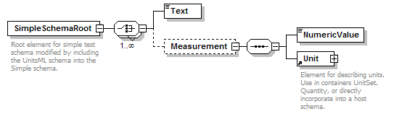
Note that since the unit is being defined by the complex UnitType defined in UnitsML, the attribute “unit” in the Measurement element has been removed.
<?xml version="1.0" encoding="UTF-8"?>
<xs:schema xmlns:xs="http://www.w3.org/2001/XMLSchema"
elementFormDefault="qualified" attributeFormDefault="unqualified">
<xs:include schemaLocation="unitsmlSchema-0.9.7-NoNamespace.xsd"/>
<xs:element name="SimpleSchemaRoot">
<xs:annotation>
<xs:documentation>Root element for simple test schema modified by including
the UnitsML schema into the Simple schema.</xs:documentation>
</xs:annotation>
<xs:complexType>
<xs:choice maxOccurs="unbounded">
<xs:element name="Text" type="xs:string"/>
<xs:element name="Measurement" minOccurs="0">
<xs:complexType>
<xs:sequence>
<xs:element name="NumericValue" type="xs:double"/>
<xs:element ref="Unit"/>
</xs:sequence>
</xs:complexType>
</xs:element>
</xs:choice>
</xs:complexType>
</xs:element>
</xs:schema>
The text below is an instance document based on the example of the including the UnitsML schema into the Simple schema.

<import> the UnitsML schema
<?xml version="1.0" encoding="UTF-8"?>
<SimpleSchemaRoot xsi:noNamespaceSchemaLocation="SimpleSchema_Include.xsd"
xmlns:xsi="http://www.w3.org/2001/XMLSchema-instance">
<Text>The width of the room is: </Text>
<Measurement>
<NumericValue>3.14159</NumericValue>
<Unit>
<UnitName lang="en-US">meter</UnitName>
<Symbol type="ASCII">m</Symbol>
</Unit>
</Measurement>
<Text>This is more text related to the test.</Text>
</SimpleSchemaRoot>
The import function behaves similarly to the include directive with the difference that it is possible to import elements from other namespaces. In the example below, only the Unit element is imported from the UnitsML schema.
<xs:import namespace="urn:oasis:names:tc:unitsml:schema:xsd:UnitsMLSchema-0.9.7" schemaLocation="unitsmlSchema-0.9.7.xsd"/>
<xs:element ref="unitsml:Unit"/>
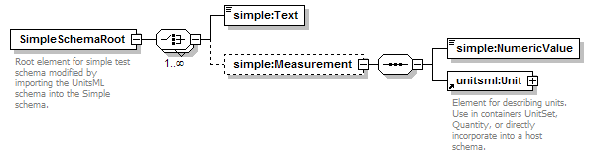
The text of the Simple schema modified to import the UnitsML schema is shown below.
Using the import option, an Simple data file would look like the example shown below. It shows that the Simple namespace (xmlns:simple) is different than the UnitsML namespace (xmlns:unitsml) and that the units part of the document is described completely in UnitsML. The following element of the <UnitSet> element <Unit> is defined globally in the UnitsML schema. This example demonstrates that it is possible to use the <Unit> element directly without using the root element <UnitsML>.
<?xml version="1.0" encoding="UTF-8"?>
<xs:schema xmlns:simple="http://unitsml.nist.gov/simple"
xmlns:xs="http://www.w3.org/2001/XMLSchema"
xmlns:unitsml="urn:oasis:names:tc:unitsml:schema:xsd:UnitsMLSchema-0.9.7"
targetNamespace="http://unitsml.nist.gov/simple"
elementFormDefault="qualified"
attributeFormDefault="unqualified">
<xs:import namespace="urn:oasis:names:tc:unitsml:schema:xsd:UnitsMLSchema-0.9.7"
schemaLocation="unitsmlSchema-0.9.7.xsd"/>
<xs:element name="SimpleSchemaRoot">
<xs:annotation>
<xs:documentation>Root element for simple test schema modified by importing
the UnitsML schema into the Simple schema.</xs:documentation>
</xs:annotation>
<xs:complexType>
<xs:choice maxOccurs="unbounded">
<xs:element name="Text" type="xs:string"/>
<xs:element name="Measurement" minOccurs="0">
<xs:complexType>
<xs:sequence>
<xs:element name="NumericValue" type="xs:double"/>
<xs:element ref="unitsml:Unit"/>
</xs:sequence>
</xs:complexType>
</xs:element>
</xs:choice>
</xs:complexType>
</xs:element>
</xs:schema>

Simple instance document with UnitsML imported in the Simple schema
<?xml version="1.0" encoding="UTF-8"?>
<simple:SimpleSchemaRoot
xsi:schemaLocation="http://unitsml.nist.gov/simple SimpleSchema_Import.xsd"
xmlns:simple="http://unitsml.nist.gov/simple"
xmlns:unitsml="urn:oasis:names:tc:unitsml:schema:xsd:UnitsMLSchema-0.9.7"
xmlns:xsi="http://www.w3.org/2001/XMLSchema-instance">
<simple:Text>The width of the room is: </simple:Text>
<simple:Measurement>
<simple:NumericValue>3.14159</simple:NumericValue>
<unitsml:Unit>
<unitsml:UnitName lang="en-US">meter</unitsml:UnitName>
<unitsml:Symbol type="ASCII">m</unitsml:Symbol>
</unitsml:Unit>
</simple:Measurement>
<simple:Text>This is more text related to the test.</simple:Text>
</simple:SimpleSchemaRoot>

<redefine> the elements of UnitsML
The redefine method is related to the include method in that the parts of the redefined schema must be in the same namespace as the host schema, whether declared or not. Thus, the version of the UnitsML schema to be redefined must have no declared namespace.
<xs:redefine schemaLocation="unitsmlSchema-0.9.7-NoNamespace.xsd"/>
Whereas the include method does not allow changes to be made to the included schema, the redefine method allows simple and complex types, as well as element and attribute groups, to be modified by extension or restriction. The example presented in this Guidelines redefines the Unit element by extension to include a child element named MyText.
<?xml version="1.0" encoding="UTF-8"?>
<xs:schema xmlns:xs="http://www.w3.org/2001/XMLSchema"
elementFormDefault="qualified" attributeFormDefault="unqualified">
<xs:redefine schemaLocation="unitsmlSchema-0.9.7-NoNamespace.xsd">
<xs:complexType name="UnitType">
<xs:complexContent>
<xs:extension base="UnitType">
<xs:sequence>
<xs:element name="MyText" minOccurs="0"/>
</xs:sequence>
</xs:extension>
</xs:complexContent>
</xs:complexType>
</xs:redefine>
<xs:element name="SimpleSchemaRoot">
<xs:annotation>
<xs:documentation>Root element for simple test schema modified by including
the UnitsML schema into the Simple schema redefining the Unit element by
extension.</xs:documentation>
</xs:annotation>
<xs:complexType>
<xs:choice maxOccurs="unbounded">
<xs:element name="Text" type="xs:string"/>
<xs:element name="Measurement" minOccurs="0">
<xs:complexType>
<xs:sequence>
<xs:element name="NumericValue" type="xs:double"/>
<xs:element ref="Unit"/>
</xs:sequence>
</xs:complexType>
</xs:element>
</xs:choice>
</xs:complexType>
</xs:element>
</xs:schema>

SimpleSchema that includes the Unit element using redefine to add the MyText element.
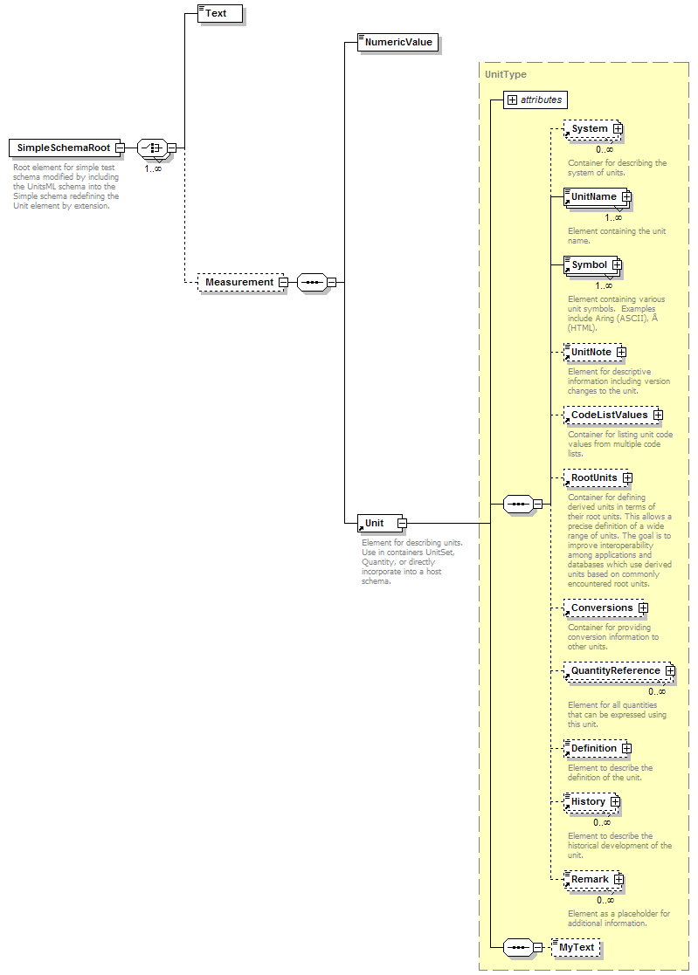
The instance document below is identical to that for the include method, but an additional element MyText is included.
<?xml version="1.0" encoding="UTF-8"?>
<SimpleSchemaRoot xsi:noNamespaceSchemaLocation="SimpleSchema_Redefine.xsd" xmlns:xsi="http://www.w3.org/2001/XMLSchema-instance">
<Text>The width of the room is: </Text>
<Measurement>
<NumericValue>3.14159</NumericValue>
<Unit>
<UnitName lang="en-US">meter</UnitName>
<Symbol type="ASCII">m</Symbol>
<MyText>This is sample text in an added element.</MyText>
</Unit>
</Measurement>
<Text>This is more text related to the test.</Text>
</SimpleSchemaRoot>

Relationship of UnitsML to UnitsDB
Place holder

Future work
Place holder

Notices
Place holder

References
SP811

Notes about this document:
- How do we easily update the references to external documents; e.g., NDR 0.4.1?

