JSR-275 Specification

Units of Measure

Version 0.9.5 - February 14, 2010

Content
1. Introduction 3
2. Requirements and Design Goals 4
2.1 Requirements 4
2.2 Design Goals 4
2.3 Source code and binary compatibility 5
3. Definitions of terms 6
3.1 Terms used in this specification 6
3.2 Example 7
4. Introduction to the API 8
4.1 Fundamental types 8
4.2 Systems of units 10
4.3 Obtaining Unit Instances 11
4.3.1 From predefined constants 12
4.3.2 From algebraic operations 12
4.3.3 From unit symbol 13
4.4 Unit Parametrization 15
4.5 Units conversions 16
5. Supported units 17
6. Frequently asked questions 18
7. Addendum 19
7.1 JavaDoc 19
8. References 20

Introduction
Java developers who work with physical quantities (such as developers in the scientific, engineering, medical, and manufacturing domains) need to be able to handle measurements of these quantities in their programs. Inadequate models of physical measurements can lead to significant programmatic errors. In particular, the practice of modeling a measure as a simple number with no regard to the units it represents creates fragile code. Another developer or another part of the code may misinterpret the number as representing a different unit of measurement. For example, it may be unclear whether a person's weight is expressed in pounds, kilograms, or stones.
Developers must either use inadequate models of measurements, or must create their own solutions. A common solution can be safer and can save development time for domain-specific work. This JSR proposes to establish safe and useful methods for modeling physical quantities.
JSR-275 specifies one or more Java packages for the programmatic handling of physical quantities and their expression as numbers of units. The specification includes:
- Interfaces and abstract classes with methods for unit operations:
- Checking of unit compatibility
- Expression of measurement in various units
- Arithmetic operations on units
- Concrete classes implementing the standard types of units (such as base and derived units) and unit conversions.
- Classes for parsing and formatting textual units representations.
- A database of predefined units.

Requirements and Design Goals

Requirements
The following features are considered critical to the success of the JSR.
- No Java Virtual Machine changes are allowed.
- Do no numerical harm. In essence, whatever algorithm the user intended to code should execute as intended.
- Should be able to inter-operate with code that does not understand units.
- Must support user-defined dimensions, units, quantities and systems of units.
- Strict symbols parsing for formatting:
- Metric Prefixes (as described in § 5) shall only be supported for use with SI units.
- Other Prefixes (e.g. locale or culture specific) work with all units, but their parsing and formatting depends on their specific context. They may be displayed simply as “unit*N” in the another (SI) context.
- Support run-time queries on (and printing of) units, measurements, and dimensions.
The last requirement implies that it must be possible to make the dimensions, their powers, and their names manifest at run-time. For example, a unit that is (kg¹·m¹·s⁻²) should be able to manifest in some version of any or all of the system (SI, in this case), the dimensions (kg, m, s), the exponents of those dimensions (1, 1, -2), and/or the name of the unit (if there is a defined name).

Design Goals
The following features are considered important to the success of the JSR.
- Small or no run-time overhead, compared with an implementation that doesn't use units.
- It should be possible to write "generic" numeric operations that compute correct results without regard to the user's choice of system, unit or quantity, while still remaining type-safe in terms of system, unit and quantity. A sample use-case would be a type-safe Newton's Method Square Root implementation.
- It should be possible to write programs that use more than one unit system simultaneously. For example, a program should be able to operate on SI, CGS, and imperial units, all simultaneously.
- Dimension errors shall be detected at compile time, not deferred to run time, when sufficient information allows a compile-time check.
- Fractional values for dimensions shall be allowed, for example kg^{3/2}. Fractional exponents sometime appear as a partial result on the way to a final value.

Source code and binary compatibility
Java 6 source code constructs and compilers will be used. Many uses of the proposed package have been discussed on Java ME platforms such as remote monitoring and sensor equipment. These platforms only support limited subsets of the Java 2 APIs. The JSR reference implementation should not stray from these areas which would make possible the creation of a binary jar file for the Java ME platform. Where proposed unification of Java SE and ME by Oracle should allow it, the code may well work in a Mobile subset or profile if those were more compatible with Java SE than today's ME platform.

Definitions of terms
The measurement of a physical quantity is the process of estimating the ratio of its magnitude to an other quantity of the same kind, which we take for unity. For example “5 meters” is an estimate of an object's length relative to an other length, the meter, which we adopt in this example as the standard unit of length. A similar approach can be taken for monetary quantities, providing that a monetary unit is properly defined.
The measurement term is also used in a looser fashion to refer to any process of assigning numbers to represent some sense of degree in an entity. For example the Mohs scale of mineral hardness characterizes the scratch resistance of various minerals through the ability of a harder material to scratch a softer material. This scale states that quartz is harder than calcite, but doesn't say how much harder. It is a somewhat arbitrary, strictly ordinal scale. Quantities expressed according such scales are comparable but not additive.
A measurement can be an estimation or an exact quantity. For example, we can determine that there are exactly 12 eggs in a carton by counting them.

Terms used in this specification
Java classes defined in this specification are not limited in scope to physical quantities. They can be applied to monetary quantities using the same API as the one for physical quantities. Users can also define their own scale, which may be ordinal. Consequently, the terms “quantity” and “unit” should be taken in their general sense unless otherwise specified as in “physical quantity” or “physical unit”.

Quantity
Any type of quantitative properties or attributes of thing. Mass, time, distance, heat, and angular separation are among the familiar examples of quantitative properties.
- No unit is needed to express a quantity, nor to do arithmetic on one. Alice can quantify the mass of her shoe by handling it. Alice can add the mass of her left shoe and the mass of her right shoe by placing them both in the pan of a balance.
- Units are needed to represent measurable quantities in a computer, on paper, on a network, etc.

Measurable
A quantity for which given a compatible unit, the magnitude stated in this unit can be retrieved.
      - Measurable are not always scalar quantities; they can be vectors, data sets or any thing for which a meaningful magnitude can be determined. For example, the magnitude of a velocity vector could be its norm, the magnitude of a collection of data samples could be the average value.

Measure
The result of a measurement, expressed as the combination of a numerical value and a unit.
- A measure is a scalar magnitude (in the sense of amount, not the sense of magnitude versus phase). Thus the mass of Alice's shoe is a magnitude.
- Measures represent exact or approximate quantities.
- Whereas the quantity being measured has infinite precision (the mass of Alice's shoe is exact) the measure may be limited by the precision of an IEEE floating point, or by the resolution of the mass scale.

Dimension
One of the fundamental aspects of quantities, such as length (L), mass (M), time (T), or combination thereof (ML/T2 dimension of force). The notion of dimension expresses a property without any concept of magnitude. Thus we can talk about length (L) without any implication that we are talking about any particular length. Two or more quantities are said to be commensurable if they have the same dimensions; and it follows that these can be meaningfully compared.

Unit
A quantity adopted as a standard, in terms of which the magnitude of other quantities of the same dimension can be stated.
Units can be created from some quantity taken as reference. For example, the foot unit corresponds to a quantity of 0.3048 meters. Regardless of how it is created, a unit can be expressed as a quantity of other units with the same dimension.

Base Unit
A well-defined unit which by convention is regarded as dimensionally independent of other base units. The SI system defines only 7 base units (including meter, kilogram and second), from which all other SI units are derived.

Derived Unit
A unit formed as a product of powers of the base units. Some derived units get a special name and symbol for convenience. In the SI system, derived units with special name include hertz, Newton and Volt.

System of units
A set of base and derived units chosen as standards for specifying measurements. Examples include the SI and Imperial System.

Prefix
A leading word that can be applied to a unit to form a decimal multiple or sub-multiple of the unit. Prefixes are primarily used in the SI system, which includes kilo- and centi-.

Example
The result of an experience measuring the wavelength of some monochromatic light emission may be expressed in the SI system of units as:
λ = 698.2 nm
where:
- λ is the symbol for the physical quantity (wavelength)
- nm is the symbol for the physical unit (nanometer), where:
- n is the symbol for the sub-multiple (nano, meaning 10⁻⁹)
- m is the symbol for the base or derived unit on which the prefix is applied
- 698.2 is the numerical value (magnitude) of the wavelength in nanometers.
The dimension of length is typically represented by the letter L in dimensional analysis. However, this dimension does not appear explicitly. Instead, it can be inferred from the quantity “λ“ or from the unit “m”.

Introduction to the API
For a detailed API description see chapter 5.

Fundamental types
At the root of this specification is the javax.measure.Measurable interface identifying quantities capable of being measured.
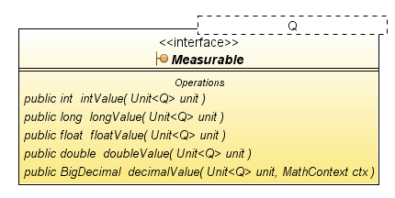
Methods of this interface are similar to the ones in java.lang.Number except that a unit has to be specified in order to retrieve the desired primitive type. Also in case of overflow, an exception is raised rather than a silent truncation being performed (safety critical).
The second important class from the javax.measure package is the abstract class Measure representing the result of a scalar measurement stated in a known unit.
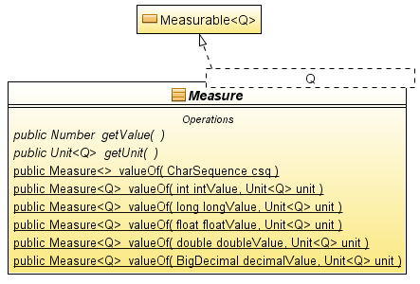
For performance reasons, the Measure class provides specialized factory methods for primitive types values (avoids auto-boxing).
This last class is mostly for convenience as it allows for the creation of simple Measurable instances from scalar decimal representations, primitive types or BigDecimal instances.
Finally the last important type the user needs to know is javax.measure.unit.Unit, the class representing a determined quantity adopted as a standard of measurement. For example “kilometer“ and “watt“ are units, but “5 kilometers” is not (at least in the international system of units). It is rather a measure.
import static javax.measure.unit.SI.*;
import static javax.measure.unit.SI.MetricPrefix.*;
...

// Speed of Light (exact from decimal representation)
Measure<Velocity> c = Measure.valueOf("299792458 m/s").asType(Velocity.class);

// Example of temperature (double approximation).
Measure<Temperature> boilingPoint = Measure.valueOf(373.15, KELVIN);

// Example of duration (exact from int value).
Measure<Duration> delay = Measure.valueOf(200, MILLI(SECOND));

// Example of frequency (arbitrary precision from BigDecimal).
Measure<Frequency> resonance = Measure.valueOf(
BigDecimal.valueOf("34.55", MathContext.DECIMAL128), GIGA(HERTZ));

Units and measure are defined in terms of each other. While Unit could be defined as a subtype of Measure, in the sense of “is a kind of”, this specification avoid such relationship in order to discourage the abuse of Unit as a general-purpose implementation of Measure.
The classes Measurable, Measure and Unit are all parametrized by their quantity type (§ 4.4). Quantity types (such as Mass, Duration) are derived from javax.measure.quantity.Quantity. The dimensions of a unit (javax.measure.unit.Dimension) can be retrieved from the unit itself (at run-time) of be inferred from its quantity type (at compile time).
Example: “centimeter“ is a unit. “2.54 centimeters“ is a measure of length (quantity), but this measure can be used as the definition of a new length unit called “inch”. “1 inch” is a measure equivalent to 2.54 centimeters. Lets emphasize that “1 inch” (the measure) and “inch” (the unit) are not synonymous. In this specification, they are represented by two distinct types with no common ancestor other than Object.
All numerical values in a program that result from a measurement are associated, directly or indirectly, to a unit. The simplest measure is the combination of a numerical value with a unit, such measure can be created directly through the Measure class.
Many numerical values associated to the same unit can form other kinds of objects such as vectors, columns in a table, remote sensing data, etc. Such constructs outline a means of storing homogeneous measurements. For example a vector can be defined as a quantity with a magnitude and a direction, specified by components all having the same unit:
Associating a single unit to a large set of numerical values has obvious advantages from a storage space point of view. But it is also advantageous on a performance point of view, since the conversion formula to another unit needs to be determined only once for a whole vector. A single unit can be associated to yet more complex objects, like matrices or collections.
public class Vector<Q extends Quantity> implements Measurable<Q> {
double[] values;
Unit<Q> unit; // Single unit for all vector components.
...
}
Measure and Unit instances are immutable and thus thread-safe. They are safe for use as static constants (final). Immutability is an essential property of Unit since the same instances are typically referenced by a large number of quantity objects, and the cost of cloning each unit (defensively copying) would be prohibitive.

Systems of units
A system of units is a set of units chosen as standards for specifying measurements. It contains a small set of well-defined units, called base units, which by convention are regarded as dimensionally independent of other base units. It contains also a larger set of derived unit formed as products of powers of the base units. A widely used units system is SI (Système International).
Base units in SI comprise meter (m), kilogram (kg) and second (s). Derived units in SI comprise square meter (m²), watt (m²∙kg∙s⁯⁻³), etc. Some derived units have been given special names and symbols for convenience. For example the above-cited watt derived unit is represented by the symbol W.
In SI, the base and derived units form a coherent set of units, where coherent means that those units are mutually related by rules of multiplication and division with no numerical factor other than 1 (BIPM, 1998).
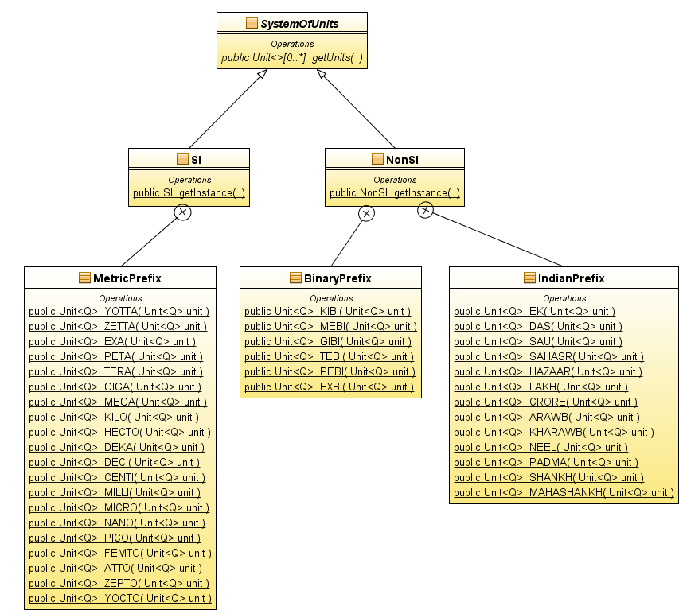
Systems of units may share the same units. For example, the Imperial System would have many of the units already defined in NonSI (e.g. NonSI.FOOT).

Obtaining Unit Instances
Unit instances can be obtained in a number of ways. The easiest way is to use one of the predefined constants provided in various SystemOfUnits subclasses like SI (§ 4.3.1). Because the constants are known to the compiler, this approach also provides compile-time checking as discussed in § 4.4. New units can also be created by applying algebraic operations on existing units (§ 4.3.2), or by parsing a unit symbol (§ 4.3.3).
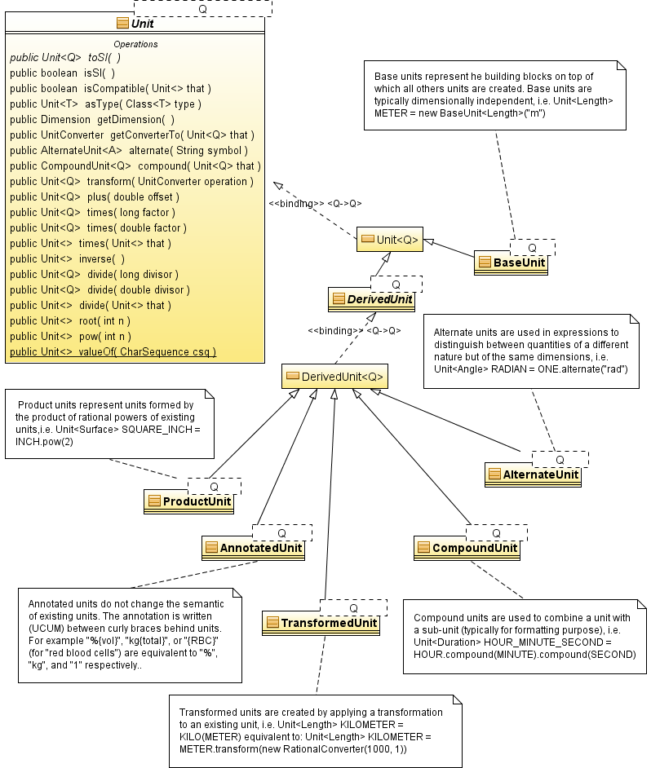

From predefined constants
System units can usually be obtained as class members of a system of units. SystemOfUnits subclasses are encouraged (but not required) to expose all their system units as static final constants. For example the SI class provides such static constants like METRE (a basic unit) or WATT (a derived unit).
METRE or METER? The former is British spelling and the later is U.S. An on-line dictionary of English gives the following explanation: “a metre is a measure and a meter a measuring device”. The BIPM brochure, ISO 31 and Wikipedia use “metre”, while NIST use “meter” (e.g. NIST SP 1038). For this specification, we retained the "meter" american spelling in the text but we use the BIPM spelling for SI constants names (e.g. SI.METRE, NonSI.LITRE; but UCUM.METER).
In the particular case of the SI class, a set of static methods is also provided for obtaining multiples or sub-multiples of system units. All those methods are named as SI prefix names changed to upper case. Examples:
Unit<Length> m = SI.METRE;
Unit<Length> km = SI.MetricPrefix.KILO(SI.METRE);
Unit<Energy> kW = SI.MetricPrefix.KILO(SI.WATT);

Unit instances obtained that way provide type safety through unit parametrization (the <Length> and <Energy> declarations above). This feature will be discussed more extensively in § 4.4.

From algebraic operations
Units can be created dynamically from existing units by the use of algebraic operations. All operations are defined as member methods of the Unit class, except the static convenience methods defined in the SI class (§ 4.3.1). Those SI methods are omitted from discussion below.

Operands:
All binary operations expect (Unit, Unit) or (Unit, n) operands where n stands for an integer value. The first operand is always the Unit instance on which the Java method is invoked.
Example: lets “m“ and “s“ be two instances of Unit. Some valid operations are “m/s”, “m·s”, “m²“ or “m·1000“ where “/”, “·“ and raising to a power maps to Java methods divide(Unit), times(Unit) and power(int) invoked on the Unit instance named “m”.

Result:
All operations – both unary and binary – return a new or an existing instance of Unit. All operations can be grouped in two categories according the dimension of the returned unit, compared to the dimension of the first Unit operand:
- Result has the same dimension as the operand. Those operations are used for the definition of new units as existing units scaled to some factors, or as existing units with the scale translated by some offset. Quantities expressed in terms of the resulting unit are convertible to the original unit. For example the inch unit can be defined as 2.54 centimeters, or equivalently as the centimeter unit scaled by a factor of 2.54.
- Result has a different dimension than the operand. Those operations are used for derivation of new units from existing one (often from base units). Quantities expressed in terms of the resulting unit are usually not convertible to the original unit. For example the watt unit can be defined as the joule unit divided by the second unit.
The following table summarizes the algebraic operations provided in the Unit class.
Result with same dimension | Result with different dimension
Binary operations:  - plus (double) or (long)  - times (double) or (long)  - divide (double) or (long)  - compound (Unit) | Binary operations:  - root (int)  - power (int)  - times (Unit)  - divide (Unit)
Unary operations:
- inverse()

Example for the first case
An other proposal for method names was add and multiply, which are more common than plus and times in JDK and Java3D libraries. However it has been reported that some users expect “A.add(B)” to perform an addition in place (i.e. the new value replace the old value into A), while “A.plus(B)” suggests the same behavior than the + operator.
The following examples define the inch unit as 2.54 centimeters. This unit is defined in three different ways, which are all equivalent up to rounding error. The algebraic functions appear in bold characters. Note that CENTI(x) is basically a convenience method for x.divide(100) with prefix symbol management added. The CENTI and METRE members are defined in the SI class, which is assumed implicit through a static import statement. The result is a new unit (inch) of the same dimension (length) as the scaled unit (meter).
- Unit<Length> INCH = CENTI(METRE).times(2.54);
- Unit<Length> INCH = METRE.times(0.01).times(2.54);
- Unit<Length> INCH = METRE.times(254).divide(100); // Recommended.
The last definition (using only integer values) is recommended as it does not introduce double imprecision (the internal representation of 2.54 is actually something like 2.540000000000000036...)

Example for the second case
The following example defines the watt unit as the joule unit divided by the second unit. Joule has the dimension of energy, while second has the dimension of time. The result is a unit with dimension of power.
- Unit<Power> WATT = JOULE.divide(SECOND).asType(Power.class);

From unit symbol
Units can be created dynamically from their string representation – usually their unit symbol, but other kinds of string representations are allowed as well. Bidirectional transformations between units and string representations (parsing and formatting) are performed by the UnitFormat class. This class serves three purposes:
- Maintains associations between an arbitrary amount of unit instances and their string representations. This usually includes all base units together with the derived units that have a special name and symbol. For example a UnitFormat instance for SI symbols should maps the “W” string to the WATT unit instance.
- Maps prefix symbols to the corresponding scaling methods, if applicable. For example a UnitFormat instance for SI symbols should map the “kW” string to the KILO(WATT) unit.
- Maps operator symbols to the corresponding arithmetic methods. For example a UnitFormat instance for SI symbols should map the “m/s” string to the METRE.divide(SECOND) unit.
UnitFormat is defined as a java.text.Format subclass in order to facilitate its usage with existing libraries like javax.swing.JFormattedTextField. Like most format classes, it contains a set of getInstance(…) static methods. They are detailed together with the rest of the UnitFormat API. Users can get Unit objects directly from a UnitFormat instance – this approach provides the greatest flexibility – or from the Unit.valueOf(CharSequence) convenience static method, which delegates to the standard (UCUM UnitFormat instance. This standard format recognizes all SI and non-SI units enumerated in the SI brochure and U.S. customary units (§ 5). Examples:
Unit<Length> metre = Unit.valueOf("m").asType(Length.class);

Unit<Length> feet = Unit.valueOf("ft").asType(Length.class);

Unit<Energy> kilojoule = Unit.valueOf("kJ").asType(Energy.class);

Unit<Force> newton = Unit.valueOf("m.kg/s2").asType(Force.class);

The asType(Class) method checks that valueOf(...) return value Unit<?> is of the proper parametrized type (e.g. Unit<Length>). More will be said in § 4.4.

Unit Parametrization
Units are always checked for compatibility at run-time prior to any operation. For example any attempt to convert a quantity from kilogram units to meters units will result in a ConversionException being thrown. Rigorous run-time checks are needed because units may be unknown at compile-time, and because it is possible to defeat the compile-time checks with unchecked casts. Note that the performance impact of systematic run time check is not always significant (§ 4.5).
In addition of run-time checks, some limited compile-time checks can be achieved in the Java language using parametrized types. Units can be parametrized with the quantities on which they apply, for example Unit<Length> for any units of length. Parametrized types allow applications to put restrictions on the units they can accept.
User can get a parametrized unit by the following means:
- Assignation from one of the predefined constants, for example all constants in the SI class.
- All operations returning always a unit of the exact same type than the operand – or, in terms of Java language, all Unit methods where the return type is exactly Unit<Q>. This include multiplication (times) and division (divide) by a dimensionless factor.
For example all the following assignations are type safe:
Unit<Length> m = METRE;
Unit<Length> cm = CENTI(m);
Unit<Length> inch = cm.times(2.54);
However, the assignations below are not type safe, because the result is a type that can not be determined statically by the Java type system. The Java compiler emits a “unchecked cast” warning for such code. Omitting the casts would result in a compiler error.
As of Java 5, units checks can't be performed at compile time for such code. However the above code can be rewritten in a slightly safer way as below:
Unit<Length> m = (Unit<Length>) Unit.valueOf("m");
Unit<Area> m2 = (Unit<Area>) m.power(2);
Unit<Pressure> Pa = (Unit<Pressure>) NEWTON.divide(m2);
The asType(Class) method which can be applied on a Unit or a Measure instance, checks at run time if the unit has the dimension of a given quantity, specified as a Class object. If the unit doesn't have the correct dimension, then a ClassCastException is thrown. This check allows for earlier dimension mismatch detection, compared to the unchecked casts which will thrown an exception only when a unit conversion is first requested.
Unit<Length> m = Unit.valueOf("m").asType(Length.class);
Unit<Area> m2 = m.power(2).asType(Area.class);
Unit<Pressure> Pa = NEWTON.divide(m2).asType(Pressure.class);
For this mechanism to work, users defining new quantity types (on top of the 40+ predefined) have to provide the SI unit of the quantity as a public final static UNIT class member of the quantity interface.
public interface Solubility extends Quantity {
public final static Unit<Solubility> UNIT
= new ProductUnit<Solubility>(MOLE.divide(CUBIC_METRE));
}

Units conversions
Conversions involve two steps: obtain a UnitConverter object for a given pair of source and target units, then uses it for converting an arbitrary number of floating point values. The example below converts 4 and 6 meters to 400 and 600 centimeters respectively.
This example illustrates the advantages for a separated UnitConverter class as opposed to a convert(double, Unit) method straight into the Unit class. The process of checking unit compatibility and computing the conversion factor (Unit.getConverterTo(Unit)) is a costly operation compared to the conversion itself (UnitConverter.convert(double)). But the conversion factor needs to be computed only once for a series of floating point values. The UnitConverter class encapsulates the result of this operation. Once available, it can be applied efficiently on a large number of values. Different implementations exist for different kind of unit scale (identity, linear, logarithmic, etc.).
Unit<Length> sourceUnit = METRE;
Unit<Length> targetUnit = CENTI(METRE);
UnitConverter c = sourceUnit.getConverterTo(targetUnit);
double length1 = 4.0;
double length2 = 6.0;
length1 = c.convert(length1);
length2 = c.convert(length2);
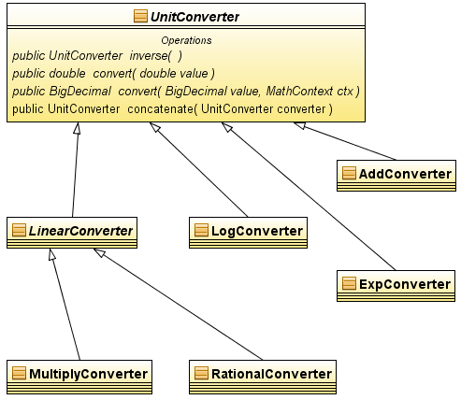
For convenience the Measure class provides direct conversion methods such as Measure.toSI(), Measure.to(Unit<Q>) and Measure.to(Unit<Q>, MathContext).
Measure<Velocity> c = Measure.valueOf("299792458 m/s", Velocity.class);
Measure<Velocity> milesPerHour = c.to(MILES_PER_HOUR, DECIMAL128);
System.out.println(milesPerHour);
> 670616629.3843951324266284896206156 [mi_i]/h

Supported units
The out-of-the-box units database shall include support for the units defined in the following documents:
- BIPM units (same as ISO 1000), including:
- Base units
- Dimensionless derived units
- Derived units with special names
- Non-SI units accepted for use with SI
- SI prefixes from 10⁻²⁴ to 10⁺²⁴.
- ISO 31 including:
- ISO 31-1: Space and time
- ISO 31-2: Periodic and related phenomena
- ISO 31-3: Mechanics
- ISO 31-4: Heat
- ISO 31-5: Electricity and magnetism
- ISO 31-6: Light and related electromagnetic radiations
- ISO 31-7: Acoustics
- ISO 31-8: Physical chemistry and molecular physics
- ISO 31-9: Atomic and nuclear physics
- ISO 31-10: Nuclear reactions and ionizing radiations
- ISO 31-11: Mathematical signs and symbols for use in the physical sciences and technology
- ISO 31-12: Characteristic numbers
- ISO 31-13: Solid state physics
- NIST
- NIST Handbook 44 - 2002 Edition; Specifications, Tolerances, And Other Technical Requirements for Weighing and Measuring Devices.
- Appendix C - General Tables of Units of Measurement
- Federal Standard 376B
- NIST Special Publication 811 - Guide for the Use of the International System of Units (SI); 1995. (Specifically units defined in appendix B8)

Frequently asked questions

Why are units parametrized with Quantity? Wouldn't Dimension be more appropriate?
The first concept from which all others are derived is Quantity (§ 3). Quantities are suitable to parametrize units as they provide an important compile time information: What kind of quantity a unit states. The standard parametrization mechanism in Java works reasonably well with quantities for the most basic operations. For example a length unit being scaled is still a length unit. Using a Dimension class for parametrization of units can lead to problems:
- Dimensions change with the model. For example the dimension of the Watt unit is [L]²·[M]/[T]³ in the standard model (SI system of units), but become [M]/[T] in the relativistic model.
- Units may have the same dimension and still apply to different quantities. For example both Torque and Energy have a dimension of [L]²·[M]/[T]² in the standard model. Nevertheless it is convenient and safer to consider them as two different quantities with their own units. Other examples are sea water salinity (PSS-78), some kind of concentration and angles, which are all dimensionless but still convenient to treat as different kind of quantity.
- Users will work primarily with Measure and Unit objects. The need to work with Dimension objects is less common. If the units were parametrized with dimension instead of quantity, the API would need to define many Dimension subtypes in the same way that it currently defines many Quantity sub-interfaces, resulting in a large increase of API size – almost doubling the amount of types.

Addendum

JavaDoc
API Docs at GeoAPI Hudson Site:
http://hudson.geomatys.com/job/JSR-275/ws/jsr-275/target/site/apidocs/index.html

References
- BIPM - Bureau International des Poids et Mesures
- Brochure on the International System of Units
- ISO - International Organization for Standardization
- ISO 31 (Quantities and units)
- ISO 1000
- ISO 10303 STEP Part 41 .
- STEP Part 41 EXPRESS Schema .
- NIST - US National Institute of Standards and Technology
- International System of Units (SI)
- Guide for the Use of the International System of Units (SI)
- UCUM - The Unified Code for Units of Measure
      - Full Specification
- JScience – Java Library for the Advancement of Sciences.
      - Home Page
  - Curl
      - Curl – Quantities and Units
      - Taking Curl for a Whirl
- Andrew Kennedy:
      - Units of Measure

This specification do not mandate the use of any particular quantity as standard unit. However, we expect SI to be the standard system of units for most applications.
We keep the SI class name in those examples for clarity. For many applications, usage of static imports will make the reading easier, as in KILO(METRE).
All static methods defined in the SI class can be implemented in terms of calls to Unit member methods. For example SI.KILO(Unit) can be mapped to Unit.times(1000)
UCUM: Unified Code for Units Of Measure, see http://unitsofmeasure.org/

